Ember & Oak
CS2024 HTML Assignment Planning Document (19 October 2026)
By Martin
Ember & Oak is a fictional student café at North Spine, Nanyang Technological University (NTU), Singapore, for students who want good kopi or coffee at a fair price and a place to study after Lee Wee Nam Library (also in North Spine) closes at 9.30pm on weeknights. The site has three pages: a homepage, a menu subpage and a content page telling the café's story.
Note: the café's founders (two NTU students, Wei Ling and Hafiz) appear only in the story on the Our story page. The persona below is a different person: a typical customer the website is designed for.

1. Target persona
Persona | Aisha Rahman
Age & role | 21, Year 3 Computer Science student at NTU. Gives tuition two evenings a week.
Situation | Lives with her family in a 4-room HDB flat in Tampines, about 1.5 hours from campus by MRT and bus. Home is noisy, so she studies on campus. Lee Wee Nam Library closes at 9.30pm on weeknights during the semester, but her FYP and assignments usually get done late at night.
Goals | Find a spot on campus where she can stay 3–4 hours with her laptop, plug in her charger, enjoy strong air-con and buy a kopi that doesn't cost a fortune.
Frustrations | Canteen stalls that close early, seats without plugs, and cafés that charge S$7 for a latte or make her feel she has to leave after one drink. Menus online that don't show prices.
Habits | Searches on her laptop or phone between lectures. Decides quickly: checks prices, opening hours and the vibe from photos. Budget about S$5–8 per visit.
Quote | “I just need a big table, a plug and a kopi I can afford till late.”
What this means for the website: prices must be visible, opening hours and the address must be easy to find on every page, and the photos and copy should show a calm place to study, not a fancy restaurant.

2. User journey map
Aisha's journey from hearing about Ember & Oak to deciding to go there tonight:
 | Entry point | Engagement | Comparing | Goal completed
What she does | A friend shares the link in their project group chat, or she searches “NTU study spot open late”. Lands on the homepage. | Reads the headline and sees the exam season deal. Scrolls through today's favourites and the four reasons students stay. | Clicks “See the menu”. Checks kopi, coffee and food prices and the matric card discount. Reads the story page to get a feel for the place. | Sees it is in North Spine and open till 11pm on weekdays. Walks over after her last tutorial.
Page | Homepage | Homepage | Menu, Our story | Any page (footer)
She thinks | “Is this place for people like me?” | “Plugs and free refills, nice.” | “Kopi-o is S$1.80 with free refills!” | “Open till 11pm. I'm going.”
Feeling | Curious | Interested | Reassured | Decided
Design response | Headline names her need straight away; hours shown next to the button. | Promotion on a sticky note; ticked list of study perks, including no time limit after 2pm (tables stay free for the lunch crowd before that). | Clear menu with dotted price lines; honest story with real details. | Address and hours repeated in every footer.

3. Sitemap
The site is flat: the homepage links to both other pages and every page shares the same navigation bar, so any page is one click away. The menu matters most to the persona, so it is linked from the hero button, the favourites section and the story page.
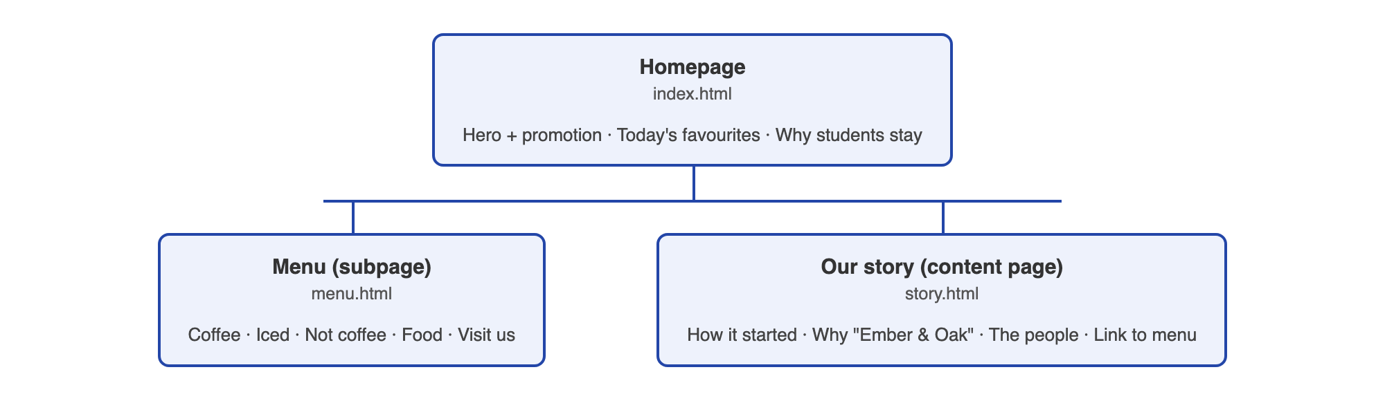
Figure 1. Sitemap: homepage, subpage (Menu) and content page (Our story).

4. Wireframes
Desktop wireframes for the three pages. All pages share the header (logo + navigation) and the dark footer (address, hours, links and a copyright line). The red double line on the left is the notebook margin from the design concept.
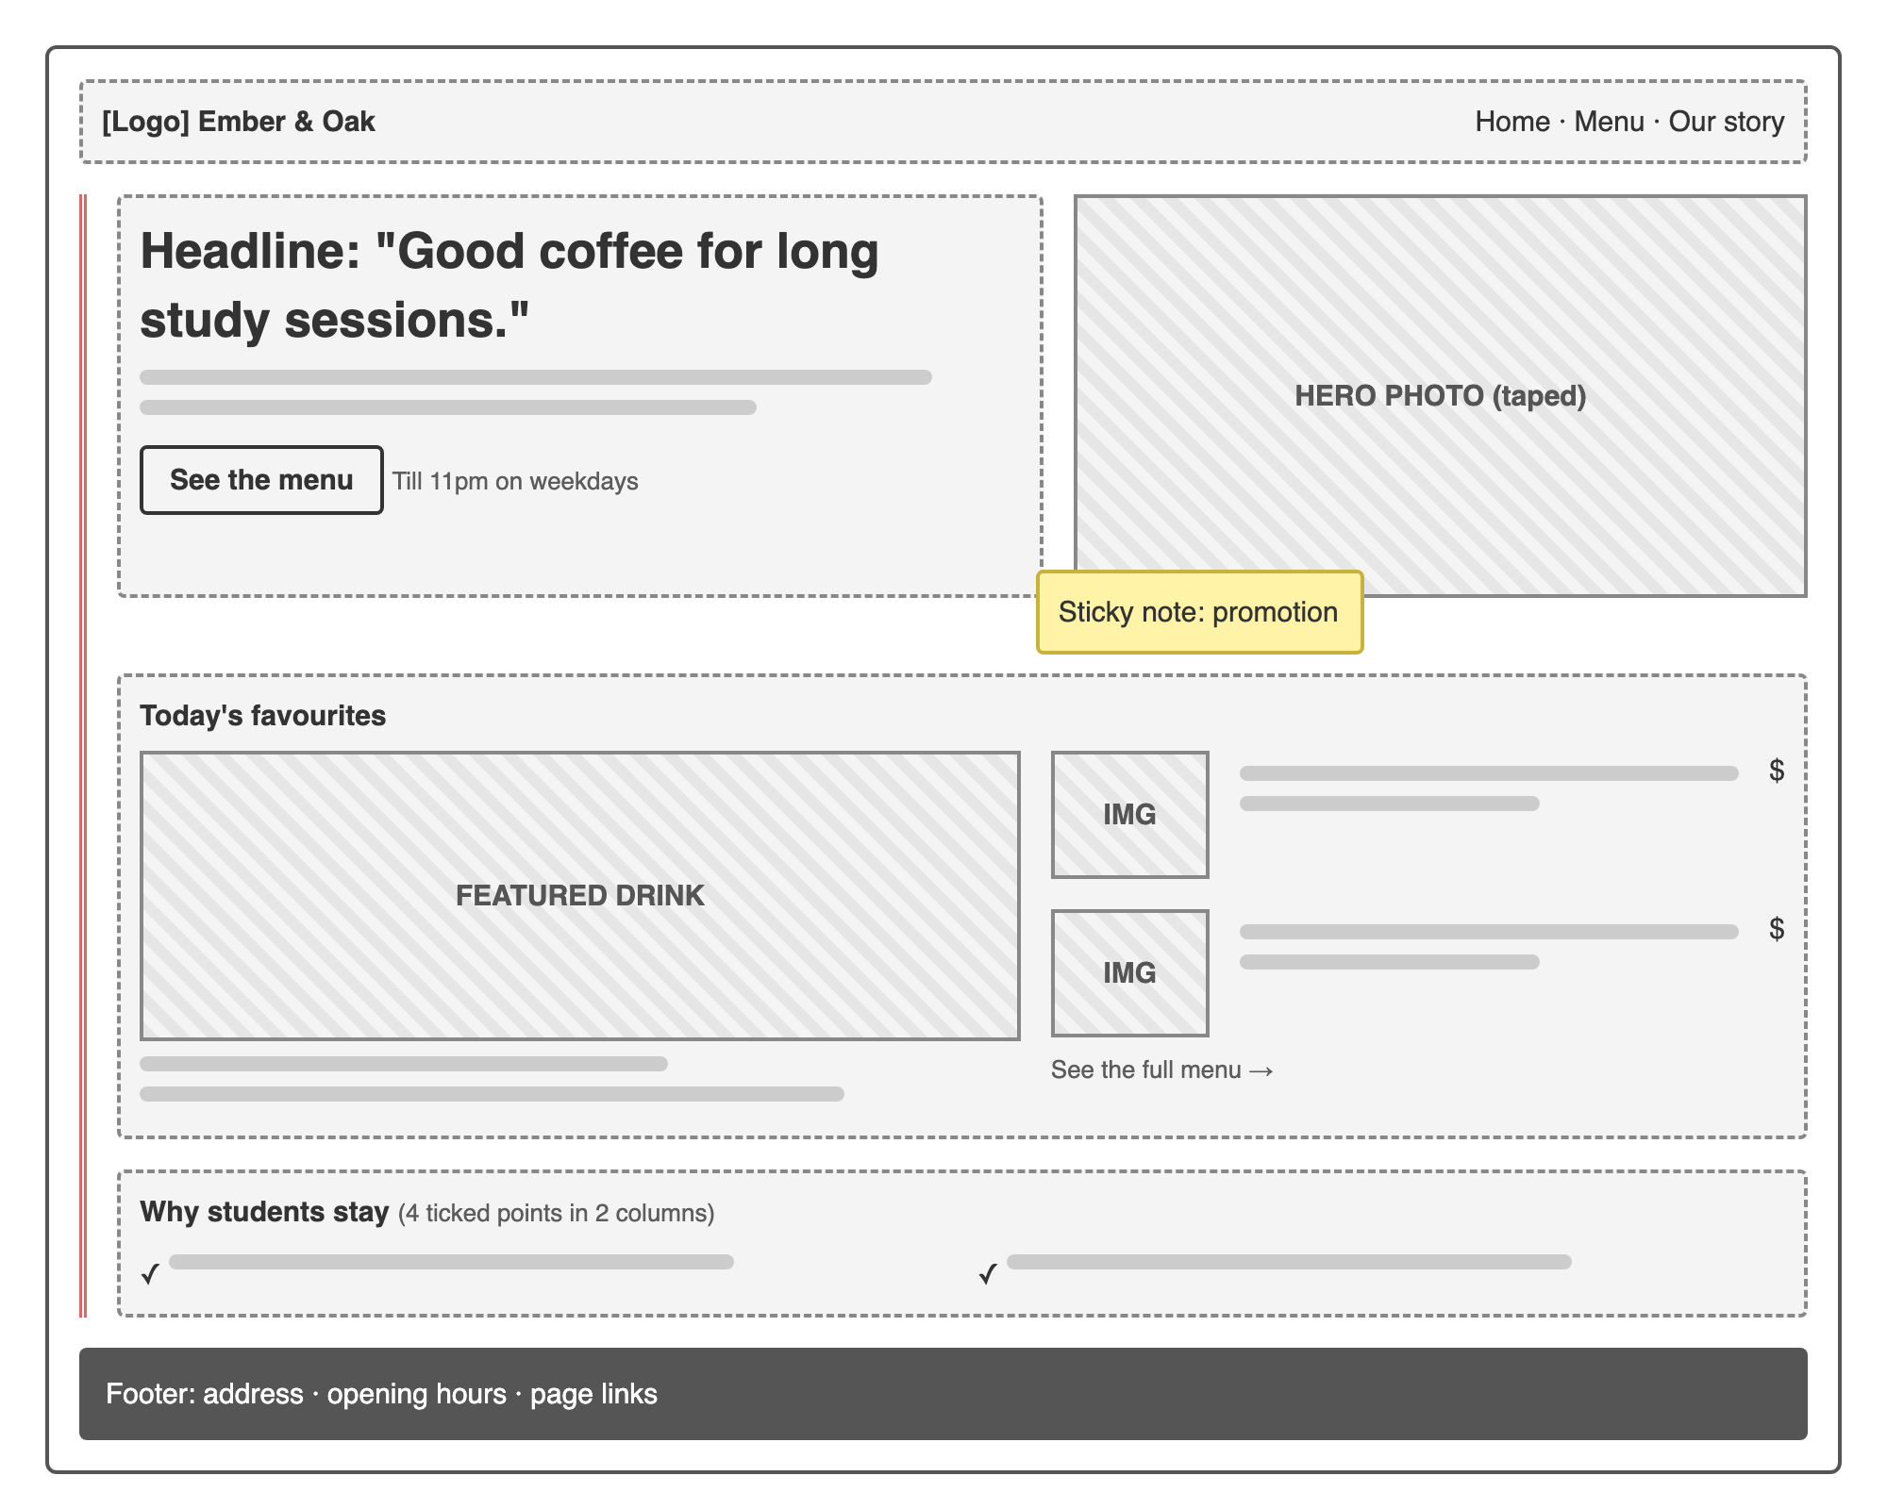
Figure 2. Homepage: headline with menu button, taped hero photo with promotion note, favourites, study perks.
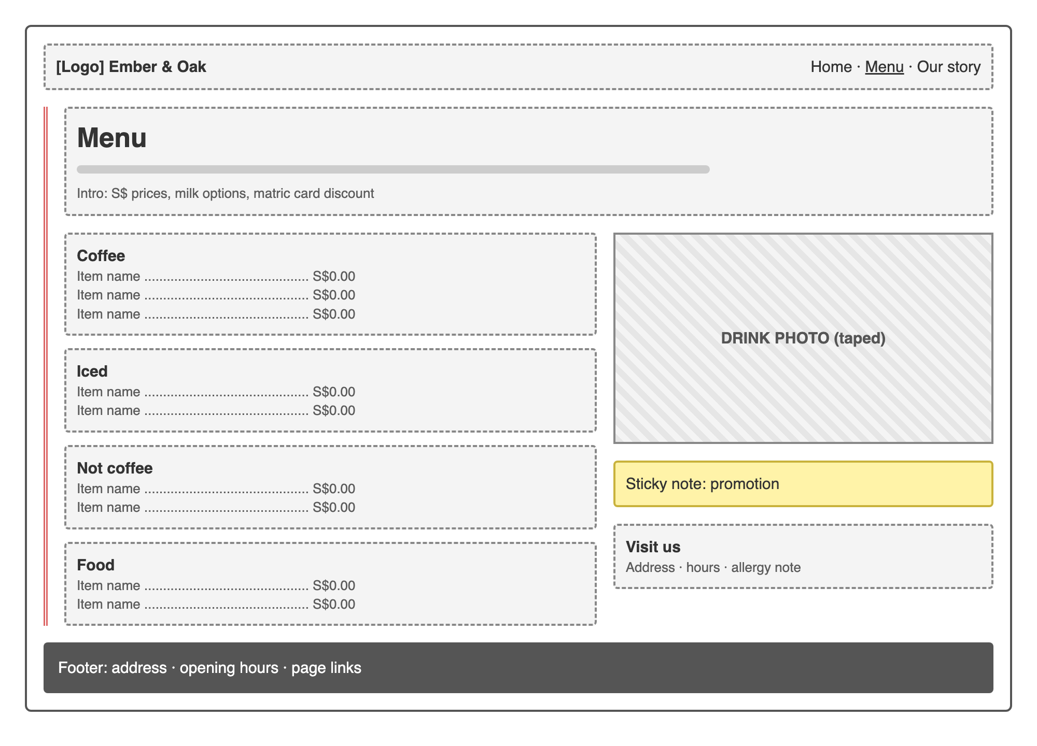  Figure 3. Menu subpage: four menu sections with prices, photo, promotion and visit details. | 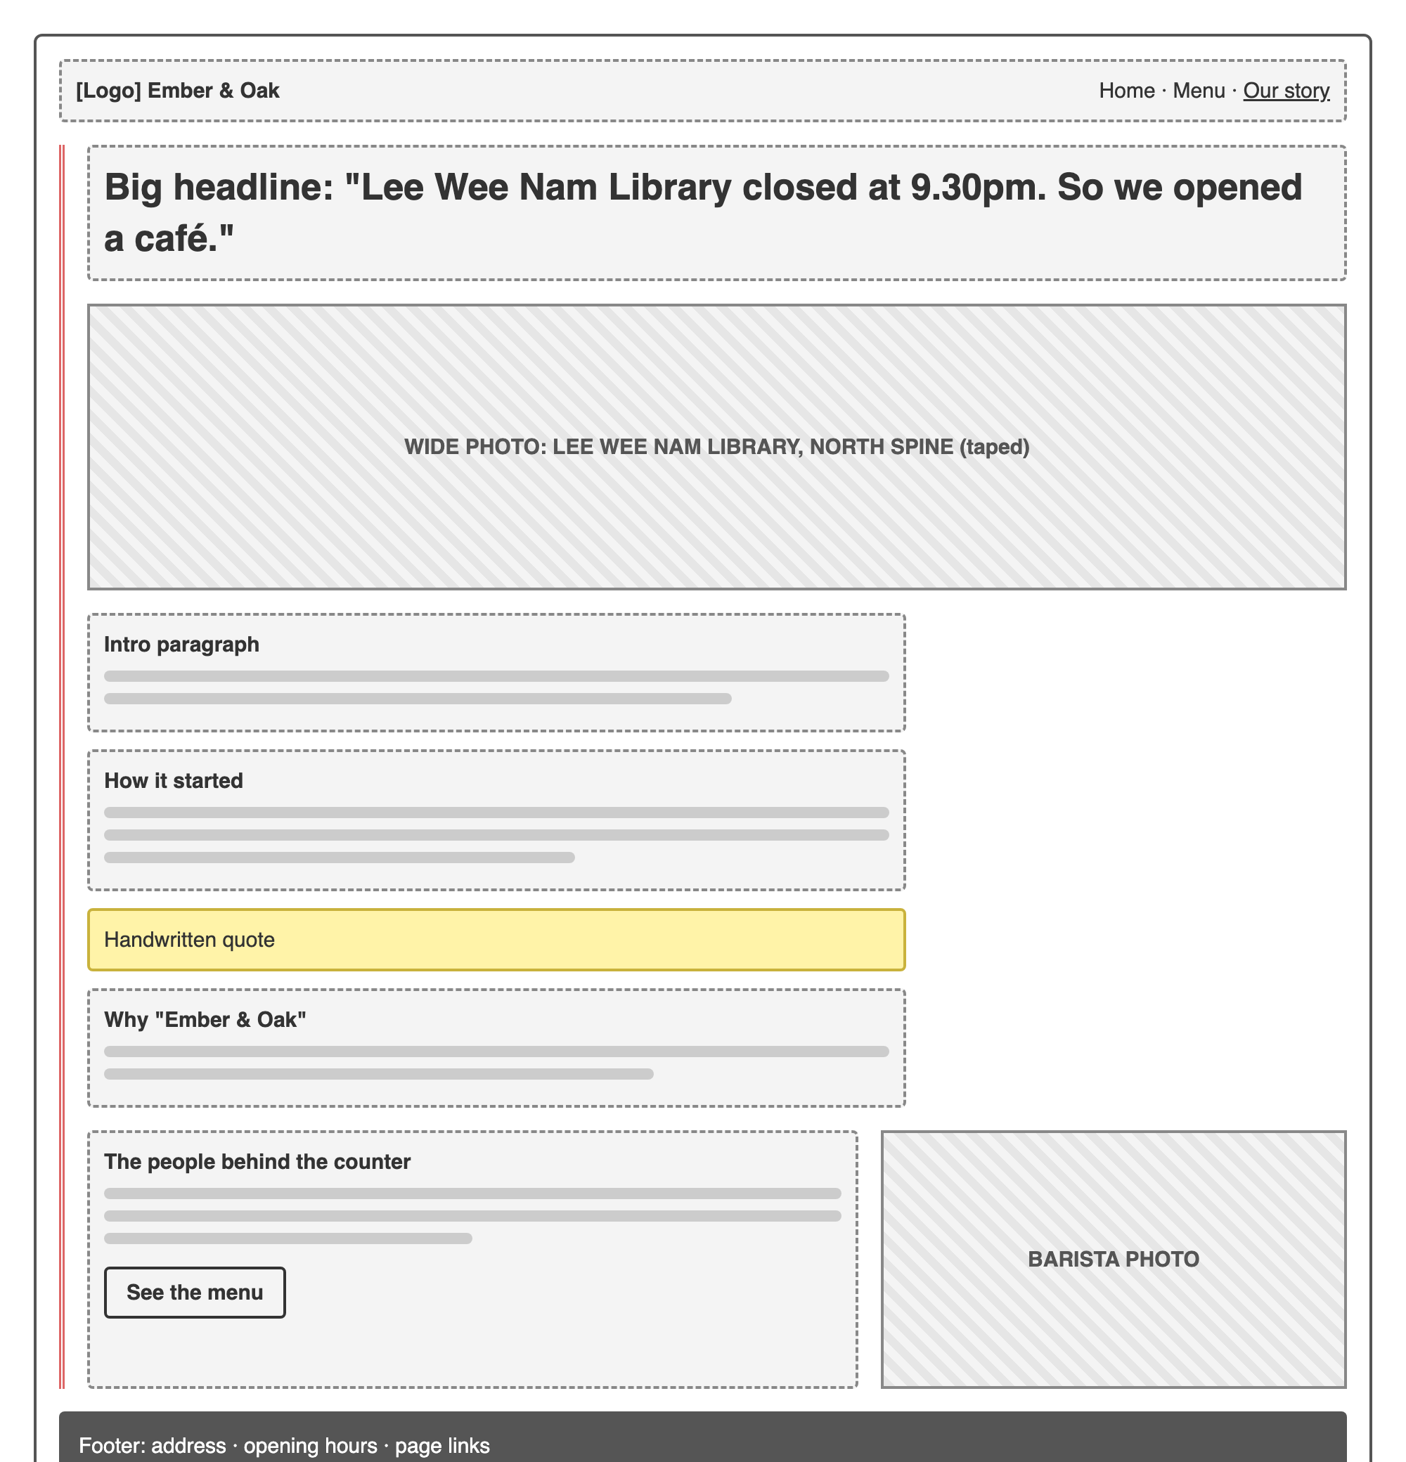  Figure 4. Our story (content page): headline, wide photo of Lee Wee Nam Library, article, barista section with a link to the menu.

5. Design planning

Concept: a page from a student's exercise book
The café is made for studying, so the website looks like a page from a notebook: pale blue ruled lines, a red margin line on the left, prices and little notes written in blue ballpoint, photos stuck on with tape and a yellow sticky note for the promotion. It feels familiar to students, calm and a bit playful, and it is different from the usual brown-and-cream café website.
(Refer to Ember-and-Oak-technical-notes.docx for how the website was built and references)

Colour scheme
 | Paper white | #FDFDFB | Page background
 | Rule blue | #D3E2F2 | Ruled lines across the page
 | Margin red | #E5675D | Margin line (margin notes use a darker red, #C0392F, so they are easier to read)
 | Ink | #1C2230 | Main text and headings
 | Ballpoint blue | #2346A8 | Prices, buttons, links, handwritten notes
 | Cover blue | #182F73 | Footer background (the notebook's back cover)
 | Sticky-note yellow | #FFE66B | Promotion note, favicon background

Fonts
- Bricolage Grotesque (Google Fonts) for headings and body text: a bold, friendly sans-serif that reads well at large sizes and stays clear in menus.
- Kalam (Google Fonts) for handwritten touches only: prices, margin notes, the sticky note, photo captions, the logo tagline and the quote on the story page. Using it sparingly keeps the page readable.

Layout ideas
- Desktop layout, 1200px wide, centred. Text lines up on a 32px grid so it sits on the ruled lines.
- Content starts to the right of the red margin; the margin holds small handwritten notes like “open late on weekdays!”.
- Photos are slightly rotated with tape strips; a yellow sticky note holds the promotion on the homepage and the menu page.
- Simple hover effects: links get a ballpoint underline drawn from left to right, and the sticky note lifts slightly.
- Favicon: a blue coffee cup on a yellow sticky-note square, matching the logo.
- Photos: free Unsplash photos chosen to feel local (a barista pulling kopi, kopi in a kopitiam cup, kaya toast, latte and iced latte). The story page uses a real photo of the Lee Wee Nam Library entrance (Wikimedia Commons, CC BY-SA 4.0), because the café itself is fictional.

