Long-term Monitoring Network

Survey of Permanent Vegetation Plots

Dark Peak

Baseline Survey – July-August 2014

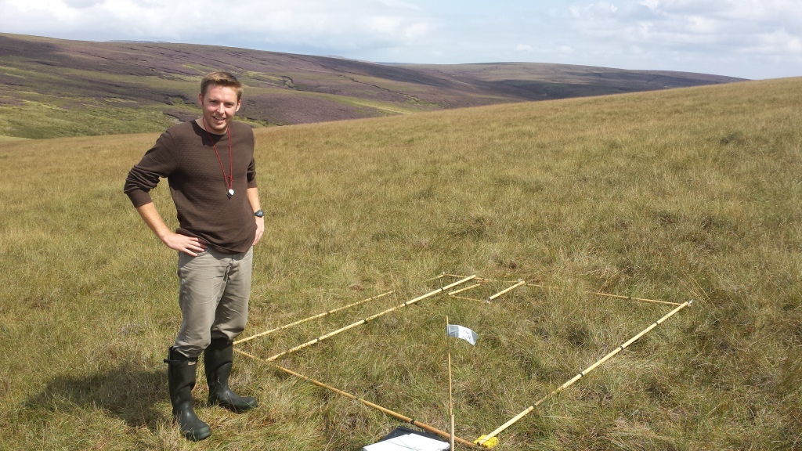

July 2015

Jennifer Bell

Long Term Monitoring Network

CONTENTS

Page
1. INTRODUCTION
04 1.1 Context 04 1.2 The history of long-term monitoring networks in the UK 1.2.1 The Environmental Change Network
1.2.2 The Environmental Change Biodiversity Network
1.2.3 The Long-term Monitoring Network
05 1.3 Survey Aims and Objectives
2. BACKGROUND
06 2.1 Site Description
06 2.2 Site Management
3. METHODS
07 3.1 Sampling Strategy
07 3.2 Quadrat Marking
08 3.3 Surveyor Logistics
08 3.4 Summary of Data Recording Method
09 3.5 Quality Assurance
09 3.6 Habitat Indicator Species
10 3.7 Data Analysis
4. RESULTS
11 4.1 Extent of Vegetation Types
11 4.2 Habitat Variables
11 4.3 Species Richness 11
12 4.4 Site-specific Indicators
4.4.1 Bog Indicator Species
4.4.2 Heath Indicator Species
14 4.5 Ellenberg Indicators
14 4.6 NVC Assignment
5. RESULTS
18 5.1 Bog
5.1.1 Ground Features
5.1.2 Species Richness
5.1.3 Indicator Species
5.1.4 Ellenberg Indicators
5.1.5 NVC Assignment
19 5.2 Heath
5.2.1 Ground Features
5.2.2 Species Richness
5.2.3 Indicator Species
5.2.4 Ellenberg Indicators
5.2.5 NVC Assignment
20 5.3 Sources of Error
21 6. CONCLUSION

SUMMARY
This report presents the results of a baseline vegetation survey at Dark Peak, conducted in August 2014. During the survey 50 permanent quadrats were distributed across Dark Peak and 5 were overlapped with existing quadrats. Information regarding the composition of the vegetation, along with selected habitat variables, was recorded at each quadrat.

Results
The bog area had a high amount of variation between quadrats in terms of both species richness and NVC communities, when compared to the heath quadrats, indicating a higher level of heterogeneity in this habitat. Ground feature analysis showed that the bog habitat was structurally flat, with limited variation in both sward height and bare peat coverage. The bog quadrats were predominantly composed of plants adapted to wet conditions with acidic pH levels and no shading.
The heath vegetation was structurally dissimilar to, and more complex than, the bog area particularly differing in sward height which is likely due to the presence of taller heather. The quadrats across this habitat shared similarities with the bog quadrats particularly in NVC communities. When the Ellenberg indicators were compared between the two habitats, the heath quadrats although similar showed much less variation. They were predominantly composed of plants adapted to wet conditions with low pH levels and limited fertility.
The survey was successful and facilitated a quantitative analysis and description of the vegetation present at Dark Peak. A robust baseline has been formed, against which future vegetation surveys can be assessed. In conjunction with the other protocols of the LTMN it is envisaged that it will be possible to attribute any changes in the vegetation to broad-scale environmental processes. This will meet the aim of providing evidence based advice on best approaches to take on biodiversity sites in response to environmental changes caused by climate change, air pollution or land management practices.

1. INTRODUCTION

This report presents the results of a vegetation survey undertaken in August 2014 by Natural England at Dark Peak.
The Long-term Monitoring Network (LTMN) is developing a long-term and integrated approach to addressing Natural England’s evidence need of assessing the effects of climate change, air pollution, and land management interventions on biodiversity. This is important as Natural England need to recognise these effects to inform their own interventions and activities and also to advise others on mitigation or adaptation actions (Natural England 2013a).

1.1 Context

It is acknowledged that climate change will impact England’s natural environment and biodiversity. Concurrently, changes will arise from the long-term impacts of air pollution and changes in land management policy and practice (Morecroft et al. 2006).

Long-term datasets are required to detect trends of change in broad-scale environmental processes that can often display high levels of transitory variation. Continuous surveillance of sites over 10 to 50 years can facilitate the separation of any short-term variability caused by more localised factors from the longer-term change in environmental processes such as climate change. Long-term monitoring provides the baseline against which the future state of the environment can be assessed in a reliable historical context and allows unanticipated changes to be identified (Natural England c.2011).

The integration of different types of data collection across a wide geographical range of key sites is essential to achieve a high degree of confidence in any resulting conclusions made at the national scale. Environmental drivers such as climate change and air pollution vary spatially and temporally and the ability to attribute change to the correct factor or combination of factors is important as it will allow conservation strategies to be implemented more effectively. Fulfilment of this aim requires data which are both high quality and spatially explicit on each of the potential causes of change to vegetation at sites of importance in terms of biodiversity (Morecroft et al. 2009).

1.2 The history of long-term monitoring networks in the UK

1.2.1 The Environmental Change Network

The Environmental Change Network (ECN) is a partnership project led by the Centre for Ecology and Hydrology (CEH). Operating since 1992, the ECN carries out detailed monitoring on 12 terrestrial and 45 freshwater sites across the UK. Seven of the terrestrial sites are located in England. The key principle of the ECN approach is that a wide range of physio-chemical and biological attributes are assessed in the same location, using standard protocols in order to identify causal relationships (Morecroft et al. 2006).

Environmental Change Network sites are owned and run by a number of partner organisations and the data collected are managed and stored by the CEH Central Co-ordination Unit (CCU). Natural England is an ECN partner and one of the network’s terrestrial sites is located on the Moorhouse, Upper Teesdale NNR (The UK Environmental Change Network 2013).

Whilst the ECN has a number of strengths, some weaknesses have been identified: the network only contains a small number of terrestrial sites; replication of habitat types across sites is limited; and, due to the number of variables assessed and the frequency of recording, the unit cost per site is high (Morecroft et al. 2006).

1.2.2 The Environmental Change Biodiversity Network

To address the weaknesses of the ECN, Defra sponsored the development of a business case for an Environmental Change Biodiversity Network (ECBN). The ECBN would be a larger network of sites collecting data using the same protocols utilised by the ECN but on a reduced range of variables (Morecroft et al. 2006).

The aim was to improve the power of change detection through an extended network, but with lower site unit costs. ECBN sites would be focused on designated sites – mostly NNRs.

1.2.3 The Long-term Monitoring Network

The Long-term Monitoring Network builds on the ECN/ECBN concept to develop ECBN sites alongside other existing or proposed long-term monitoring activities. The LTMN, led by Natural England, forms England’s contribution to the UK ECBN. As part of the Integrated Monitoring Programme, it is carried out in a cost-effective way that meets Natural England’s evidence needs (Natural England 2013a).

The requirement for greater efficiency and collaborative working across the Defra network has provided an opportunity for Natural England to lead the development of long-term integrated monitoring. It is likely that many of the organisation’s needs could be met by collaborating with partners to develop a network of sites. Partnership with other data gatherers will enable Natural England to access and incorporate additional long-term data collected for a range of environmental purposes.

1.3 Survey Aims and Objectives

This survey aims to produce a baseline of the vegetation present at the site, from which long-term trends in plant community composition and structure may be identified in the future. Alignment with the methods used in previous long-term monitoring will allow continued comparisons to be drawn with historic datasets. To achieve this aim, the following objectives have been identified:
- To mark and survey 55 permanent quadrats, from which species information and habitat variables will be recorded
- To conduct a survey in line with and comparable to the methodology set out in the ECN coarse-grain vegetation protocol
- To survey a representative sample of the target habitats on the site

2. BACKGROUND

2.1 Site Description

Dark Peak in the district of Derbyshire is located in the north west of England. The site covers an area of 86,604ha, 73.071ha (84%) of which, is within the Peak District National Park. The site is made up of Special Protection Areas (SPAs), Special Areas of Conservation (SACs), National Nature Reserves (NNRs) and Sites of Special Scientific Interest (SSSIs) (Natural England, 2012).
The site supports a range of characteristic moorland habitats and species. Dry heath, mostly bilberry dominated, occurs on the lower slopes, with heather dominated dry bog below the plateau and cotton grass moorland on the plateau. Extensive tracts of Ashop and Alport moor have been managed as grouse moors through rotational burning of heather. The moorland plateau is not managed by burning and supports blanket bog, with a range of characteristic species, for example cotton-grass, deer grass and a suite of dwarf shrubs including heather, crowberry and cross-leaved heath. This area is particularly important for breeding populations of upland birds including dunlin and golden plover. Several cloughs dissect the site and these support a range of habitats including springs and flushes (The National Trust, 2013).
Blanket bog
This habitat represents a range of vegetation types occurring over deep peat from cotton-grass dominated vegetation with a waterlogged surface and features such as bog pools, to areas of moorland dominated by dense heather over a dry peat surface.The deep peat areas of the Kinder plateau and Featherbed Moss support blanket bog vegetation dominated by cottongrass and a range of dwarf shrubs (The National Trust, 2013).
Non-heather dominated bog is found across the sites slopes, just below the plateau, and supports frequent crowberry (Empetrum nigrum), bilberry (Vaccinium myrtillus) and cotton grass. Both these species show areas of local dominance in a patchy mosaic which includes occasional heather (Calluna vulgaris) and occasional cloudberry (Rubus chamaemorus).
Heather dominated bog is extensive on Black Ashop Moor and the slopes leading into Ashop Clough. Cottongrass is frequent locally in these areas.
Dry dwarf-shrub heath
A reduction in grazing pressure has led to the recovery of heather in many areas.
Grassland
Acid grassland occurs mainly on steeper slopes and stream sides. It varies from Mat grass (Nardus stricta) to soft rush (Juncus effusus) dominated and is often in mosaic with other habitats, particularly overgrazed heath. Areas of wet flushed ground are typically dominated by soft rush (Juncus effusus), sedges and bog mosses (acid flushes, Juncus dominated marshy grassland). The open areas more diverse with frequent sedges, brown mosses, common cotton grass (Eriophorum angustifolium), and bog pond weed (Potamogeton polygonifolius) marsh arrow grass (Triglochin palustris) opposite-leaved goldensaxifrage (Chrysosplenium oppositifolium), round leaved water crowfoot (Ranunculus omiophyllus), cranberry (Vaccinium oxycocco) and sphagnum. These permanently wet areas are an important part of the moorland habitat mosaic. They tend to support a wide range of invertebrates and are therefore important feeding grounds for wading birds. Areas dominated by soft-rush also provide valuable cover for feeding birds and breeding waders (The National Trust, 2013).
Cloughs and gullies
Cloughs are important as habitats in their own right as the banks are more likely to support tall, mature/degenerate dwarf-shrubs as burning is not recommended on steep slopes. The occurrence of large, mature bilberry (Vaccinium myrtillus) bushes tends to be restricted to clough sides. The tops of cloughs are often important sites for breeding merlin (Falco columbarius) and the retention of tall, mature heather is important.
Bracken
The majority of the bracken beds are found to east of the moor with isolated patches to the north and west.
Bird interest
The site is also of great importance for the upland breeding birds it supports. The site has areas known as the preferred nest sites for short-eared owl and merlin. The areas Golden plover populatuion requires diversity in the vegetation structure with a mosaic of short vegetation for feeding and taller areas for nesting and cover from predators. Curlew are widely distributed across the site although tend to favour dry heath.Lapwings are associated with the sites areas of short vegetation, often where there are large areas of recent burns or vegetation is naturally short. Ring ouzels require ground cover for nesting and they favour short grassy areas for feeding (The National Trust, 2013).
Geological Interest
There are 2 Geological SSSIs on this site:
Featherbed Moss
Peat deposits provide a record of local and regional changes to vegetation and climate for a significant portion of the Flandrian (current post-glacial) period (c. 12,000 years). The site also contains all the peat erosion types now recognised in the southern Pennines. Research has identified two periods of active erosion: c. 900 AD, and post 1800 AD. The peat deposits also illustrate the depositional processes that have given rise to this feature over recent millennia.
Blackden Brook
Exposures in the stream bed display much of the UK sequence of Upper Carboniferous sediments, which record a complex period of ancient river delta formation. These deposits can be split into 4 main units: Kinder Grit; Grindslow Shales; Shale Grit; and the Mam Tor Flagstone Beds. The river sediments were probably sourced from the ancient Caledonian Continent to the north.

2.2 Site Management

Management is in place in order to achieve the following aims for the site:
- to deliver favourable condition for all interest features for which the SSSI, SAC and SPA, have been designated, to conserve and enhance HER features and to strengthen the landscape character, whilst seeking to do this in a way that is consistent with the owner’s business and other objectives.

Grazing and Livestock
The site is made up of grazing units which are not physically separate from the surrounding moorland. Stock management is applicable to all grazed areas. Stocking rates are calculated according to vegetation type and its carrying capacity (The National Trust,2013). The livestock are shepherded to ensure they do damage the vegetation through heavy grazing.
Burning and Cutting
The heather moorland is managed by rotational burning/cutting in order to stimulate new growth of heather from stem bases and create a mosaic of stands of heather of different ages.
Burning and cutting near blanket bog habitats is done carefully to ensure the peat resource and any sensitive vegetation is not damaged.
Bracken control
Bracken will be chemically treated In order to prevent its spread onto the open moor. Repeat applications will be carried out every other year until the control is effective.
Drainage
Hydrological integrity of moorland habitats is an important part of sustainable moorland management. It is therefore agreed that there will be no new drainage works or gripping carried out on the land. The maintenance of drains along walls or established tracks (surfaced tracks where drains currently exist) can be maintained but not deepened, widened or improved. These will be defined and mapped. Artificial (e.g. grips) and other man-induced (e.g. erosion gullies) drainage across areas of moorland and in particular blanket bog can lead to significant changes in the hydrology, morphology and ecology of the habitat (The National Trust, 2013).

3. METHODS

The Long-term Monitoring Network vegetation survey protocol is modelled on the ECN’s coarse-grain protocol to ensure that data collected from both networks are comparable. However, the monitoring cycle is shorter in the LTMN, with surveys occurring every four years opposed to every nine (Rodwell et al. 1996).

3.1 Sampling Strategy

Bog and Dwarf shrub heath habitats were surveyed, within these broad habitats, priority habitats were surveyed; Blanket bog, Lowland Raised bog, Lowland heathland and Upland heathland. Quadrats were assigned to habitats using a stratified random sampling approach within the entire delineated survey area. In total, 45 quadrats were assigned to Bog and 5 were assigned to Heath. To view the spatial arrangement of quadrats refer to Figures 7 and 8.

3.2 Quadrat Marking

Quadrats were marked using Feno Markers – permanent physical markers – denoting the south-west corner of every 2m² quadrat. The specific Feno Markers used at this site consisted of a yellow composite polyroc head held in place by a galvanised steel spike. The location of each marker was recorded using a Garmin GPS Unit to aid their rediscovery at subsequent surveys.

3.3 Surveyor Logistics

Data were collected by 44 volunteers over three days. Groups of three or four were assembled based on their botanical identification skills and surveying experience. Every group had at least one skilled botanist to reduce surveyor error. Experts were assigned quadrats in their specialism habitat where possible.

Every group was provided with historic site-specific species lists to support with the verification of plant identification. Furthermore, guidance sheets were provided with codes for habitat types and variables. The most widely referenced plant identification books were available to every group: Rose’s ‘The Wild Flower Key’ (2006); ‘Mosses and Liverworts of Britain and Ireland: a field guide’ by Atherton et al. (2010); and Rose’s ‘Grasses, Sedges, Rushes and Ferns’ (1989). Additionally, the lead botanist for the survey – a Natural England plant specialist - acted as a roaming expert between groups to assist with identification of problematic specimens at each quadrat.

3.4 Summary of Data Recording Method

Feno Markers indicated the south-west corner of each quadrat. A quadrat measuring 2m x 2m was placed on the ground and the following variables were recorded from within the quadrat:

- Location, aspect, slope angle, indicators of grazing pressure, signs of disturbance or obvious management
- Vegetation in the stand surrounding the quadrat was assigned to one of the Hodgson Land Use codes and habitat/vegetation types outlined in Appendix 1

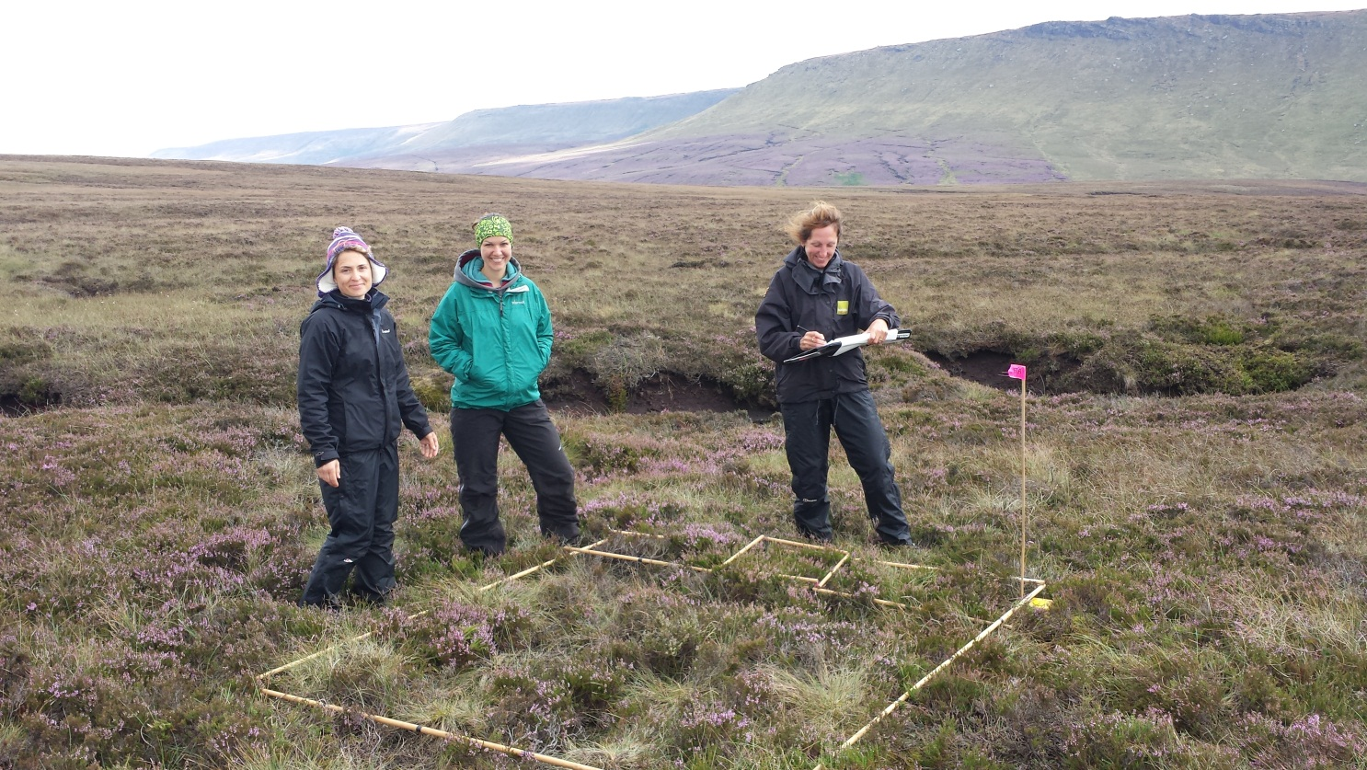
Fig.1: A 2m x 2m quadrat marked out using wooden poles on the at Dark Peak

Each quadrat was sub-divided into 25 cells measuring 40cm x 40cm and the following variables were recorded:

- Presence of all vascular plants rooted in the cell - therefore excepting any plants growing on rocks or wood. Non-vascular plants were recorded and bryophytes were recorded to species level where possible
- Height of the sward measured at the centre of each cell using a 200g drop disc
- Presence of the following ground features: litter; bare ground; bare rock; dead wood; and open water

Percentage covers of every species and ground feature were then estimated at the quadrat scale.

3.5 Quality Assurance

A number of procedures were implemented to limit error in the survey and increase record levels and the accuracy of the data collected. Specimens of plant species that surveyors were unable to identify during the survey were sent to expert botanists and the resulting identifications, where possible, were included in the spreadsheets.

Data were entered onto spreadsheets using Microsoft Excel. These data were checked for entry error by randomly selecting rows of the spreadsheet and cross-referencing with the original survey forms. In Excel, plot data were checked for recording errors and some were changed after inspection of the species and habitat types recorded revealed that the entry was highly implausible. The finalised spreadsheets were sent to the Site Manager and expert botanists involved with the survey for final inspection.

3.6 Habitat Indicator Species

To detect ecological change over time in habitat quality or composition, it is useful to analyse subsets of data that are deemed as particularly representative of a habitat when it is in ‘favourable’ or ‘unfavourable’ condition. Species used as positive and negative indicators for the purposes of data analysis were suggested by the site Managers, following consultation with experienced botanists familiar with the site. Natural England ‘Integrated Site Assessment’ lists for specified National Vegetation Classification (NVC) codes were also used to aid in this selection process. These species were used for a more in-depth analysis of each habitat (Walker et al. 2010).

Within the bog habitats, 8 positive indicator species were identified and 0 negative indicator species were found to be present. For the heath habitat 6 positive indicator species were identified and 0 negative indicator species were identified.

It is hoped that a national list of indicator species for each habitat type will be developed for use in future analyses to facilitate more vigorous between-site comparisons at the national level.

3.7 Data Analysis

Data were analysed using IBM SPSS Statistics 19 and Modular Analysis of Vegetation Information System (MAVIS) (Centre for Ecology & Hydrology 2013). Species data were grouped using the target habitat classifications of Bog and Heath. Standard deviations and standard errors were displayed where relevant to show variation and accuracy of data respectively. Control quadrats were included for data analysis in their relevant target habitats.

Abundance was shown using the presence frequency per quadrat measure. This was chosen in favour of percentage cover because it is less subjective, therefore reducing the influence of surveyor error. A potential limitation of this approach is that this method could under-represent the effect of infrequent but large species (Rodwell et al. 1996).
Each quadrat was divided into 25 cells, to allow the frequency presence data to be recorded at a fine scale. Frequency values were converted into percentage frequency of their target habitat type for ease of interpretation. Differences in results for both measures were also assessed statistically. Kolmogorov-Smirnov tests for normality revealed that the data for every indicator species was found to be normally distributed. A Mann-Whitney U Test was carried out for every indicator species and there were no significant differences in abundance scores between presence frequency and percent cover records. The ground features were reported using the percent cover records as they are obvious features that should enable surveyors to estimate their coverage without complications. Therefore, findings were expected to be more accurate than presence and absence measures. The mean percent covers for all species are available for reference in Appendix 3.

To characterise the target habitats in terms of their species assemblages, Ellenberg Indicator scores were calculated for every quadrat using MAVIS. This enabled a broad quantitative description of each habitat’s plant community which will aid temporal comparison following the next vegetation survey (Centre for Ecology & Hydrology 2013).

National Vegetation Classification code assignment was carried out using MAVIS. The output was manually interpreted using Rodwell (1995; 2000) and the first code given by MAVIS was not always the one used, although this was the case for the majority of quadrats. The NVC assignments were overlaid on top of a hierarchical cluster analysis measuring the quadrats relatedness in terms of relative abundance of species using the Squared Euclidean Distance measure.

4. RESULTS

4.1 Extent of Vegetation Types

Forty five quadrats of bog habitat were surveyed. There were five quadrats of targeted heath habitat. A full list of the quadrats surveyed and their details can be referred to in Appendix 2.

4.2 Habitat Variables

The mean averages for each recorded habitat variable are shown in Table 1, together with an indicator of the variation within the data. The bog quadrats had a reasonably low growing sward with a low average sward height of 8.47– the tallest sward was measured at 12.76cm. There was more structural complexity and variation around the mean in the heath quadrats- the tallest sward was measured at 21.54cm. Furthermore, most quadrats were in areas where high levels of ground litter were observed. While areas of bare peat were present across all of the quadrats, it had a much higher presence across the bog quadrats. The quadrats across each habitat were relatively flat with little variation around the mean slope angle.

Table 1: Mean averages of all recorded quadrat variables for the target habitats at Dark Peak

4.3 Species Richness

In the bog habitat, a total of 48 species were recorded, whilst in the heath, 26 species were identified. Figure 2 shows the variation in species richness between quadrats and reveals that most of the top 28 quadrats in terms of species richness were in the bog habitat with only 1 being saw sedge bed. The mean species richness per quadrat was 13 in bog quadrats, ranging from 8 to 20 species. The heath had an average of 15 species per quadrat and richness varied from 10 to 15 species. To view the full output of species abundances in quadrats refer to Appendix 3.
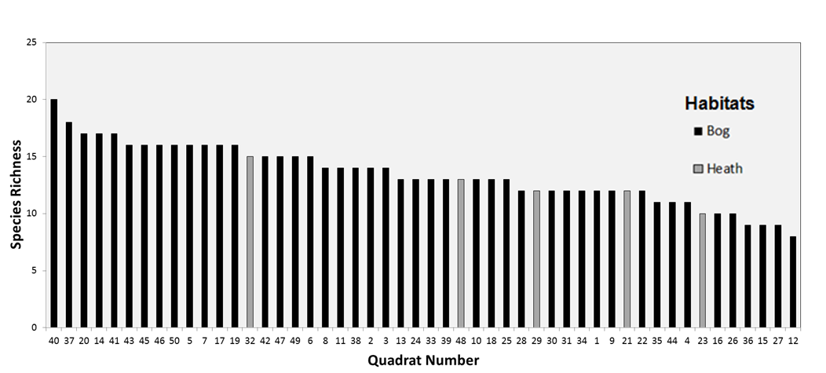

Fig.2: Plant species richness of every quadrat surveyed at Dark Peak.

4.4 Site-specific Indicators

4.4.1 Bog Indicator Species
Abundances of positive indicators for the bog habitat are shown in Figure 3. The most abundant two positive indicator species were in the top five species overall. Contrastingly, four other positive indicator species were below 20% abundance across the habitat.
The positive indicator species identified in the bog habitat were Common Cottongrass (Eriophorum angustifolium), Crowberry (Empetrum nigrum), Common Heather (Calluna vulgaris), Cloudberry (Rubus chamaemorus), Hare’s-tail cotton grass (Eriophorum vaginatum), Bilberry (Vaccinium myrtillus), Sphagnum sp. and Sphagum subnitens.

There were no negative indicator species found for this habitat during the survey. The negative indicators for this habitat range from Bracken (Pteridium aquilinum), Common Bent (Agrostis capillaris), Common reed (Phragmites australis), Creeping Buttercup (Ranunculus repens) Yorkshire-fog (Holcus lanatus).
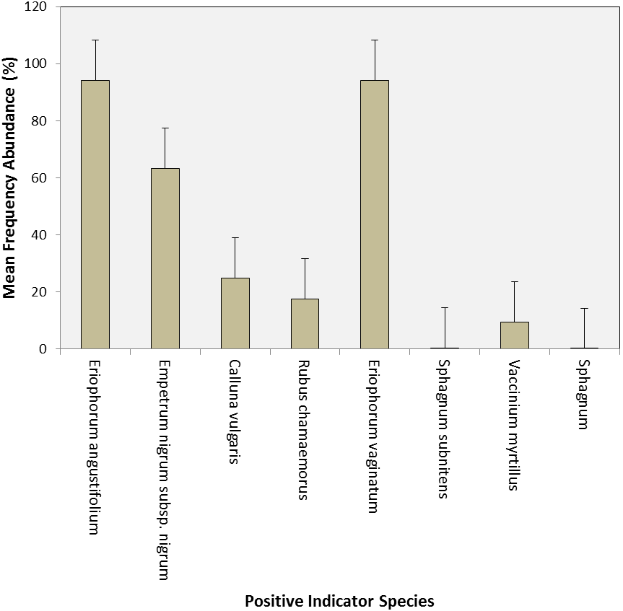

Fig. 3: The mean frequency abundance of selected positive indicator species for the bog target habitat at Dark Peak.

4.4.2 Heath Indicator Species

Abundances of positive indicators for the heath habitat are shown in Figure 4. The most abundant two positive indicator species were in the top five species overall. Contrastingly, two other positive indicator species were below 20% abundance across the habitat. There were no negative indicator species found for this habitat during the survey. The positive indicator species found were Common Cottongrass (Eriophorum angustifolium), Hare’s-tail cotton grass (Eriophorum vaginatum), Crowberry (Empetrum nigrum), Common Heather (Calluna vulgaris), Cloudberry (Rubus chamaemorus), and Bilberry (Vaccinium myrtillus).

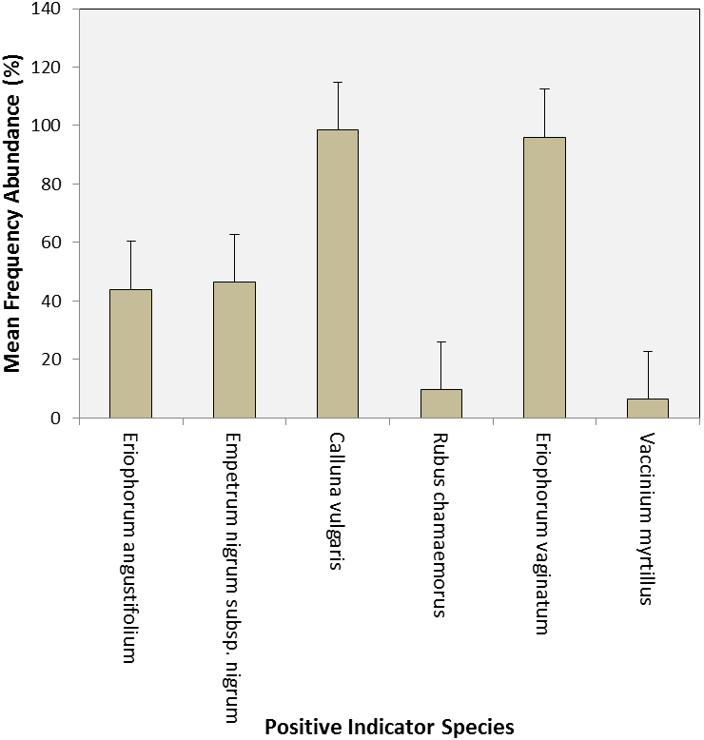

Fig. 4: The mean frequency abundance of selected positive indicator species for the heath target habitat at Dark Peak.

4.5 Ellenberg Indicators

The Ellenberg Indicator scores for both bog and heath quadrats are shown in Figure 5. The plant species assemblages surveyed across both the bog and heath habitats had a low variation in indicator scores, particularly in the heath quadrats for light and fertility. On average both habitats’ quadrats contained species that required high light levels, high water availability, acidic soils and an intermediate nutrient availability. For full results of each quadrat, refer to Appendix 4.

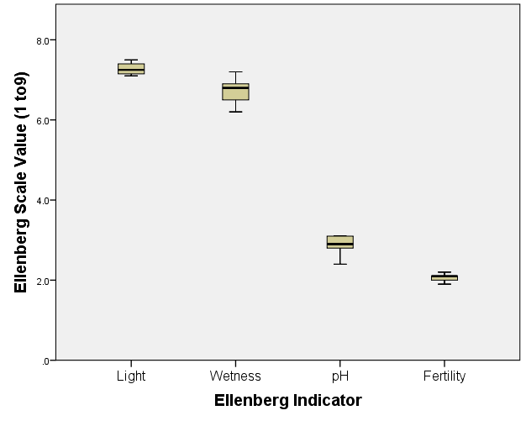
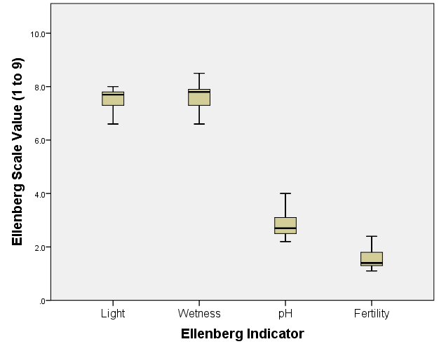
a) b)

Fig. 5: Boxplot showing the Ellenberg Indicator values for variables in the a) Bog target habitat and b) Heath target habitat

4.6 NVC Assignment

The dendrogram shown in Figure 6 illustrates the relationship in terms of plant community composition between the quadrats surveyed. Working from the bottom up, the lower clusters were predominantly blanket mire NVC communities (M19a, M19b).

Although the majority of the Heath habitat was found to be M19, the same NVC codes were found across both habitats.

The full extent of variety across the habitats was a mixture between blanket mire, blanket and raised mire and heath (M19a, M19b, M20a, H12a).M19 and M20 dominated the site with little variety between the two target habitats. Despite the lack of variation between the habitats, the heath plots still clustered tightly together. Figure 6 shows that, working from the bottom up, all of the heath quadrats are grouped together in the bottom 10. This leads on to the bog habitat quadrats which fill the rest of the dendrogram showing the differences between the habitats and the similarities within them. The only heath NVC code, H12 (Calluna vulgaris-Vaccinium myritillus heath), was found in a habitat targeted for being a bog. For full results of the NVC output from MAVIS refer to Appendix 4.
Figure 7 shows the spatial arrangement of the NVC communities on the survey site.

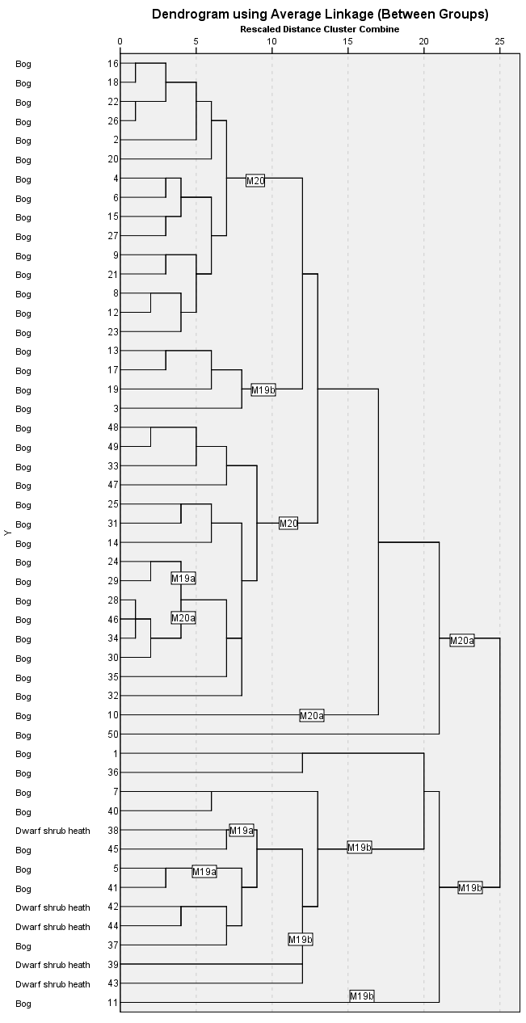
Habitat and Quadrat Number

Fig. 6: Hierarchical cluster analysis of all quadrats based on their vegetation community composition. NVC classifications are annotated onto the branches of the dendrogram and apply to all branches stemming from them to the left.

5 DISCUSSION
Fig. 7: Map showing positions of quadrats in Dark Peak and their NVC classifications based on results from MAVIS

5.1 Bog Target Habitat

5.1.1 Ground Features

The low sward height across the bog suggests a flat habitat with many areas of bare peat showing. Variation suggests a range of vegetation also suggesting different surface features are present across the bog. Although large amounts of bare peat were present, a large amount of litter was also present across the habitat.

5.1.2 Species Richness

The variation of species richness between quadrats in the bog areas indicates that there is a good level of heterogeneity in the habitat. This is a sign of good condition in bog habitats and suggests that the implemented management interventions may be having a positive effect, although this could also be caused by changes in other environmental conditions. There is also a high level of species richness in the bog area with 48 species recorded across the quadrats.

5.1.3 Indicator Species

There were 8 positive indicator species surveyed in the bog quadrats, the majority of which had an abundance of over 20%.The number of positive indicator species and their abundances were higher in the bog habitat when compared with its negative indicator species as no negative indicator species were identified during the survey.

5.1.4 Ellenberg Indicators

The Ellenberg indicators for the bog habitat show some variation across the habitat, suggesting the species present may be adapted to a changing environment. The levels of each indicator vary, this could be due to a bogs differing habitat. The Ellenberg wetness scores indicate that there was variation in drainage levels on different areas of the habitat allowing for a variety of plant species. Quadrats placed over waterlogged bog pools may have increased the suggested water availability and caused a decrease in the pH whereas dense heather dominated dry peat would indicate a drier habitat. This diverse habitat would offer support for a different range of vegetation and result in variable Ellenberg indicators. Most quadrats contained plants that thrived in an area with a high level of light, high water availability and in quite acidic soils of medium to low fertility.

5.1.5 NVC Assignment

A variety of NVC communities were assigned to quadrats in the bog habitat. This reflects the fine-scale structural differences between quadrats and the changes in availability of nutrients and soil pH that occur on Dark Peak. Dark Peak contains a mosaic of Calluna vulgaris- Eriophorum vaginatum blanket mire, Eriophorum vaginatum blanket and raised mire and Calluna vulgaris- Vaccinium myrtillus heath. Bog NVC communities such as M19a, M19b, M20 and M20a confirmed all but one of the quadrats to identify as bog. The variety of NVC codes found in the bog habitat indicates a slight level of heterogeneity.

5.2 Heath Target Habitat

5.2.1 Ground Features

The ground feature analysis for the heath quadrats showed a much larger sward height likely due to the taller heather present compared to the bog vegetation. These levels fluctuated due to the management of the area. This suggests the heath is providing the correct diverse structures necessary for breeding birds through the management strategies of grazing burning and bracken treatment. A very high level of litter coverage was found across the heath quadrats leaving limited bare peat.

5.2.2 Species Richness

The variation of species richness between quadrats in the heath areas indicated that the habitat has slightly lower species richness than the bog with only 26 species identified across it. This area needs to continue with its management techniques as these areas are regularly used as breeding grounds for many bird species. The species richness for the heath quadrats was lower than the bog. However, this does not suggest this habitat is in worse condition as a range of different species were identified here.

5.2.3 Indicator Species

There were 6 positive indicator species identified on the heath habitat during the survey. The positive indicator species’ abundances were higher compared with the negative indicator species as no negative indicator species were identified in this habitat during the survey. The most abundant two positive indicator species Common heather (Calluna vulgaris) and Hare’s-tail cotton grass (Eriophorum vaginatum) are common heath plants and were also in the surveys top five species overall.

5.2.4 Ellenberg Indicators

The Ellenberg Indicator scores for the heath habitat show very little variation between the quadrats. They are very similar to the indicator scores for the bog habitat showing a high level of light, high water availability and in basic soils of medium fertility. There is some light variation in the pH levels and wetness. This low amount of variation across the habitat, suggests the species requirements have very little variation.

5.2.5 NVC Assignment

The same NVC mosaic of Calluna vulgaris- Eriophorum vaginatum blanket mire and Eriophorum vaginatum blanket and raised mire was found across both the bog and heath habitats. The NVC community assignments for heath quadrats show the slight variation in this habitat. NVC codes such as M19a, M19b and M20a were found across the heath quadrats. The variety of NVC codes found in the heath habitat indicates a low level of heterogeneity.

5.3 Sources of Error

The number of surveyors was one of the major potential sources of error: with over forty surveyors of varying botanical identification expertise, it is inevitable that there were some differences in skill level between groups and that some plants may have been misidentified or abundances erroneously recorded. To mitigate this risk, experts were distributed between groups evenly and rigorous quality assurance checks were carried out following completion of the survey. Typically hard to identify vegetation types, particularly bryophytes, would be the most affected by this type of error. Again, this was controlled for by sending samples to an expert when they were unable to be identified in the field.

In future a standardised protocol for quality assurance and dealing with vegetation samples should be developed. Quality assurance protocols should be standardised to ensure that each survey is treated with the same level of rigour and to increase the confidence in any conclusions obtained. A number of bryophytes could not be entered onto the finalised database even though they had been positively identified due to the lack of a labelling system on the samples. Putting in place simple procedures such as these could increase the efficiency with which the vegetation is sampled and analysed in future.

The statistical packages used for the data analysis could be another source of error. NVC classification using MAVIS only gives an indication of the NVC codes that each quadrat’s plant community was most closely matched with. MAVIS output results require a level of interpretation and as a consequence the final result is somewhat subjective and may not be consistent between data analysts. By reporting the two closest matches for each quadrat in Appendix 4 it is envisaged that these data could be inspected by others and refinements could be made to the process.

6. Conclusion

This survey has used a number of analytical methods to produce a baseline assessment of the vegetation at Dark Peak. The number of replicates of quadrats and the fine-scale level of recording employed are envisaged to provide a sufficiently detailed evaluation of the vegetation present to facilitate temporal comparisons following subsequent LTMN vegetation surveys in four years and beyond.

The analyses carried out in the compiling of this report are principally of use to future surveys carried out on these permanent quadrats. They will serve as an indicator of each target habitat’s condition and how this changes over time, if at all. It has not been attempted to categorise the status of the current vegetation assemblage on the site in this report – although this may have been possible. Primarily, this is because the aim of this report was to establish a baseline and enable future temporal analyses to understand which factors affect it. However, the results of this survey offer the potential to contribute towards other Natural England objectives that depend on monitoring activities, such as Integrated Site Assessments for the SSSI units present, and this possibility should be investigated.

REFERENCES
Atherton, I, Bosanquet, S, Lawley, M (eds) (2010) Mosses and Liverworts of Britain and Ireland: a field guide. Plymouth: British Bryological Society

Centre for Ecology & Hydrology (2013) Modular Analysis of Vegetation Information System (MAVIS). [Online]. Available from: http://www.ceh.ac.uk/products/software/cehsoftware-mavis.htm. Downloaded: 20th April 2015

Morecroft, M.D, Sier, A.R.J, Elston, D.A, Nevison, I.M, Hall, J.R, Rennie, S.C, Parr, T.W, Crick, H.Q.P (2006) Targeted Monitoring of Air Pollution and Climate Change Impacts on Biodiversity. Report to Defra, CCW and English Nature no. CR0322

Morecroft, M.D, Bealey, C.E, Beaumont, D.A, Benham, S, Brooks, D.R, Burt, T.P, Critchley, C.N.R, Dick, J, Littlewood, N.A, Monteith, D.T, Scott, W.A, Smith, R.I, Walmsley, C, Watson, H (2009) The UK Environmental Change Network: Emerging Trends in the Composition of Plant and Animal Communities and the Physical Environment. Biological Conservation 142: 2814-2832

Natural England (c.2011) Analysis of Long-term Vegetation Monitoring Data at Martin Down NNR, Hampshire. [Unpublished Report]

Natural England (2012) Dark Peak. [Online]. Available from: http://www.google.co.uk/url?sa=t&rct=j&q=&esrc=s&frm=1&source=web&cd=1&ved=0CCIQFjAAahUKEwjR2pvQ8OvGAhUpm9sKHZg9APw&url=http%3A%2F%2Fpublications.naturalengland.org.uk%2Ffile%2F3717539&ei=vwyuVZH_Jam27gaY-4DgDw&usg=AFQjCNEGu1Fx9TxDBVFS1EFSyLQTJY8L6w&bvm=bv.98197061,d.ZGU Accessed: 21st July 2015

Natural England (2013a) Long-term Monitoring Network. [Online]. Available from: http://www.naturalengland.org.uk/ourwork/evidence/register/ltmn.aspx. Accessed: 20th April 2015

Rodwell, J.S (ed.) (1995) British Plant Communities Volume 4: Aquatic Communities, swamps and tall-herb fens. Cambridge: Cambridge University Press

Rodwell, J.S, Sykes, J.M, Helps, M.B (1996) The UK Environmental Change Network Protocols for Standard Measurements at Terrestrial Sites. [Online pdf]. Available from: http://www.ecn.ac.uk/measurements/terrestrial/v. Accessed: 20th April 2015

Rodwell, J.S (ed.) (2000) British Plant Communities Volume 5: Maritime Communities and Vegetation of Open Habitats. Cambridge: Cambridge University Press

Rose, F (1989) Grasses, Sedges, Rushes and Ferns of the British Isles and north-western Europe. London: Penguin Group

Rose, F (2006) The Wild Flower Key, 2nd edn, revised by Reilly, C. London: Penguin Group

The National Trust (2013) The Dark Peak SSSI. Moorland Management prescriptions 45pp

The UK Environmental Change Network (2013) What We Do. [Online]. Available from: http://www.ecn.ac.uk/what-we-do. Accessed: 20th April 2015

Walker, K, Dines, T, Hutchinson, N, Freeman, S (2010) Designing a new plant surveillance scheme for the UK. JNCC Report 440

Appendix 1 – Codes used during vegetation surveys
Slope form, land use and feature codes |  | Broad and priority habitats
Slope form |  | Broad habitat | Priority habitats
Convex | 1 | Calcareous grassland | Lowland calcareous grassland
Straight (rectilinear) | 2 | Calcareous grassland | Upland calcareous grassland
Concave | 3 | Acid grassland | Lowland dry acid grassland
Land use |  | Improved grassland | Coastal and floodplain grazing marsh
Ley grassland | 1 | Neutral grassland | Lowland meadows
Permanent or long-term grassland | 2 | Neutral grassland | Upland hay meadows
Rough grazing | 3 | Coniferous woodland
Cereals | 4 | Broadleaved woodland | Lowland beech and yew woodland
Green crops | 5 | Broadleaved woodland | Lowland mixed deciduous woodland
Root crops | 6 | Broadleaved woodland | Upland mixed ashwoods
Horticultural crops | 7 | Broadleaved woodland | Upland oakwood
Fallow | 8 | Broadleaved woodland | Wet woodland
Other crops (specify) | 9 | Broadleaved woodland | Wood pasture and parkland
Orchard | 10 | Arable and horticultural | Arable field margins
Deciduous woodland | 11 | Arable and horticultural | Traditional orchards
Coniferous woodland | 12 | Boundary and linear | Hedgerows
Scrub | 13 | Bracken
Lowland heath | 14 | Dwarf shrub heath | Lowland heathland
Heather moor | 15 | Dwarf shrub heath | Upland heathland
Grassland | 16 | Bog | Blanket bog
Saltmarsh | 17 | Bog | Lowland raised bog
Fen, moor or bog | 18 | Fen, marsh and swamp | Lowland fens
Montane vegetation | 19 | Fen, marsh and swamp | Reedbeds
Public park | 20 | Fen, marsh and swamp | Upland fens, flushes and swamps
Golf course | 21 | Fen, marsh and swamp | Purple moor-grass and rush pastures
Other (specify) | 22 | Inland rock | Calaminarian grassland
Feature |  | Inland rock | Inland rock outcrops and scree habitats
Path | P | Inland rock | Limestone pavement
Stream | S | Montane | Mountain heath and willow scrub
Wall | W | Built-up and gardens | Open mosaic habitats on previously developed land
Hedge | H | Supralittoral sediment | Sand dunes
Ditch | D | Supralittoral sediment | Vegetated shingle
Natural Boundary | N | Littoral sediment | Saltmarsh
Fence | F | Littoral sediment | Intertidal mudflats
Bank | B | Supralittoral rock | Maritime cliff and slopes

Appendix 2 – Quadrat Information

Appendix 3 – Full abundance measure results

Appendix 4 – MAVIS results for Ellenberg Indicators and NVC Classification

