1. Your folder should look like this. Rename_habitat.csv has the manual habitat name changes and a list of the accepted names for habitats.

1. Put all the survey files in the Data folder. Here I have used just two (one each from two sites) so it will make a dataframe with all the plots in only these two surveys. This might be useful if you wanted to compare two surveys but would not be suitable to make a ‘report’ using the report code. Add all the surveys in on the sites you want to investigate.

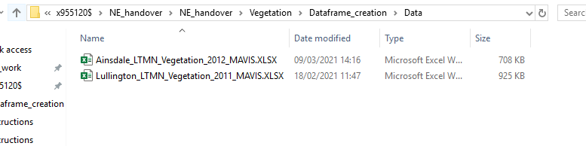

1. Put all the outputs of the ‘MAVIS_out2.R’ code in the MAVIS_data folder. There should be one for each of the surveys you put in the Data folder.

1. Go to the main folder with the code in it and right click on the address bar and click ‘Copy address as text’.

1. Double click on ‘df_metrics.R’ to open it in Rstudio. Replace the text in the setwd(‘’) function with the text you have copied. Replace all the backslashes \ with forward slashes /. The address you copy in will be unique to your computer and where you put the code.

1. At the top of the code there may be a message like this. Click on install. Don’t worry if the names of the packages are different or if there isn’t a message.

1. Highlight all of the code, all the way down to the bottom and click on ‘run’ to the top right of the code.

1. There should now be a csv file with all the information created in this code in the main folder. It will be called the same as you have named it in the code. ‘all_plots.csv’ here. Now Double click on ‘df_species.R’.

1. Repeat step 4-5 in this new code to replace the address in the serwd(‘’) function again.

1. Now highlight all the code down to the bottom and click ‘run’. The names of the file outputs are at the bottom and are currently set to ‘species_f.csv’ and ‘species_pc.csv’

1. The final folder should look like this.

