1. Your folder should look like this

1. Put the survey files in the folder “Data”

1. The “dataframes” folder should have these three files. “rename.csv” has a list of manual name swaps that the code will use. The wrong_name column is the list of names that will be changes and the right_name column has the list that the names will be changed to. ‘tree_rename.csv’ has the same but for the excel page with the tree species. ‘species_list.csv’ has all the accepted names in a big list so that the code can match the names in the survey to them.

1. Double click on the file MAVIS_in.R to open it in RStudio. At the top of the code you will see the image below. Don’t worry if all the colours are different. Click on install

1. Scroll down in the code until you see this

1. Go back to your folder, right click on the address bar and click ‘copy address as text’

1. Paste it back into the code here above the ‘setwd()’ function

1. Replace the text in your setwd() function with the copied address. The text will be specific to your computer. Replace all the \ with /

1. The highlight all of the code, from the first line to the bottom line. Then click ‘run’.

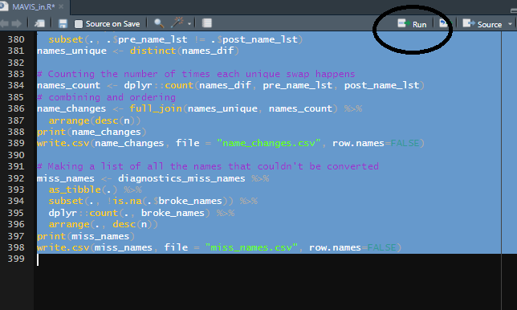

1. There will be some moving text somewhere on the screen. The names of the surveys will that you put in the Data folder will flash up. There will also be some species names, this indicates the names that have been changed or failed to match. If you go back to your folder it should look like this. To adapt the name swaps, refer to the instructions ‘name_swap_instructions’ in the instructions folder.

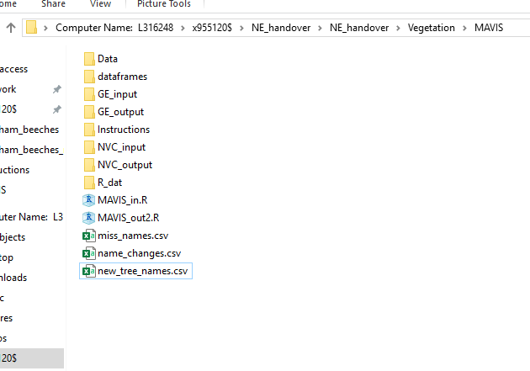

1. There should be text files in the GE_input and NVC_input. As many files as surveys you put in Data.

1. Open MAVIS, click on ‘file’ in the top left and click on ‘open’

1. Navigate to the input files in GE_input and double click on the first one. You will see this screen below. Click on ‘OK’

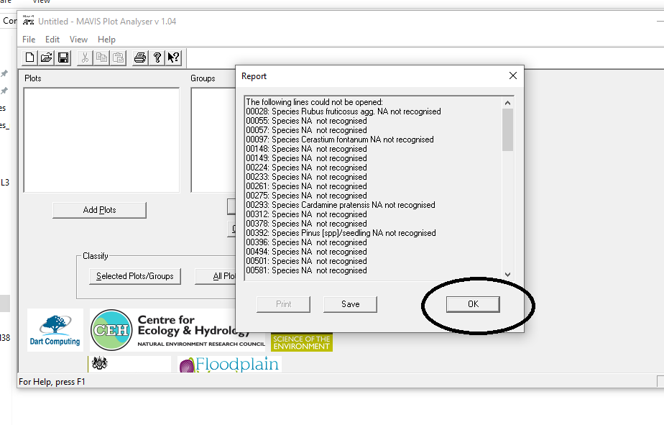

1. Click on ‘all plots/groups’.

1. Click on ‘Save’

1. Click on the name of the input file you used to add that as the name you will save the output as.

1. Then navigate to GE_output which should be an empty folder.

1. Do steps 12-17 for every file in GE_input AND nvc_input. The end result should be a text file in GE_output and nvc_output for each survey you put in. Should look like this

1. Now double click on MAVIS_out2.R (the other R script in the main folder). Repeat step 4 if a similar message shows. Highlight everything and click on ‘run’.

1. The main folder should now look like this with the folder ‘MAVIS_data’ there.

1. In that folder should be an output file for each of the surveys you put in Data.

The data will be inputted with any gaps necessary so that only need to copy and paste the relevant columns into the ‘whole plot data’ tab of the survey excel files.