1. Your initial folder should look like this. This can be anywhere on your computer.

1. The styles folder contains this and contains the formatting for the report outputs. In here you can change things like the font and the background colour. The one we use is air but any can be used. You don’t need to click on these or open them if you don’t know what they are.

1. The dataframes folder has manually inputted information which the code uses. “LTMN positive and negative….csv” contains a list of potential positive and negative indicator species for various sites and habitats. This is not used by the code. “Positive indicators.csv” is a condensed version which the code can read. If you want to do more sites, you may wish to add a column in here for the new site. This will be the species that the species graph shows. “rename_habitat.csv” is some manual habitat name changes as well as a list of all accepted habitat names.

1. Copy the three dataframes you created in the dataframe_creation folder into here.

1. Go back to the main folder and open the ‘data_prep_figure4.R’ file. If you see a message like this on the top, click on install. Don’t worry if the names of the packages are different.

1. Now open the ‘report.Rmd’ file and find the setwd(‘’) function. It may have a different bit of text in there. It also may be different colours.

1. Go back to the main folder where the code is, right click on the address bar and click ‘Copy address as text’

1. Replace the text in the setwd(‘’) function with what you have copied and replace all backslashes \ with forward slashes /. The text will be different according to your computer and where you put the files.

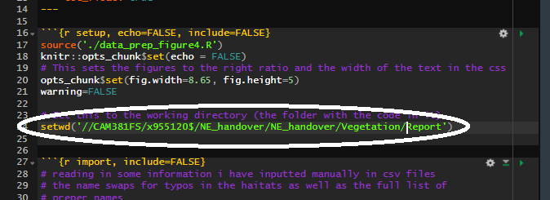

1. At the top of the file you will see the title. Change this whatever you want the title of the report to be. The css will be the file with the formatting that you want. At the moment it is set to air, but any can be used in the folder. Just change the bit of text saying ‘air’ to ‘modern’.

1. Scroll down to ‘General’ where you can choose a site to make a report on. Change ‘SITECOE’ to ‘B01’ or ‘B36’ depending on what site you want.

1. A few examples are given below. Here is Lullington, you can see the change to ‘B14’. There are a few things you can change in here (though you don’t have to). The rem_plot() function removes a plot from the analysis. Here plot 30 is removed. Sometimes there is one that has some issues which ruin the statistics (either errors in the data or more usually, a plot with only 1 species). The select_by function chooses the habitats to monitor. It is normally set to 15 (above) which means it requires more than 15 plots of that habitat across all surveys to include that habitat in the analysis. As more surveys get added this should be increased. Here (below) I have changed it to 700 so that none are selected, instead I have provided a list of specific haitats to manually include.

1. Above at the place where the data is being loaded in from the data frame created in dataframe_creation. Make sure the name of the file with the dataframe is the same name you have given it. ‘all_plots.csv’ here.

1. Much further below we enter in the data from the species dataframe. Make sure it is the same as the one you have created. Here you choose whether to use percent cover ‘species_pc.csv’.

1. Finally, when you want to make the report, at the top click on ‘knit’ > ‘knit to HTML’. (you do no need to highlight the text.)

