1. Your working folder should look like this.

1. Put all the surveys you want to include in the Data folder

1. In the ‘dataframes’ folder should be: ‘BBSI_plant_names.xlsx’ and ‘ECN_VESPAN_dictionary.csv’ which contain dictionaries of all the plant species. These have been collated and adapted slightly (include genus sp.) in ‘full_species_list.csv’. If this is lost or altered in some way and you want to get it back, refer to step ‘12/13-optional’. Finally, the ‘rename’ file has all our manual renames, if you want to add to this, refer to step 10 and 11.

1. Double click on ‘Species_list.R’ in the main folder to open it in RStudio. If you see a message like this on the top, click on ‘install’.

1. Go to the main folder, right click in the address bar and click ‘copy address as text’.

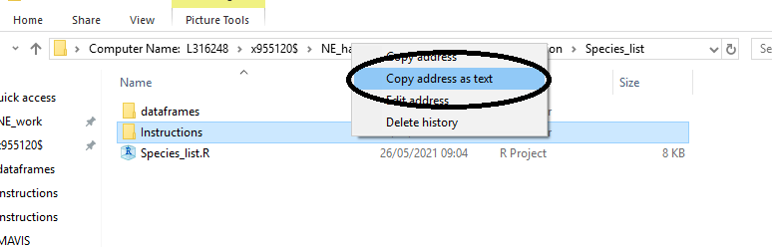

1. Find this place in the code and copy it in.

1. The thing you copied in will be uique to your computer and the place you have your folder. Replace the file path that is already in the code with the part you copied in and swap all the \ for /

1. Highlight all the text from the top to the bottom and click on ‘run’.

1. The end result should look like this

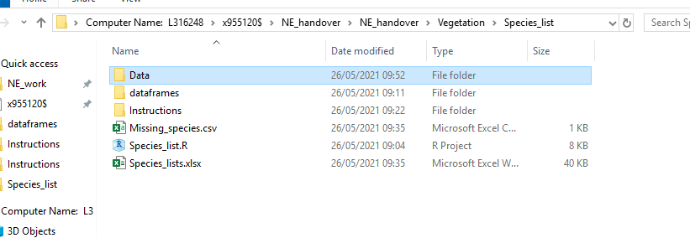

1. Check in ‘Missing_species.csv’. If there are any names under the missing names column, you may wish to make a manual change to all of these names in all future surveys.

1. Copy the name and open ‘rename’ in the dataframes folder.

1. Scroll to the bottom and paste it in the first column, add the correct name in the column next to it. This will make the change for you whenever that name comes up in any survey.

In the ‘Species_lists.xlsx’ file created by this code there will be 4 tabs. The first is a list of all the unique species found in all the surveys you put in the Data folder. The second is a list of all the unique species found in each site present in the surveys you put in the Data folder. The third is a list of all the unique species found in each survey you put in that folder and the final is a list of all the species as they are found in the ‘species_template’ tab of the survey file. These are made with the typos corrected and any missing rows included so that you can just copy and paste them across.

12-optional. If you want to remake the full_species_list, find this part of the code

13-optional, highlight it and press ctrl-shift-c and it will look like this. Then click ‘run’

