CSE351 Computer Networks
Programming Assignment #4 Report
Student ID : 20211277
Name : Hojun Lee

- Code Implementation
- sr_router.c
- validation & firewall
Validates the packet by checking its length and IP checksum. And also Blocks packets related to the blacklisted subnet (10.0.2.0/24) via the ip_black_list function.
- classification & processing
Destined for the Router itself:
Responds with an Echo Reply if an ICMP Echo Request (Ping) is received. Sends an ICMP Port Unreachable (Type 3, Code 3) message if a TCP/UDP packet is received, as the ports are closed.
Destined for External Network (Forwarding):
Checks the TTL; if it is 1 or less, sends an ICMP Time Exceeded (Type 11) message and drops the packet. Performs a Longest Prefix Match (LPM) on the routing table. If no route is found, sends an ICMP Net Unreachable (Type 3, Code 0) message.
- Forwarding
Decrements the TTL and recalculates the checksum. Checks the ARP cache for the Next Hop's MAC address. If found, sends the packet immediately; otherwise, queues the packet and schedules an ARP request.

- sr_arpcache.c
- retransmission
Checks ARP requests approximately every second. If there is a request that has not yet received a reply, it re-broadcasts the ARP Request packet.
- Failure Handling
If an ARP request receives no reply after 5 attempts, it determines that the host is unreachable. Sends an ICMP Destination Host Unreachable (Type 3, Code 1) message to the sender for all packets waiting in the queue for that ARP request, and then destroys the request.
- Execution Results
- ARP success case
Figure1 shows that the implementation successfully performed ARP resolution, and the ICMP Echo Request was processed correctly.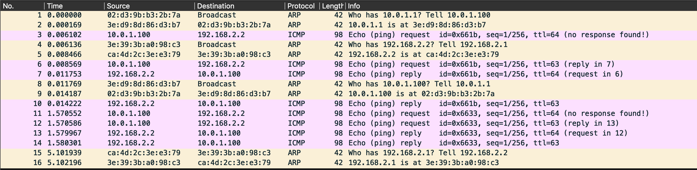
Figure 1.

- Other ICMP
Figure 2 demonstrates that the router correctly handles the ARP failure scenario. After five unsuccessful ARP requests, the router generates an ICMP Destination Host Unreachable (Type 3, Code 1) message as required.
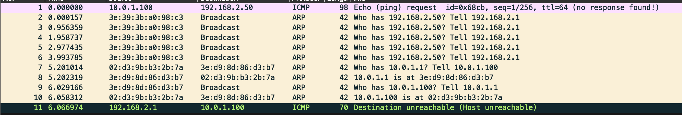
Figure 2
Figure3 shows the router successfully received the UDP packet and correctly responded with an ICMP Port Unreachable message.
Figure 3

Using ping binary with -t 1 option, I checked the router correctly handled packets with expired TTL values by generating an ICMP Time Exceeded message. Check Figure4.
Figure 4

Figure 5 demonstrates that the router correctly handles packets destined for unknown networks. When no matching route is found, the router generates an ICMP Destination Unreachable (Type 3, Code 0) message.
Figure 5

- Firewall
My firewall successfully blocked.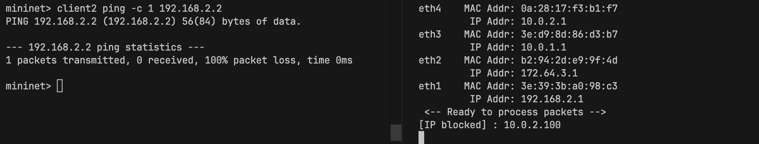

Reference
D. Plummer, "An Ethernet Address Resolution Protocol: Or Converting Network Protocol Addresses to 48.bit Ethernet Address for Transmission on Ethernet Hardware," RFC 826, Nov. 1982.
J. Postel, "Internet Protocol," RFC 791, Sep. 1981.
J. Postel, "Internet Control Message Protocol," RFC 792, Sep. 1981.

