Document Name |  | Confidentiality Level
Contract Management System |  | Only for Recipients Reference
Template Code | Version | Document Code

Contract Management System
Project Closure Summary Report



Copyright © Ruankosoft Technologies (Shenzhen) Co., Ltd.
All Rights Reserved
Revision Record
Date | Revision Version | CR ID /Defect ID | Sec No. | Change Description | Author

Content
1. Project Basic Situation 3
2. Project Acceptance Coverage 3
2.1 Project progress 3
2.2 Development environment 4
2.3 Project Structure 4
2.4 Application 4
2.5 Deliverables 5
3. Project Work Summary 5
3.1 Code statistics 5
3.2 Document work summary 5
4. Lessons learned and Suggestions for Improvement 6

1. Project Basic Situation
Project Name: | Contract Management System | Project Category: | Web Application
Project ID: |  | Technology Used: | Java,HTML,CSS,Javascript
Development Environment: | Eclipse Jee Mars | Running Platform: | Windows,Tomcat
Project Start & Finish Time: | 2017/5/24-2017/6/21 | Project Working Place: | BeijinJiaoTongUniversity
Project Manager: | 钱洋
Project Developer: | 祝梦婷，陈奕奕，黄慧群，李晓薇
Project Description | Contact Management System Can draft contract quickly and standardly, according to the process of contract management to countersign, approve, sign, executive management etc, and Provide effective data query, statistical analysis and other management functions. Conducive to the signing of the contract, implementation and management.  This project combines contract data and process management organically, based on B/S structure, centralized management of data, ensure that the specification of contract management, rigorous and efficient, conducive to improve the work efficiency and accuracy.

2. Project Acceptance Coverage

2.1 Project progress
(S.N.) | Stages | Scheduled start/end time | Actual start/end time | List of deliverables | Remarks
1 | Project start | 2017/5/24 | 2017/5/24 | 项目启动文档 | 李晓薇
2 | Project planning | 2017/5/24 | 2017/5/24 | 项目计划文档 | 钱洋
3 | Requirement analysis | 2017/5/24 | 2017/5/24 | 需求分析文档 | 祝梦婷
4 | System design | 2017/5/24 | 2017/5/24 | 项目设计文档 | 陈奕奕
5 | Coding and test | 2017/5/24-2017/6/21 | 2017/5/28-2017/6/21
6 | Acceptance

2.2 Development environment
System/Tool/Component | In English (version number) | Remarks
Operating system | Microsoft.Windows10
Development tool | Eclipse Jee Mars,Tomcat,bootstrap

2.3 Project Structure
1. Project structure design idea
The functions are divided into several modules to manage and develop respectively. System is divided into 6 modules: Register, Login, Contract Management, Query, Fundamental Data Management, System Management.The detailed modules of system are as follows:
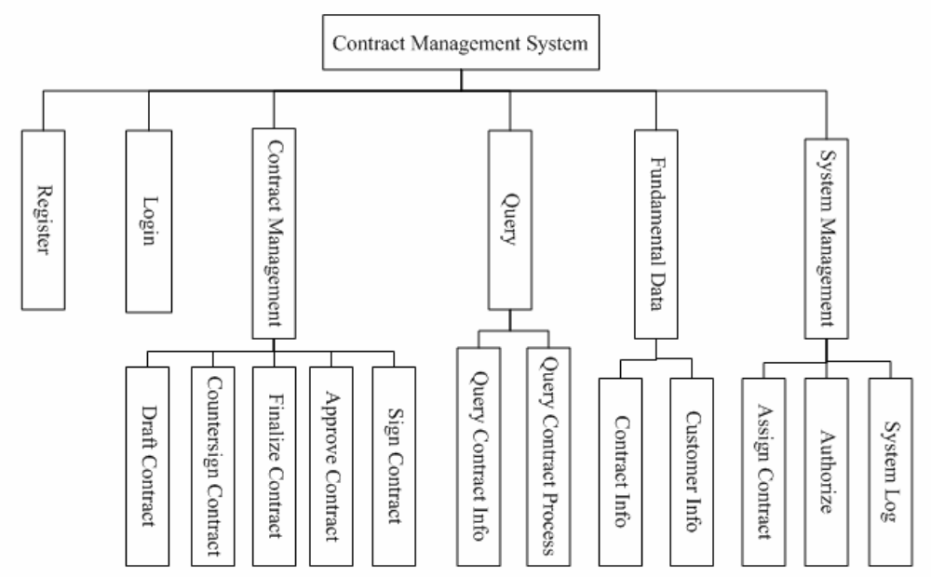
2. Project directory structure
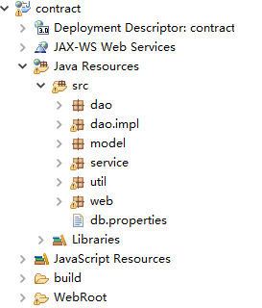

2.4 Application（以下代码仅展示处理网页请求的Servlet层）
1. Requirement Function : Resgister
(1) Functional description
用户注册

(2) Running screenshot
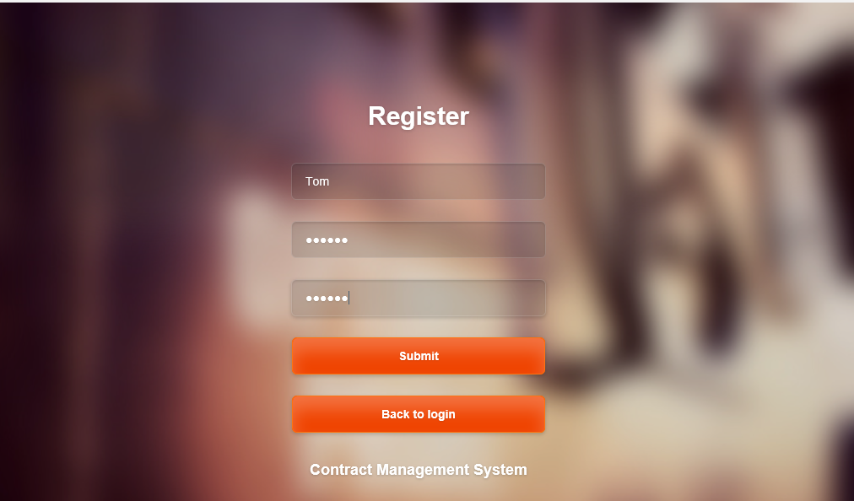
(3) Development idea and core code
处理注册请求
public class RegisterServlet extends HttpServlet {
private static final long serialVersionUID = 1L;

/**
* @see HttpServlet#HttpServlet()
*/
public RegisterServlet() {
super();
// TODO Auto-generated constructor stub
}

/**
* @see HttpServlet#doGet(HttpServletRequest request, HttpServletResponse
* response)
*/
protected void doGet(HttpServletRequest request, HttpServletResponse response)
throws ServletException, IOException {
// TODO Auto-generated method stub
doPost(request, response);
}

/**
* @see HttpServlet#doPost(HttpServletRequest request, HttpServletResponse
* response)
*/
protected void doPost(HttpServletRequest request, HttpServletResponse response)
throws ServletException, IOException {
request.setCharacterEncoding("UTF-8");
String name = request.getParameter("username");
String password = request.getParameter("password");
String password2 = request.getParameter("password2");

boolean flag = false;
String message = "";
User user = new User();
UserService userService = new UserService();

if (name == "" || password == "" || password2 == "") {
System.out.println("---Entered incorrectly!---");
System.out.println("User name, password, and the repeat password can not be empty!");
message = "User name, password, and the repeated password can not be empty!";
} else if (!password2.equals(password)) {
System.out.println("---Entered incorrectly!---");
System.out.println("Repeat password and password should keep consistent!");
message = "Repeat password and password should keep consistent!";
} else {
try {

user.setName(name);
user.setPassword(password);
flag = userService.addUser(user);
if (flag) {
message = "Registration Successful!";
System.out.println("Registration Successful!");
response.sendRedirect("ToLogin");
} else {
message = "Registration failed!";
System.out.println("Registration failed!");
request.setAttribute("message", message);
request.getRequestDispatcher("/Register.jsp").forward(request, response);

}
} catch (AppException e) {
e.printStackTrace();
message = "System exception!";
response.sendRedirect("/ToError");
}
}

}

}
2. Requirement Function ：Login
(1) Functional description
用户登录
(2) Running screenshot
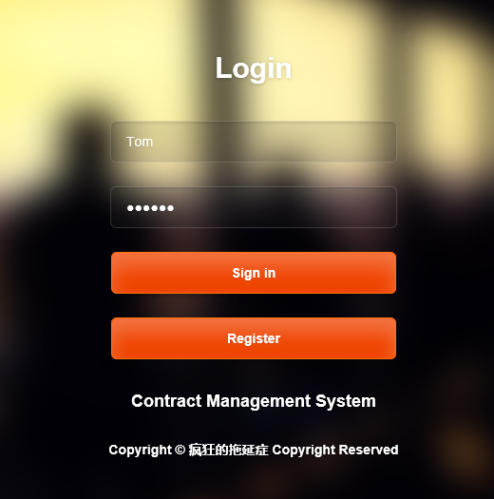

(3) Development idea and core code
处理登录请求
public class LoginServlet extends HttpServlet {
private static final long serialVersionUID = 1L;

/**
* @see HttpServlet#HttpServlet()
*/
public LoginServlet() {
super();
// TODO Auto-generated constructor stub
}

/**
* @see HttpServlet#doGet(HttpServletRequest request, HttpServletResponse
* response)
*/
protected void doGet(HttpServletRequest request, HttpServletResponse response)
throws ServletException, IOException {
// TODO Auto-generated method stub
this.doPost(request, response);
}

/**
* @see HttpServlet#doPost(HttpServletRequest request, HttpServletResponse
* response)
*/
protected void doPost(HttpServletRequest request, HttpServletResponse response)
throws ServletException, IOException {
// TODO Auto-generated method stub
request.setCharacterEncoding("UTF-8");
String name = request.getParameter("username");
String password = request.getParameter("password");

String message = "";
if (name == "" || password == "") {
System.out.println("---Entered incorrectly!---");
System.out.println("User name and password can not be empty!");
message = "User name and password can not be empty!";
request.setAttribute("message", message);
request.getRequestDispatcher("/ToLogin").forward(request, response);
} else {
int userID = -1;
try {
UserService userService = new UserService();
userID = userService.login(name, password);

if (userID > 0) {
HttpSession session = null;
session = request.getSession();
session.setAttribute("userId", userID);
session.setAttribute("userName", name);
Right right = null;
Role role = null;
right = userService.getRightByUserID(userID);
int roleId = right.getRoleId();
role = userService.getRoleByRoleId(roleId);
session.setAttribute("role", role);
//session.setAttribute("Role", role);

if (role.getName().equals("none")) {
response.sendRedirect("ToNewUser.jsp");
} else if (role.getName().equals("admin")){
response.sendRedirect("Frame2.jsp");
} else if (role.getName().equals("operator")){
response.sendRedirect("Frame1.jsp");
}
} else {
message = "用户名或密码不正确！";
request.setAttribute("message", message);
request.setAttribute("userName", name);
request.getRequestDispatcher("/ToLogin").forward(request, response);
}
} catch (AppException e) {
e.printStackTrace();
response.sendRedirect("/ToError");
}
}
}

}
3. Requirement Function ： Contract Draft
(1) Functional description
起草合同：已授权的用户可以起草合同
(2) Running screenshot
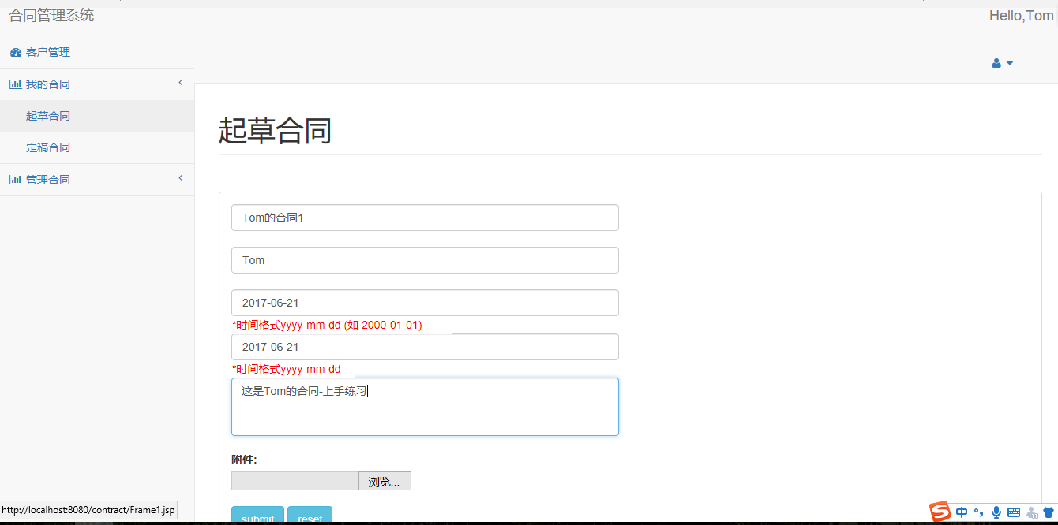
(3) Development idea and core code
处理起草合同请求
public class ToDraftServlet extends HttpServlet {

/**
* Jump to draft contract page
*/
public void doPost(HttpServletRequest request, HttpServletResponse response)
throws ServletException, IOException {
//Set the request's character encoding
request.setCharacterEncoding("UTF-8");

// Declare session
HttpSession session = null;
// Get session by using request object
session = request.getSession();
Integer userId = (Integer)session.getAttribute("userId");

// If user is not login, jump to login page
if (userId == null) {
response.sendRedirect("ToLogin");
}else {
// Forward to draft page
request.getRequestDispatcher("/draft.jsp").forward(request, response);
}
}

/**
* Process GET requests
*/
public void doGet(HttpServletRequest request, HttpServletResponse response)
throws ServletException, IOException {
// call doPost() to process request
this.doPost(request, response);
}

}
处理起草合同界面的请求
public class DraftServelt extends HttpServlet {
private static final long serialVersionUID = 1L;

/**
* @see HttpServlet#HttpServlet()
*/
public DraftServelt() {
super();
// TODO Auto-generated constructor stub
}

/**
* @see HttpServlet#doGet(HttpServletRequest request, HttpServletResponse response)
*/
protected void doGet(HttpServletRequest request, HttpServletResponse response) throws ServletException, IOException {
// TODO Auto-generated method stub
doPost(request,response);
}

/**
* @see HttpServlet#doPost(HttpServletRequest request, HttpServletResponse response)
*/
protected void doPost(HttpServletRequest request, HttpServletResponse response) throws ServletException, IOException {
// TODO Auto-generated method stub
request.setCharacterEncoding("UTF-8");
response.setContentType("text/html; charset=UTF-8");
response.setCharacterEncoding("UTF-8");
//HttpSession session = null;
HttpSession session = null;
// Get session by using request object
session = request.getSession();
Integer userId = (Integer)session.getAttribute("userId");

if (userId == null){
response.sendRedirect("ToLogin");
}else{
String name = request.getParameter("name1");
String customer = request.getParameter("customer");
String content = request.getParameter("content");
String beginTime = request.getParameter("beginTime");
String endTime = request.getParameter("endTime");
//response.getWriter().append("Served at: ").append(name+" "+customer+" "+content+" "+beginTime);
// Instantiate begin and end of java.util.Date type,for accepting transformed beginTime and endTime
Date begin = new Date();
Date end = new Date();

// Define a date format object, transform the time of String type into java.util.Date data type
SimpleDateFormat dateFormat = new SimpleDateFormat("yyyy-MM-dd");

// Initialize prompt message
String message = "";

try {
begin = dateFormat.parse(beginTime);
end = dateFormat.parse(endTime);

// Build a Contract object and assign value for the object's attribute
Contract contract = new Contract();
contract.setUserId(userId);
contract.setName(name);
contract.setCustomer(customer);
contract.setBeginTime(begin);
contract.setEndTime(end);
contract.setContent(content);

// Initialize contractService
ContractService contractService = new ContractService();

// Operation success or failure, return draft page, giving prompt message
if (contractService.draft(contract)) {
message = "Drafting succeeded!";
// Transform the information created now to page for display
request.setAttribute("contract", contract);
response.sendRedirect("Frame1.jsp");
} else {
message = "Drafting failure!";
}

} catch (ParseException e) {
e.printStackTrace();
message = "Contract data is required. Incorrect date format";
} catch (AppException e) {
e.printStackTrace();
//Redirect to the exception page
response.sendRedirect("toError");
return;
}
// Save message to request
//request.setAttribute("message", message);
// Forward to draft page
//request.getRequestDispatcher("draft.jsp").forward(request, response);

}

}

}

4. Requirement Function ： Contract Countersign
(1) Functional description
合同会签：已授权且被指定的用户需要会签合同，即对合同作进一步修改及完善。
(2) Running screenshot
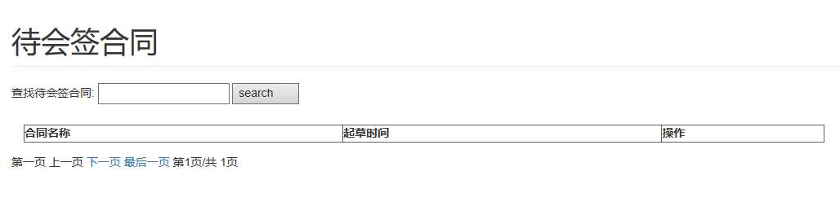

(3) Development idea and core code
处理会签合同请求
public class DhqhtListServlet extends HttpServlet {
private static final long serialVersionUID = 1L;

/**
* @see HttpServlet#HttpServlet()
*/
public DhqhtListServlet() {
super();
// TODO Auto-generated constructor stub
}

/**
* @see HttpServlet#doGet(HttpServletRequest request, HttpServletResponse response)
*/
protected void doGet(HttpServletRequest request, HttpServletResponse response) throws ServletException, IOException {
// Set the request's character encoding
request.setCharacterEncoding("UTF-8");

// Declare session
HttpSession session = null;
// Get session by using request
session = request.getSession();
Integer userId = (Integer)session.getAttribute("userId");

// If user is not login, jump to login page
if (userId == null) {
response.sendRedirect("ToLogin");
}else {

try {
// Initialize contractService
ContractService contractService = new ContractService();
// Initialize contractList
List<ConBusiModel> contractList = new ArrayList<ConBusiModel>();
// Call business logic layer to get list of contract to be countersigned
contractList = contractService.getDhqhtList(userId);

// Save contractList to request
request.setAttribute("contractList", contractList);

// Forward to page of contract to be countersigned
request.getRequestDispatcher("/dhqhtList.jsp").forward(request, response);
} catch (AppException e) {
e.printStackTrace();
// Redirect to the exception page
response.sendRedirect("toError");
}
}
}

/**
* @see HttpServlet#doPost(HttpServletRequest request, HttpServletResponse response)
*/
protected void doPost(HttpServletRequest request, HttpServletResponse response) throws ServletException, IOException {
// TODO Auto-generated method stub
/**response.setContentType("text/html;charset=UTF-8");
String docType=request.getParameter("text");
System.out.println(docType);**/

}

}
处理会签合同界面的请求
public class DhqhtDoneListServlet extends HttpServlet {
private static final long serialVersionUID = 1L;

/**
* @see HttpServlet#HttpServlet()
*/
public DhqhtDoneListServlet() {
super();
// TODO Auto-generated constructor stub
}

/**
* @see HttpServlet#doGet(HttpServletRequest request, HttpServletResponse response)
*/
protected void doGet(HttpServletRequest request, HttpServletResponse response) throws ServletException, IOException {
// TODO Auto-generated method stub
request.setCharacterEncoding("UTF-8");

// Declare session
HttpSession session = null;
// Get session by using request
session = request.getSession();
Integer userId = (Integer)session.getAttribute("userId");

// If user is not login, jump to login page
if (userId == null) {
response.sendRedirect("ToLogin");
}else {

try {
// Initialize contractService
ContractService contractService = new ContractService();
// Initialize contractList
List<ConBusiModel> contractList = new ArrayList<ConBusiModel>();
// Call business logic layer to get list of contract to be countersigned
contractList = contractService.getDhqhtDoneList(userId);

// Save contractList to request
request.setAttribute("contractList", contractList);
request.setAttribute("userId", userId);

// Forward to page of contract to be countersigned
request.getRequestDispatcher("/DhqhtDoneList.jsp").forward(request, response);
} catch (AppException e) {
e.printStackTrace();
// Redirect to the exception page
response.sendRedirect("toError");
}
}
}

/**
* @see HttpServlet#doPost(HttpServletRequest request, HttpServletResponse response)
*/
protected void doPost(HttpServletRequest request, HttpServletResponse response) throws ServletException, IOException {
// TODO Auto-generated method stub
doGet(request, response);
}

}

5. Requirement Function ： Contract Finalize
(1) Functional description
合同定稿：当所有已授权且被指定会签合同的用户会签完毕后，合同状态将自动从会签变为定稿，即无需用户与该过程交涉，同时该过程为下一步审批合同做准备。
(2) Running screenshot
(3) Development idea and core code

6. Requirement Function ： Contract Approve
(1) Functional description
审批合同：已授权且被指定的用户需要在合同定稿之后进行审批，并提供审批意见。
(2) Running screenshot

(3) Development idea and core code
处理审批合同请求
public class ToBeApprovedServlet extends HttpServlet {

public void doPost(HttpServletRequest request, HttpServletResponse response) throws ServletException, IOException {

request.setCharacterEncoding("UTF-8");

HttpSession session = null;
session = request.getSession();

Integer userId = (Integer) session.getAttribute("userId");

if (userId == null) {
response.sendRedirect("ToLogin");
} else {
int toPage = Integer.parseInt(request.getParameter("toPage"));
int trPerPage = Integer.parseInt(request.getParameter("trPerPage"));
request.setAttribute("toPage", toPage);
request.setAttribute("trPerPage", trPerPage);
try {
ContractService conService = new ContractService();
List<ConBusiModel> conList = new ArrayList<ConBusiModel>();

conList = conService.getDshphtList(userId);
request.setAttribute("contractList", conList);

request.getRequestDispatcher("/dshphtList.jsp").forward(request, response);
} catch (AppException e) {
e.printStackTrace();
// Redirect to the exception page
response.sendRedirect("toError");
}
}
}

public void doGet(HttpServletRequest request, HttpServletResponse response) throws ServletException, IOException {
this.doPost(request, response);
}
}
处理审批合同界面的请求
public class AddApprovedOpinionServlet extends HttpServlet {
private static final long serialVersionUID = 1L;

/**
* @see HttpServlet#HttpServlet()
*/
public AddApprovedOpinionServlet() {
super();
// TODO Auto-generated constructor stub
}

protected void doPost(HttpServletRequest request, HttpServletResponse response)
throws ServletException, IOException {
// TODO Auto-generated method stub

request.setCharacterEncoding("UTF-8");

HttpSession session=null;
session=request.getSession();
Integer userId=(Integer)session.getAttribute("userId");
if(userId==null){
response.sendRedirect("ToLogin");
}
else{
int conId=Integer.parseInt(request.getParameter("conId"));
String content=request.getParameter("content");
String standpoint=request.getParameter("standpoint");

ConProcess conProcess=new ConProcess();
conProcess.setConId(conId);
conProcess.setUserId(userId);
conProcess.setContent(content);

if(standpoint.equals("true")){ //�޳�
conProcess.setState(Constant.DONE);
}
else{ //����
conProcess.setState(Constant.VETOED);
}

try{
ContractService conService=new ContractService();

conService.approve(conProcess);

response.sendRedirect("ToBeApprovedServlet?toPage=0&trPerPage=1");
}
catch(AppException e){
e.printStackTrace();

response.sendRedirect("toError");
}
}
}

/**
* @see HttpServlet#doGet(HttpServletRequest request, HttpServletResponse response)
*/
protected void doGet(HttpServletRequest request, HttpServletResponse response) throws ServletException, IOException {
// TODO Auto-generated method stub

this.doPost(request, response);
}

}

7. Requirement Function ：Sign Contract
(1) Functional description
签订合同：已授权的用户在合同审批顺利通过后，进行合同签订。
(2) Running screenshot

(3) Development idea and core code
处理签订合同的请求
public class Sign extends HttpServlet {
private static final long serialVersionUID = 1L;

public Sign() {
super();
// TODO Auto-generated constructor stub
}

public void doGet(HttpServletRequest request, HttpServletResponse response)
throws ServletException, IOException {
this.doPost(request, response);
}

public void doPost(HttpServletRequest request, HttpServletResponse response)
throws ServletException, IOException{
HttpSession session = null;
// Get session by using request
session = request.getSession();
Integer userId = (Integer) session.getAttribute("userId");

database_operation d_o=new database_operation();
List<Contract> lists = new ArrayList<Contract>();
String remark=request.getParameter("remark");//锟斤拷锟�
String str_id=request.getParameter("con_id");//锟斤拷同id
String if_ok=request.getParameter("if_ok");//锟角凤拷通锟斤拷
String searchwords=request.getParameter("searchwords");
int if_pass=-1;
if(if_ok!=null)
if_pass= Integer.valueOf(if_ok).intValue();
int id=-1;
if(str_id!=null)
id= Integer.valueOf(str_id).intValue();
String flag=request.getParameter("flag");
if(searchwords==null&&remark==null){
lists=d_o.select_contract_for_sign();
request.setAttribute("lists", lists);//锟斤拷lists锟脚碉拷锟斤拷锟斤拷锟斤拷
}else if(searchwords!=null&&remark==null){
lists=d_o.search_by_user(searchwords);
request.setAttribute("lists", lists);//锟斤拷lists锟脚碉拷锟斤拷锟斤拷锟斤拷
}else if(remark!=null){
ConProcess cp= new ConProcess();
cp.setConId(id);
cp.setUserId(userId);//////////锟斤拷要锟睫革拷
cp.setType(5);
cp.setState(1);
cp.setContent(remark);
cp.setDel(if_pass);
d_o.update_after_sign(cp);
lists=d_o.select_contract_for_sign();
request.setAttribute("lists", lists);//锟斤拷lists锟脚碉拷锟斤拷锟斤拷锟斤拷
}
String curPage=request.getParameter("curPage");
request.setAttribute("curpage", curPage);
request.getRequestDispatcher("/contract_sign.jsp").forward(request, response);
}

}
处理签订合同界面的请求
public class Signed extends HttpServlet {
private static final long serialVersionUID = 1L;

/**
* @see HttpServlet#HttpServlet()
*/
public Signed() {
super();
// TODO Auto-generated constructor stub
}

/**
* @see HttpServlet#doGet(HttpServletRequest request, HttpServletResponse response)
*/
protected void doGet(HttpServletRequest request, HttpServletResponse response) throws ServletException, IOException {
// TODO Auto-generated method stub
this.doPost(request, response);
}

/**
* @see HttpServlet#doPost(HttpServletRequest request, HttpServletResponse response)
*/
protected void doPost(HttpServletRequest request, HttpServletResponse response) throws ServletException, IOException {
database_operation d_o=new database_operation();
List<Contract> lists = new ArrayList<Contract>();
List<ConProcess> conlist = new ArrayList<ConProcess>();
String searchwords=request.getParameter("searchwords");
/*
* �����ȡ�û���ݺ�id
*/
int if_admin=1;
HttpSession session = null;
// Get session by using request
session = request.getSession();
Integer userId = (Integer) session.getAttribute("userId");

if(searchwords==""||searchwords==null){
lists=d_o.select_contract_after_sign(0,userId);//��һ������Ϊ0ʱ��ѯ�����û���ͬ��������ݵڶ����������û�id��ѯ
request.setAttribute("lists", lists);//��lists�ŵ�������

conlist=d_o.select_detail_after_sign(lists);//��ѯǩ����ϸ��Ϣ
request.setAttribute("conlist", conlist);
}else{
lists=d_o.search_after_sign_contract_by_user(searchwords);
request.setAttribute("lists", lists);//��lists�ŵ�������

conlist=d_o.select_detail_after_sign(lists);//��ѯǩ����ϸ��Ϣ
request.setAttribute("conlist", conlist);
}

String curPage=request.getParameter("curPage");
request.setAttribute("curpage", curPage);
request.getRequestDispatcher("/Singed.jsp").forward(request, response);
}

}

8. Requirement Function ：Query Contract Info
(1) Functional description
查询合同信息
(2) Running screenshot

(3) Development idea and core code
处理查看合同明细的请求
public class ContractDetailsServlet extends HttpServlet {
private static final long serialVersionUID = 1L;

/**
* @see HttpServlet#HttpServlet()
*/
public ContractDetailsServlet() {
super();
// TODO Auto-generated constructor stub
}

/**
* ��ת����ͬ��ϸ����
*/
protected void doPost(HttpServletRequest request, HttpServletResponse response) throws ServletException, IOException {
// TODO Auto-generated method stub

request.setCharacterEncoding("UTF-8");

HttpSession session=null;
session=request.getSession();
Integer userId=(Integer)session.getAttribute("userId");

if(userId==null){
response.sendRedirect("ToLogin");
}
else{
int conId=Integer.parseInt(request.getParameter("conId"));

try{
ContractService conService=new ContractService();

ConDetailBusiModel conDetail=conService.getContractDetail(conId);
request.setAttribute("conDetailBusiModel", conDetail);

request.getRequestDispatcher("/contractDetail.jsp").forward(request, response);
}
catch(AppException e){
e.printStackTrace();

response.sendRedirect("toError");
}
}
}

/**
* @see HttpServlet#doGet(HttpServletRequest request, HttpServletResponse response)
*/
protected void doGet(HttpServletRequest request, HttpServletResponse response) throws ServletException, IOException {
// TODO Auto-generated method stub

this.doPost(request, response);
}

}

9. Requirement Function ：Query Contract Process
(1) Functional description
查询合同流程：查询合同当前状态，如是否定稿
(2) Running screenshot
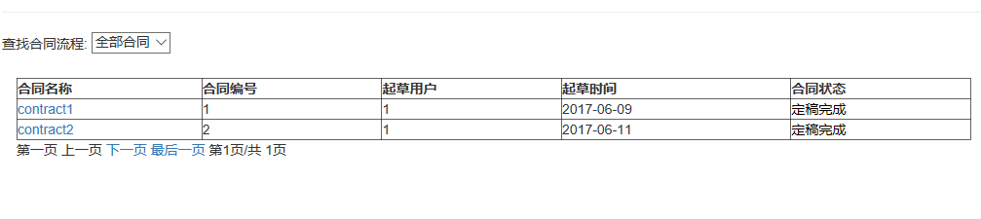
(3) Development idea and core code
处理查询合同流程的请求
public class ConSateQuery extends HttpServlet {
private static final long serialVersionUID = 1L;

/**
* @see HttpServlet#HttpServlet()
*/
public ConSateQuery() {
super();
// TODO Auto-generated constructor stub
}

/**
* @see HttpServlet#doGet(HttpServletRequest request, HttpServletResponse response)
*/
protected void doGet(HttpServletRequest request, HttpServletResponse response) throws ServletException, IOException {
// TODO Auto-generated method stub
request.setCharacterEncoding("UTF-8");

// Declare session
HttpSession session = null;
// Get session by using request
session = request.getSession();
Integer userId = (Integer)session.getAttribute("userId");

// If user is not login, jump to login page
if (userId == null) {
response.sendRedirect("ToLogin");
}else {

try {
// Initialize contractService
ContractService contractService = new ContractService();
// Initialize contractList
List<ConProModel> contractList = new ArrayList<ConProModel>();
// Call business logic layer to get list of contract to be countersigned
contractList = contractService.getAllConStateList();

// Save contractList to request
request.setAttribute("contractList", contractList);

// Forward to page of contract to be countersigned
request.getRequestDispatcher("/conSateQuery.jsp").forward(request, response);
} catch (AppException e) {
e.printStackTrace();
// Redirect to the exception page
response.sendRedirect("toError");
}
}
}

/**
* @see HttpServlet#doPost(HttpServletRequest request, HttpServletResponse response)
*/
protected void doPost(HttpServletRequest request, HttpServletResponse response) throws ServletException, IOException {
// TODO Auto-generated method stub
doGet(request, response);
}

}

10. Requirement Function ：Customer Info
(1) Functional description
客户管理
(2) Running screenshot
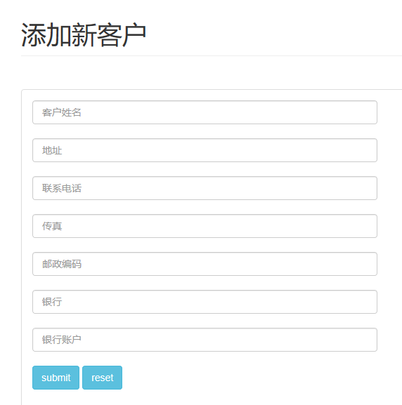
(3) Development idea and core code
处理添加客户的请求
public class AddCustomerServlet extends HttpServlet {
private static final long serialVersionUID = 1L;

/**
* @see HttpServlet#HttpServlet()
*/
public AddCustomerServlet() {
super();
// TODO Auto-generated constructor stub
}

/**
* @see HttpServlet#doGet(HttpServletRequest request, HttpServletResponse
* response)
*/
protected void doGet(HttpServletRequest request, HttpServletResponse response)
throws ServletException, IOException {
this.doPost(request, response);
}

/**
* @see HttpServlet#doPost(HttpServletRequest request, HttpServletResponse response)
*/
protected void doPost(HttpServletRequest request, HttpServletResponse response) throws ServletException, IOException {
request.setCharacterEncoding("UTF-8");
String name = request.getParameter("customername");
String address = request.getParameter("address");
String tel = request.getParameter("telephone");
String fax = request.getParameter("fax");
String code = request.getParameter("code");
String bank = request.getParameter("bank");
String account = request.getParameter("account");

boolean flag = false;
String message = "";
Customer customer = new Customer();
CustomerService customerService = new CustomerService();

if(name == "" || address == "" || tel == "" || fax == "" || code == "" || bank == "" || account == ""){
System.out.println("---Entered incorrectly!---");
System.out.println("Customer name, address, tel, fax, code, bank and account can not be empty!");
message = "Customer name, address, tel, fax, code, bank and account can not be empty!";
}
else {
try{
customer.setName(name);
customer.setAddress(address);
customer.setTel(tel);
customer.setFax(fax);
customer.setCode(code);
customer.setBank(bank);
customer.setAccout(account);
flag = customerService.addNewCustomer(customer);
if (flag){
message = "Add new customer Successful!";
System.out.println("Add new customer Successful!");
response.sendRedirect("Frame1.jsp");
}
else{
message = "Add new customer failed!";
System.out.println("Add new customer failed!");
request.setAttribute("message", message);
request.getRequestDispatcher("Index.jsp").forward(request, response);
}
} catch (AppException e) {
e.printStackTrace();
message = "System exception!";
response.sendRedirect("/ToError");
}
}
}

}

11. Requirement Function ：Assign Contract
(1) Functional description
分配合同：已授权的用户将刚起草的合同分配出去，如指定哪位用户来会签，审批等等。
(2) Running screenshot
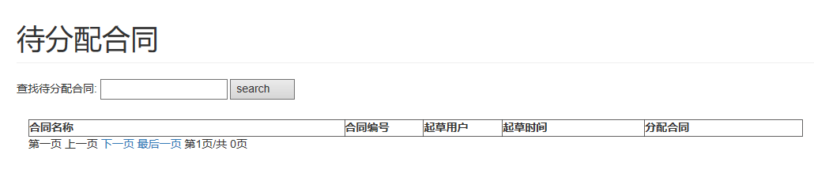
(3) Development idea and core code
处理分配合同的请求
public class ToAssignOperServlet extends HttpServlet {

/**
* Jump to operator assignment page
*/
public void doPost(HttpServletRequest request, HttpServletResponse response)
throws ServletException, IOException {
doGet(request,response);
}

/**
* Process GET requests
*/
public void doGet(HttpServletRequest request, HttpServletResponse response)
throws ServletException, IOException {
// Set the request's character encoding
request.setCharacterEncoding("UTF-8");

// Declare session
HttpSession session = null;
// Get session by using request
session = request.getSession();
//Integer userId = (Integer)session.getAttribute("userId");
Integer userId=1;
// If user is not login, jump to login page
if (userId == null) {
response.sendRedirect("toLogin");
}else {
// Get contract id
int conId = Integer.parseInt(request.getParameter("conId"));
try {
// Initialize contractService
ContractService contractService = new ContractService();
// Query contract information according to contract id
Contract contract = contractService.getContract(conId);

// Initialize userService
UserService userService = new UserService();

/*
* Need to get user list with "countersign", "approve", "sign" permissions
* Operator role have above rights, here using hard-coding way to set operator role's role id to 2,
* RoleId = 2 corresponding to the role's primary key who have rights as above in contract rights table
*/
int roleId = 2;
// Initialize userList
List<User> userList = new ArrayList<User>();
// Get user list according to role id
userList = userService.getUserListByRoleId(roleId);

// Save contract to request
request.setAttribute("contract", contract);
// Save userList to request
request.setAttribute("userList", userList);
// Forward to operator assignment page
request.getRequestDispatcher("assignOperator.jsp").forward(request,response);
} catch (AppException e) {
e.printStackTrace();
//Redirect to the exception page
//response.sendRedirect("toError");
}
}
}
}
处理分配合同界面的请求
public class AssignOperServlet extends HttpServlet {

/**
* Process result of assign contrct
*/
public void doPost(HttpServletRequest request, HttpServletResponse response)
throws ServletException, IOException {
// Set the request's character encoding
request.setCharacterEncoding("UTF-8");
response.setContentType("text/html; charset=UTF-8");
response.setCharacterEncoding("UTF-8");
// Declare session
HttpSession session = null;
// Get session by using request
session = request.getSession();
Integer userId = (Integer)session.getAttribute("userId");
// If user is not login, jump to login page
if (userId == null) {
response.sendRedirect("ToLogin");
}

/*
* Get information of assign contract
*/
//Get Contract id
int conId = Integer.parseInt(request.getParameter("conId"));
// Get assigned cuntersign people's id
String[] hqht = request.getParameterValues("hqht");
// Get assigned approver's id
String[] spht = request.getParameterValues("spht");
// Get assigned signer's id
String[] qdht = request.getParameterValues("qdht");

try {
// Initialize contractService
ContractService contractService = new ContractService();
/*
* Call business logic layer to distributed contract
*/
// Assigned cuntersign people
for (String hq : hqht) {
contractService.distribute(conId, Integer.parseInt(hq),Constant.PROCESS_CSIGN);
}

// Assigned approver
for (String sp : spht) {
contractService.distribute(conId, Integer.parseInt(sp), Constant.PROCESS_APPROVE);
}

// Assigned signer
for (String qd : qdht) {
contractService.distribute(conId, Integer.parseInt(qd), Constant.PROCESS_SIGN);
}

// After complete assignment,redirect to page of to be distributed
// response.sendRedirect("toDfphtList");
} catch (AppException e) {
e.printStackTrace();
// Redirect to exception page
response.sendRedirect("toError");
}
request.getRequestDispatcher("Frame2.jsp").forward(request,response);
}

/**
* Process GET requests
*/
public void doGet(HttpServletRequest request, HttpServletResponse response)
throws ServletException, IOException {
// Call doPost() to process request
this.doPost(request, response);
}

}

12. Requirement Function ：Authorize
(1) Functional description
授权：管理员对用户分配权限
(2) Running screenshot
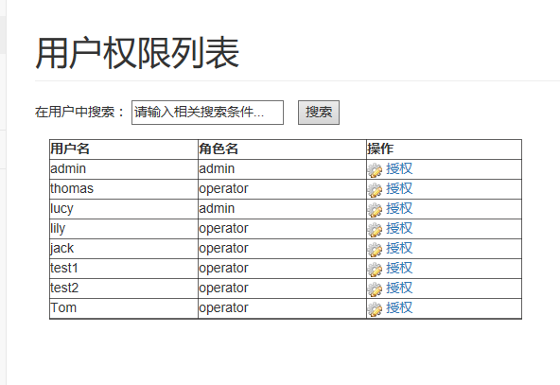
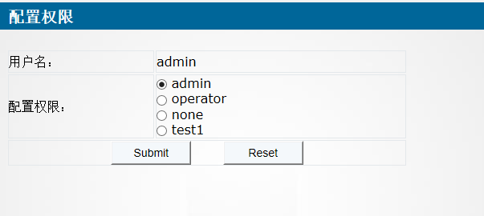
(3) Development idea and core code
处理授权的请求
public class ToAuthorizeServlet extends HttpServlet {
private static final long serialVersionUID = 1L;

/**
* @see HttpServlet#HttpServlet()
*/
public ToAuthorizeServlet() {
super();
// TODO Auto-generated constructor stub
}

/**
* @see HttpServlet#doGet(HttpServletRequest request, HttpServletResponse response)
*/
protected void doGet(HttpServletRequest request, HttpServletResponse response) throws ServletException, IOException {
// TODO Auto-generated method stub
this.doPost(request, response);
}

/**
* @see HttpServlet#doPost(HttpServletRequest request, HttpServletResponse response)
*/
protected void doPost(HttpServletRequest request, HttpServletResponse response) throws ServletException, IOException {
// TODO Auto-generated method stub

request.setCharacterEncoding("UTF-8");

UserService userService=new UserService();
int currentUserId=Integer.parseInt(request.getParameter("userId"));
PermissionBusiModel permission=new PermissionBusiModel();
List<Role> roleList=new ArrayList<Role>();
try {
Right currentRight=userService.getRightByUserID(currentUserId);
permission.setRoleId(currentRight.getRoleId());
permission.setRoleName(currentRight.getDescription());
permission.setUserId(currentUserId);
User currentUser=userService.getUserById(currentUserId);
permission.setUserName(currentUser.getName());

roleList=userService.getRoleList();

request.setAttribute("permissionId", currentRight.getId());
} catch (AppException e) {
// TODO Auto-generated catch block
e.printStackTrace();
response.sendRedirect("/ToError");
}
request.setAttribute("permission", permission);
request.setAttribute("roleList", roleList);
request.getRequestDispatcher("/assignPermission.jsp").forward(request, response);
}

}
处理授权界面的请求
public class AssignPermissionServlet extends HttpServlet {
private static final long serialVersionUID = 1L;

/**
* @see HttpServlet#HttpServlet()
*/
public AssignPermissionServlet() {
super();
// TODO Auto-generated constructor stub
}

/**
* @see HttpServlet#doGet(HttpServletRequest request, HttpServletResponse response)
*/
protected void doGet(HttpServletRequest request, HttpServletResponse response) throws ServletException, IOException {
// TODO Auto-generated method stub
this.doPost(request,response);
}

/**
* @see HttpServlet#doPost(HttpServletRequest request, HttpServletResponse response)
*/
protected void doPost(HttpServletRequest request, HttpServletResponse response) throws ServletException, IOException {
// TODO Auto-generated method stub

request.setCharacterEncoding("UTF-8");

int permissionId=Integer.valueOf( request.getParameter("permissionId"));
int userId=Integer.valueOf( request.getParameter("userId"));
int roleId=Integer.valueOf( request.getParameter("roleId"));

boolean flag = false;
String message = "";
UserService userService=new UserService();
try {
Role role=userService.getRoleByRoleId(roleId);
Right newRight=new Right();
newRight.setId(permissionId);
newRight.setRoleId(roleId);
newRight.setDescription(role.getName());
newRight.setUserId(userId);

flag=userService.UpdatePermission(newRight);
if (flag) {
message = "UpdatePermission Successful!";
} else {
message = "UpdatePermission failed!";
}
} catch (AppException e) {
// TODO Auto-generated catch block
e.printStackTrace();
message = "System exception!";
response.sendRedirect("/ToError");
}
request.setAttribute("message", message);
request.getRequestDispatcher("ToPermissionListServlet").forward(request, response);
}

}

13. Requirement Function ：System Log
(1) Functional description
日志管理
(2) Running screenshot

(3) Development idea and core code
处理日志管理的请求
public class LogServlet extends HttpServlet {
private static final long serialVersionUID = 1L;

/**
* @see HttpServlet#HttpServlet()
*/
public LogServlet() {
super();
// TODO Auto-generated constructor stub
}

/**
* @see HttpServlet#doGet(HttpServletRequest request, HttpServletResponse response)
*/
protected void doGet(HttpServletRequest request, HttpServletResponse response) throws ServletException, IOException {
// TODO Auto-generated method stub
this.doPost(request, response);
}

/**
* @see HttpServlet#doPost(HttpServletRequest request, HttpServletResponse response)
*/
protected void doPost(HttpServletRequest request, HttpServletResponse response) throws ServletException, IOException {
database_operation d_o=new database_operation();
Log log=new Log();
List<Log> lists = new ArrayList<Log>();
int if_admin=1;
HttpSession session = null;
// Get session by using request
session = request.getSession();
Integer userId = (Integer) session.getAttribute("userId");

String operation=request.getParameter("searchwords");
if(operation==""||operation==null){
lists=d_o.select_Log_by_UserId(0,userId); }else
lists=d_o.search_log_by_operation(operation);
request.setAttribute("lists", lists);
String curPage=request.getParameter("curPage");
request.setAttribute("curpage", curPage);
request.getRequestDispatcher("/log.jsp").forward(request, response);
}

}

2.5 Deliverables
Processes(Stages) | Deliverables | Deliver or not（√） | Remarks
Project start | Project Start Report | √
Project planning | Project Planning Report | √
Requirement analysis | Requirement Specifications（SRS） | √
System design | System Design Specifications（SD） | √
Coding implementation and test | Project Source Code | √
Coding implementation and test | Project user’s manual | √
Acceptance and close | Project Closure Summary Report | √

3. Project Work Summary

3.1 Code statistics
File | Lines of coding | Lines of comments | Comment rate
Dao | 490
Dao.impl | 1750
Model | 1500
Service | 1950
Util | 270
Web | 5400
WebRoot | 8400
total | 19760

Prompt: Comment rate = Comment lines/( Comment lines + Code lines)

3.2 Document work summary
Name | Process | Document | Pages
 | Initialization | Project Start Report | 7
 | Plan | Project Planning(optional) | 5
 | RA | Requirement Specification(optional) | 29
 | System Design | System Design(optional) | 33
 | Implement | User Manual
 | Accepting | Project Acceptance report
 | Accepting | Project Closure Summary Report | 34
Total

4. Lessons learned and Suggestions for Improvement
Lessons about:
We have learned how to build a web application, what are html, css, javascript, and learned how to use them. By the way, we also learn how to work together through Github.

Suggestions about:
Constraints are needed in several special situation, but we didn’t complete due to the limited time.

