Document Name |  | Confidentiality Level
DBMS Project |  | Only for Recipients Reference
Template Code | Version | Document Code

DBMS Project Closure Summary Report



Copyright © Ruankosoft Technologies (Shenzhen) Co., Ltd.
All Rights Reserved
Revision Record
Date | Revision Version | CR ID /Defect ID | Sec No. | Change Description | Author
2017.6.21 | 1.0 | 15301097 |  | 初稿 | 钱洋

Content
1. Project Basic Situation 3
2. Project Acceptance Coverage 3
2.1 Project progress 3
2.2 Development environment 4
2.3 Project Structure 4
2.4 Application 4
2.5 Deliverables 5
3. Project Work Summary 5
3.1 Code statistics 5
3.2 Document work summary 5
4. Lessons learned and Suggestions for Improvement 6

1. Project Basic Situation
Project Name: | Database Management System | Project Category: | MFC SDI application
Project ID: |  | Technology Used: | MFC SDI, C++
Development Environment: | Visual Studio 2015 | Running Platform: | Window Operating System
Project Start & Finish Time: | 2017.4.26-2017.5.24 | Project Working Place: | Classroom and apartment in Beijing JiaoTong University
Project Manager: | 钱洋
Project Developer: | 钱洋，祝梦婷，李晓薇
Project Description | Database Management System is large-scale software which can manipulate and manage the database. It is used to establish, use and maintain the database, and called DBMS for short. It manages and controls the database in a unified manner to ensure the security and integrity of the database. The user accesses the data in the database through DBMS. The database administrator also maintains the database through DBMS. It can make many applications and users establish, modify and query the database through different methods at the same time or different moments. Most DBMS provide DDL (Data Definition Language) and DML (Data Manipulation Language) for users to define the schema structure and permission constraint of the database, and implement the data operations: add, delete, etc.

2. Project Acceptance Coverage

2.1 Project progress
(S.N.) | Stages | Scheduled start/end time | Actual start/end time | List of deliverables | Remarks
1 | Project start | 2017.4.26 | 2017.4.26 | 项目启动文档 | 李晓薇
2 | Project planning | 2017.4.27 | 2017.4.27 | 项目计划文档 | 祝梦婷
3 | Requirement analysis | 2017.4.27 | 2017.4.27 | 项目需求文档 | 祝梦婷
4 | System design | 2017.4.28-5.2 | 2017.4.29-5.2 | 系统设计文档 | 钱洋，  祝梦婷
5 | Coding and test | 2017.5.3-5.24 | 2017.5.3-5.24
6 | Acceptance |  | 2017.6.14

2.2 Development environment
System/Tool/Component | In English (version number) | Remarks
Operating system | Windows 8.1/10
Development tool | Visual Studio 2015

2.3 Project Structure
1. Project structure design idea
Prompt: describing how to fulfill design of project framework, as well as technology employment (or technological prototyping).
Reference: System Design (sample)
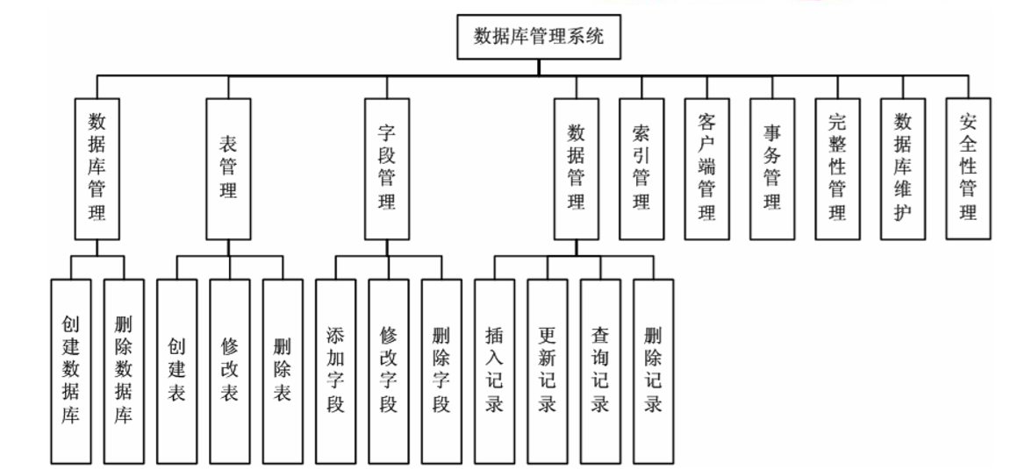
The database management system are divided into 10 parts in the diagram. Actually, we didn’t finish these modules as “索引管理”,“客户端管理”,“事务管理”,“数据库维护”and “安全性管理”. So we mainly finished the left 5 modules. For convenience, we just finish the MVC’s three layers vertically. This division reduces the degree of code crossover.
2. Project directory structure
Prompt: adhering project directory screenshot.
Reference: System Design (sample)
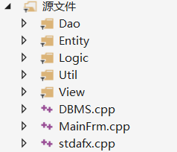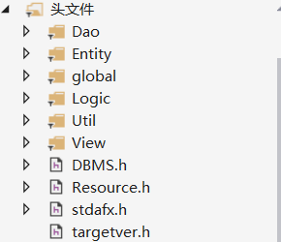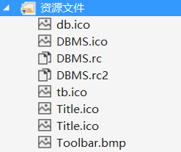

2.4 Application（以下源码只讲Dao层）
1. Requirement Function X
(1) Functional description
Prompt: describing specific aspects of the function.
Reference: Coding Stage X:

(2) Running screenshot
Prompt: adhering screenshots on running (pass over if not applicable).

(3) Development idea and core code
Prompt: describing functional development idea or development process, with core code to be copied and attached herewith.

1. Requirement Function login/register
(1) Functional description
基本的登录注册
(2) Running screenshot
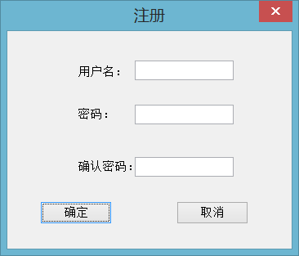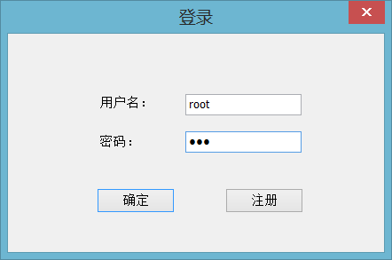
(3) Development idea and core code
Dao层的注册代码：
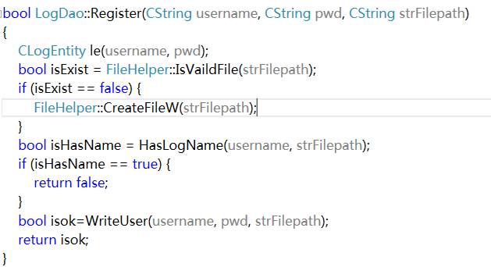

Dao层的登录代码：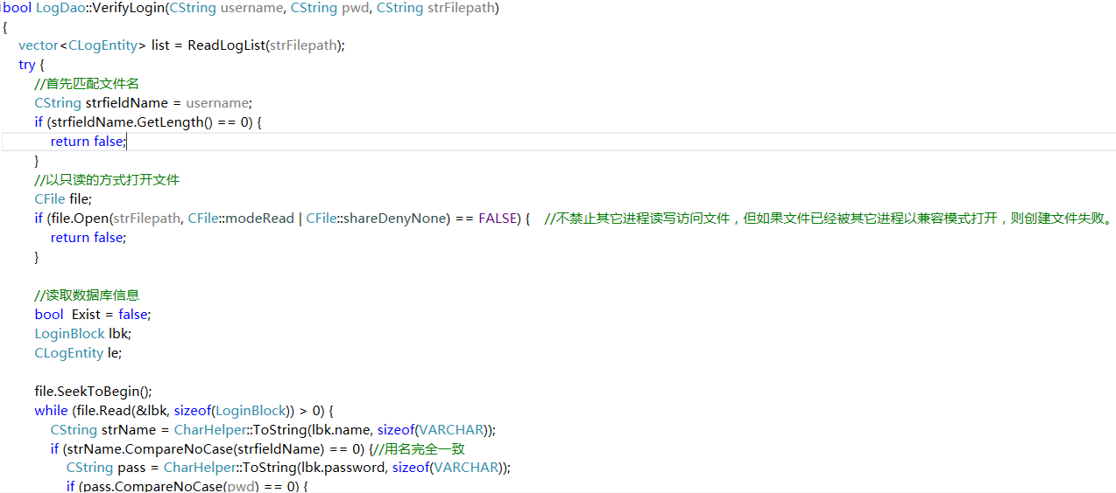
实现基本思路：将用户注册的账号和确认过相同的密码用CFile的文件读写形式按LoginBlock结构体块写入文件，HasLogName()方法用于匹配用户名是否重复，登录时在文件中按结构体块进行匹配，如果用户名相同，则允许登录。
2. Requirement Function Database
(1) Functional description
数据库的增删改，以及备份

(2) Running screenshot
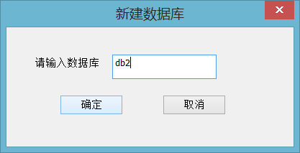
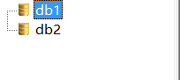
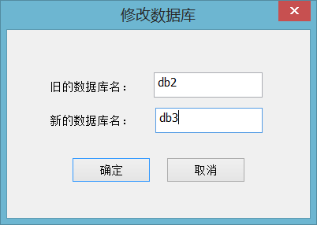
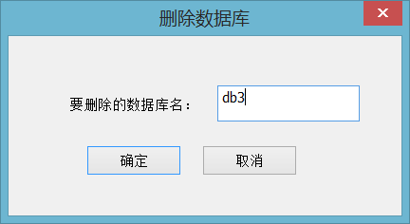
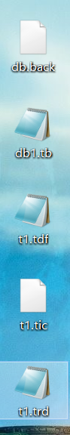备份的文件
(3) Development idea and core code
//创建数据库，将数据库信息保存到文件中
bool DBDao::Create(const CString strFilepath, CDBEntity &db, bool bAppend) {
try {
CFile file;
if (bAppend == true) {
if (file.Open(strFilepath, CFile::modeWrite | CFile::shareDenyWrite) == FALSE) {
return false;
}
}
else {
if (file.Open(strFilepath, CFile::modeCreate | CFile::modeWrite | CFile::shareDenyWrite) == FALSE) {
return false;
}
}

file.SeekToEnd(); //跳转至文件的开头进行写入
file.Write(&db.GetBlock(), sizeof(DatabaseBlock)); //写入数据库块的信息
file.Close();

return true;
}
catch (CException *e) {
//删除异常信息
e->Delete();
//抛出一个常规的异常
throw new CAppException(_T("Failed to create the database file!"));
}

return false;
}

删除数据库：删除star.db文件中关于该数据库的块信息，并删除该数据库文件夹下的所有文件
bool DBDao::DeleteDB(const CString strFilepath, CString &dbname) {
vector <CDBEntity> res;
if (dbname.GetLength() == 0) {
return false;
}
res = ReadDBList(strFilepath);
for (vector<CDBEntity>::iterator ite = res.begin(); ite != res.end(); ++ite) {
CDBEntity db = ite->GetBlock();
CString strDBName = db.getDBName();
if (strDBName.CompareNoCase(dbname)==0) { //如果数据库名一致，则从vector数组中删除该数据库块的信息
res.erase(ite);
break;
}
}

try {
CFile file;
if (file.Open(strFilepath, CFile::modeCreate | CFile::modeWrite | CFile::shareDenyWrite) == FALSE) {
return false;
}
file.SeekToBegin();
for (vector<CDBEntity>::iterator ite = res.begin(); ite != res.end(); ++ite) {
CDBEntity db = ite->GetBlock();
file.Write(&db.GetBlock(), sizeof(DatabaseBlock));
file.SeekToEnd();
}
}
catch (CException *e) {
e->Delete();
throw new CAppException(_T("Failed to delete the database!"));
}

return true;
}

修改数据名来修改数据库，先将数据库文件列表读出，修改匹配上的，然后再写会，同时修改数据库文件夹的路径和数据库表描述文件的路径
bool DBDao::ModifyDB(CString strFilePath, CString &oldDBName, CString &newDBName) {
vector <CDBEntity> res;
FileLogic m_logic;
if (oldDBName.GetLength() == 0 || newDBName.GetLength() == 0) {
return false;
}
res = ReadDBList(strFilePath);
for (vector<CDBEntity>::iterator ite = res.begin(); ite != res.end(); ++ite) {
CDBEntity db = ite->GetBlock();
CString strDBName = db.getDBName();
if (strDBName.CompareNoCase(oldDBName) == 0) { //如果当前查找的数据库名与老数据库名一致，则进行修改
ite->setDBName(newDBName);
CString strDBFolder = m_logic.GetDBFolder(ite->getDBName());
ite->setDBFilePath(strDBFolder);
break;
}
}

备份数据库：将要备份的数据库文件夹中的所有文件拷贝到新的文件位置，并创建db.back文件
bool DBDao::BackupDB(CString &dbName, CString &filepath, CString &destPath)
{
FileHelper helper;
helper.CopyDirectory(filepath, destPath);
CDBEntity *db = new CDBEntity();
db->setDBName(dbName);
db->setDBFilePath(destPath + L"/db.back");
if (helper.IsVaildFile(destPath + L"/db.back") == FALSE) {
helper.CreateFileW(destPath + L"/db.back");
}
return Create(destPath + L"/db.back", *db, TRUE);
}
3. Requirement Function table
(1) Functional description
表的增删改
(2) Running screenshot
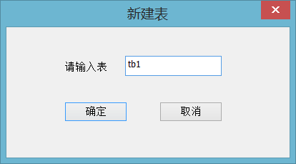
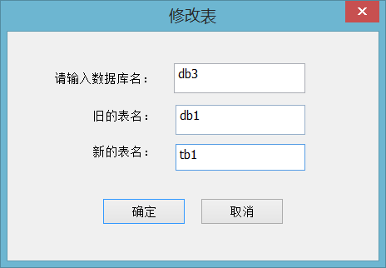
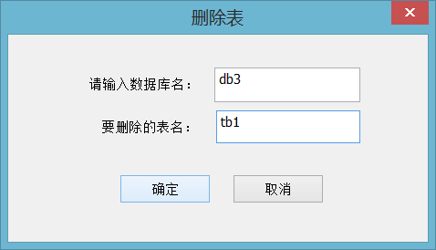
(3) Development idea and core code
创建表，将表信息块写入对应数据库下的表描述文件中
bool TableDao::Create(const CString strFilePath, CTablEntity &te) {
try {
CFile file;
if (file.Open(strFilePath, CFile::modeWrite | CFile::shareDenyWrite) == FALSE) {
return false;
}

file.SeekToEnd();
file.Write(&te.GetBlock(), sizeof(TableBlock));

file.Close();
return true;
}
catch (CException *e) {
e->Delete();
throw new CAppException(_T("Failed to add table information!"));
}
}
修改表：在表描述文件中修改表名，同时修改相关的文件路径
bool TableDao::ModifyTBName(CString strFilePath, CString &oldTBName, CString &newTBName) {
vector <CTablEntity> res;
if (oldTBName.GetLength() == 0 || newTBName.GetLength() == 0) {
return false;
}
res = ReadTableList(strFilePath);
for (vector <CTablEntity>::iterator ite = res.begin(); ite != res.end(); ++ite) {
CTablEntity tb = ite->GetBlock();
CString tbName = tb.getTableName();
if (tbName.CompareNoCase(oldTBName) == 0) {
ite->setTableName(newTBName);
break;
}
}

try {
CFile file;
if (file.Open(strFilePath, CFile::modeCreate | CFile::modeWrite | CFile::shareDenyWrite) == FALSE) {
return false;
}
file.SeekToBegin();
for (vector<CTablEntity>::iterator ite = res.begin(); ite != res.end(); ++ite) {
CTablEntity tb = ite->GetBlock();
file.Write(&tb.GetBlock(), sizeof(TableBlock));
file.SeekToEnd();
}
file.Close();

bool TableDao::ModifyTBFile(CString dbFolderPath, CString &oldTBName, CString &newTBName) {
CString oldTrdFilePath = dbFolderPath + CString("\\") + oldTBName + CString(".trd");
CString newTrdFilePath = dbFolderPath + CString("\\") + newTBName + CString(".trd");
CString oldTdfFilePath = dbFolderPath + +CString("\\") + oldTBName + CString(".tdf");
CString newTdfFilePath = dbFolderPath + +CString("\\") + newTBName + CString(".tdf");
CString oldTicFilePath = dbFolderPath + +CString("\\") + oldTBName + CString(".tic");
CString newTicFilePath = dbFolderPath + +CString("\\") + newTBName + CString(".tic");

删除表：在表描述文件中删除表信息，并删除相关的字段文件，记录文件，完整性文件
bool TableDao::DeleteTable(CString strFilePath, CString &tbname) {
vector <CTablEntity> res;
if (tbname.GetLength() == 0) {
return false;
}
res = ReadTableList(strFilePath);
for (vector <CTablEntity>::iterator ite = res.begin(); ite != res.end(); ++ite) {
CTablEntity tb = ite->GetBlock();
CString tbName = tb.getTableName();
if (tbName.CompareNoCase(tbname) == 0) { //如果表名一致，则从vector数组中删除该表块的信息
res.erase(ite);
break;
}
}

try {
CFile file;
if (file.Open(strFilePath, CFile::modeCreate | CFile::modeWrite | CFile::shareDenyWrite) == FALSE) {
return false;
}
file.SeekToBegin();
for (vector<CTablEntity>::iterator ite = res.begin(); ite != res.end(); ++ite) {
CTablEntity tb = ite->GetBlock();
file.Write(&tb.GetBlock(), sizeof(TableBlock));
file.SeekToEnd();
}
file.Close();
}

bool TableDao::DeleteTBFile(CString dbFolderPath, CString &tbname) {
CString trdFilePath = dbFolderPath + CString("\\") + tbname + CString(".trd");
CString tdfFilePath = dbFolderPath + CString("\\") + tbname + CString(".tdf");
CString ticFilePath = dbFolderPath + CString("\\") + tbname + CString(".tic");

DeleteFile(trdFilePath)

1. Requirement Function field
(1) Functional description
字段的增删改
(2) Running screenshot

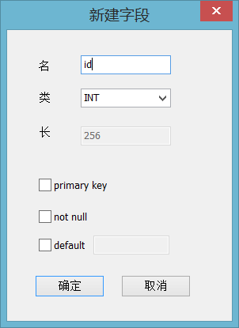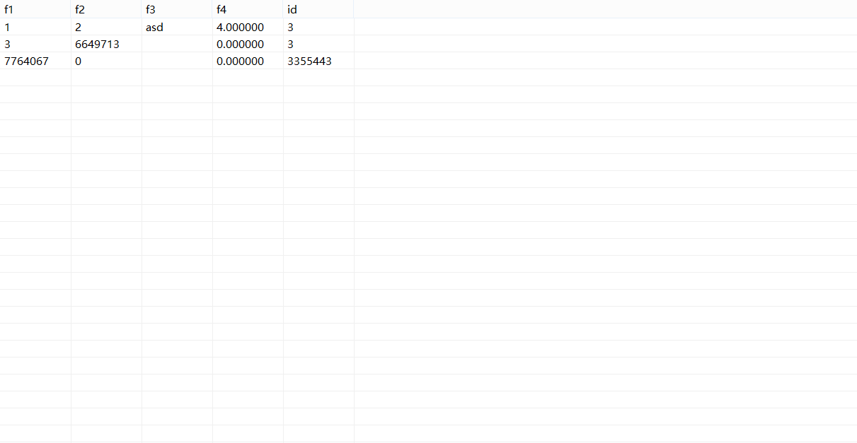
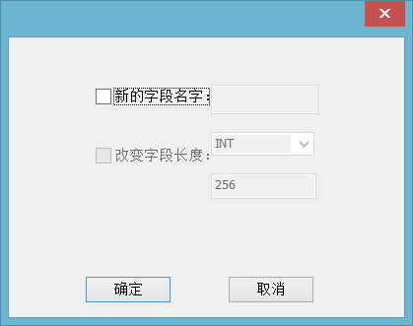
(3) Development idea and core code
创建字段，在tdf文件中写入对应的字段结构块信息
bool FieldDao::CreateField(const CString strFilepath, CFieldEntity &fd, bool bAppend)
{
try {
CFile file;
if (bAppend == true) {
if (file.Open(strFilepath, CFile::modeWrite | CFile::shareDenyWrite) == FALSE) {
return false;
}
}
else {
if (file.Open(strFilepath, CFile::modeCreate | CFile::modeWrite | CFile::shareDenyWrite) == FALSE) {
return false;
}
}

file.SeekToEnd(); //跳转至文件的开头进行写入
file.Write(&fd.GetBlock(), sizeof(FieldBlock)); //写入数据库块的信息
file.Close();

return true;
}

修改字段会修改字段的名字，会删除原文件并重命名临时文件，也是将类型修改后的临时文件重命名，并删除原文件
bool FieldDao::ChangeFieldName(const CString strFilepath, const CString strIndexPaath, CString oldNamme, CString newName)
{
try {
//首先匹配文件名
CString strfieldName = oldNamme;
if (strfieldName.GetLength() == 0) {
return false;
}
//以只读的方式打开文件
CFile file;
if (file.Open(strFilepath, CFile::modeRead | CFile::shareDenyNone) == FALSE) { //不禁止其它进程读写访问文件，但如果文件已经被其它进程以兼容模式打开，则创建文件失败。
return false;
}

//读取数据库信息
bool Exist = false;
FieldBlock fbk;
CFieldEntity fb;
file.SeekToBegin();
while (file.Read(&fbk, sizeof(FieldBlock)) > 0) {
CString strName = CharHelper::ToString(fbk.name, sizeof(VARCHAR));
if (strName.CompareNoCase(strfieldName) == 0) {//数据库名完全一致
CharHelper::ToChars(fbk.name, newName,sizeof( VARCHAR));
Exist = true;
}
fb.SetBlock(fbk);
if (FileHelper::IsVaildFile(strIndexPaath) == false) {
if (FileHelper::CreateFile(strIndexPaath) == false) {
return false;
}
}
if (CreateField(strIndexPaath,fb,TRUE)==FALSE) {
return false;
}
}
file.Close();
//删除原文件并重命名临时文件
char* name1=new char[sizeof(VARCHAR)];
char* name2 = new char[sizeof(VARCHAR)];
memset(name1, 0, sizeof(VARCHAR));
memset(name2, 0, sizeof(VARCHAR));
CharHelper::ToChars(name1, strIndexPaath, sizeof(VARCHAR));
CharHelper::ToChars(name2, strFilepath, sizeof(VARCHAR));
remove(name2);
rename(name1,name2);

return Exist;
}

修改字段的类型:同样字段类型也存了一个文件，
bool FieldDao::ChangeFieldTType(const CString strFilepath, const CString strIndexPaath, CString oldNamme, int length)
{
try {
//首先匹配文件名
CString strfieldName = oldNamme;
if (strfieldName.GetLength() == 0) {
return false;
}
//以只读的方式打开文件
CFile file;
if (file.Open(strFilepath, CFile::modeRead | CFile::shareDenyNone) == FALSE) { //不禁止其它进程读写访问文件，但如果文件已经被其它进程以兼容模式打开，则创建文件失败。
return false;
}

//读取数据库信息
bool Exist = false;
FieldBlock fbk;
CFieldEntity fb;
file.SeekToBegin();
while (file.Read(&fbk, sizeof(FieldBlock)) > 0) {
CString strName = CharHelper::ToString(fbk.name, sizeof(VARCHAR));
if (strName.CompareNoCase(strfieldName) == 0) {//数据库名完全一致
fbk.param = length;
Exist = true;
}
fb.SetBlock(fbk);
if (FileHelper::IsVaildFile(strIndexPaath) == false) {
if (FileHelper::CreateFile(strIndexPaath) == false) {
return false;
}
}
if (CreateField(strIndexPaath, fb, TRUE) == FALSE) {
return false;
}
}
file.Close();
//删除原文件并重命名临时文件
char* name1 = new char[sizeof(VARCHAR)];
char* name2 = new char[sizeof(VARCHAR)];
memset(name1, 0, sizeof(VARCHAR));
memset(name2, 0, sizeof(VARCHAR));
CharHelper::ToChars(name1, strIndexPaath, sizeof(VARCHAR));
CharHelper::ToChars(name2, strFilepath, sizeof(VARCHAR));
remove(name2);
rename(name1, name2);
return Exist;
}

1. Requirement Function record
(1) Functional description
记录的增删改查
(2) Running screenshot
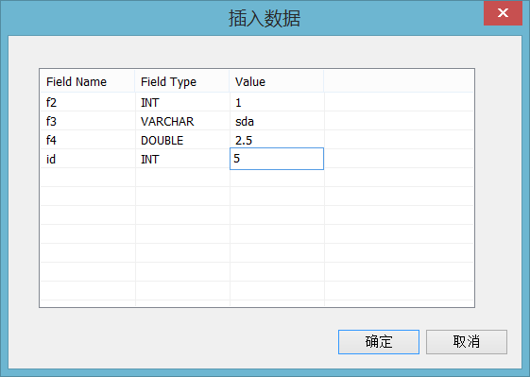
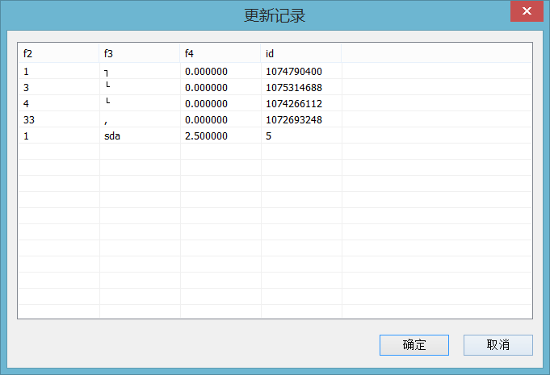
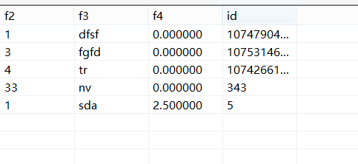
记录的全查询

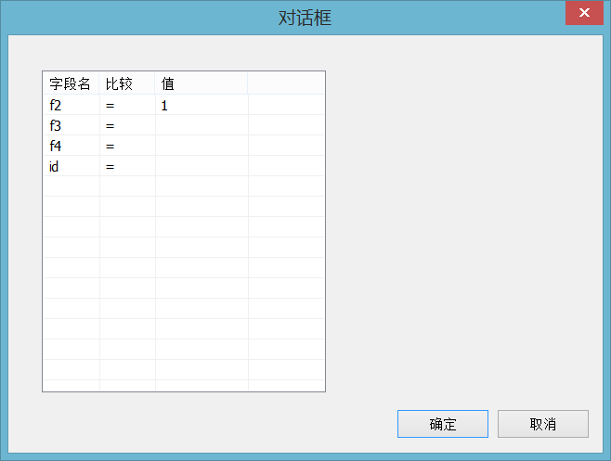
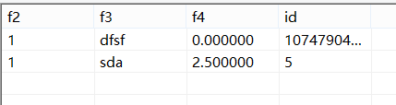
记录的详细查询，相当于where关键字查询

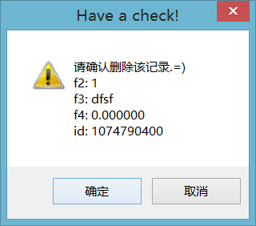
(3) Development idea and core code
记录的插入：将一条记录按照字段的对应顺序写入记录文件
bool RecordDao::Insert(CString strFilepath, CTablEntity &te, CRecordEntity &re)
{
try
{
CFile recordFile;
if (recordFile.Open(strFilepath, CFile::modeWrite | CFile::shareDenyWrite) == FALSE)
return false;
recordFile.SeekToEnd(); //从文件尾开始写入

Write(recordFile, te, re);
recordFile.Close();

return true;
} //异常处理：插入记录失败

查询所有记录，从文件读取所有记录块的信息
int RecordDao::SelectAll(CString strFilepath, CTablEntity &te, RECORDARR &data)
{
try
{
CFile recordFile;
if (recordFile.Open(strFilepath, CFile::modeRead | CFile::shareDenyNone) == FALSE)
return false;
recordFile.SeekToBegin();

int nCount = 0;
while (true)
{
CRecordEntity* pRecdEntity = new CRecordEntity();
if (Read(recordFile, te, *pRecdEntity) == true)
{
data.Add(pRecdEntity);
nCount++;
}
else
{
delete pRecdEntity;
pRecdEntity = NULL;
break;
}
}

更新记录：按记录index顺序进行记录信息的修改
bool RecordDao::Update(CString strFilepath, CTablEntity &te, RECORDARR &newData) //uniqueID starts from 0
{
try
{
CFile recordFile;
if (recordFile.Open(strFilepath, CFile::modeCreate | CFile::modeWrite | CFile::shareDenyWrite) == FALSE)
return false;
recordFile.SeekToBegin();

for (int i = 0; i < newData.GetSize(); i++)
{
Write(recordFile, te, *newData.GetAt(i));
}

recordFile.Close();

return true;
}

记录信息的重写方法
bool RecordDao::Rewrite(CTablEntity &te, RECORDARR &data)
{
try
{
CFile recordFile;
if (recordFile.Open(te.getTableTrdPath(), CFile::modeCreate | CFile::modeWrite | CFile::shareDenyWrite) == FALSE)
return false;
recordFile.SeekToBegin();

for (int i = 0; i < data.GetSize(); i++)
{
Write(recordFile, te, *data.GetAt(i));
}
recordFile.Close();

return true;
}
catch (CException *e)
{
e->Delete();
throw new CAppException(_T("刷新记录失败！"));
}

return false;
}

写记录信息的方法
bool RecordDao::Write(CFile &recordFile, CTablEntity &te, CRecordEntity &re)
{
try
{
int nFieldNum = te.getFieldNum();
for (int i = 0; i < nFieldNum; i++)
{
CFieldEntity* pField = te.getField(i);

CString fieldName = pField->getFieldName();
CString strVal = re.get(fieldName);

switch (pField->getFieldParamNum())
{
case CFieldEntity::DT_INTEGER:
{
int nVal = _wtoi(strVal);
recordFile.Write(&nVal, sizeof(int));
break;
}
case CFieldEntity::DT_BOOL:
{
int bVal = _wtoi(strVal);
recordFile.Write(&bVal, sizeof(bool));
break;
}
case CFieldEntity::DT_DOUBLE: //floating-point number
{
double dbVal = _wtof(strVal);
recordFile.Write(&dbVal, sizeof(double));
break;
}
case CFieldEntity::DT_DATETIME:
{
SYSTEMTIME st = TimeHelper::ToSystemTime(strVal);
recordFile.Write(&st, sizeof(SYSTEMTIME));
break;
}
case CFieldEntity::DT_VARCHAR:
{
/*CArchive arch(&recordFile, CArchive::store);
arch << strVal;
arch.Close();
break;*/

// 字符串的长度
// pField->setParam(256);
int nSize = sizeof(char) * pField->GetParam();
//创建一个缓存来储存这个字符串
char* pBuf = new char[nSize];
CharHelper::ToChars(pBuf, strVal, nSize);
//写入文件
recordFile.Write(pBuf, nSize);
//释放缓存
delete[] pBuf;
break;
}
default: //异常处理：其他数据类型
{
throw new CAppException(_T("保存记录时遇到无法识别的数据类型！"));
break;
}
} //end-switch
} //end-for

return true;
} //异常处理：保存记录失败

详细记录的查询，按照大于等于小于号做对应的查询条件区分，然后去文件中选取对应条件的记录存到一个vector数组中
void RecordLogic::DetailedSelect(CString DBName, CTablEntity &te, vector<CString> compare, vector<CString> values, RECORDARR *data) {
CString trdPath = m_fileLogic.GetRecordFile(DBName, te.getTableName());
RECORDARR AllData;
m_daoRecord.SelectAll(trdPath, te, AllData);
CRecordEntity* oneRecord;
vector<CFieldEntity> list;
FieldLogic logic;
FileLogic f;
CString tbName = te.getTableName();
list = logic.GetFieldList(DBName, tbName);

for (int i = 0; i < AllData.GetSize(); i++)
{
oneRecord = AllData.GetAt(i);
bool condition = true;
for (int i = 0; i < compare.size(); i++)
{
if (values[i] != L"")
{
if (compare[i] == L"="&&oneRecord->get(list[i].getFieldName()) != values[i])
{
condition = false; break;
}
else if (compare[i] == L">"&&oneRecord->get(list[i].getFieldName()) <= values[i])
{
condition = false; break;
}
else if (compare[i] == L"<"&&oneRecord->get(list[i].getFieldName()) >= values[i])
{
condition = false; break;
}
}
else if (values[i] == L"")
{
condition = false;
}

if (condition)
data->Add(oneRecord);
}
}
}

2.5 Deliverables
Processes(Stages) | Deliverables | Deliver or not（√） | Remarks
Project start | Project Start Report | √
Project planning | Project Planning Report | √
Requirement analysis | Requirement Specifications（SRS） | √
System design | System Design Specifications（SD） | √
Coding implementation and test | Project Source Code | √
Coding implementation and test | Project user’s manual | √
Acceptance and close | Project Closure Summary Report | √

3. Project Work Summary

3.1 Code statistics
Prompt: counting original codes only, discarding referenced ones, with statistic result to be attached herewith.
File | Lines of coding | Lines of comments | Comment rate
Dao | 1495
Entity | 673
Logic | 902
Util | 319
View | 2724
total | 6113

Prompt: Comment rate = Comment lines/( Comment lines + Code lines)

3.2 Document work summary
Name | Process | Document | Pages
 | Initialization | Project Start Report
 | Plan | Project Planning(optional)
 | RA | Requirement Specification(optional)
 | System Design | System Design(optional)
 | Implement | User Manual
 | Accepting | Project Acceptance report
 | Accepting | Project Closure Summary Report
Total

4. Lessons learned and Suggestions for Improvement
Lessons about:
分层架构让项目的逻辑变得清晰，但分层写代码存在一定的局限性，就是需要很强的实时交互，否则一层层往上，不太容易满足上一层的接口，所以每个人写一整块成了我们的工作方式，这样代码的交互率会低一些。以后尽量用github来分工合作，这样可能分层写代码会比较容易实现，这才是合理的工作模式。

Suggestions about:
可能额外功能加的不是特别多，可能把索引，安全性管理，事务管理等功能加上会好一些。对MFC单文档的机制理解还不够深，所以还需要加强。另外对于完整性检查，可以做得更完善一些。

