**Advanced Java**

Project: Project 4 – CPU List with streams, lambda functions, then stored in a database retrieved and reported

Name: Michael Fox

Date: 161016

Description:

This program utilized the reading stream code from project 3 but then took the CPU list and store it into a database that had been previously created with sql statements. A class called CpuDb was used to encapsulate the SQL calls and MySql objects. The CPU fields were then read back out of the database and sorted with the following SQL statement in the code:

*//Get all of the fields from the cpu table*r = s.executeQuery(**"SELECT * from cputable order by price DESC"**);

The CpuDb class then returned a CpuList object that then created the report screen below.

Here is the output of the program. The report screen was done with the data stored in the database:

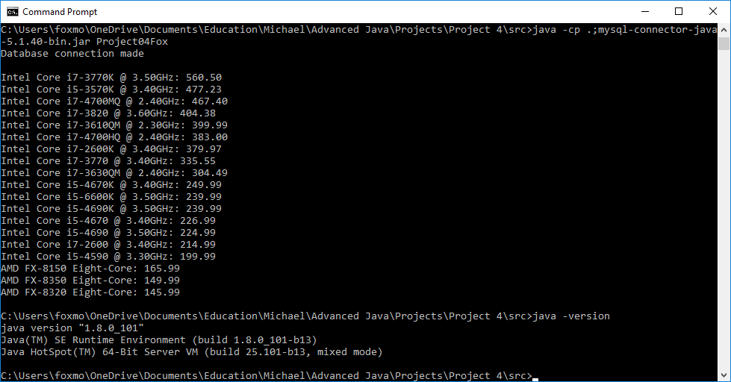

I used the IntelliJ tool and GitHub for version control and archival. I experimented with JavaDoc more and had it placing in a Class header into the output html files such as:

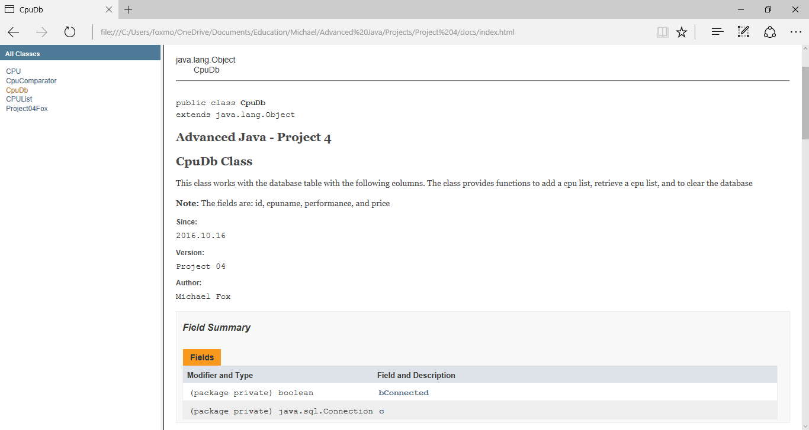

Here is the data shown through SqlWorkbench that was stored by the java program into the database:

