**Advanced Java**

Project: Project 6 – JavaFx dialog interfacing to MySQL with a MVC model

Name: Michael Fox

Date: 161116

Description:

This program uses a JavaFx dialog and a list view to show a CPU table that is stored in MySQL. The architecture used a Model-View-Controller class framework. The Model encapsulates the interface to the database. The View has all of the GUI components and callbacks. The Controller simply linked the Model and View together. There were three pushbuttons with their callbacks in the View class. The “Save” callback would take the data from the text fields and then determine if we are doing a new record or an update on an existing record in the database. The “Delete” pushbutton would use the identifier to then perform a delete of that record in the database.

The program worked as specified for the assignment

Initial Screen:

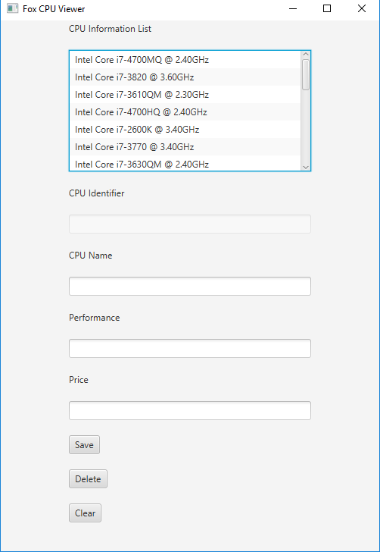

Clicking a list view item will then populate the text boxes:

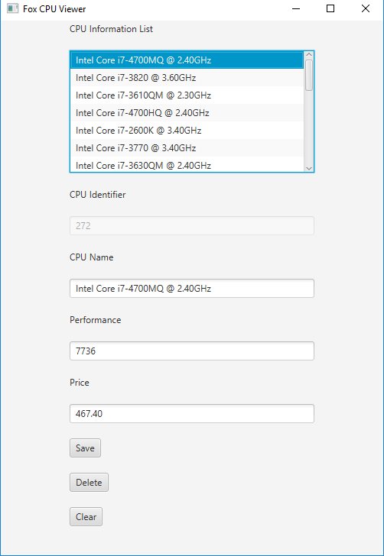

Clicking the clear pushbutton then filling in new information will enable a new record to be created:

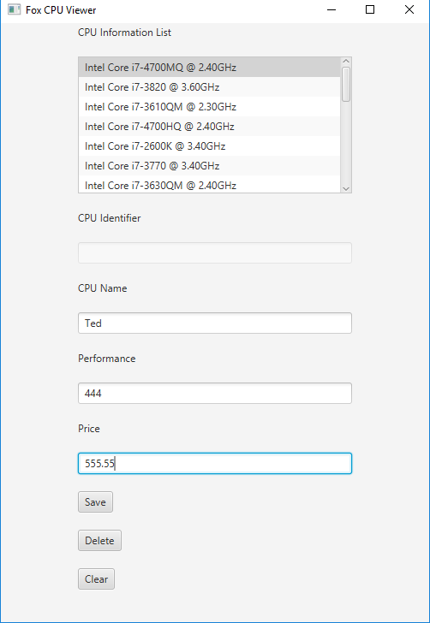

After hitting the “Save” pushbutton the record is added to the database:

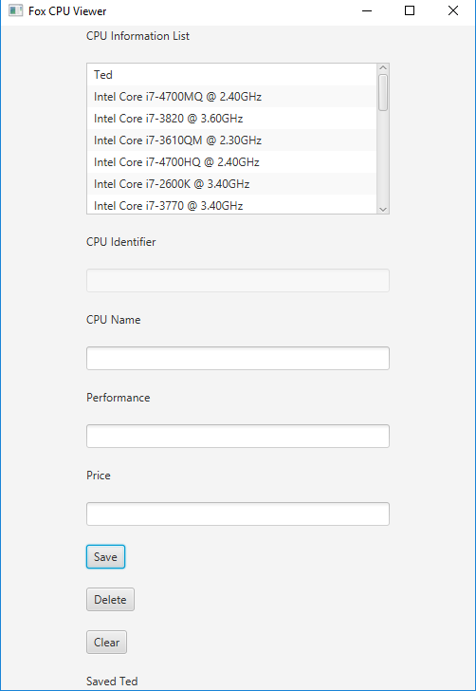

An attempt to “Save” without all of the fields will show an error:

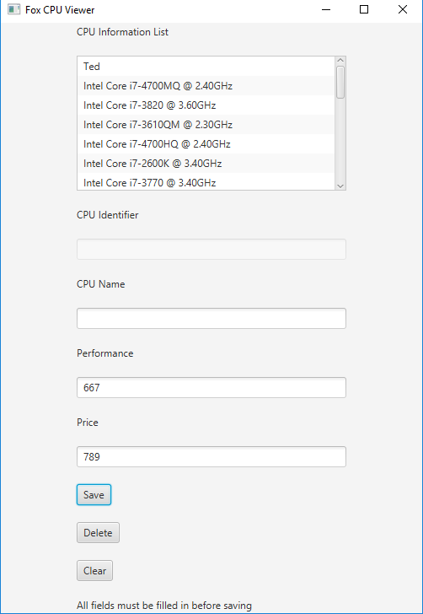

Selecting the “Ted” record and clicking “Delete” will remove the record.

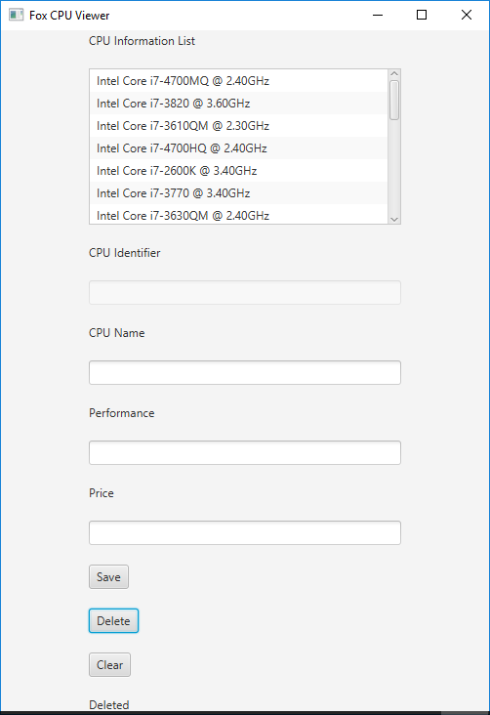

Command Prompt with the Java compiler version:

