**Advanced Java**

Project: Project 7 – JavaFx with a TableView dialog interfacing to MySQL with a MVC model

Name: Michael Fox

Date: 161127

Description:

This program uses a JavaFx dialog and a tableview to show the CPU information. 3 fields for each record are editable. The program does catch invalid values in the performance and price columns by overriding the DoubleStringConverter and IntegerStringCoverter in the View class. The program has Model View Controller architecture. In the OnEditCommit functions the program will catch if the invalid value is present and set back to the old value and provides a warning to the command line. The program will also allow the user to delete a record and then updates the database and tableview.

The program worked as specified for the assignment

Here is the initial screen with the table view populated from the database data:

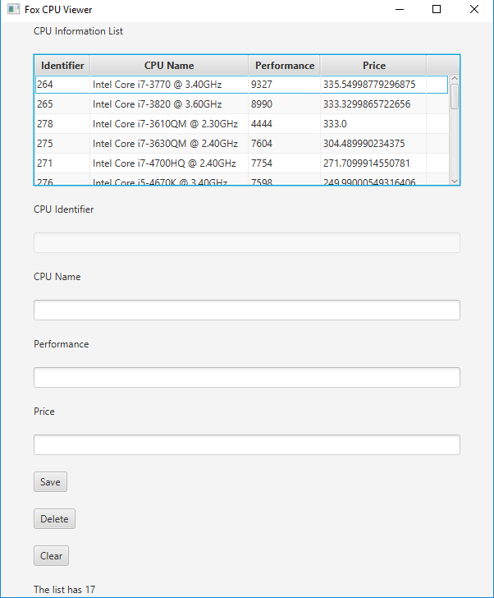

I then highlight the first row and performed a “Delete”. Notice the first row with CPU “3770” is no longer present. The status at the bottom indicates “deleted”

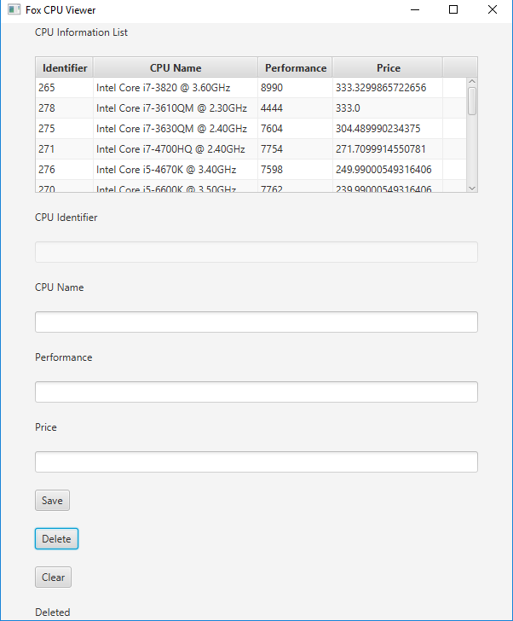

Now updating the first row performance to “555”.

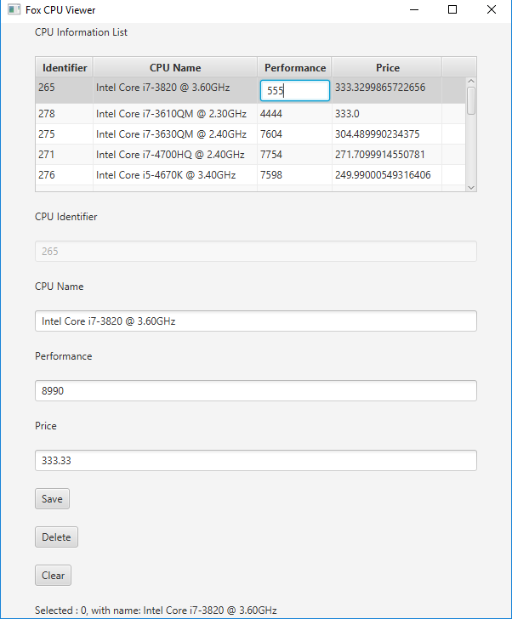

The resulting table after hitting the “enter” key: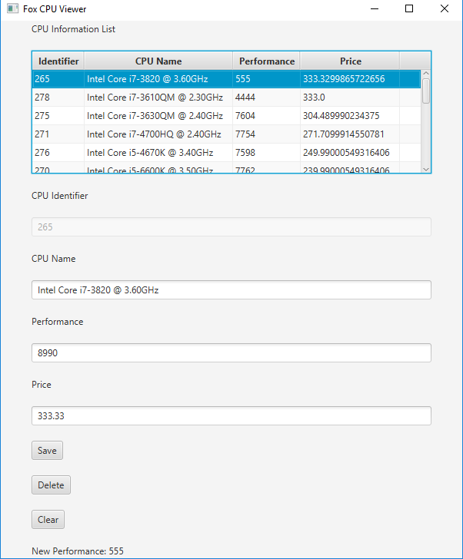

Now trying to set the second rows price to an invalid value “ralph”:

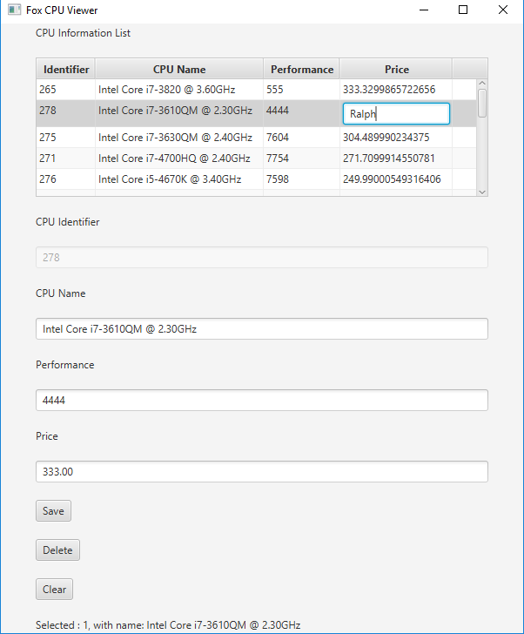

After hitting “enter”, the previous value appears and a warning goes to the status

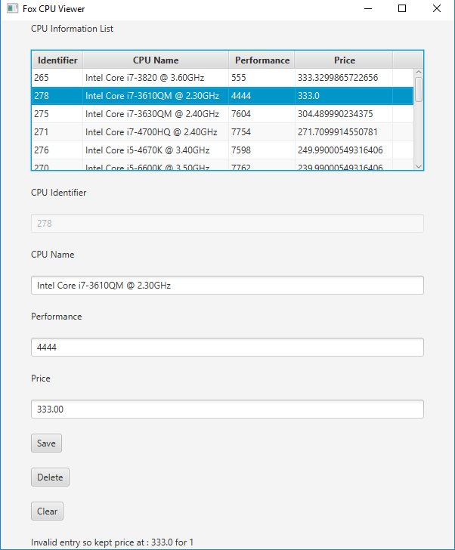

Now changing the second row’s CPU name to “Ted”

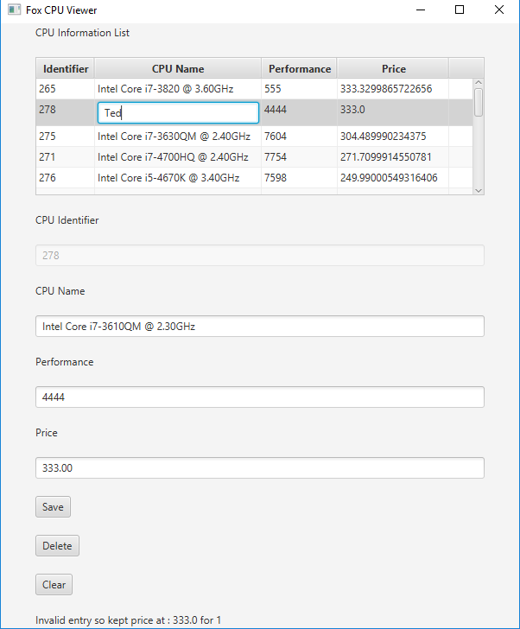

After hitting enter it is now “Ted”. The following is after closing and opening the program to prove it made it to the database.

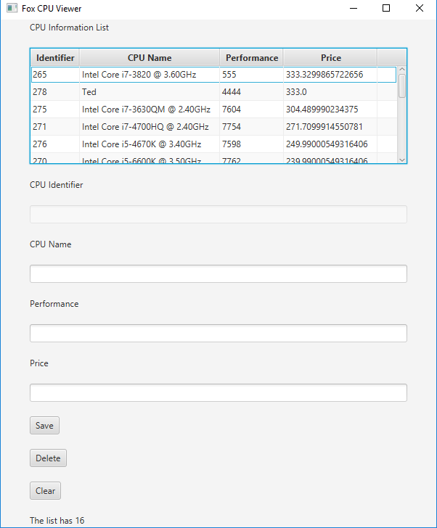

The Java Version Number:

