CS 148/248
IF Design Document
Winter 2013

Names of Students in Team: Rhys Larkins, Steven Hack
Tentative IF Name: Future Tense Delirium

Describe the story arc for your game. What happens in the beginning, middle, and end? Is there a central dilemma or crisis that the player character has to overcome?

The main character has worked themselves too hard trying to move away from home. They are on the verge of being kicked out. Because of this, they get sick, and succumb to a fever dream. In this dream, they are confronted with the many possibilities lying ahead of them, and the difficulties that each one brings. They are faced with the possibilities of moving to a new home and getting a job, going off to college, or joining the military. By the end, the main character decides the path they wish to walk, and to face the respective challenges head-on. At this point, the fever ends.

What is the role of the player character in the game? Does the player play multiple characters? If so, what is the relationship between the multiple characters?

The player character is the focal point of the story. He is navigating through the surreal world caused by the fever dream, and undertaking the tasks that each area requires, using the experiences to help him decide his future path. The character himself, however, is mostly a blank slate, to be defined by the player’s actions.

Describe each location that will appear in your game. Draw a map showing how the locations relate to each other (boxes and lines are fine for the map).

Your Bedroom - the hub from which the player accesses all other areas. The player both starts and ends the game in this room. After completing a room or series of rooms, the player will be returned here.

Item Rooms – Each item leads to a room or two, in which various situations happen related to the symbolism of the item. Depending on how the player acts in these rooms, the character’s affinity for the path the item represents will increase or decrease. See the item descriptions below for the objects’ symbolism. When the player has completed the scenarios in an item’s rooms, they will return to the hub, and from there be able to go to other items.

Gun Barrel – the initial item room for the gun. While in here, the player has the choice to remove the gunpowder (and let the gun-holder be fired upon), let the gun fire, or light the gunpowder themselves. After any of these occur, the player will be moved to the battlefield.

Battlefield – an item room for the gun. While here, the player has the choice to fire upon the enemy (Who the enemy is depends on the player’s choice in the gun barrel). If they do not, the enemy will fire upon them in a few turns.

Library – the item room for the textbook. While here, the player must answer the increasingly absurd questions of the testing computer. Answering correctly will require reading the textbook and analyzing the information contained within.

Real Estate Office – the item room for the rent contract. While here, the player has the choice to sign the contract, or leave without signing. However, the player will only take action the third time the action is requested. Prior to that, the character will try to convince himself to take the other option.
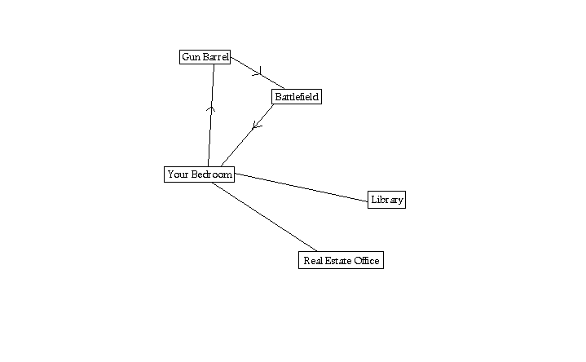

What are the significant objects in your game? What role do they play in the game?

As you examine the key items, they take the player to locations that try him/her with the various difficulties inherent in the path they represent.

Key items:
Textbook – Represents the choice to go to college. Tests willingness to admit ignorance, and to obtain answers to odd or seemingly pointless questions.

Gun – Represents the choice to join the military. Tests willingness to take lives.

Rent contract – Represents the choice to rent a house. Tests willingness to commit to a financial burden.

Non-key items:
Lighter – Used primarily to ignite the gunpowder while in the gun barrel.
Pen – Used to sign the rent contract.

What is the role of non-player characters (NPCs) in your game? Can the player talk with NPCs? If so, how will dialog be implemented (topic keywords, conversation dialogs, etc.)? Do NPCs move around and take action or are they primarily conversational? If NPCs move around and take actions, what do they do?

This varies from NPC to NPC:
The two Japanese people are there to be enemies. As such, you can shoot them, and if you do not, they will eventually shoot you. They do not respond to dialog.
The testing computer asks you questions. It will respond to answers with Correct. or Incorrect. It will not respond to any other interaction.
The real estate agent is basically there just to be there. He will dismiss most dialog and ask the player to sign the contract. However, he does respond differently to a few queries.

What prior stories, story genres, or games will your game reference? If so, how will you leverage the player's prior knowledge in your design?

The story will draw references from various pieces of surreal fiction. Thus, many of the transitions will work in unexpected ways, and the situations will be exaggerated and distorted from realistic versions. However, we do not rely on the player’s knowledge for anything in particular.
(Although there are a couple references to things in the testing computer’s question-answer set, so a player who knows what’s being referred to has a better chance of producing the right answer.)

How will player interaction be integrated into the story structure? Will the player be uncovering a story that already happened? Will the player have an impact on the plot (and if so, how)? What will be the relationship between story and discourse in your game? In describing the interactive story structure of your game, use terminology from the readings from the first half of the class.

While the player is in the item rooms, their actions will determine the character’s affinity for the choice represented by that item. These affinities will then determine the ending.

