COMP303_Assignment4_Screenshots

Liping Wu 300-958-061 4/10/2020

Contents

About the Project 3

Eureka Server: http://localhost:8761/ 3

Job 4

Home http://localhost:8081/ 4

List of all jobs 4

Add a new job 5

Add a new job with Validation 5

Update a job 6

Update a job with Validation 6

A job information details 6

Delete a job 7

Category 8

Home http://localhost:8083/ 8

List of all categories 8

Add a new category 8

Add a new category with Validation 9

Update a category 9

Update a category with Validation 10

A category information details 10

Delete a category 10

Organization 11

HOME http://localhost:8082/ 11

List of all organizations 11

Add a new organization 12

Add a new organization with Validation 12

Update an organization 13

Update an organization with Validation 13

An organization details 14

Delete an organization 14

# About the Project

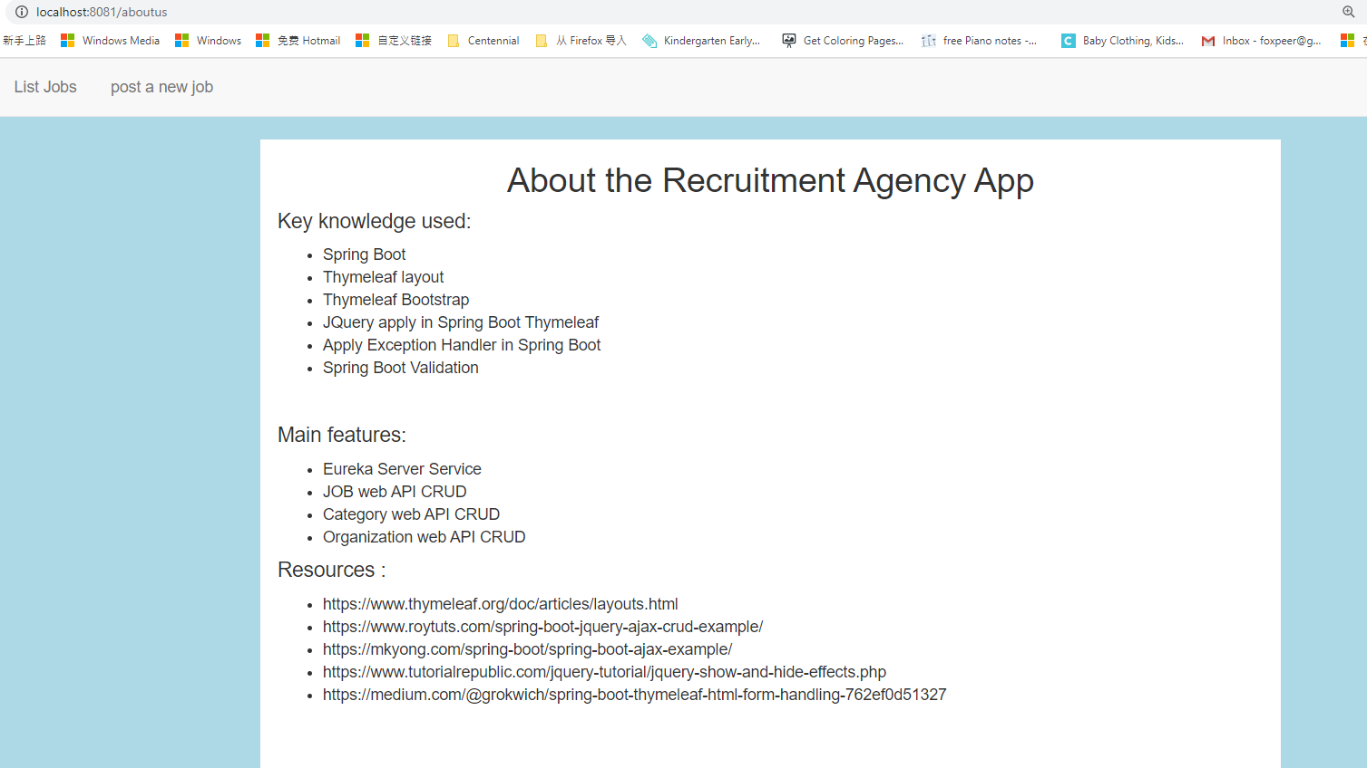

# Eureka Server: <http://localhost:8761/>

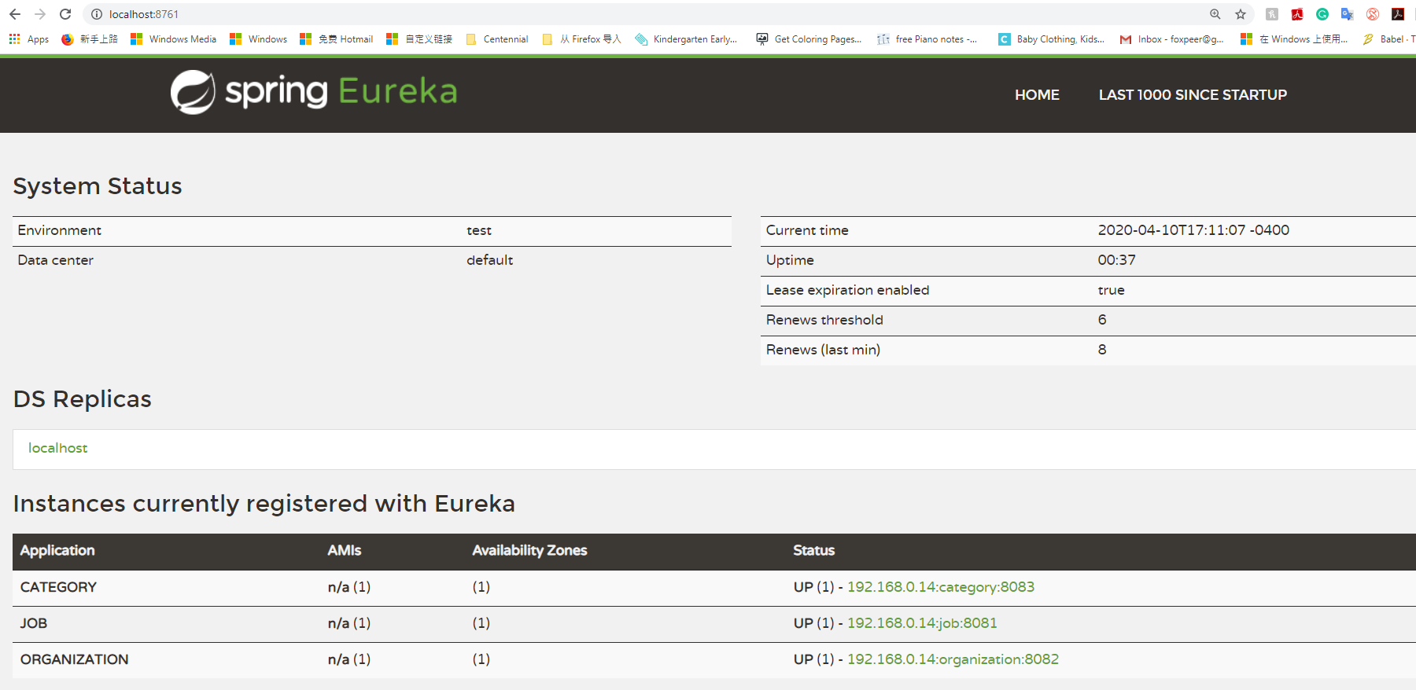

# Job

## Home <http://localhost:8081/>



## List of all jobs

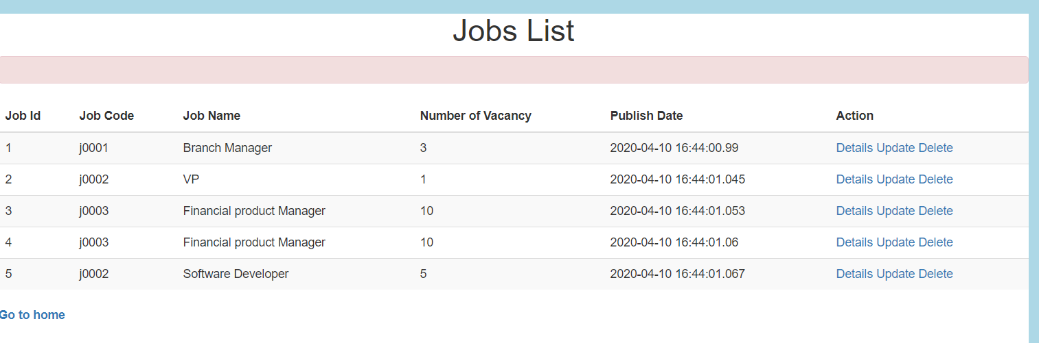

## Add a new job

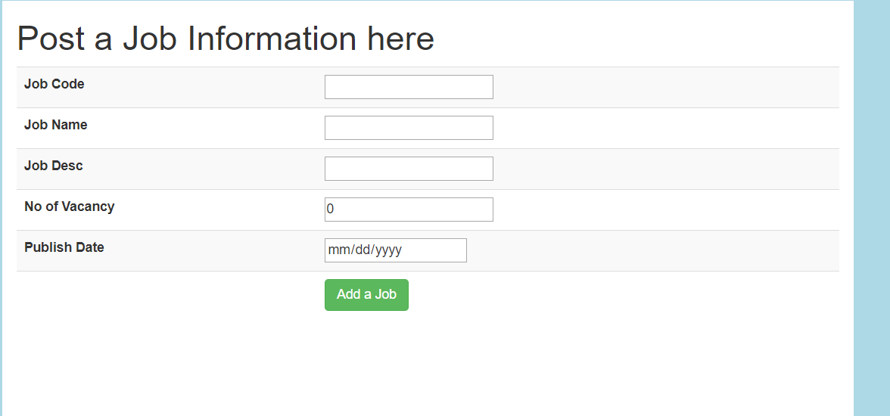

## Add a new job with Validation

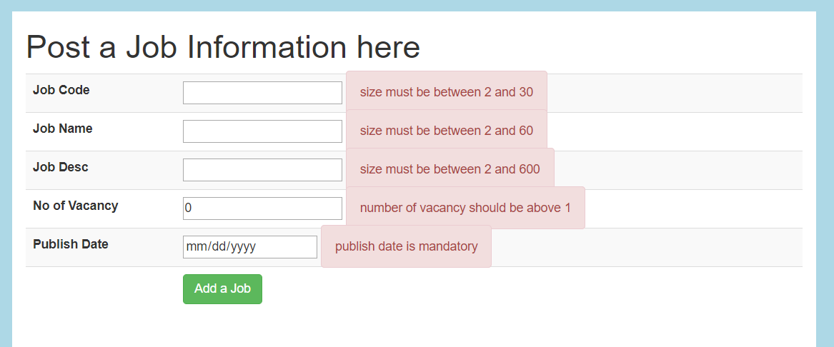

## Update a job

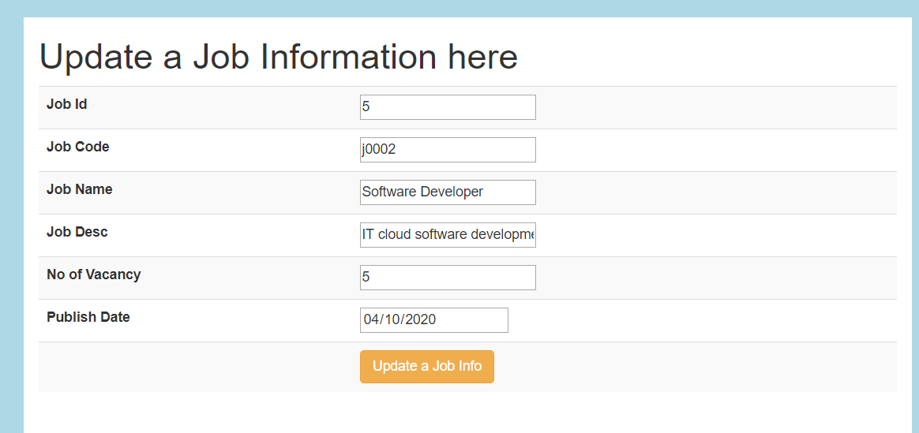

## Update a job with Validation

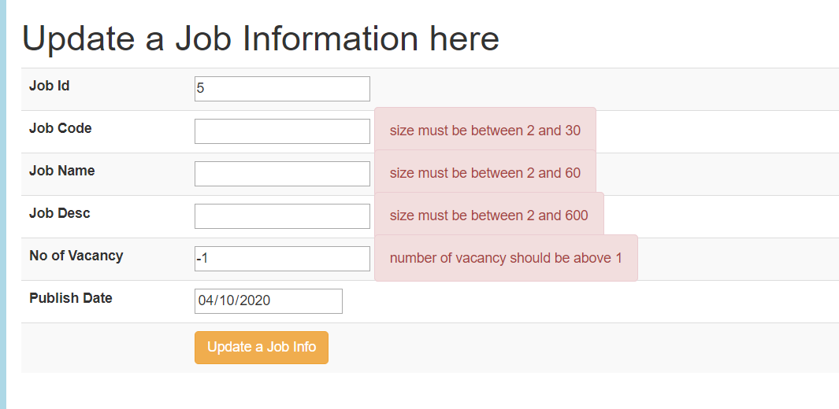

## A job information details

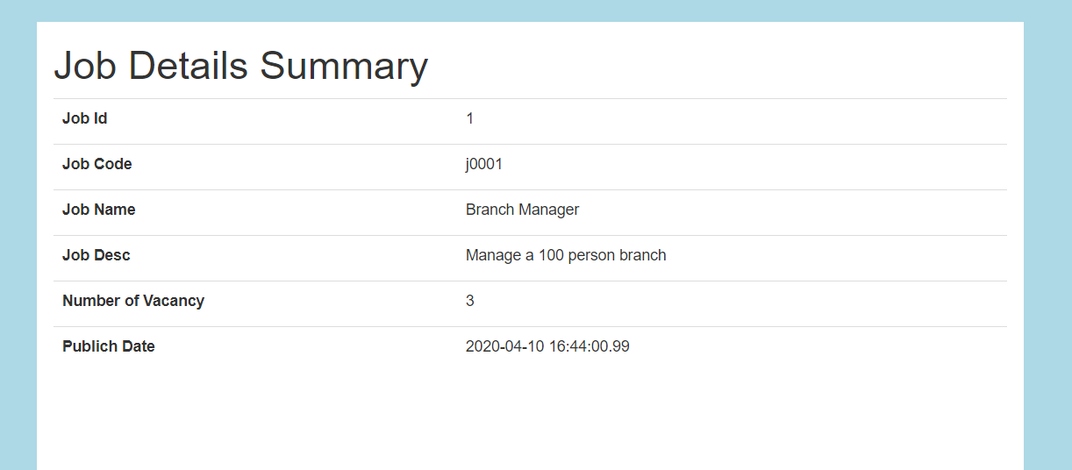

## Delete a job

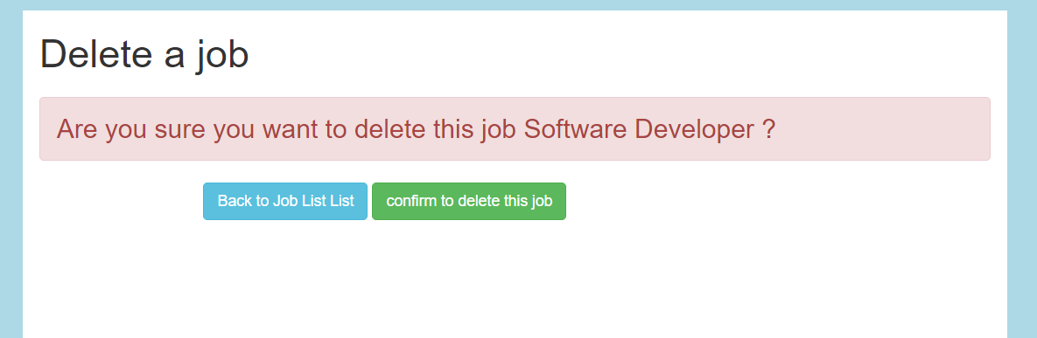

# Category

## Home <http://localhost:8083/>

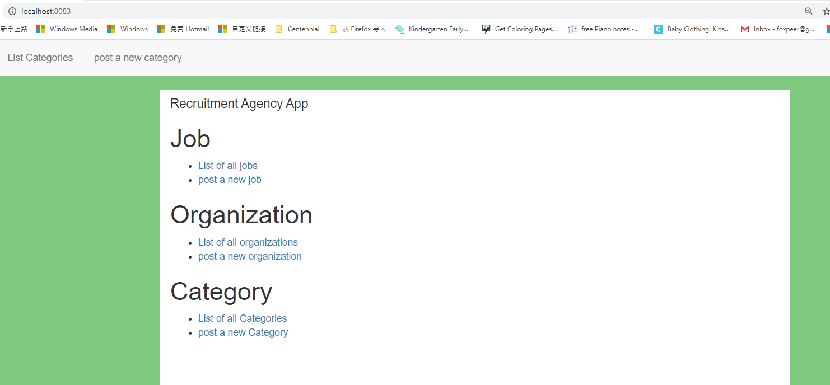

## List of all categories

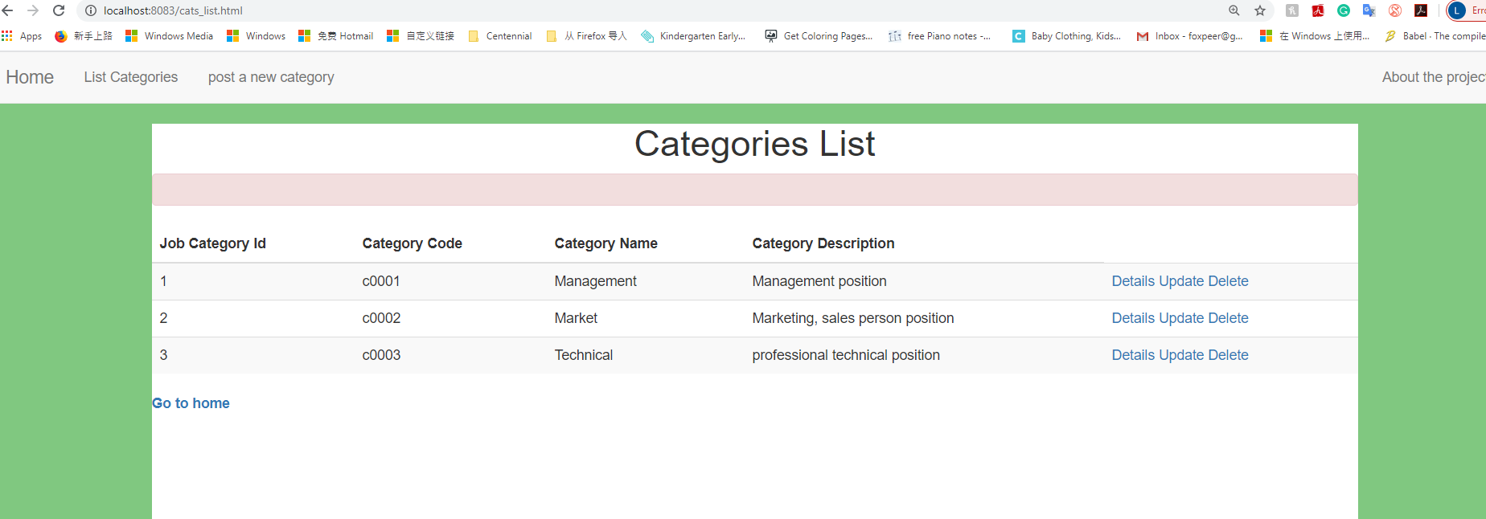

## Add a new category

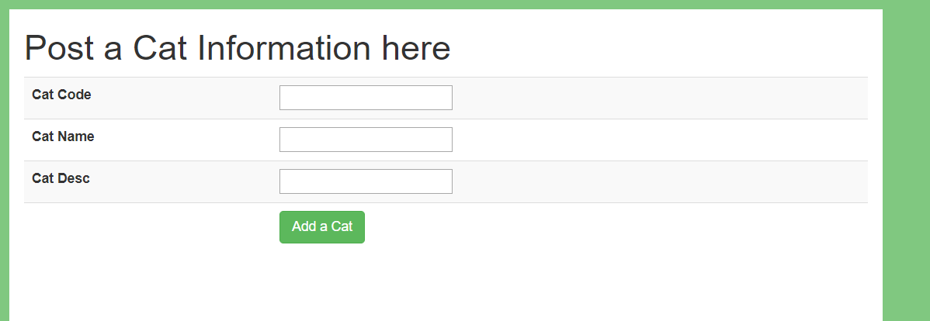

## Add a new category with Validation

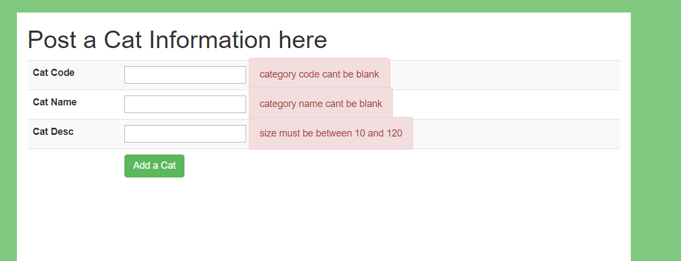

## Update a category

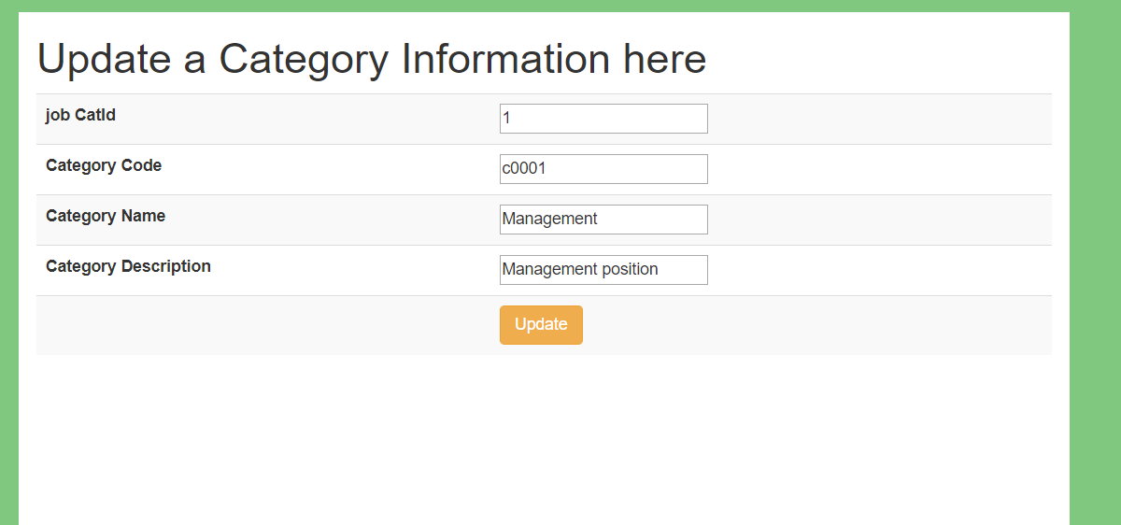

## Update a category with Validation

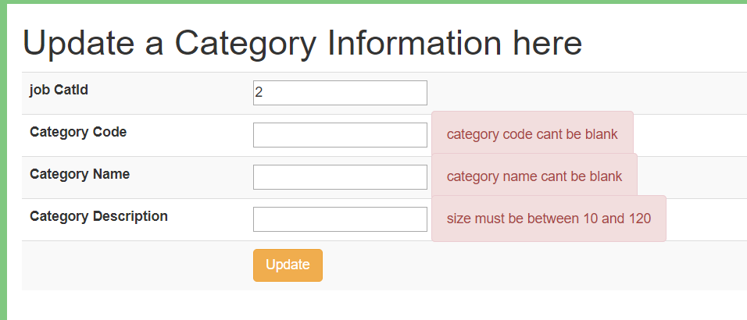

## A category information details

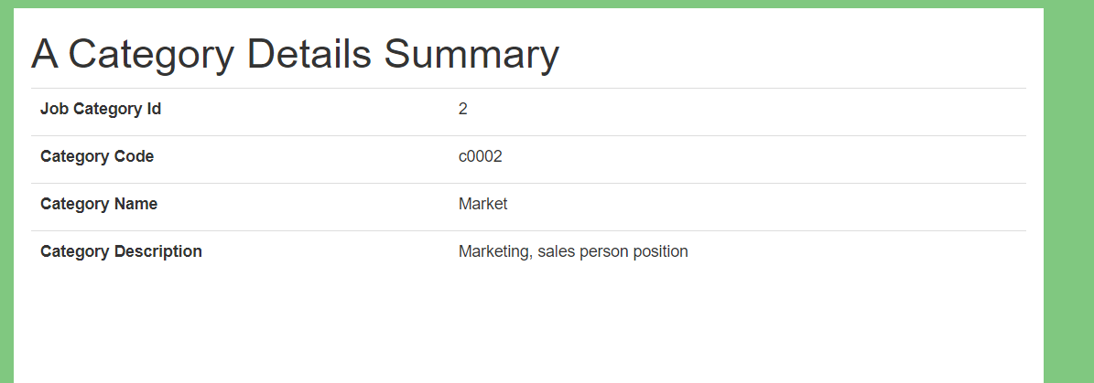

## Delete a category

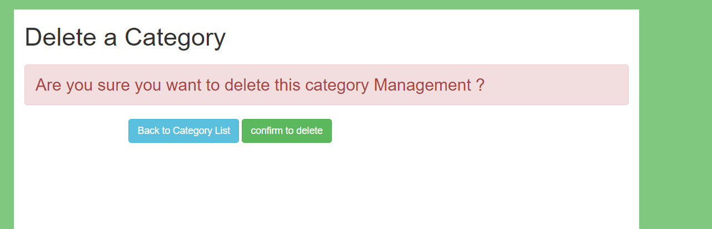

# Organization

## HOME <http://localhost:8082/>

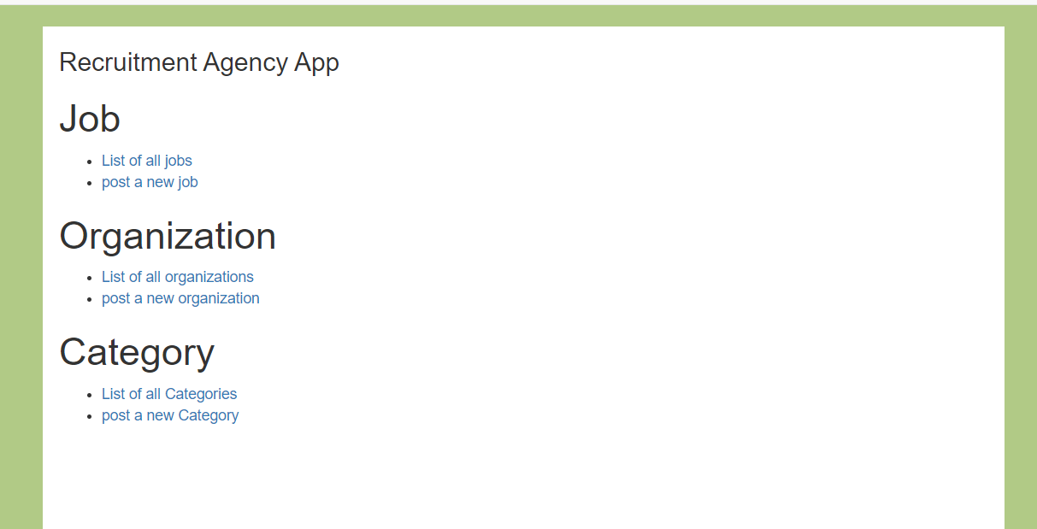

## List of all organizations

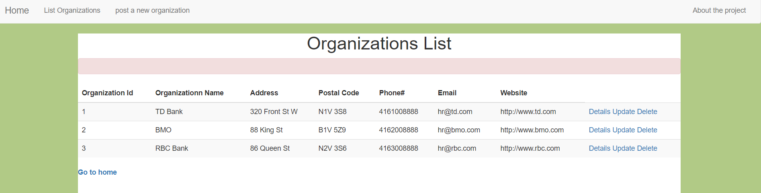

## Add a new organization

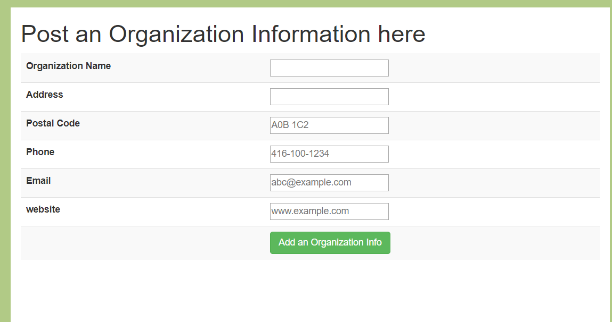

## Add a new organization with Validation

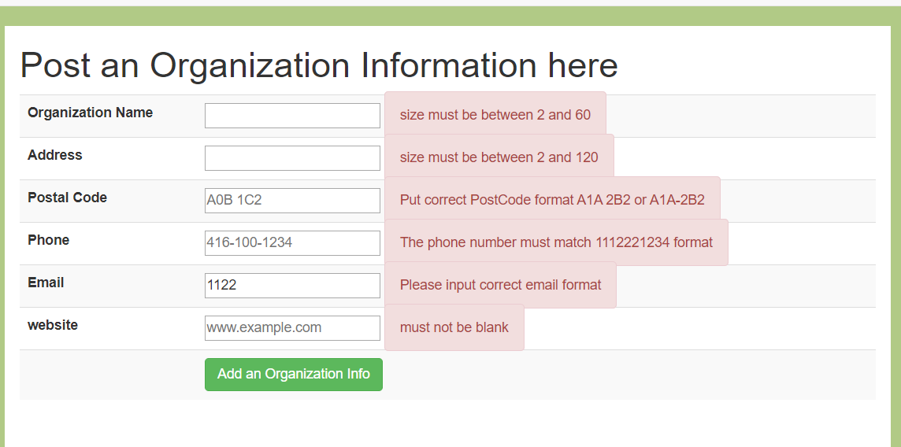

## Update an organization

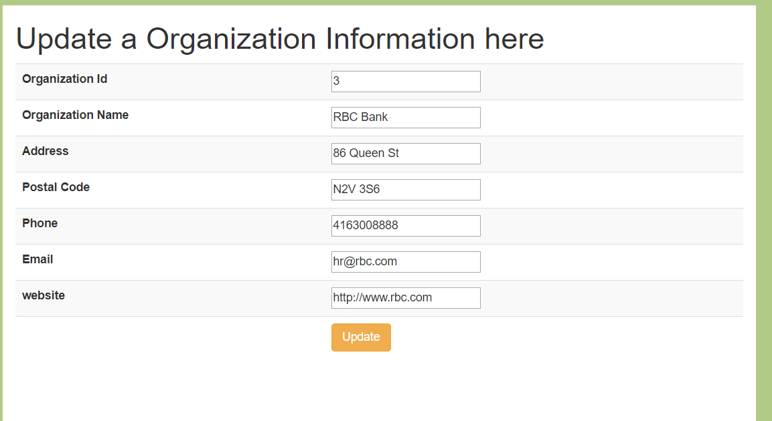

## Update an organization with Validation

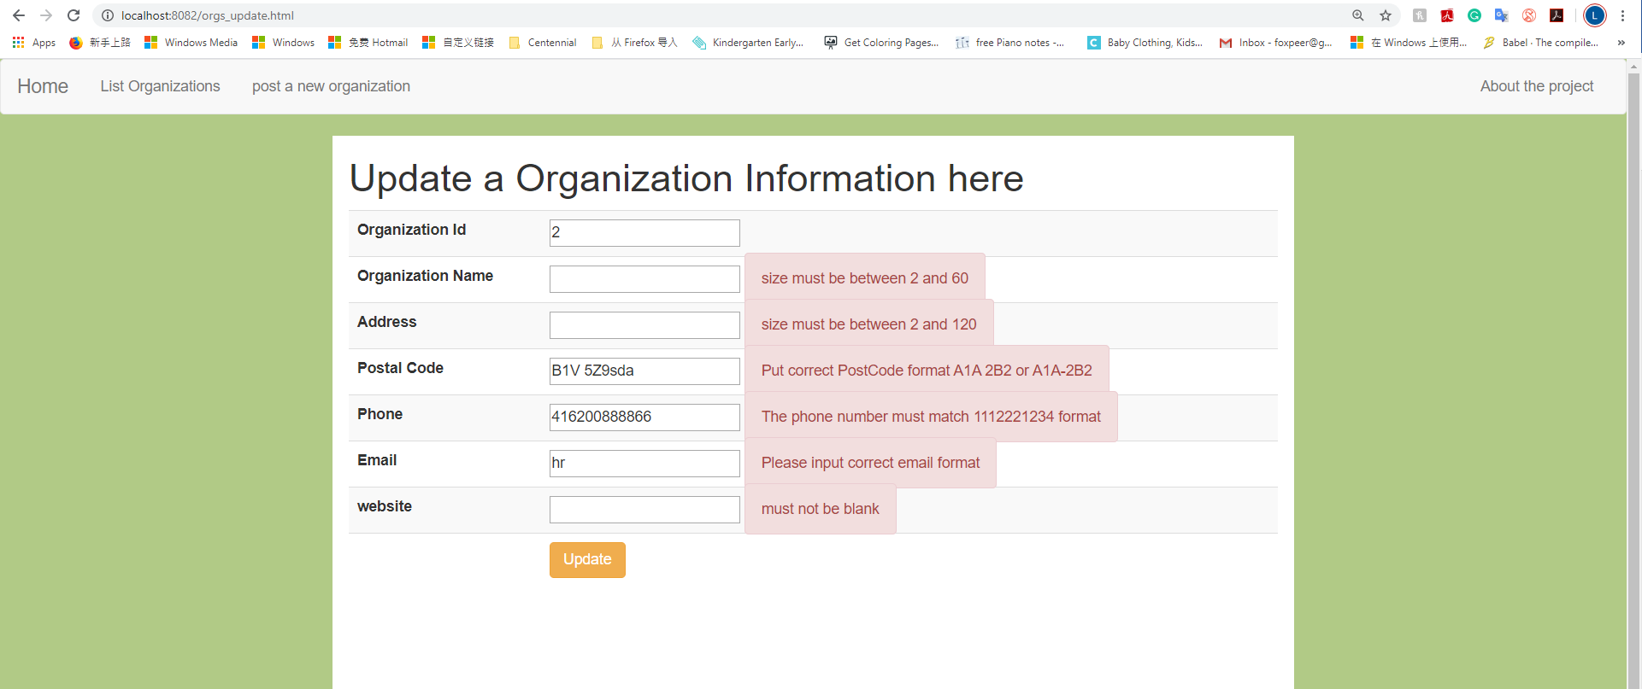

## An organization details

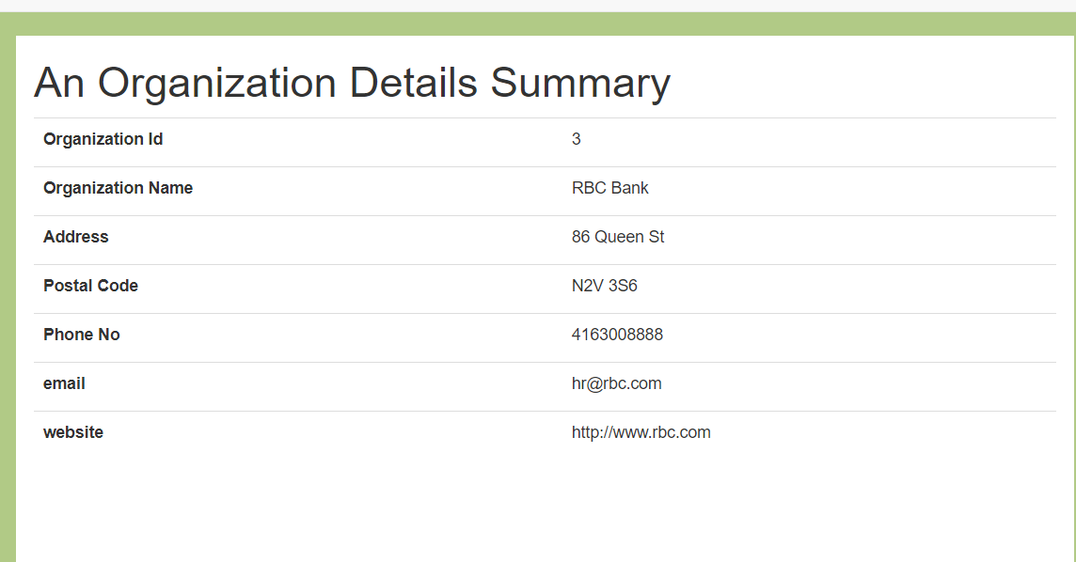

## Delete an organization

