FOXSI POINTING INFO FOR POST-FLIGHT OPTIC CALIBRATIONS

This table lists the centroid location of the FOXSI flare in “payload coordinates” (i.e. each detector’s origin is in its center and the y-axis points toward the top of the payload). These locations do not include our attempt at detector coregistration, which is why they don’t all agree.

The centroids for D1 and D3 are suspect because of an ASIC issue (D1) and the gross misalignment of D3, so I have not included these numbers.

The last column gives our first guess at the mounting misalignment of each optic. These numbers come from an email that Steven sent on Oct 8 2012; they are the result of examination of the laser alignment images. (Steve, you probably want to revisit that analysis if you’re going to use the last column to drive any of the testing.) The numbers in the last column are unsigned; to tell which way each alignment is off requires going back to the alignment images (which could be done if necessary)

.

|  |  |  |  |  |
| --- | --- | --- | --- | --- |
| Detector | Optic | Flare position  (payload coords) [x,y] | Off-axis angle | Optic mounting misalignment (initial guess) |
| D0 | X6 | [+314, +268]” | 6.9 arcmin | 2.18 arcmin |
| D1 | X1 | -- | -- | 0.5 arcmin |
| D2 | X2 | [+353, +258]” | 7.3 arcmin | 1.12 arcmin |
| D3 | X3 | -- | -- | -- |
| D4 | X4 | [+312, +304]” | 7.3 arcmin | 0.54 arcmin |
| D5 | X5 | [+305, +282]” | 6.9 arcmin | 0.72 arcmin |
| D6 | X0 | [+318, +288]” | 7.2 arcmin | 0.66 arcmin |

Below are the flare images for each detector and RHESSI images for comparison. Again, the images for D1 and D3 should not be taken seriously because of their individual issues.

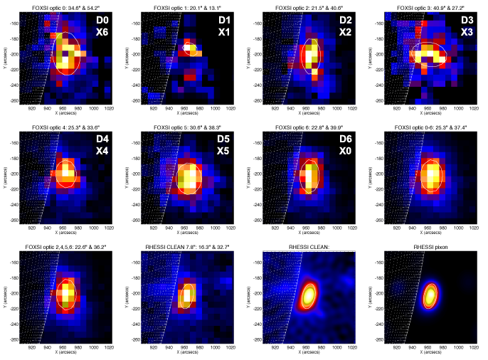

My recommendations for optics to test at the SLF:

If time to test 3 optics, test X4, X5, and X0 (D6) since these detectors have the “best” flare images.

If only time for 2, test X4 and X0 (D6), since they both have good images but show differing source shapes.

If only time for 1, I’d choose X4. For the nonflaring targets D4 measured a significantly higher flux than any of the other detectors (perhaps indicating that it was not so severely affected by blanketing absorption). So this would also be the best pick for the far-off-axis measurement.

Below is an AIA image with the four targets marked. The detectors are clocked differently (intentionally!) with the result that each has a slightly different field of view. The FOVs shown are for D4. The green cross is the approximate position of the flare.

We need to know how stray flux from the flare could affect count rates in target 1. The two questions are (1) how much stray flux do we expect in Target 1 from a source at the green cross, and (2) how even is this stray flux across the FOV of Target 1? I’d suggest taking measurements ranging from 20 to 40 arcminutes off-axis. It would be best if we have some way to relate these flux measurements to the flux at the peak, so perhaps the CZT single-pixel detector would be appropriate for this test. On the other hand, the CCD would give us images (from which we may see features like single-bounce rings, etc). It would also be useful to measure the flux at some intermediate off-axis angles as these will help in analyzing data from Targets 0 and 2.

