Applying a MapReduce framework for Large Data Processing
COEN498 PP Assignment 2 Report

Javier E. Fajardo
Department of Electrical and Computer Engineering
Concordia University
Montréal, Québec, Canada
j_fajard@encs.concordia.ca

Abstract—As memory and storage becomes more affordable, larger sets of data can be created to retain important information. However, extracting information from sets of data may be impractical through conventional computation means. Therefore, cloud computing offers a solution to process increasingly large data sets through different programming paradigms thanks in part to the commoditization of hardware. MapReduce is one such paradigm for data processing that is freely available through the Hadoop framework and is applied broadly as a solution to data processing needs.

Overview
One of the well-known applications of cloud computing is to process large data sets off-site. These sets of data are generally collected over a period of time and would otherwise be impractical to process in a single computer. Through parallel programming frameworks and a network of computers, these data sets can be efficiently processed. One such parallel programming tool is Hadoop, a MapReduce framework enabling submission of data processing jobs across a cluster of computers.
This report focuses on applying the Hadoop Streaming tools to process a large government data set. Specifically, the selected data set is the Canadian airborne radioactivity data over the past eight years. From this set, four statistics were extracted from measures of beryllium concentration in the air across various locations

Technology Selection
The Hadoop Framework is the most prominent set of tools that implement the MapReduce style of parallel computation. While there are alternatives, Hadoop is a mature and highly tested set of tools. However, rather than writing a traditional Hadoop job in Java, the framework’s preferred language, an alternative language was preferred. Through Hadoop Streaming, the framework extends its functionality to any application that can read and write to the standard input/output streams.
Hadoop Streaming enabled writing a Map and Reduce task scripts using Python. This was ultimately the preferred implementation due to issues between Java versions that makes it so that compiled “.jar” files are bound to the version of Hadoop that they were compiled against. Using the Python implementation, the scripts can be run on any computer where Hadoop Streaming is available and Python 3 is installed.

Running the Application
As mentioned previously, the application requires a recent version of Hadoop to be present (installation includes Hadoop Streaming, by default) and a Python 3 version to have been previously installed and available. To run the Hadoop job, simply execute the Hadoop executable with the following parameters:
“hadoop jar $HADOOP_DIR/share/hadoop/tools/lib/hadoop-streaming-2.7.1.jar -input nms_airborne_radioactivity_ssn_radioactivite_dans_air.csv -output output -mapper "python3 map.py" -reducer "python3 reduce.py”
This assumes that the shell variable “$HADOOP_DIR” points to the Hadoop installation directory. The results of the job are placed in the “output” directory, which will be created in the current working directory.
For convenience, a “test.csh” script has been created that can be used to run the Hadoop job on the Concordia servers after executing the “module load hadoop” command. The script essentially runs the command detailed above and places the results in a new “output” directory, as mentioned above.

Algorithm Implementation
The algorithm behind the implemented MapReduce job is remarkably simple. For the mapping step, a simple python script, “map.py”, is used to summarize a row of data in terms of location, date and the Beryllium isotope concentration. The data, being read through standard input, is presented as comma-separated values (CSV). After splitting the data into chunks and placing them in a list, the appropriate columns are selected and then written in a new format to the standard output, where the Hadoop Streaming framework then sorts them and passes them on to Reducer tasks. The mapper can select a specific location, or will process all locations if none are specified.
The Reducer task is more complex. The python script, “reduce.py”, reads the incoming sorted data through standard input and registers the location and date associated to the measurement. At the heart of its functioning is a “Stat” class, which is used to keep track of the minimum, maximum, average, median and standard deviation of the data set per location per year. Every time a new data point for a particular year and a particular location is received, the reducer updates the statistics object immediately. In other words, all statistic data quantities are calculated as the data stream is being received. When a location or year is registered that is not currently being tracked, the previous statistic object is printed to standard output and a new one is created. This indicates that the processing for a particular year and location is finalized.

Trace-Based Profiling
In order to measure the performance of the Map and Reduce tasks, certain Python tools were used to measure time and produce appropriate logs. Logs in Hadoop Streaming must be written to through the operating system’s standard error output stream in order to be registered by the Hadoop Framework as logs and not an active data segment.
When either task starts, the time in milliseconds is saved. The precision of this recorded time is dependent on the system’s clock granularity. Immediately before either task finishes, the elapsed time is calculated in milliseconds. This is then formatted and printed to the error output.
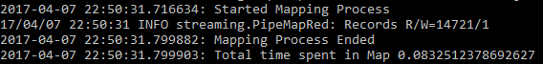
Figure 1: Map Task Log to Hadoop Streaming

Figure 2: Reduce Task Log to Hadoop Streaming

According to the collected logs after several repeated executions of the job, the Map task seems to take the longest of the two when a specific location has been chosen. The total execution time for the map task was approximately 90 milliseconds on average compared to 2 milliseconds for the reduce task. In contrast, when processing all locations, both the mapper and the reducer are roughly equivalent. The map task reports approximately 100 milliseconds with the reduce task taking up to 110 milliseconds.

Sample Output
The result output of the Hadoop Job is presented through screenshots. For better presentation outputs have been word-wrapped
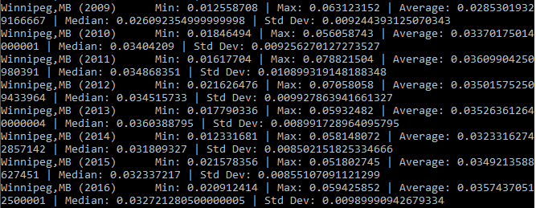
Figure 3: Winnipeg, MB Airborne Beryllium Data

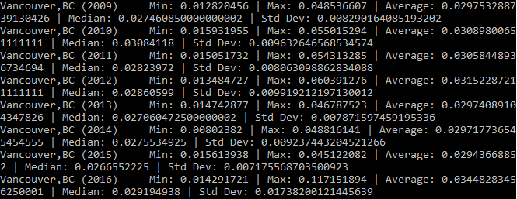
Figure 4: Vancouver, BC Airborne Beryllium Data

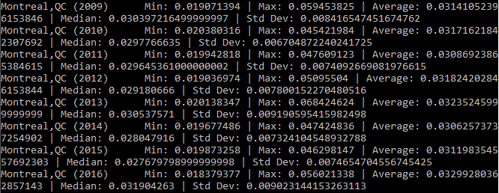
Figure 5: Montréal, QC Airborne Beryllium Data

