Cab Booking System - Phan Tich Va Thiet Ke He Thong

1. Muc tieu he thong
He thong Cab Booking System duoc thiet ke theo kien truc microservices de phuc vu 3 nhom nguoi dung:
- Customer App: tao booking, theo doi trang thai chuyen di, xem thong bao va danh gia.
- Driver App: nhan de nghi chuyen, cap nhat trang thai, hoan tat chuyen di.
- Admin Dashboard: quan sat he thong, tong hop du lieu van hanh, quan ly driver.
He thong backend duoc tach thanh cac service chuyen trach, moi service so huu database rieng hoac tap du lieu rieng. API Gateway dong vai tro diem vao duy nhat cho HTTP va Socket.IO realtime.

2. Kien truc tong the

2.1 Thanh phan chinh
- API Gateway: xac thuc JWT, route request, Socket.IO hub, fan-out realtime event.
- Auth Service: quan ly dinh danh, dang nhap, vai tro, refresh token.
- User Service: quan ly profile nguoi dung.
- Driver Service: quan ly ho so tai xe, thong tin xe, tinh san sang, vi tri.
- Booking Service: tao va xac nhan booking.
- Ride Service: quan ly state machine cua chuyen di va workflow matching.
- Pricing Service: tinh gia, he so surge, co the goi AI Service de du doan.
- Payment Service: quan ly fare, payment, refund, outbox event.
- Notification Service: luu lich su thong bao va xu ly kenh gui bat dong bo.
- Review Service: luu review va thong ke danh gia.
- AI Service: du doan ETA va he so gia.

2.2 So do kien truc he thong
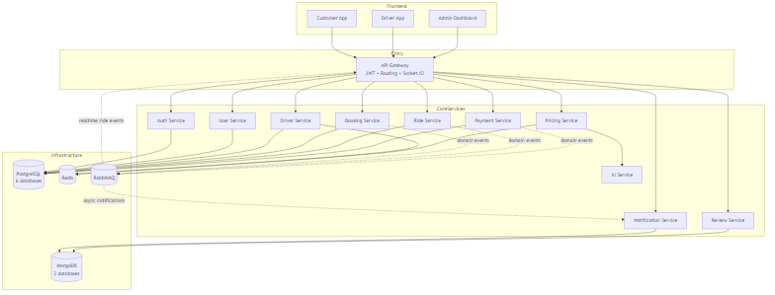

2.3 Nguyen tac thiet ke
- Moi microservice so huu du lieu rieng, khong join truc tiep cross-database.
- API Gateway la realtime hub duy nhat cho customer, driver, admin.
- Ride Service so huu hoan toan workflow matching va ride state machine.
- Driver Service chi so huu driver data, availability va nearby search; khong so huu matching orchestration.
- Auth Service so huu identity, JWT, role; User Service chi so huu profile.
- Cac lien ket giua database chu yeu la lien ket logic theo ID, khong phai foreign key xuyen service.

2.4 Chuc nang hien tai cua he thong
Phan nay mo ta he thong hien dang lam duoc gi theo implementation hien co, khong chi theo y tuong thiet ke.

2.4.1 Chuc nang theo vai tro nguoi dung

A. Customer
Customer hien co the:
- Dang ky tai khoan CUSTOMER.
- Dang nhap, refresh token, xem thong tin tai khoan hien tai.
- Tao booking voi diem don, diem tra, loai xe, phuong thuc thanh toan.
- Xac nhan booking va huy booking.
- Lay uoc tinh gia truoc khi dat xe.
- Tao ride truc tiep hoac nhan ride duoc tao tu booking da xac nhan.
- Theo doi ride hien tai va lich su ride.
- Nhan realtime update qua API Gateway Socket.IO khi ride duoc assign, accepted, picking up, started, completed, cancelled.
- Tao profile trong User Service va xem profile theo userId .
- Xem lich su notification.
- Tao review cho driver sau chuyen di.
- Xem top rated drivers va thong ke review cua driver.

B. Driver
Driver hien co the:
- Dang ky tai khoan DRIVER qua Auth Service.
- Tao ho so driver trong Driver Service.
- Xem profile driver hien tai.
- Chuyen trang thai online / offline.
- Cap nhat vi tri hien tai.
- Xem danh sach available rides o che do browse.
- Nhan offer ride / notification ride moi qua Socket.IO hub tai API Gateway.
- Accept ride tu danh sach available rides hoac accept offer danh rieng.
- Reject offer ride.
- Xem assigned ride hien tai.
- Chuyen ride qua cac moc nghiep vu: accept, pickup, start, complete.
- Xem lich su ride cua minh.
- Xem driver earnings qua Payment Service.

C. Admin
Admin hien co the:
- Dang nhap voi role ADMIN.
- Xem danh sach user trong Auth Service.
- Cap nhat role cua user.
- Xem dashboard thong ke tong hop tu Gateway aggregation route.
- Xem danh sach rides toan he thong.
- Xem danh sach drivers da duoc normalize kem thong tin user.
- Xem danh sach customers.
- Xem danh sach payments va payment stats.
- Trigger refund theo ride.
- Xem logs placeholder endpoint.
- Set hoac tinh surge multiplier trong Pricing Service thong qua API backend.

2.4.2 Chuc nang theo service backend

A. API Gateway
API Gateway hien dang dam nhan cac chuc nang sau:
- Health check cho chinh gateway va tong hop health check cua cac service backend.
- Authentication middleware cho request di qua gateway.
- Proxy route den cac service: /api/auth /api/rides /api/drivers /api/payments /api/bookings /api/pricing /api/users /api/reviews /api/notifications
- Swagger API documentation tai /api-docs .
- Admin aggregation routes tai /api/admin .
- Map helper endpoints: Geocode dia chi. Reverse geocode tu lat/lng ra dia chi. Route calculation thong qua OSRM. POI lookup co cache Redis.
- Socket.IO realtime hub duy nhat cua he thong.
- RabbitMQ event consumer de: fan-out ride lifecycle events. day thong bao ride moi den driver. dong bo realtime update cho customer va driver.

B. Auth Service
Auth Service hien dang ho tro:
- POST /register : dang ky user moi voi role CUSTOMER hoac DRIVER.
- POST /login : dang nhap va cap access token + refresh token.
- POST /refresh : cap token moi.
- POST /logout : dang xuat.
- GET /me : lay thong tin user hien tai.
- POST /verify : verify token phuc vu internal service call.
- GET /users : admin xem danh sach user.
- PATCH /users/:userId/role : admin doi role user.
Gia tri nghiep vu hien tai cua Auth Service:
- La nguon su that cho identity, role, status.
- Cung cap user list cho admin aggregation.
- Cung cap token verification cho cac service khac.

C. User Service
User Service hien dang co pham vi hep va ro:
- POST /api/users : tao profile user.
- GET /api/users/:userId : lay profile theo user.
No khong so huu login, role, token, ma chi so huu profile metadata.

D. Driver Service
Driver Service hien dang ho tro:
- Dang ky driver profile.
- Lay driver profile hien tai.
- Driver online / offline.
- Cap nhat vi tri.
- Lay available rides cho driver.
- Driver accept ride.
- Lay assigned ride hien tai.
- Tim nearby drivers (noi bo / admin).
- Lay toan bo driver cho admin.
- Verify driver profile.
- Lay driver theo userId de phuc vu internal mapping.
Gia tri nghiep vu hien tai:
- Quan ly source of truth cho vehicle, license, availability.
- Ho tro geo-query qua Redis cho bai toan nearby drivers.
- Cung cap du lieu driver cho admin dashboard va gateway realtime resolution.

E. Booking Service
Booking Service hien dang ho tro:
- Tao booking.
- Confirm booking.
- Cancel booking.
- Lay booking theo bookingId .
- Lay danh sach booking cua customer.
Gia tri nghiep vu hien tai:
- Luu yeu cau dat xe truoc khi ride duoc matching.
- Lam aggregate truoc ride trong flow customer booking.

F. Ride Service
Ride Service la service nghiep vu trung tam hien tai, dang ho tro:
- Tao ride.
- Tao ride tu booking.
- Lay ride theo rideId .
- Lay customer ride history va active ride.
- Lay driver ride history va active ride.
- Lay available rides cho driver browse.
- Driver accept ride.
- Driver reject ride.
- Driver start ride.
- Driver mark picked up.
- Driver complete ride.
- Cancel ride.
- Internal assign driver.
- Accept offer / reject offer.
- Admin ride stats.
- Admin get all rides.
Gia tri nghiep vu hien tai cua Ride Service:
- So huu state machine ride tu CREATED den COMPLETED / CANCELLED .
- So huu matching workflow event-driven: ride.finding_driver_requested ride.reassignment_requested ride.offered ride.assigned ride.offer_timeout
- Theo doi offered drivers, rejected drivers, reassign attempts.
- Ghi lich su state transition qua bang RideStateTransition .

G. Pricing Service
Pricing Service hien dang ho tro:
- POST /estimate : tinh gia uoc tinh theo diem don/tra va loai xe.
- GET /surge : lay he so surge hien tai.
- POST /surge : cap nhat surge multiplier.
- POST /surge/calculate : tinh surge dong theo active rides, available drivers, thoi gian.
Gia tri nghiep vu hien tai:
- Co fallback tinh gia deterministic.
- Co the goi AI Service de enrich ETA va price_multiplier .
- Luu/lay gia tri surge qua Redis.

H. Payment Service
Payment Service hien dang ho tro:
- Tao card payment intent.
- Nhan mock webhook payment.
- Lay payment theo ride ID.
- Lay lich su payment cua customer.
- Lay driver earnings.
- Admin get all payments.
- Admin payment stats.
- Refund payment theo ride.
- Lay danh sach payment methods.
Gia tri nghiep vu hien tai:
- Quan ly bang Fare va Payment tach rieng.
- Ho tro nhieu provider / method o muc schema va service logic.
- Su dung outbox pattern cho event reliability.

I. Notification Service
Notification Service hien dang ho tro:
- Lay notification cua user.
- Gui custom notification.
- Retry failed notifications.
- Lay thong ke notification.
Gia tri nghiep vu hien tai:
- Luu lich su notification trong MongoDB.
- Ho tro nhieu kenh: EMAIL, SMS, PUSH, IN_APP.
- Theo doi retry, status, priority.

J. Review Service
Review Service hien dang ho tro:
- Tao review.
- Lay review received theo user.
- Lay review given theo user.
- Lay review theo ride.
- Lay review stats theo user.
- Lay driver stats.
- Cap nhat review.
- Xoa review.
- Lay top rated drivers.
Gia tri nghiep vu hien tai:
- Ho tro review hai chieu: customer -> driver, driver -> customer.
- Chan duplicate review tren cung ride bang unique compound index.
- Co thong ke rating distribution va top drivers.

K. AI Service
AI Service hien dang ho tro:
- GET /api/health : kiem tra tinh san sang.
- POST /api/predict : du doan ETA va price_multiplier .
- GET /api/stats : tra ve thong tin model/service.
Gia tri nghiep vu hien tai:
- Dong vai tro optional estimator cho Pricing Service.
- Khong so huu ride lifecycle, matching, payment state.

2.4.3 Chuc nang realtime hien tai
He thong realtime hien tai dang ho tro cac capability sau:
- Driver nhan NEW_RIDE_AVAILABLE tu API Gateway.
- Customer nhan RIDE_STATUS_UPDATE khi ride duoc assigned, accepted, picking up, in progress, cancelled.
- Customer nhan RIDE_COMPLETED khi ride hoan tat.
- Driver nhan ride:status , ride:cancelled , ride:timeout theo nguyen tac fan-out tu gateway.
- API Gateway tieu thu RabbitMQ event va resolve driver socket recipient qua driver/user mapping.

2.4.4 Chuc nang theo luong nghiep vu lon

Luong 1: Dang ky va xac thuc
- User dang ky CUSTOMER hoac DRIVER.
- User dang nhap nhan JWT.
- He thong cho phep refresh token, logout, get current user.

Luong 2: Dat xe va tao booking
- Customer gui diem don/tra va yeu cau xe.
- Pricing Service tra gia uoc tinh.
- Booking Service tao booking.
- Booking duoc confirm de chuyen sang flow ride.

Luong 3: Matching va nhan chuyen
- Ride Service tao ride va phat matching events.
- API Gateway nhan event, tim driver online phu hop va day realtime offer.
- Driver co the accept / reject offer.
- Khi timeout, he thong tu dong reassign den driver khac theo danh sach exclude.

Luong 4: Van hanh chuyen di
- Ride duoc assign.
- Driver accept ride.
- Driver danh dau picking up.
- Driver start ride.
- Driver complete ride.
- Toan bo qua trinh duoc ghi lai trong RideStateTransition .

Luong 5: Thanh toan
- He thong tao payment intent cho card flow.
- He thong luu fare, payment status, payment metadata.
- He thong ho tro refund va thong ke doanh thu.

Luong 6: Hau mai sau chuyen di
- Notification Service luu va cung cap thong bao.
- Review Service luu danh gia sau chuyen di.
- Admin co the xem tong hop rides, drivers, customers, payments, stats.

2.4.5 Muc do hoan thien hien tai
Nhung gi da co ro rang trong codebase hien tai:
- Auth flow backend hoan chinh.
- Booking -> pricing -> ride flow co the test end-to-end.
- Ride state machine va offer timeout / reassignment da duoc test.
- Payment schema va API admin/customer chinh da ton tai.
- Notification va review API da co CRUD / statistics co ban.
- Admin aggregation o Gateway da co route tong hop thuc te.
- Map support va Swagger docs da co.
Nhung thanh phan hien nghien ve tang ho tro hon la nghiep vu khach hang cuoi:
- AI Service hien moi lam bo sung du doan cho pricing.
- Notification Service dang manh ve persistence va async channel, khong phai realtime hub.
- Mot so admin endpoint nhu logs moi o muc placeholder.

3. Ban do service va database
Service | DB / Storage | Bang / Collection chinh | Muc dich
Auth Service | auth_db | users , refresh_tokens | Identity, role, token
User Service | user_db | user_profiles | Profile nguoi dung
Driver Service | driver_db + Redis | drivers | Ho so tai xe, availability, vi tri
Booking Service | booking_db | Booking | Yeu cau dat xe
Ride Service | ride_db | Ride , RideStateTransition | Trang thai chuyen di, matching
Payment Service | payment_db | Fare , Payment , OutboxEvent | Thanh toan va event publishing
Notification Service | notification_db | Notification | Lich su thong bao
Review Service | review_db | Review | Danh gia hai chieu
Pricing Service | Redis | key-value surge / cache | Gia, cache, optional AI enrich

4. Cau truc database chi tiet

4.1 auth_db

Bang users
Nhom thuoc tinh | Cot chinh | Y nghia
Dinh danh | id , email , phone | Dinh danh va thong tin dang nhap cua user
Bao mat | password_hash | Mat khau da bam de xac thuc
Phan quyen | role , status | Xac dinh user la customer, driver hay admin va tinh trang tai khoan
Ho so co ban | first_name , last_name , avatar | Thong tin hien thi nhanh ngay trong Auth Service
Audit | created_at , updated_at | Theo doi thoi diem tao va cap nhat
Thuoc tinh can nho nhat trong bang nay la email, password_hash, role, status va id; cac field profile chi o muc co ban.

Bang refresh_tokens
Nhom thuoc tinh | Cot chinh | Y nghia
Dinh danh token | id , token_id | Dinh danh duy nhat cho moi refresh token
So huu | user_id | Lien ket den user so huu token
Vong doi | expires_at , revoked_at | Quan ly han su dung va revoke
Thiet bi truy cap | device_info , ip_address | Luu vet nguon dang nhap
Audit | created_at | Thoi diem tao token

Lien ket vat ly
- refresh_tokens.user_id -> users.id la foreign key co onDelete: Cascade .

4.2 user_db

Bang user_profiles
Nhom thuoc tinh | Cot chinh | Y nghia
Dinh danh | id , user_id | Tach profile ra khoi identity cua Auth Service
Thong tin ca nhan | first_name , last_name , phone , avatar | Ho so hien thi cua nguoi dung
Trang thai profile | status | Kiem soat profile o tang nghiep vu
Audit | created_at , updated_at | Theo doi lich su cap nhat

Lien ket logic
- user_profiles.user_id tham chieu logic den auth_db.users.id .
- Khong co foreign key vat ly do khac database/service.

4.3 driver_db

Bang drivers
Nhom thuoc tinh | Cot chinh | Y nghia
Dinh danh | id , user_id | Lien ket driver profile voi auth user
Phe duyet va san sang | status , availability_status | Cho biet driver da duoc duyet chua va co dang online/ban hay khong
Thong tin xe | vehicle_type , vehicle_brand , vehicle_model , vehicle_plate , vehicle_color , vehicle_year | Bo thuoc tinh mo ta phuong tien phuc vu matching va hien thi
Giay phep | license_number , license_expiry_date , license_verified | Ho tro xac minh hop le tai xe
Danh gia | rating_average , rating_count | Phuc vu xep hang va hien thi chat luong driver
Van hanh | current_ride_id , last_location_lat , last_location_lng , last_location_time | Theo doi ride hien tai va vi tri cuoi
Audit | created_at , updated_at | Theo doi cap nhat ban ghi
Bang nay co nhieu field nhat vi no gom ca profile tai xe, phuong tien, xac minh va du lieu van hanh.

Lien ket logic
- drivers.user_id -> auth_db.users.id .
- drivers.current_ride_id -> ride_db.Ride.id .
- Redis duoc dung bo tro geo-index va presence, khong thay the du lieu goc trong PostgreSQL.

4.4 booking_db

Bang Booking
Nhom thuoc tinh | Cot chinh | Y nghia
Dinh danh | id , customerId | Xac dinh booking thuoc ve ai
Diem don va diem tra | pickupAddress , pickupLat , pickupLng , dropoffAddress , dropoffLat , dropoffLng | Du lieu dau vao co ban cua yeu cau dat xe
Lua chon dich vu | vehicleType , paymentMethod , notes , customerPhone | Tuy chon cua khach hang khi dat xe
Uoc tinh gia | estimatedFare , estimatedDistance , estimatedDuration , surgeMultiplier | Snapshot ket qua pricing tai thoi diem booking
Trang thai | status , confirmedAt , cancelledAt | Quan ly booking tu pending den confirmed/cancelled
Audit | createdAt , updatedAt | Theo doi thoi diem tao va cap nhat

Lien ket logic
- Booking.customerId -> auth_db.users.id .
- Sau khi booking CONFIRMED , Booking Service kich hoat quy trinh tao ride va matching.

4.5 ride_db

Bang Ride
Nhom thuoc tinh | Cot chinh | Y nghia
Dinh danh va vai tro | id , customerId , driverId , acceptedDriverId | Xac dinh ai tao ride va ai la driver cuoi cung
Trang thai nghiep vu | status , cancelReason , cancelledBy | Dieu khien state machine cua ride
Cau hinh chuyen di | vehicleType , paymentMethod | Lua chon xe va cach thanh toan
Hanh trinh | pickupAddress , pickupLat , pickupLng , dropoffAddress , dropoffLat , dropoffLng | Thong tin diem don, diem tra
Gia tri chuyen di | distance , duration , fare , surgeMultiplier | So lieu tinh cuoc va tong hop ride
Matching | suggestedDriverIds , offeredDriverIds , rejectedDriverIds , reassignAttempts | Theo doi qua trinh tim tai xe
Moc thoi gian | requestedAt , offeredAt , assignedAt , acceptedAt , pickupAt , startedAt , completedAt , cancelledAt | Ghi lai tung moc chinh cua vong doi ride
Audit | createdAt , updatedAt | Theo doi cap nhat ban ghi
Day la bang trung tam cua he thong nen du lieu vua phuc vu nghiep vu ride, vua phuc vu matching, vua phuc vu bao cao lich su.

Bang RideStateTransition
Nhom thuoc tinh | Cot chinh | Y nghia
Dinh danh | id , rideId | Xac dinh transition thuoc ride nao
Chuyen trang thai | fromStatus , toStatus | Luu vet state machine
Tac nhan | actorId , actorType , reason | Cho biet ai gay ra thay doi va vi sao
Thoi gian | occurredAt | Moc audit cua transition

Lien ket vat ly va logic
- RideStateTransition.rideId -> Ride.id la foreign key vat ly.
- Ride.customerId -> auth_db.users.id la lien ket logic.
- Ride.driverId va Ride.acceptedDriverId gan voi driver identity trong domain driver; realtime layer can resolve sang auth user de emit socket event.

4.6 payment_db

Bang Fare
Nhom thuoc tinh | Cot chinh | Y nghia
Dinh danh | id , rideId | Moi ride co mot snapshot fare
Cau thanh gia | baseFare , distanceFare , timeFare , surgeMultiplier | Cac thanh phan tinh cuoc
Tong hop | totalFare , distanceKm , durationMinutes , currency | Ket qua tinh cuoc va don vi tien
Audit | createdAt , updatedAt | Theo doi thoi diem cap nhat

Bang Payment
Nhom thuoc tinh | Cot chinh | Y nghia
Dinh danh giao dich | id , rideId , customerId , driverId | Xac dinh giao dich gan voi ride va cac ben lien quan
Gia tri thanh toan | amount , currency , method , provider , status | Noi dung cot loi cua payment
Tich hop cong thanh toan | transactionId , paymentIntentId , paymentMethodId , clientSecret , idempotencyKey | Du lieu can cho Stripe/mock/provider
Mo rong va xu ly loi | gatewayResponse , metadata , failureReason | Luu response va nguyen nhan loi
Moc thoi gian | initiatedAt , completedAt , failedAt , refundedAt , createdAt , updatedAt | Vong doi cua giao dich

Bang OutboxEvent
Nhom thuoc tinh | Cot chinh | Y nghia
Dinh danh su kien | id , eventType , correlationId | Nhan dien event nghiep vu
Noi dung | payload | JSON string can publish sang he thong khac
Trang thai publish | createdAt , publishedAt | Cho biet event da duoc day di hay chua

Lien ket vat ly va logic
- Payment.rideId tham chieu vat ly den Fare.rideId theo quan he 1-1.
- Fare.rideId va Payment.rideId lien ket logic den ride_db.Ride.id .
- Payment.customerId -> auth_db.users.id , Payment.driverId -> driver identity logic.

4.7 notification_db (MongoDB)

Collection notifications
Nhom thuoc tinh | Field chinh | Y nghia
Doi tuong nhan | userId , recipient | Xac dinh thong bao gui cho ai
Loai va muc uu tien | type , priority | Chon kenh gui va muc quan trong
Noi dung | subject , message , metadata | Phan than thong bao
Trang thai xu ly | status , sentAt , failureReason , retryCount | Theo doi gui thanh cong/that bai
Audit | createdAt , updatedAt | Theo doi ban ghi

Index quan trong
- { createdAt: -1 }
- { userId: 1, createdAt: -1 }
- { status: 1, priority: -1 }

4.8 review_db (MongoDB)

Collection reviews
Nhom thuoc tinh | Field chinh | Y nghia
Nguon review | rideId , bookingId , type | Xac dinh review nay phat sinh tu chuyen nao va theo huong nao
Nguoi viet | reviewerId , reviewerName | Chu the tao danh gia
Nguoi duoc danh gia | revieweeId , revieweeName | Doi tuong nhan review
Noi dung danh gia | rating , comment , tags | Diem va nhan xet chi tiet
Audit | createdAt , updatedAt | Theo doi lich su ban ghi

Index quan trong
- { revieweeId: 1, createdAt: -1 }
- { reviewerId: 1, createdAt: -1 }
- { rating: -1 }
- Unique compound index { rideId: 1, reviewerId: 1 }

4.9 Cau truc du lieu Redis va du lieu tam thoi
Ngoai PostgreSQL va MongoDB, he thong hien tai con luu mot lop du lieu van hanh tren Redis. Day khong phai la nguon du lieu goc, nhung rat quan trong vi no tac dong truc tiep den matching, realtime va dynamic pricing.

Redis keys trong Pricing Service
Key | Kieu du lieu | TTL | Noi dung
surge:multiplier | String | 3600 giay | He so surge hien tai dang duoc ap dung toan cuc
surge:zones | JSON String | tuy cau hinh | Danh sach khu vuc surge neu mo rong theo zone
Du lieu nghiep vu chua trong surge:multiplier:
- Gia tri tu 1.0 den 3.0 .
- Duoc cap nhat boi admin flow hoac ham calculateDynamicSurge .
- Anh huong truc tiep den Booking.estimatedFare , Ride.fare , Fare.totalFare .

Redis keys trong Driver Service va API Gateway
Key | Kieu du lieu | TTL | Noi dung
drivers:geo:online | Geo Set / Sorted structure | khong co TTL mac dinh | Luu vi tri driver dang online de geo-query nearby
Thuoc tinh logic duoc luu/khai thac trong drivers:geo:online:
- member : driver identity duoc dung cho matching.
- longitude , latitude : toa do hien tai cua driver.
- Duoc Driver Service cap nhat khi driver goOnline hoac updateLocation .
- Duoc API Gateway doc de tim driver phu hop khi nhan event ride.finding_driver_requested va ride.reassignment_requested .

Redis keys trong Ride Service
Key | Kieu du lieu | TTL | Noi dung
ride:offer:{rideId} | JSON String | 20 giay mac dinh | Offer hien tai dang cho driver phan hoi
ride:offered:{rideId} | Set | khong co TTL mac dinh | Tat ca driver da tung duoc offer ride nay
ride:rejected:{rideId} | Set | khong co TTL mac dinh | Driver da reject hoac timeout
Payload JSON cua ride:offer:{rideId} co cau truc:
Thuoc tinh | Kieu | Y nghia
rideId | String | Dinh danh ride dang offer
driverId | String | Driver dang duoc moi nhan chuyen
offeredAt | ISO Date String | Thoi diem bat dau offer
expiresAt | ISO Date String | Moc het han de xu ly timeout
Gia tri nghiep vu cua lop Redis nay:
- Tach du lieu timeout khoi bang Ride , giup xu ly nhanh va event-driven.
- Ngan offer lap lai cung mot driver thong qua ride:offered:{rideId} .
- Ho tro co che reassign den khi dat MAX_REASSIGN_ATTEMPTS = 3 .

4.10 Ma nghiep vu, enum va cac gia tri trang thai
De tai lieu day du hon, duoi day la cac ma trang thai va gia tri enum dang ton tai trong codebase, vi day la mot phan cua cau truc du lieu nghiep vu, khong chi la ten cot.

Auth Service enums
Enum | Gia tri
UserRole | CUSTOMER , DRIVER , ADMIN
UserStatus | ACTIVE , INACTIVE , SUSPENDED

User Service enums
Enum | Gia tri
UserStatus | ACTIVE , INACTIVE , BANNED

Driver Service enums
Enum | Gia tri
DriverStatus | PENDING , APPROVED , REJECTED , SUSPENDED
AvailabilityStatus | OFFLINE , ONLINE , BUSY
VehicleType | CAR , MOTORCYCLE , SUV

Booking Service enums
Enum | Gia tri
BookingStatus | PENDING , CONFIRMED , CANCELLED , EXPIRED
VehicleType | ECONOMY , COMFORT , PREMIUM
PaymentMethod | CASH , CARD , WALLET

Ride Service enums
Enum | Gia tri
RideStatus | CREATED , FINDING_DRIVER , OFFERED , ASSIGNED , ACCEPTED , PICKING_UP , IN_PROGRESS , COMPLETED , CANCELLED
cancelledBy | CUSTOMER , DRIVER , SYSTEM
actorType | CUSTOMER , DRIVER , SYSTEM

Payment Service enums
Enum | Gia tri
PaymentStatus | PENDING , PROCESSING , REQUIRES_ACTION , COMPLETED , FAILED , REFUNDED
PaymentMethod | CASH , CARD , WALLET , MOMO , VISA
PaymentProvider | STRIPE , MOCK , MOMO , VISA , ZALOPAY

Notification va Review enums
Enum | Gia tri
NotificationType | EMAIL , SMS , PUSH , IN_APP
NotificationStatus | PENDING , SENT , FAILED , QUEUED
NotificationPriority | LOW , MEDIUM , HIGH , URGENT
ReviewType | CUSTOMER_TO_DRIVER , DRIVER_TO_CUSTOMER

5. So do ERD tung khoi du lieu

5.1 ERD cua cac bang PostgreSQL co lien ket vat ly
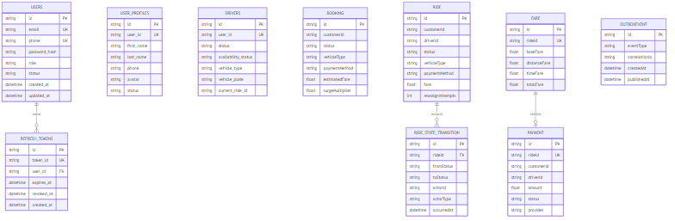

5.2 So do lien ket logic xuyen microservice
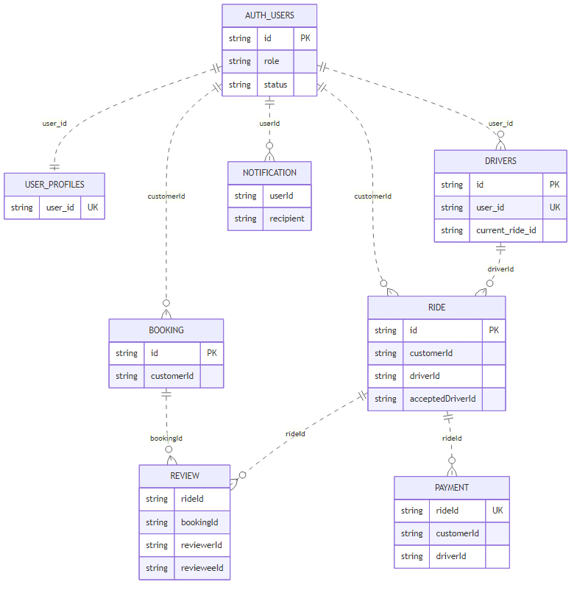
Ghi chu:
- Duong ||--o{ la quan he vat ly trong cung schema.
- Duong ||..o{ la quan he logic giua cac service khac database.

5.3 So do use case tong quat
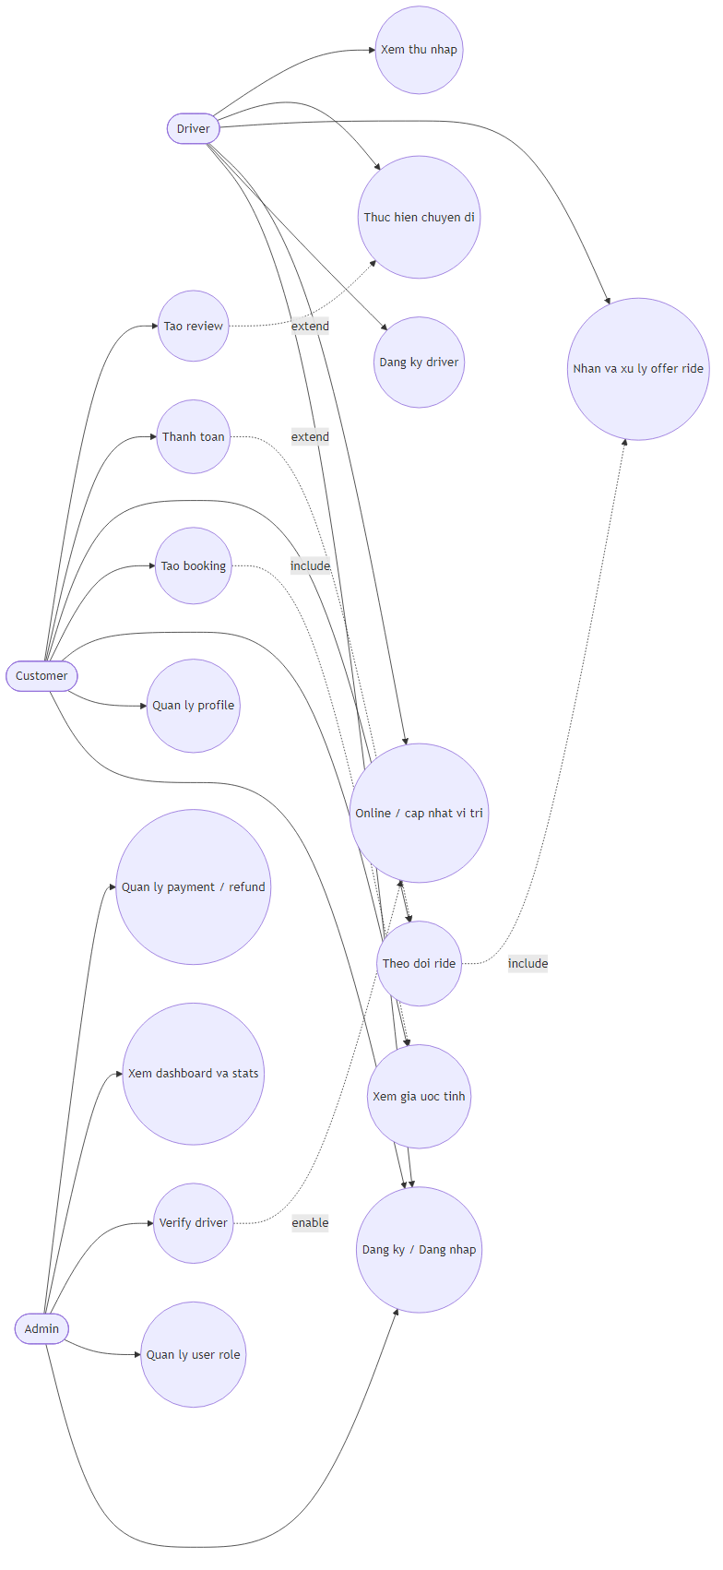

5.4 So do use case theo vai tro

5.4.1 Use case cua Customer
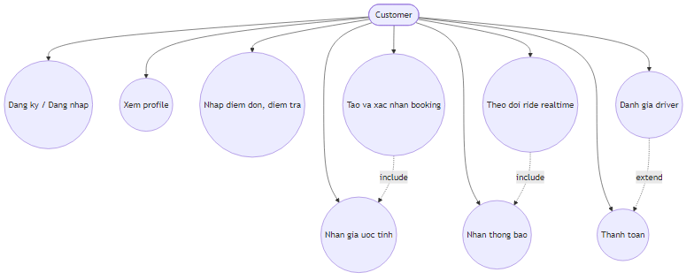

5.4.2 Use case cua Driver
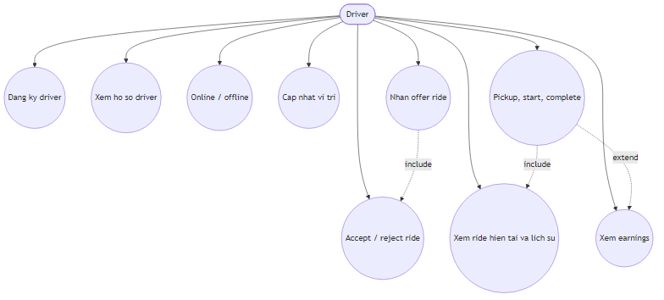

5.4.3 Use case cua Admin
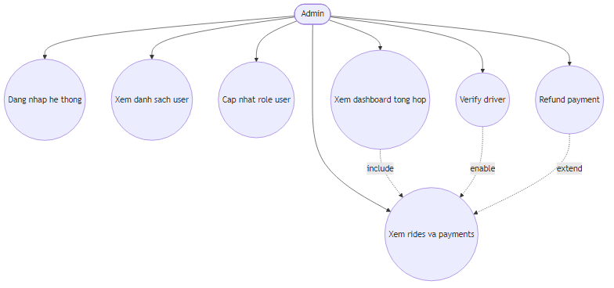

5.5 So do nghiep vu tong quat cua he thong
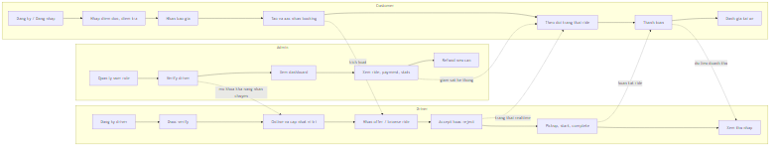

5.6 So do schema database tong the
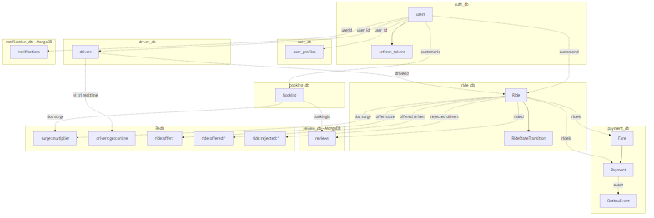

5.7 Sequence nghiep vu dat xe den hoan tat
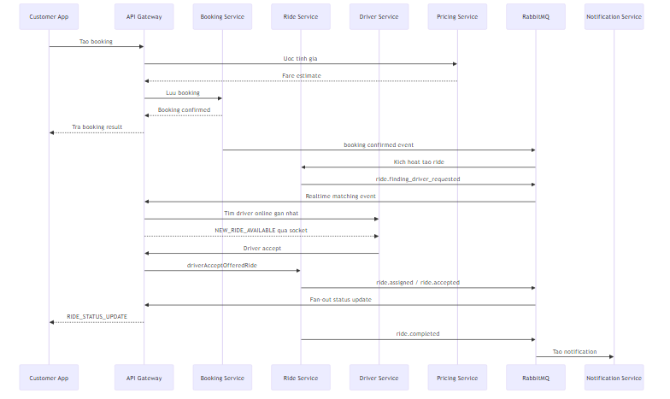

5.8 Sequence nghiep vu matching va timeout
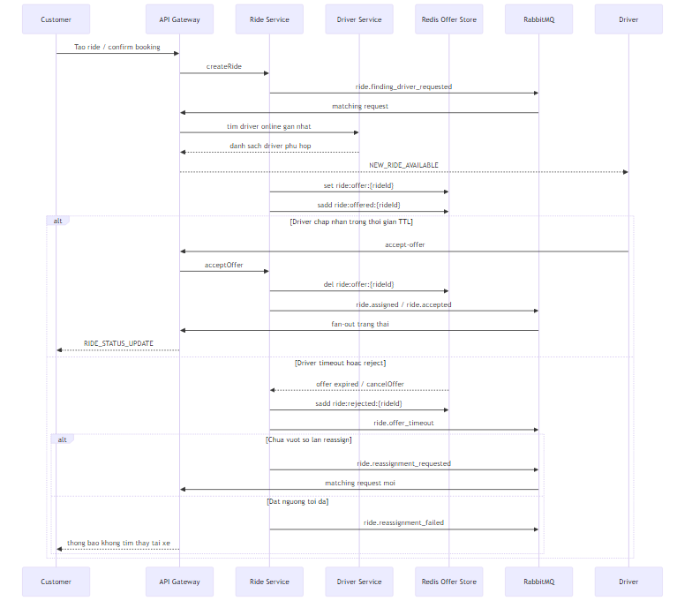

5.9 Sequence nghiep vu thanh toan va hau mai
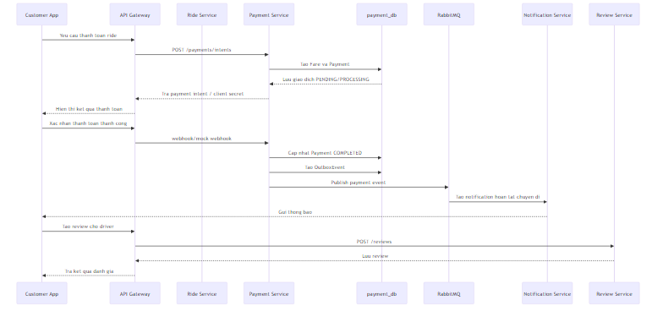

5.10 Luong nghiep vu chi tiet theo chuc nang

Luong A: Dang ky tai khoan va xac thuc
- Client goi POST /auth/register de tao tai khoan.
- Auth Service tao record trong auth_db.users voi role , status , password_hash .
- Khi dang nhap POST /auth/login , he thong xac minh email/phone va mat khau.
- Auth Service tao refresh token trong refresh_tokens gom token_id , user_id , expires_at , device_info , ip_address .
- Client dung access token de goi cac service, API Gateway hoac service khac co the goi POST /auth/verify de verify JWT.
- Khi logout, token duoc revoke bang cach cap nhat revoked_at hoac xoa hieu luc refresh token.
Du lieu thay doi trong luong nay:
- Them moi users .
- Them moi refresh_tokens .
- Co the cap nhat role bang admin endpoint PATCH /auth/users/:userId/role .

Luong B: Dang ky driver va kich hoat kha nang nhan chuyen
- User co role driver goi POST /drivers/register .
- Driver Service tao record drivers voi day du thong tin xe va GPLX.
- Gia tri mac dinh la status = PENDING , availability_status = OFFLINE , license_verified = false .
- Admin hoac quy trinh xac minh goi PATCH /drivers/:driverId/verify de dua driver sang trang thai hop le.
- Driver goi POST /drivers/me/online de bat dau nhan chuyen.
- Driver cap nhat vi tri qua POST /drivers/me/location ; he thong vua ghi lastLocationLat , lastLocationLng , lastLocationTime vao PostgreSQL, vua day du lieu vao Redis geo key.
Du lieu thay doi trong luong nay:
- Bang drivers duoc tao va cap nhat lien tuc.
- Redis drivers:geo:online duoc them/cap nhat vi tri.

Luong C: Bao gia va tao booking
- Customer nhap diem don, diem tra, loai xe.
- API Gateway goi Pricing Service POST /estimate .
- Pricing Service tinh distance , duration , surgeMultiplier , breakdown.baseFare , distanceFare , timeFare , totalFare .
- Booking Service nhan yeu cau POST /bookings va tao record Booking .
- Booking ban dau o PENDING , chua chuyen sang matching ngay neu chua confirm.
- Khi customer dong y gia, he thong goi POST /bookings/:bookingId/confirm .
- Booking Service cap nhat status = CONFIRMED , set confirmedAt .
- Sau buoc nay, flow Ride Service duoc kich hoat de tao chuyen di that.
Du lieu thay doi trong luong nay:
- Bang Booking nhan toan bo thong tin diem don, diem tra, vehicle type, payment method, estimate.
- Redis pricing co the doc surge:multiplier de tao estimate tai thoi diem booking.

Luong D: Tao ride, matching, offer, reassign
- Ride Service tao record Ride tu request truc tiep hoac tu booking da confirm.
- Ride.status chuyen tu CREATED sang FINDING_DRIVER .
- He thong ghi 1 dong vao RideStateTransition de audit state change.
- Ride Service publish ride.finding_driver_requested len RabbitMQ.
- API Gateway tieu thu event, doc Redis drivers:geo:online , tim driver phu hop theo ban kinh va danh sach exclude.
- Gateway phat NEW_RIDE_AVAILABLE qua socket den driver.
- Ride Service tao Redis key ride:offer:{rideId} va add driver vao ride:offered:{rideId} .
- Neu driver chap nhan, Ride Service cap nhat acceptedDriverId , driverId , assignedAt , acceptedAt , status va publish ride.assigned , ride.accepted .
- Neu driver reject hoac timeout, driver duoc dua vao rejectedDriverIds trong bang Ride va vao Redis set ride:rejected:{rideId} .
- Neu reassignAttempts chua dat nguong, Ride Service publish ride.reassignment_requested ; neu da dat nguong, publish ride.reassignment_failed .
Du lieu thay doi trong luong nay:
- Bang Ride : status , driverId , acceptedDriverId , offeredDriverIds , rejectedDriverIds , reassignAttempts , cac cot timestamp.
- Bang RideStateTransition : them nhieu dong lich su.
- Redis: tao/xoa offer TTL, cap nhat set offered/rejected.
- RabbitMQ: phat cac event matching va status update.

Luong E: Van hanh chuyen di tu assigned den completed
- Sau khi duoc gan, driver co the vao ASSIGNED va sau do ACCEPTED .
- Driver goi POST /rides/:rideId/pickup khi den diem don; status chuyen sang PICKING_UP .
- Driver goi POST /rides/:rideId/start ; ride chuyen sang IN_PROGRESS va set startedAt .
- Driver goi POST /rides/:rideId/complete ; ride chuyen sang COMPLETED , set completedAt .
- Moi transition deu duoc ghi vao RideStateTransition kem actorId , actorType , reason neu co.
- API Gateway nhan event tu RabbitMQ va fan-out cho customer/driver bang socket de cap nhat realtime.
Du lieu thay doi trong luong nay:
- Bang Ride : cap nhat pickupAt , startedAt , completedAt , status .
- Bang RideStateTransition : them cac transition nghiep vu thuc thi.

Luong F: Thanh toan, webhook va refund
- Sau khi co thong tin cuoc, Payment Service tao Fare voi baseFare , distanceFare , timeFare , surgeMultiplier , totalFare , distanceKm , durationMinutes .
- Khi customer chon thanh toan online, he thong goi POST /payments/intents de tao Payment record va payment intent neu dung Stripe.
- Ban ghi Payment luu amount , method , provider , status , paymentIntentId , clientSecret , idempotencyKey , metadata .
- Khi webhook hoac mock webhook ve, Payment.status duoc cap nhat thanh COMPLETED hoac FAILED ; cac moc completedAt , failedAt , failureReason duoc ghi lai.
- Moi thay doi quan trong co the tao them OutboxEvent de publish event reliable sang service khac.
- Neu admin refund, he thong cap nhat status = REFUNDED , ghi refundedAt va tao outbox event tuong ung.
Du lieu thay doi trong luong nay:
- Bang Fare la snapshot cuoc phi.
- Bang Payment la snapshot giao dich.
- Bang OutboxEvent la hang doi event chua/phat thanh cong.

Luong G: Hau mai sau chuyen di, thong bao va danh gia
- Sau khi ride hoan tat, Notification Service co the tao thong bao moi den user.
- Collection notifications luu type , status , priority , recipient , message , metadata , retryCount .
- Neu gui that bai, he thong tang retryCount , cap nhat failureReason , va co the dua notification sang QUEUED hoac FAILED .
- Customer hoac driver goi Review Service de tao review sau chuyen di.
- Collection reviews luu rideId , bookingId , reviewerId , revieweeId , rating , comment , tags .
- Unique index (rideId, reviewerId) dam bao mot nguoi khong review lap lai cung ride.
- Driver rating tong hop co the duoc suy ra de cap nhat ve drivers.ratingAverage , drivers.ratingCount .

5.11 Ma tran thay doi du lieu theo tung luong
Luong nghiep vu | PostgreSQL | MongoDB | Redis | RabbitMQ
Dang ky / login | users , refresh_tokens | Khong | Khong | Co the khong
Dang ky driver | drivers | Khong | drivers:geo:online khi online | Khong bat buoc
Bao gia / booking | Booking | Khong | surge:multiplier duoc doc | Khong bat buoc
Matching / offer | Ride , RideStateTransition | Khong | ride:offer:* , ride:offered:* , ride:rejected:* , drivers:geo:online | ride.finding_driver_requested , ride.offered , ride.reassignment_requested , ride.reassignment_failed
Van hanh chuyen di | Ride , RideStateTransition | Khong | Co the dung de support realtime | ride.assigned , ride.accepted , ride.started , ride.completed , ride.cancelled
Thanh toan / refund | Fare , Payment , OutboxEvent | Khong | Khong | Event qua outbox
Notification / review | Khong | notifications , reviews | Khong | Co the tieu thu event de tao document

6. Tong hop lien ket va muc do rang buoc

6.1 Foreign key vat ly dang ton tai
- auth_db.refresh_tokens.user_id -> auth_db.users.id
- ride_db.RideStateTransition.rideId -> ride_db.Ride.id
- payment_db.Payment.rideId -> payment_db.Fare.rideId

6.2 Lien ket logic xuyen service
- user_db.user_profiles.user_id -> auth_db.users.id
- driver_db.drivers.user_id -> auth_db.users.id
- booking_db.Booking.customerId -> auth_db.users.id
- ride_db.Ride.customerId -> auth_db.users.id
- ride_db.Ride.driverId -> driver identity trong driver domain
- payment_db.Payment.customerId -> auth_db.users.id
- payment_db.Payment.driverId -> driver identity trong driver domain
- review_db.reviews.rideId -> ride_db.Ride.id
- review_db.reviews.bookingId -> booking_db.Booking.id
- notification_db.notifications.userId -> auth_db.users.id

7. Phan tich thiet ke he thong

7.1 Kieu kien truc va ly do lua chon
He thong duoc thiet ke theo mo hinh microservices ket hop event-driven communication. Cach tach nay phu hop voi bai toan goi xe vi nghiep vu khong dong nhat:
- Auth va profile co toc do thay doi khac ride va payment.
- Matching va realtime can xu ly nhanh, tach khoi CRUD thong thuong.
- Notification va review phu hop hon voi document store.
- Payment can giu tinh doc lap cao vi lien quan giao dich va retry.
API Gateway duoc dat o trung tam de lam 3 viec:
- diem vao HTTP duy nhat,
- xac thuc va unify route,
- realtime hub duy nhat cho customer va driver.

7.2 Phan tach domain va ownership
He thong dang co phan tach domain kha ro:
- Auth Service so huu identity, token, role.
- User Service so huu profile hien thi.
- Driver Service so huu profile driver, phuong tien, availability, vi tri.
- Booking Service so huu yeu cau dat xe truoc matching.
- Ride Service so huu vong doi ride va matching state.
- Pricing Service so huu logic tinh gia va surge.
- Payment Service so huu fare, payment, refund va outbox.
- Notification Service so huu lich su thong bao.
- Review Service so huu review va thong ke danh gia.
Loi ich cua cach tach nay la moi service co ranh gioi ro ve du lieu va logic, giam nguy co mot service can thiep qua sau vao bang cua service khac.

7.3 Phan tich luong xu ly nghiep vu
Tu goc nhin thiet ke, he thong co 3 luong trung tam:
- Luong dong bo: register, login, create profile, create booking, lay du lieu lich su.
- Luong bat dong bo: matching, ride status propagation, notification, payment event publishing.
- Luong realtime: driver nhan ride moi, customer nhan thay doi trang thai ride.
Mo hinh nay hop ly vi:
- request can phan hoi ngay cho nguoi dung van di qua HTTP,
- cac xu ly co the cham hon hoac can retry duoc day sang RabbitMQ,
- cac thay doi can hien thi tuc thoi duoc API Gateway day qua Socket.IO.

7.4 Phan tich du lieu va rang buoc
Tu goc nhin co so du lieu, he thong dang ap dung database-per-service dung huong. Tuy nhien, doi lai la nhieu quan he chi ton tai o muc logic, vi du:
- user_profiles.user_id tro den users.id nhung khong co foreign key vat ly.
- Ride.customerId , Payment.customerId , drivers.user_id deu phu thuoc vao Auth Service.
- reviews lien ket den Ride va Booking bang ID, khong phai relation vat ly.
Dieu nay co nghia la tinh toan ven du lieu phu thuoc nhieu vao service logic, validator va event contract. Day la trade-off pho bien trong microservices: tang do doc lap, giam rang buoc vat ly, nhung can ky luat API contract rat chat.

7.5 Phan tich thiet ke matching va realtime
Matching la phan thiet ke noi bat nhat cua he thong hien tai. Kien truc dang chia thanh 4 lop:
- Driver Service quan ly vi tri va availability.
- Redis giu geo-index va offer timeout state.
- Ride Service giu state machine va quyet dinh nghiep vu.
- API Gateway lam realtime fan-out layer.
Cach chia nay co y nghia vi:
- Ride Service khong can tu minh lam socket hub.
- Driver Service khong can so huu matching orchestration.
- Redis giam tai cho PostgreSQL trong bai toan timeout va nearby lookup.
- RabbitMQ giup reassign, timeout va status propagation tach khoi request-response thong thuong.

7.6 Phan tich thiet ke payment va do tin cay su kien
Payment Service co mot quyet dinh thiet ke tot la tach Fare va Payment:
- Fare la snapshot tinh cuoc.
- Payment la snapshot giao dich.
Khi do he thong co the:
- tinh lai logic fare ma khong nham lan voi trang thai thanh toan,
- ho tro nhieu payment provider,
- retry publish su kien thong qua OutboxEvent .
Outbox pattern la diem quan trong ve do tin cay, vi no han che tinh trang da cap nhat database nhung chua day event di duoc.

7.7 Uu diem thiet ke hien tai
- Tach ro service boundary va ownership theo nghiep vu.
- Ride workflow duoc model ro bang state machine va bang transition lich su.
- Auth va profile da tach rieng, giam coupling giua identity va thong tin ho so.
- Payment co outbox pattern, phu hop event-driven architecture.
- MongoDB hop ly cho notification va review vi schema linh hoat, truy van theo user va thoi gian.
- Redis duoc dung dung muc dich cho geo search, surge cache, TTL state.

7.8 Han che va diem can hoan thien
- Nhieu quan he cross-service chi la lien ket logic bang ID, can enforcement o tang application.
- Ride.driverId va Payment.driverId can thong nhat ro la driver profile ID hay auth user ID trong tai lieu nghiep vu va API contract.
- Payment dang rang buoc vat ly voi Fare , nhung van khong rang buoc truc tiep voi Ride ; can dam bao dong bo qua service logic.
- Booking va Ride la 2 aggregate tach rieng, vi vay truy vet booking -> ride can dua vao event flow hoac mapping nghiep vu, khong dua vao foreign key vat ly.
- API Gateway dang giam kha nhieu vai tro: proxy, admin aggregation, map helper, realtime hub; neu he thong lon hon nua co the can tach bot tai.

7.9 Dinh huong mo rong de xuat
- Bo sung service discovery hoac centralized config neu mo rong deployment.
- Chuan hoa event schema va versioning cho RabbitMQ message.
- Bo sung saga/compensation ro hon cho cac flow phuc tap nhu booking -> ride -> payment.
- Tach reporting/read model rieng neu admin dashboard can query nang.
- Bo sung tracing va correlation log xuyen service de debug production de hon.

8. Ket luan
He thong hien tai la mot kien truc microservices kha ro rang, trong do:
- auth_db , user_db , driver_db , booking_db , ride_db , payment_db luu nghiep vu quan he.
- notification_db va review_db luu du lieu document.
- Redis va RabbitMQ la hai thanh phan ha tang phuc vu realtime, matching, cache va asynchronous processing.
- API Gateway giu vai tro cuc ky quan trong trong viec hop nhat truy cap, xac thuc va phan phoi realtime event.
Tai lieu nay phan anh dung cau truc schema va model dang ton tai trong codebase, do do co the dung lam tai lieu phan tich va thiet ke he thong muc implementation.

