Robert Fox 20088034

SSD 1 | communications

SSD1 CA 3

mARY CLARKE

**Setting up home a media center**

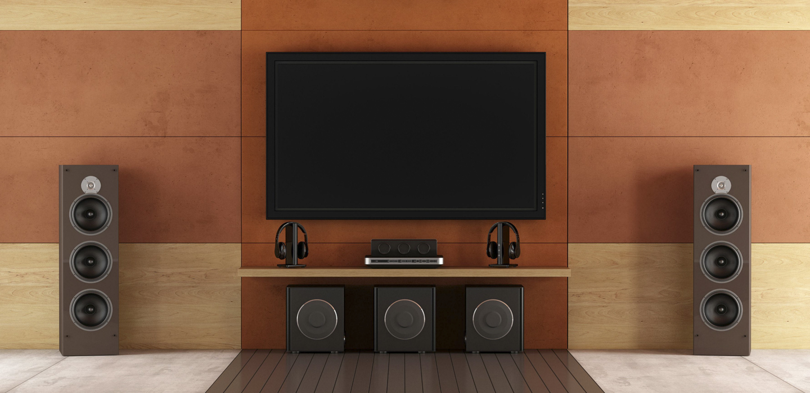

# The aim of this workshop is to equip you with the know-how to set up your own personalized home media center.

## It will be a 2-day event in which we look at 4 of your 5 senses and how they relate to enhancing your entertainment experience.

## The senses we will be concerned with are: Sight, Sound, Smell and Touch.

## I’ll leave the Taste and the Snacks up to you!

Robert Fox: 20088034@wit.ie

Table of Contents

**Title Page0**

Executive Summary1

Table of Contents2

**Workshop Plan3**

SIGHT4

Sight Agenda5

SOUND6

Sound Agenda7

SMELL8

Smell Agenda9

TOUCH10

Touch Agenda11

**Survey12**

**Flyer13**

Bibliography14

Declaration15

# Agenda

|  |  |
| --- | --- |
| Home Media Workshop | Date January 6th – January 7th |

|  |  |
| --- | --- |
| Meeting called by | Robert Fox |
| Attendees: | General Public, anyone is welcome from students to lecturers and anyone that’s interested |
| Please read: | Something in relation to what you want to get out of the workshop e.g. Wired Magazine. |
| Please bring: | Whatever existing devices you have at home that you could show us. Also pen & paper. |

|  |  |  |
| --- | --- | --- |
| Jan 6th 9am – 12pm | Sight Monitors  Televisions  Ambience | Presenter: Professor. X | Location: WIT Room: IT220 |
| Jan 6th 1pm – 4pm | Sound Headphones  Speakers  Ambience | Presenter: Doctor. Y | Location: WIT Room: IT220 |
| Jan 7th 9am – 12pm | Smell Cleanliness  Fans & Candles  Ambience | Presenter: Mrs. A | Location: WIT Room: IT119 |
| Jan 7th 1pm – 4pm | Touch Seats  Mouse & Keyboards  Ambience | Presenter: Mr. B | Location: WIT Room: IT119 |

## Additional Information:

Attendee Profile: We expect to mostly see students here, maybe someone from the public may drop in too.

Feel free to use any communication channels you wish e.g. Social Media



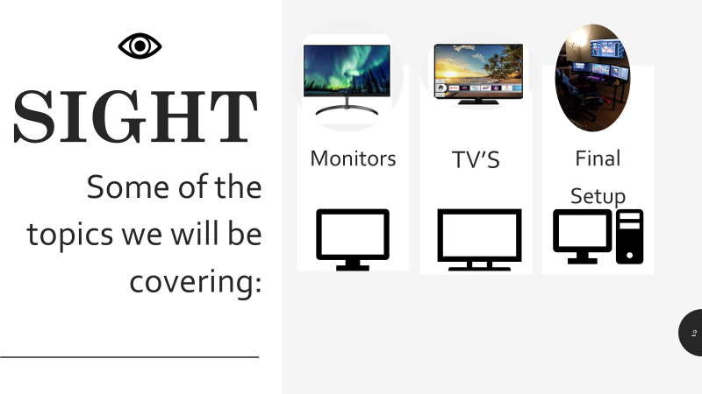

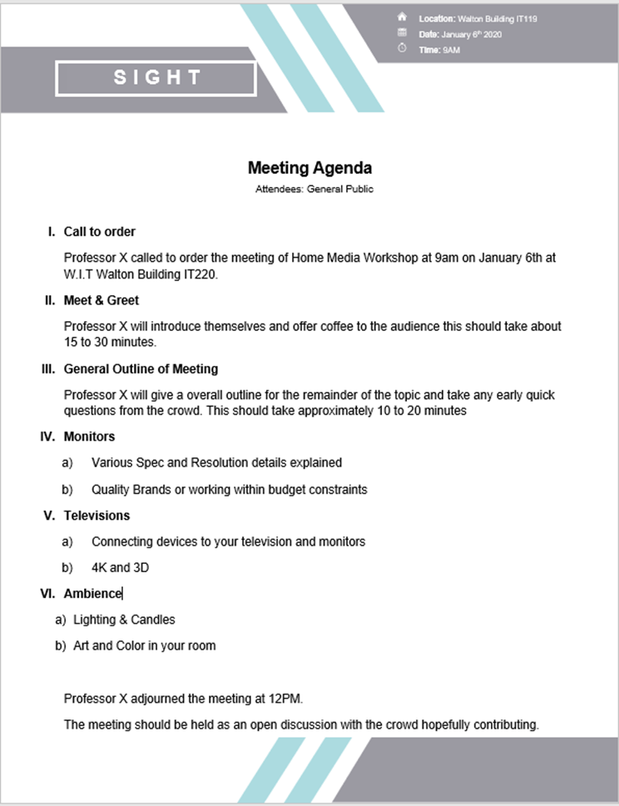



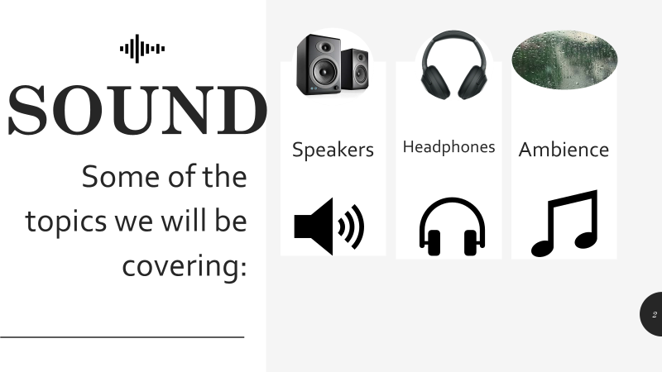



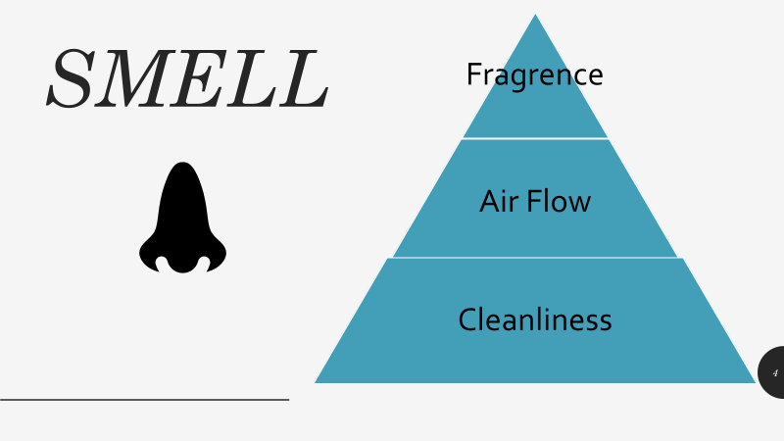



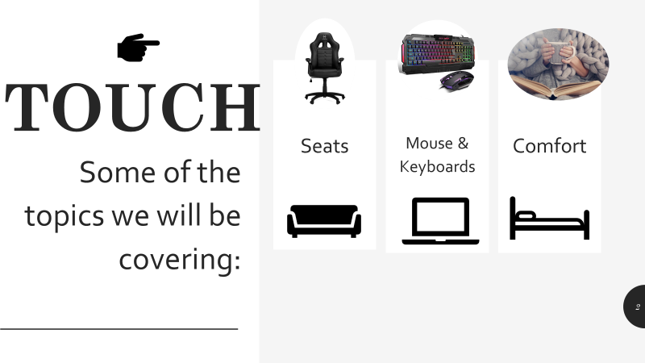

**Home Media Setup Questionnaire**

1. How would you rate your experience from 1 to 10? _______________________________________________
2. Would you change the presentations in anyway? ____________________________________________
3. Any other Comments? ­­­___________________________________________________________

***Device Questions***

1. Did you Bring a Device? ____________________________________________
2. If so, what kind is it? ____________________________________________
3. Did you see any devices you now want to have? ____________________________________________

***Questions you may have can be answered by approaching a presenter at break***

|  |  |  |
| --- | --- | --- |
| **Home media** | | |
| **diy For all ages and abilities** | | |
| Marker  **WIT Walton**  **Building**  **Envelope**  **Email us** | We will cover **4 topics** over a **2-day** workshop.  We would love to hear your input no matter your ability there’s something to learn for everyone here!  Bring along any portable devices you have! | |
| **sight**  **Monitors, TV’s** | **sound**  **Headphones, Speakers** |
|  |  |  |
|  | **smell**  **Fragrences, Fans** | **touch**  **Keyboards, Seats** |

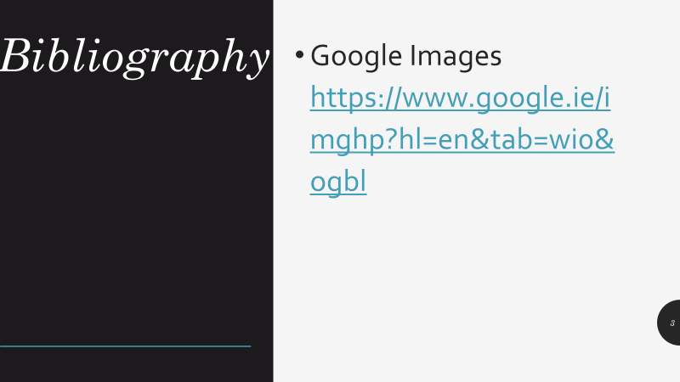

**Declaration**

I certify that this word document report is all my own work and contains no plagiarism. By Submitting this assignment, I agree to the following terms:

Any text, diagrams, summaries or other material copied from other sources (including, but not limited to, books, journals and the internet) have been clearly acknowledged and referenced. This written submission will note these materials in the text by the use of ‘quotation marks’ (or indented Italics for longer quotations) followed by the author’s name and date [e.g. (Byrne, 2008)] either in the text or in a footnote/endnote.

These details are then confirmed by a fuller reference in the bibliography.

I have read the sections on referencing and plagiarism in the handbook or in the WIT Plagiarism policy and I understand that only assignments which are free of plagiarism will be awarded marks. I further understand that WIT has a plagiarism policy which can lead to the suspension or permanent expulsion of students in serious cases (WIT, 2008).

Date: 15/12/2019

Student signature: Robert Fox

Student email: 20088034@wit.ie