20088034

20088034@mail.wit.ie

Rob Fox

tower hotel health & leisure centre

Systems Analysis Design & Testing

# Introduction to Project

This is my project for systems analysis & design, the aim of this project is to investigate the data recorded and used by the Tower Hotel Leisure Centre, and their use of social media and other IT systems, if applicable. I will create a questionnaire and interview a member of staff to achieve these ends. Once I have completed my investigation hopefully I can provide some kind of solutions to improve their systems.

# Organisation/Club/Business Background

The Tower Hotel & Leisure Centre, established in 1962, is found at one of the city's most central location overlooking Reginald's Tower on the doorstep of the Viking Triangle.The gym is equipped with a wide range of cardiovascular and resistance equipment. Tower Leisure Centre has a 20-metre deck level pool, this modern pool also has a separate kiddie’s pool as well as a Jacuzzi, steam room and a sauna. A number of classes are also offered including aqua aerobics and adult & children's swimming lessons. Instructors will create programmes that suits individual needs and requirements.

# Current State of the Organisation/Club/Business

The Tower Hotel & Leisure Centre has approximately 700 members and 6 staff members. They utilize both paper based and electronic means of recording data.

Customer details such as Name, D.O.B, Contact Details, Emergency Contact Details and Medical Status are kept in exel spreadsheets on the PC’s hard drive as well as on paper in filing cabinets.

Swimming classes and Gym programme appointments are available by contacting the leisure centre by phone or email or of course, by coming in in person.

On a daily basis only very basic data is recorded, hotel residents use a sign in sheet. On a weekly/ monthly basis Attendance and Sales are logged.

## Current IT Systems

A single PC is used by a staff with a high speed broadband connection. Custom software (concept) has been installed on the computer to make recording data easier for staff. Also used, are a variety of Microsoft based software such as MS Office, MS Word, MS Outlook and MS Exel.

A printer and landline telephone are also available to staff for whenever necessary. A card reader is also available to take payments.

Payroll software is only used by members of the accounts department.

## Current Social Media

Facebook is being utilized to advertise services such as aqua aerobics classes and kids swimming lessons. They also make good use of social media by posting information such as classes being cancelled or a change in operating hours etc… This is updated by a member of leisure centre staff about once every 2 weeks.

There is also a website for the hotel itself in which the leisure centre has a section. It is primarily used for hotel information and booking but leisure centre information and contact options are also available. This is updated by someone from the hotel’s marketing team.

# Feasibility Study

In this section suggested improvements will be discussed and if the organisation should move ahead with implementation based on Payback figures.

## Suggested Improvement 1

Including a payment option on the leisure centre’s website.

**Costs: €**

Hire a Website Engineer to design website and payment options**:** 1000

Expand memory banks, start using cloud computing: 200

Advertise new website: 300

Train Staff: 300

Train Staff(recurring): 100

Maintenance(recurring): 150

**Benefits:**

One member per month(recurring): 2400

Less staff hours(recurring): 500

## Suggested Improvement 2

Buy some swimming and gym equipment for resale at a slightly marked up price

**Costs: €**

Order equipment 500

**Benefits:**

Revenue from resale(recurring) 200

## Payback for Suggested Improvement (one only)

## Move Forward

## Yes, I would move forward with these investments as we can see a positive CBA over the 4 years and

The Net Present Value of these investments is estimated at €6853. ROI on these investments is at 1.42.

# Analysis & Design

In this section data used within the organisation is analysed and a DFD and ER diagram is used to show the flow of data.

## Data used within the Organisation/Club/Business

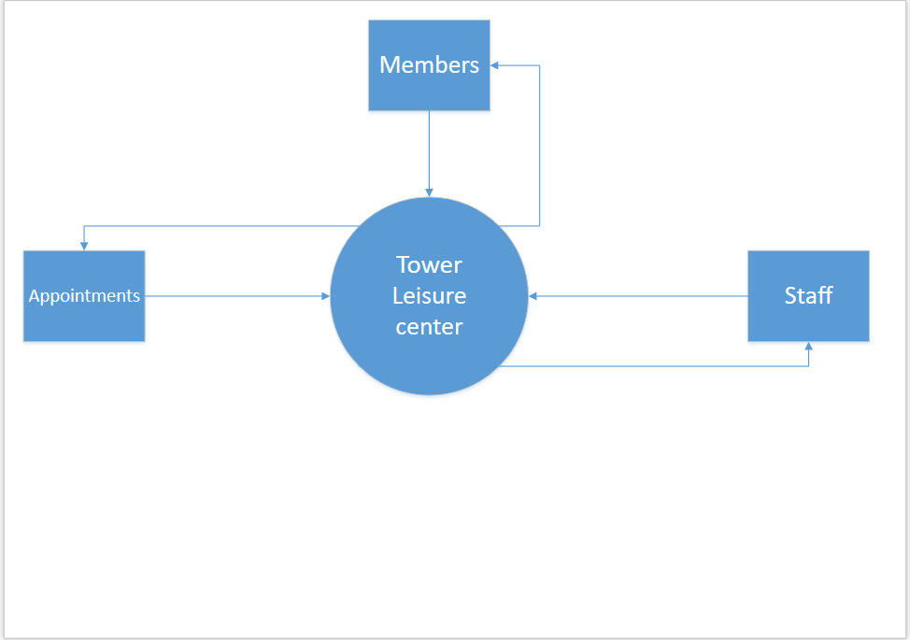

## Data Flow Diagram

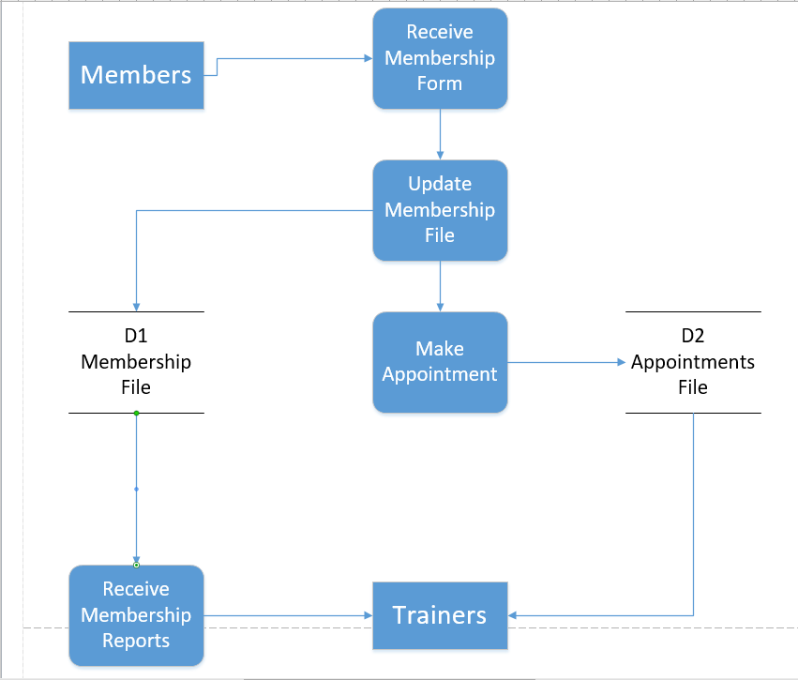

## ER Diagram

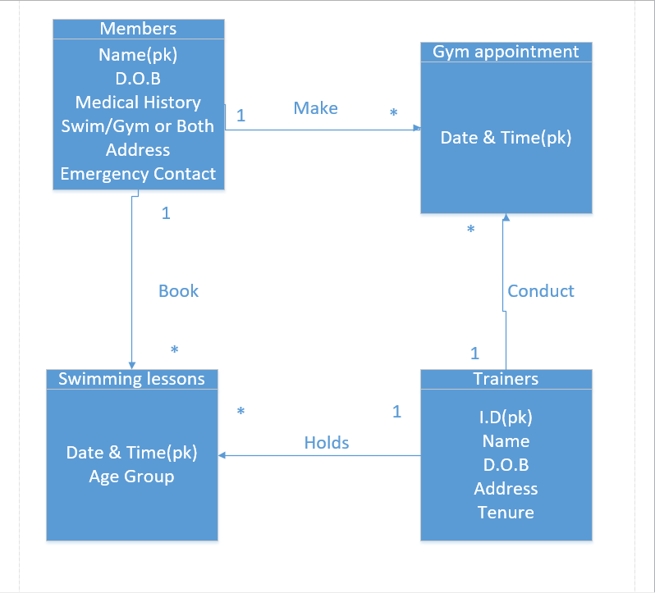

# Conclusion

In Conclusion, I would definitely go ahead with the suggested improvements/investments.

There seems to be plenty of room to improve on the current state of the system being utilized at the Tower Hotel.

Hiring a website engineer to improve the site and also add in a payment option would be the best option to improve their. Also with cloud computing, storing data will be made much easier for staff.

Another simple idea was to buy some equipment for re sale which seems to yield positive results.

This organization has much potential for small scale ideas and changes, however on a larger scale not a huge amount can be changed.

# Copy of Questionnaire

Tower Hotel & Leisure Centre Questionnaire

1. How many employees work here? _______________________________________________
2. How many people are members here? ____________________________________________

***Data Questions***

1. Do you keep a record of your customers/members? _________________________________
2. What are the specific details you need to record, e.g. customer name, contact details...?

__________________________________________________________________________

1. How do you record this data? Please tick the appropriate box(s).

|  |  |
| --- | --- |
| Pen & Paper? | Exel Spreadsheet? |
| Data base? | Word Document? |

If other, please specify here_____________________________________________________

1. Where is this data stored? Please tick the appropriate box(s).

|  |  |
| --- | --- |
| Filing Cabinet? | Exel Spreadsheet? |
| Data base? | Cloud Sharing? |

If any other, please specify here __________________________________________________

1. Do your customers need to make appointments/reservations for classes? ________________
2. How do they make the appointment? Please tick the appropriate box(s).

|  |  |
| --- | --- |
| Face to Face? | Telephone? |
| Online? | Social Media? |

If any other, please specify here _________________________________________________

1. What data do you record for classes? _____________________________________________
2. What kind of data do you record on a day to day basis? ______________________________
3. What kind of data would you record on a monthly or yearly basis?

_____________________________________________________________________

***Social Media Questions***

1. Does your organisation utilise Social Media? _______________________________________
2. If so, what social media platform do you use? Please tick the appropriate box(s).

|  |  |
| --- | --- |
| Facebook? | Instagram? |
| Twitter? | Snapchat? |

If other, please specify here _____________________________________________________

1. What do you use Social Media for? Please tick the appropriate box(s).

|  |  |
| --- | --- |
| Advertising? | Communication? |
| Arranging appointments? | Issuing Notifications? |

If any other, please specify here __________________________________________________

1. Is it updated frequently? _______________________________________________________
2. If so by whom? ______________________________________________________________

***Hardware Questions***

1. What device(s) do you use? Please tick the appropriate box(s).

|  |  |
| --- | --- |
| PC? | Phone? |
| Tablet? | Laptop? |

If any other, please specify here _________________________________________________

1. If so, how many, and what are they used for? ______________________________________
2. Do you have broadband connectivity here? ________________________________________

***Website***

1. Do you have a web site? ______________________________________________________
2. Who maintains it, is it updated regularly? ­________________________________________
3. What is its purpose? _________________________________________________________
4. Do you know who hosts your website? ___________________________________________

***Software***

1. Do you know what kind of software do you use? ____________________________________
2. Do you use any kind of payroll software here? _____________________________________
3. Do you use any of the following software? Please tick the appropriate box(s).

|  |  |
| --- | --- |
| Microsoft Word | Microsoft Exel |
| Microsoft Office | Microsoft Outlook |

1. If any other, please specify here __________________________________________________