Luke Fox

Student ID: 30011364

COMP.5209

Interface Analysis and Design

Assignment 1: Analysis Assignment

Due Date 12 April 2019

Table of Contents

Abstract 3

Website planning 3

Appling P.A.C.T 4

People: 4

Activities: 4

Context 5

Technologies: 5

Two Frameworks 6

Bootstrap 6

Tailwind 7

References 8

Appendix 9

Flow Diagram of Toiohomai café website system 9

Rich Picture to illustrate user flow in a café website system 10

# Abstract

## Website planning

The purpose of this report is to demonstrate some contemporary planning stages of a system design – in this case a website for Tauranga Toi-ohomai café. A model called PACT (people, activities, context, and technology) was used as it helps stay people focused, delivering answers to what are the needs for people involved in this system.

Two website frameworks Bootstrap and Tailwind are selected for the website with pros and cons as to why they should or should not be used to help design the café website.

A flow-diagram is attached to show the website system and to help vision what the final product will be like.

A Rich picture is used to capture the user stories in the website system illustrated using the CATWOE model (Customer, actors, transformation of inputs and outputs, worldview, owner, and environment).

Appling P.A.C.T design to a Toiohomai café website

PACT (People, Context, Activities, Technology design framework)

The aim of PACT is to eliminate problems that may occur in a design process by addressing people needs, context needs, activities that may occur, and the technology used (Kranenburg, 2019).

### People:

The assumed majority of people interested in a website for this tertiary education institute café would be students aged 16 to 40 with a minority of other outside parties such as teachers/staff, investors, and competition.

Tertiary-education aged students’ needs would be reasonable prices on food. Somewhere safe to eat the food. The website could have a pricing system. For example, an online calculator of popular food that will be in store or a step further, an online shopping cart, which the staff could receive a notification and prepare the food for when the students come into the shop.

Teachers or students that shop regularly could receive a discount. Investors or sponsors could have advertising on the website.

*Physical.* Website should display disabled access availability. And location, maybe with a map pinned. Eftpos and no Paywave should be acknowledged.

*Psychological*. Prices should cater to students with no hidden terms. Maybe have a vegetarian section to click on. Shop colours seem to be black and yellow themed; this usually indicates a warning type of colour (Bootstrap, 2019). The website could follow this theme. Also, pies and fresh fruits are displayed by the counter to encourage fresh food. – Everything is displayed in a particular order. The website should reflect this by having food pages separate to activity pages for example.

*Social*. The system should cater to allot of ethical details as the institute is multi-cultured. Example, the café does not sell pig as some people get offered by it. Prices should not be written in red, as this is not a neural colour. I need to beware of these cultural differences, when designing.

### Activities:

This website should be simple and clear to cater for the above audience which are presumably always in a rush or do not care that much and just want a quick price on an item or see what activities the café offers such as table tennis, pool, photos of lots of space with chairs and tables -- a place to hang out.

The café should be open during student time-tables for business. Be aware of holiday times and display this information on website home or about page … somewhere with limited navigation to find.

Safety: food signs rating signs or awards that comply with New Zealand’s health and safety standards would be a beneficial if shown on the website, so the audience does not have to worry about where the food came from.

Context**:** The website should reflect the location of the shop. For example, the café is in Tauranga New Zealand. An image of Tauranga could be displayed to attract attention with special attractions in the area: For example, the nearest closest shops are... or 15-minute drive from the beach. The café provides parking and easy access toilets advertising. An example of inappropriate context could be an image of a coffee sign stuck in the mud. Customers might think they need gumboots.

The website may include positive messages such as, waiting times are rare as our staff are well trained or beat the crowd, come before lunch or after. Or, we (the café) offer special Toiohomai lunch available by (food study) students to students. And give times.

Social context: When having a look around the café, it felt safe. I could eat my lunch in peace or approach other students playing ping-pong or pool. This could be another message in the website to promote the feel of the environment.

Organisational context: The website could display photos of the café showing a well organised clean shop with smiling staff to show the staff have a passion for their job or at least do not hate what they do (Clinebell & Shadwick, 2005).

### Technologies:

The café website should cater to the devices that would be commonly used, such as phones. This means, scalability and responsiveness to page, window, and image size.

The user experience should be pleasant, on looks and speed. For example, try use limited plugins for faster run time and make sure there every line of code is in use and optimised

(Kranenburg, 2019).

Maybe have a privacy message. For example, the website could contain a message stating no cookies for data collection will be used. This might attract more people to the site via word of mouth or insure students can leave the tab open.

*Summary:*

PACT helps brainstorm the key features to address and design a website for a student focused café with other customers and parties in mind. PACT’s holist people approach helps organise a seemly overwhelming task into key sections to focus on one part of the system at a time.

Two Frameworks that could be a good fit for a café website:

Bootstrap and Tailwind seem a good fit. Here’s why:

## Bootstrap

Toiohomai uses Bootstrap for their MOODLE (modular object-oriented dynamic learning environment). Therefore, I could match the theme for the café to the exact colours or the shop colours yellow and black yet keep match a similar layout – for example button shapes.

*Benefits of Bootstrap:*

It is a component framework: The classes are premade, therefore if limited knowledge of CSS bootstrap is a big help for a tight timeframe.

Everything works as soon as you add a CSS class to an element, meaning a wireframe of the site can be done very fast.

The backend PHP code follows best practices. Therefore, optimised and has a good history with the development community.

Lots of online material to help learn Bootstrap. It is well known in the web development community (Bootstrap, 2019).

*Downside:*

No or little control over detailed customised themes; can be done, however, very advanced learning curve or lots of time to learn and read through the documentation.

Unnecessary overhead code if I import the entire library or do not even use all the minimum requirements such as alerts or all the styles on my server or the customers computer or a paid third-party.

Bootstrap themes look very similar to each other. And has a very limited colour palate. The website might not pop or standout.

There is sufficient documentation. Which can be found: <https://getbootstrap.com/docs/4.3/getting-started/introduction/>

(Bootstrap, 2019).

## Tailwind

*Benefits*:

Tailwind is a utility framework, meaning more of a tool to help with CSS, yet has lots of classes built in. Great for customisation yet do-not have to start CSS from scratch.

Tailwind also follows best practices.

No need for expert knowledge.

With utilities, I can have more control over making classes. For example, can make yellow and black buttons to suit the café logo. Although, I am still unsure why the café used a warning colour (from a graphical design perspective). Maybe, to capture attention. It does not create a relaxing feel however. Therefore, I am leaning more towards Bootstrap to match the aqua blue feel of MOODLE.

*Downside:*

Little control. More than Bootstrap. However, still using a CSS framework.

Also, may-not use all the features of what I download or the customer downloads, hindering space and speed. For example, if I do-not use the margin top and bottom helper.

Longer learning curve. Must know some CSS.

Not as-well known or used compared to Bootstrap. If the owner did not have knowledge of CSS or a new owner acquired the business, he or she could not add to their site easily (post production).

Sufficient documentation can be found: <https://tailwindcss.com/docs/what-is-tailwind/>

(Tailwind, 2019).

# References

Bootstrap (2019). *Documentation: Introduction.* Retrieved 5 April 2019 from

<https://getbootstrap.com/docs/4.3/getting-started/introduction/>

Clinebell, S. Shadwick, G. (2005). The Importance of Organizational Context on Employees'

Attitudes: An Examination of Working in Main Offices Versus Branch Offices.

*Journal of Leadership and Organizational studies, 11,* 89-100.

Retrieved 7 April 2019 from <https://journals.sagepub.com/doi/pdf/10.1177/107179190501100209>

Kranenburg, J. (2019). *PACT and Flowcharts and user flows* [PowerPoint slides].

Retrieved from <https://moodle.toiohomai.ac.nz/mod/page/view.php?id=169024>

Tailwind (2019). *Tailwind: A utility-first CSS framework for rapidly building custom user*

*interfaces.* Retrieved 6 April 2019 from

<https://tailwindcss.com/docs/what-is-tailwind/>

# Appendix

## Flow Diagram of Toiohomai café website system

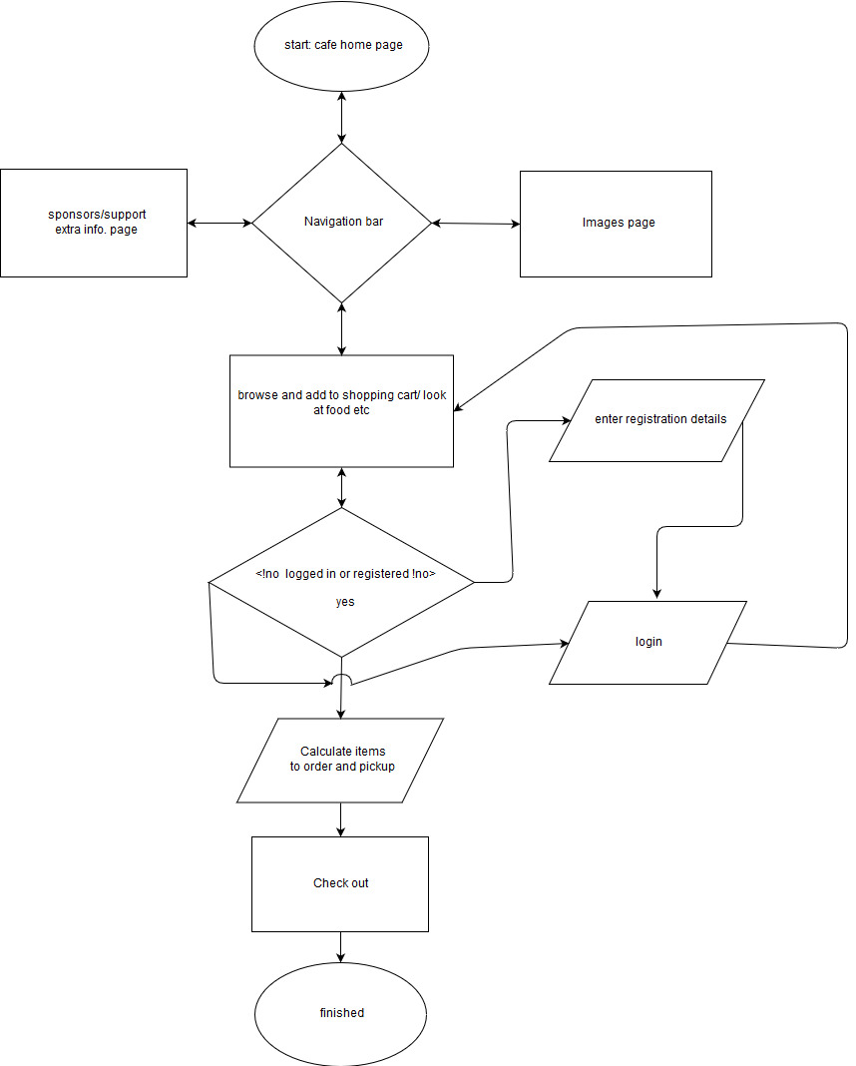

## Rich Picture to illustrate user flow in a café website system

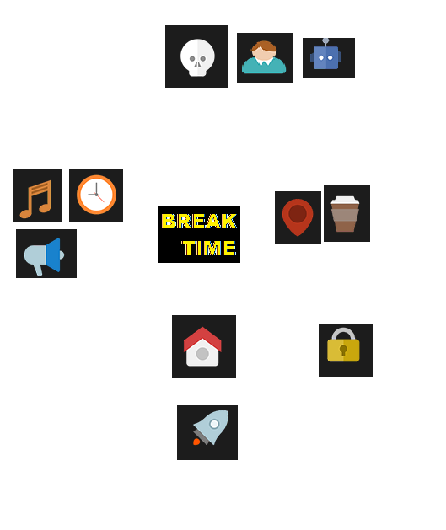

Checkout:

This can involve other actors such as banks.

Sponsor actors such as Toi-ohomai; food and coffee suppliers.

Starving Customer

Some worldviews could be

They are the real boss, as they provide the money.

Website calculator.

Staff could

prepare

food if order online.

Environment: Images on website reflect café.

Actors such as coffee and food suppliers involved in system

Technology: music, safety alarm, opening hours.



Break Time home and navigation page.

Shop: The food environment.

Mixed with activities and toilets. This should be a clean environment checked regularly by actors such as staff.

Login/signup.

3rd party actors could get involved with login EG Google.

Owner

(Actor)

Staff

(Actor)

**CATWOE of a café website system. The people, technology, worldviews, owner/s, and environments involved in a Café website system.**