# Luke Davis Fox (NZ born) Graduate Programmer

**Te whakatinana Whakaakoranga Implementing Education**

**+6421-1888876**

[**foxyflow@contractor.net**](mailto:foxyflow@contractor.net)

### Seeking

IT work (software and hardware) or Intermediate webapp development and game programming roles in New Zealand or Australia. Happy to move or work remotely for an ideal job; currently living in Tauranga.

Current programming projects:

2023: Currently focusing on a TypeScript project using Phaser3 (for the 2D game part) and using Godot with C# for a 3D and VR game – the goal: people can checkout the website and game without downloading.

### Skills from educational and work experience

*Please check out my projects in my GitHub:* [*https://github.com/foxyflow*](https://github.com/foxyflow)

##### Strong Experience:

Object-oriented programming (OOP)

* C# and .NET
* TypeScript and React
* Python
* Solidity (Blockchain)

Software:

* Unreal Engine
* Unity Software
* IDEs: Visual Studio 2019 (and PyCharm)
* Apache: WAMP
* Adobe Suite software

3 Years’ Educational Experience:

Other languages:

* Linux Bash
* API creation
* PHP
* SQL
* C++

Software:

* Maya and Photoshop (3D and 2D modelling)
* Trello (Kanban and Scrum)
* Java Software (Weka (Machine Learning)
* Postman (Backend testing)
* Ubuntu on Windows (Bash)

### Portfolio

[**https://foxyflow.github.io/Portfolio/**](https://foxyflow.github.io/Portfolio/)

**Have a go at a game on my 2D JavaScript game site (no downloading required)**

**Foxyflow.net**

### My blog website:

**https://lukeslanguagelearning.tech/blog**

##### for links to downloadable projects

**A series of lessons teaching programming in Python via a game:**

[**https://tinyurl.com/LukesLessonsPlaylist**](https://tinyurl.com/LukesLessonsPlaylist)

**An agile business plan for game design:** [**https://tinyurl.com/LukesLanguageLearningPlan**](https://tinyurl.com/LukesLanguageLearningPlan)

Other projects

[**https://github.com/foxyflow**](https://github.com/foxyflow)

Games: The *lukeslanguagelearning* link contains an *Unreal* Project made with C++ and Unreal’s blueprints with over 10,000 words of agile test-driven project managed documentation. Other 2D and 3D videogame projects such as Unity3D and Universal Windows Platform (UWP) applications were created using OOP in C# .NET also available linked via my foxyflow GitHub.

### Information about myself

I have created a series of programming videos to teach core concepts such as Object Orientated Programming (OOP) – this is taught using Python for future proofing applications because of its vast versatility in the marketplace … videos on YouTube. <https://www.youtube.com/channel/UC9IZmtiofWELTH9zk8GHxHQ>

After graduating I got a paid internship as a blockchain developer. Within the remote role I created a website using the Solidity language for the backend with NodeJS and NextJS with JavaScript and ReactJS as the frontend. The website can convert your artwork into an NFT using the ERC721 standard smart-contract and connecting to a web3 platform such as Metamask. I problem-solved how to create, list, and sell NFTs for people – this was a solo

project as the others in the team were not technical in this respect. As the contract has ended, I can now display my work: <https://github.com/foxyflow/BlockchainWork>

I enjoy the whole creation process of designing something from programming. That is, a game, application, or website. Problem solving is very satisfying especially when it can lead to better life improvements. I have created several websites and applications over the years.

Within the workforce, I have come from an applied Education and Construction background. Although I enjoy it, I then completed a Bachelor of Science major in Applied Computing -- a three year heavily focused programming degree in a variety of languages to set myself up for the future and keep up with more relevant present conditions.

Additional information

* **Spare time passion project: 3D website game using three.js for upcoming 3D screens.**

*Other hobbies:* chess, guitar, skateboarding, and Italian culture.

* Holidays (before covid) in: Australia, Cook Islands, USA, UK, Italy, and China.
* Hold a current passport, full car, and learner bike licence.

Software role models

* + John Carmack
  + Tim Sweeney
  + Jeff Delaney
  + [Nader Dabit](https://dev.to/dabit3)
  + Paul Morris
  + **Jacob Van SIlfhout**

### Work experience

*Current Software work*

**Blockchain software developer** for NFT_Flash (Mid-January to current with small start-up company)

Creating a smart-contract website using Solidity and ReactJS.

**Software consultant** for Manaaki (August. 2021 to December 2021 with Manaaki)

Helping small business via demonstrating and implementing current software products into their roadmaps and lifecycles.

Previous jobs – Not related to software

##### Interior Plastering

Self-employed for the last seven years. *(April 2016 to current.)* <https://foxyflow.wordpress.com/> -- only to pay the bills while looking for the next software job.

Foxstop Plaster Service *(2010 to March 2016.)*

###### Weekend Hostel Manager

***Brookfield Accommodation Hamilton NZ*** *(2006 to 2010 4years 4months.)*

This job required administration and management skills; organising trades; trust with money and time; Eftpos and cash-up using excel; writing reports and recommendations; eviction notices; and a range of diverse people skills.

###### Barista

Red Cart Hamilton East (4+ years while working at Brookfield Accommodation.)

I volunteered mornings for perfecting coffee skills with Rob at Red Cart Hamilton East for many years and remain good friends.

###### Teacher

Ministry of Education Wellington (6 months set-time contract)

Teaching high school Math. and English NCEA levels. *(2005.)*

Youth Horizons Porirua Wellington (1 year)

Teaching with outdoor activities such as skateboarding. Ages 12 to 15 with ‘conduct disorders’ (contract with Youth Horizons Porirua Wellington) *(2004.)*

Music Teacher

Teaching guitar over the years to a range of children and adults. *(2001 – 2007 -- 7+ years part-time while studying.)*

### Referees

Character reference:

Rob Parr: Coffee maker: +64221082847 Manaaki – please ask for the phone number.

Programming teachers happy to be a reference:

Andrew Chapman*:* former supervisor on <https://lukeslanguagelearning.academy/> Project and Project Management.

[Andrew.chapman@toiohomai.ac.nz](mailto:Andrew.chapman@toiohomai.ac.nz)

Paul Morris: former GUI UI C# UWP Teacher from Manchester -- Paul worked on the first Tomb Raider game.

[paul.morris@toiohomai.ac.nz](mailto:paul.morris@toiohomai.ac.nz)

Construction

* Phil Wickens painter -- 02108575915
* PM building LTD Phil Murry -- 021-231-1879
* Luke Blackman, builder -- 027-6901043

Hospitality

Former manager at hostel. Colin Nordstrom: +6421-831-094

**Education**

## In space time

Supporting Reuben Ward’s Patreon C++ Survival Game Course <https://www.patreon.com/reubenward/posts>

#### Creating a game using Unreal Engine 5 – a long-term project.

Coding practice:

<https://www.codecademy.com/profiles/Foxyflow>

How do I learn, and problem solve? I enjoy a range of Udemy courses (videos); I buy programming books; and read documentation.

## Formal

Current education (Finished July 2021)

*Bachelor of Science: Major in Applied Computing (University of Waikato).*

Class representative, volunteering for these papers: Statistics for Science, Applied Computing Tools, and Advanced Database Concepts. Plus, managing and playing in the University of Waikato’s basketball team (good times).

Former tertiary education

* Postgraduate Certificate in Education (University of Waikato).
* Bachelor of Arts Major in Education (Victoria University of Wellington).
* Contemporary Music Certificate (Nelson School of Music).
* Teacher Aide Certificate (University of Canterbury).

### Certificates and transcripts

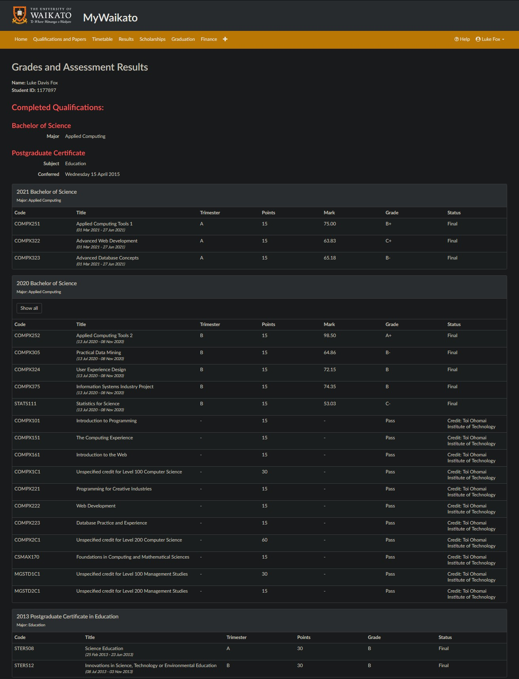

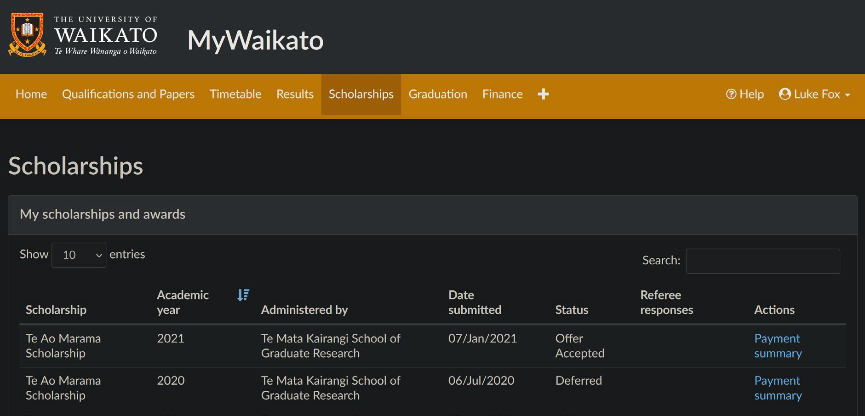

Awarded: University of Waikato’s Te Ao Marama Graduate Scholarship

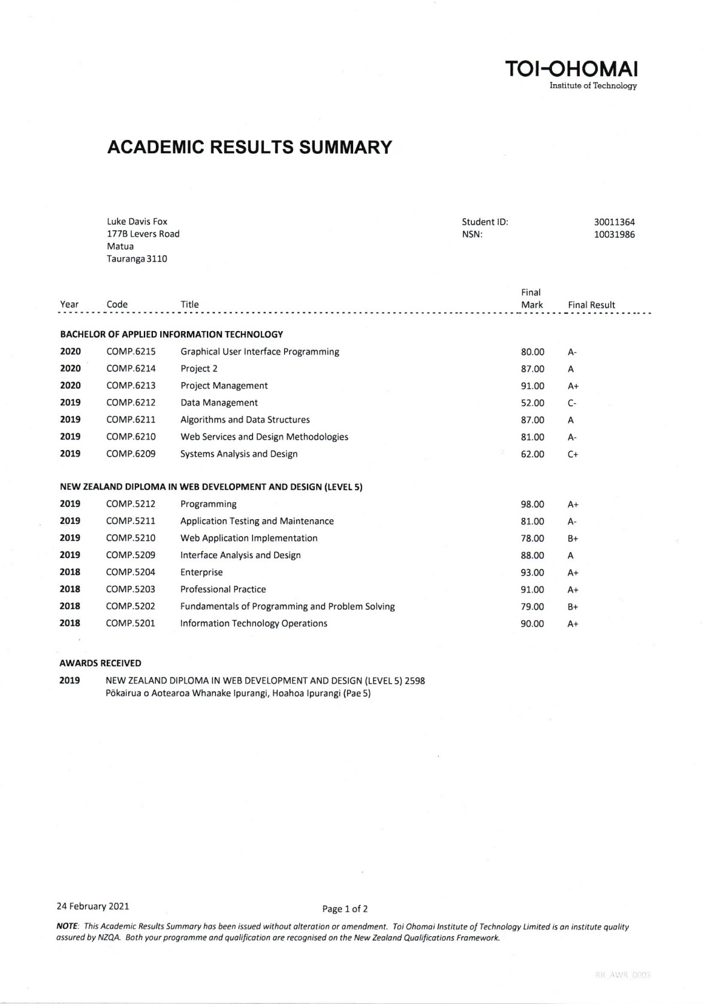

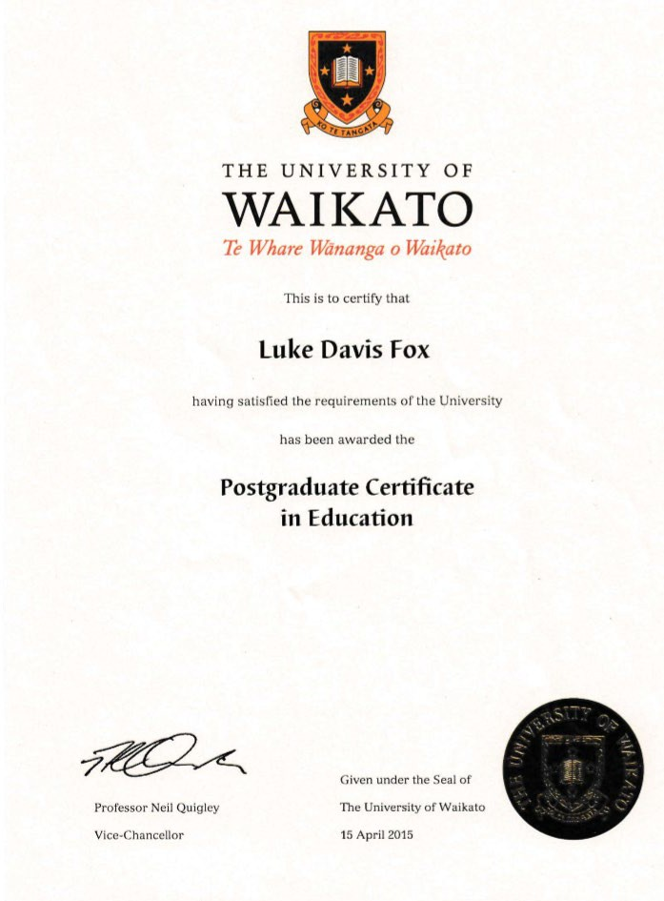

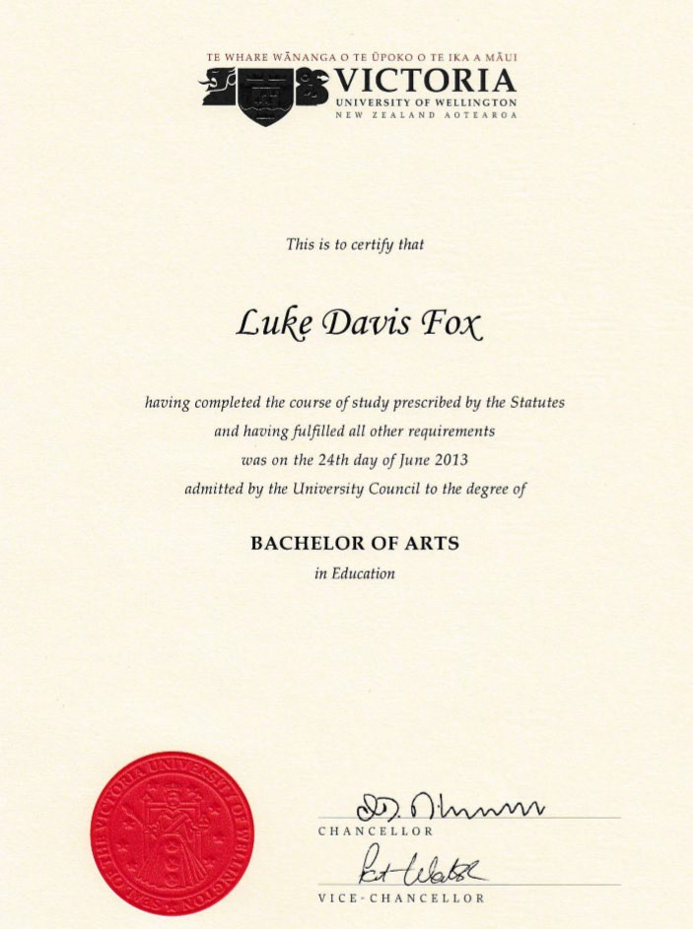

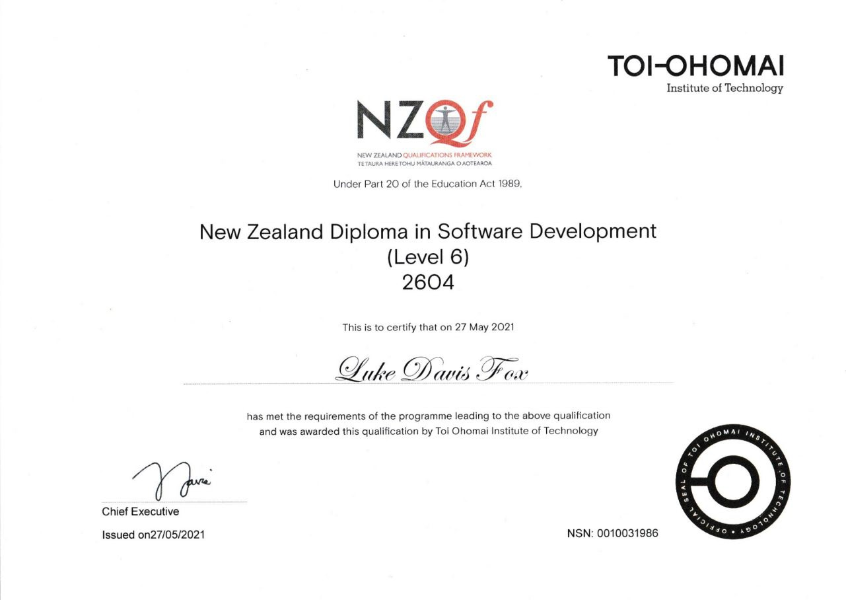

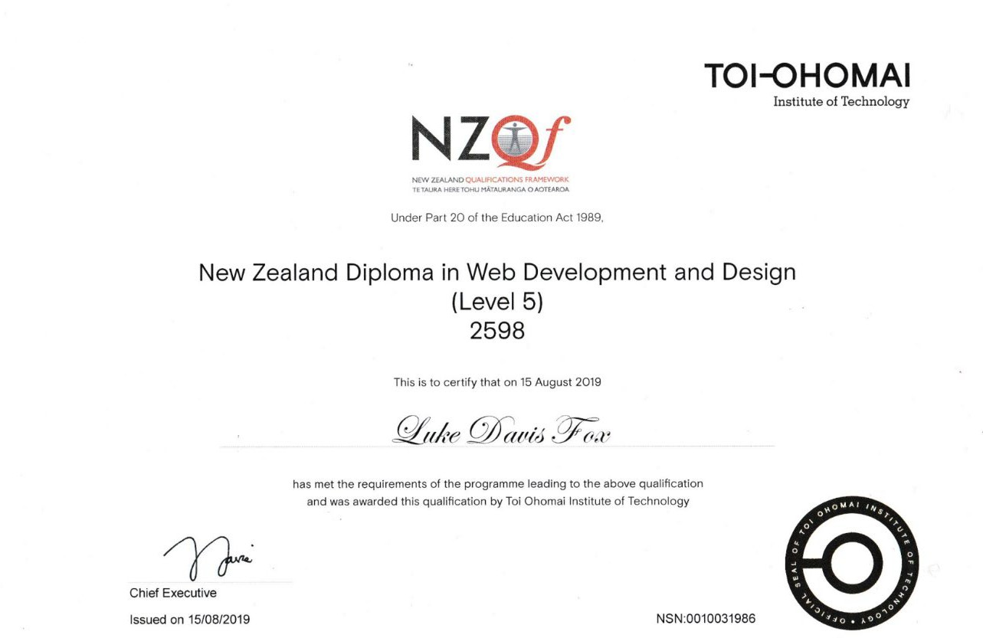

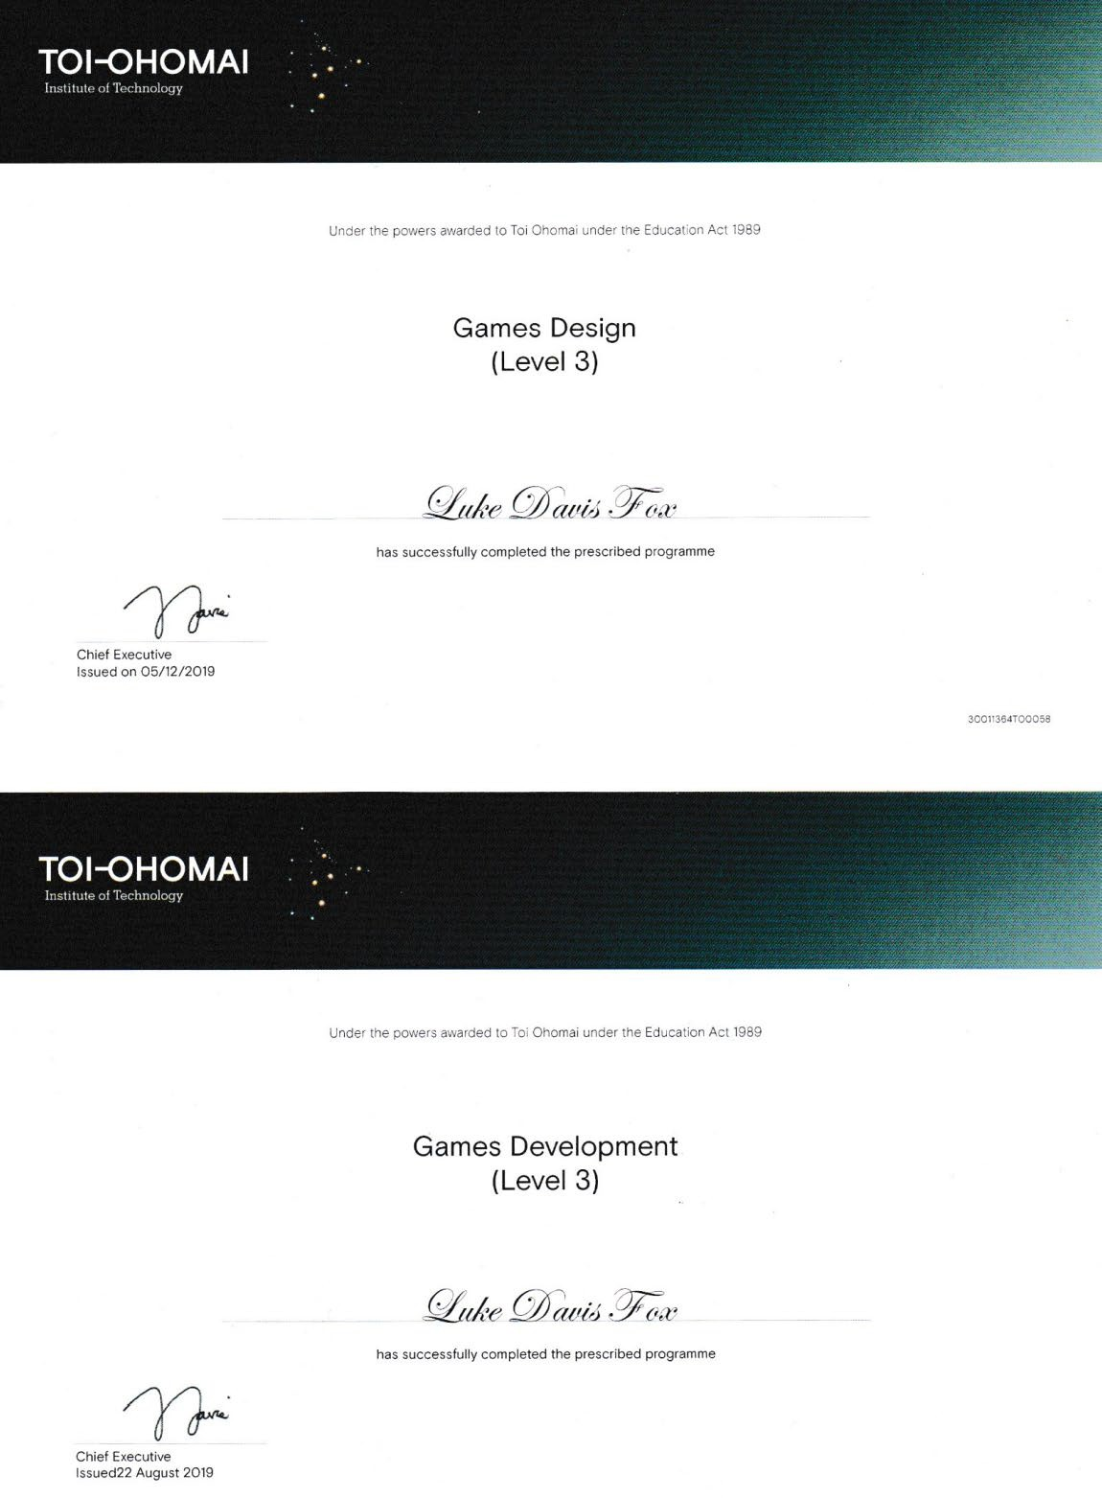

Please visit: <https://foxyflow.github.io/Portfolio> for the most up-to-date CV and projects’ information.