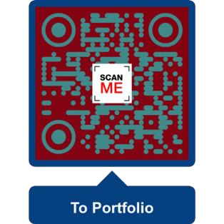**Luke Davis Fox BA BSc (NZ born) Programmer**

**Te whakatinana Whakaakoranga**

**Implementing Education**

**foxyflow@contractor.net**

# Seeking

Game development work. Remote or onsite. Game tester or **Unity** programming. If I am applying for onsite it means I am willing to move to that location. If you are a recruiter, feel free to throw around the provided email address, it is created for job seeking.

Current programming projects:

2024: Personal project C# Unity puzzle platform game. This is private as not finished.

Here is an older game in Unity: <https://www.youtube.com/watch?v=uMmfBBgyuCo>

Current job:

From Easter 2023 to current – Fulltime IT technician and consultant for Geeks on Wheels.

# Skills from educational and work experience

*Please check out my projects in my GitHub:* [*https://github.com/foxyflow*](https://github.com/foxyflow)

**Strong Experience:**

Object-oriented programming (OOP)

* Python
* JavaScript
* C#
* Web Development

**Software:**

* Unreal Engine
* Unity 3D Software (C#)
* Visual Studio and VSCode
* Adobe Suite software
* Microsoft 365 software

4

**Educational Experience:**

Other languages:

* Linux Bash
* API creation using JSON
* PHP
* SQL
* C++

**Software:**

* Maya and Blender (3D and 2D modelling)
* Trello (Kanban and Scrum)
* Java Software (Weka (Machine Learning)
* Postman (Backend testing)
* Ubuntu on Windows (Bash)

# Portfolio

[**https://foxyflow.github.io/Portfolio/**](https://foxyflow.github.io/Portfolio/)

**A series of lessons teaching programming in Python via a game: https://tinyurl.com/LukesLessonsPlaylist**

**Other projects** [**https://skateboardware.com**](https://skateboardware.com/)

**Enjoy filming and editing for local skateboard scene.**

# Information about myself

I have been programming since the Amica days. More recently, I have created a series of programming videos to teach core concepts such as Object Orientated Programming (OOP) – this is taught using Python for future proofing applications because of its vast versatility in the marketplace and little dependence on developers changing programming libraries … videos on YouTube. <https://www.youtube.com/channel/UC9IZmtiofWELTH9zk8GHxHQ>

After graduating in Applied Computer Science, I got a paid internship as a blockchain developer. Within the remote role I created a website using the Solidity language for the backend with NodeJS and NextJS with JavaScript and ReactJS as the frontend. The website can convert your artwork into an NFT using the ERC721 standard smart-contract and connecting to a web3 platform such as Metamask. I problem-solved how to create, list, and sell NFTs for people – the team bounced ideas however had no developers.

<https://github.com/foxyflow/BlockchainWork>

**Additional information**

* Travel (before covid) in: Australia, Cook Islands, USA, UK, Italy, and China.
* I hold a current passport, full car, and learner bike license.
* *Personal hobbies:* chess and puzzle games, guitar, skateboarding, and Italian culture.

**Software role-models**

John Carmack; Tim Sweeney; Jeff Delaney; Nader Dabit; Paul Morris; Jacob Van Silfhout**.**

# Work experience

**IT Technician and Consultant** 2023 to Current for Geeks on Wheels.

Developing a 2D retro pixel-art game for Tattoo World using Assembly6502 and NES Maker. 2022 to 2023.

**Blockchain software developer** for NFT_Flash (January 2022 to April with small start-up company)

**Software consultant** for Manaaki (August. 2021 to December 2021 with Manaaki)

Helping small business via demonstrating and implementing current software products into their roadmaps and lifecycles.

Previous jobs

**Interior Plastering**

Self-employed for the last seven years. *(April 2016 to current.)* <https://foxyflow.wordpress.com/>

Foxstop Plaster Service *(2010 to March 2016.)*

## Weekend Hostel Manager

***Brookfield Accommodation Hamilton NZ*** *(2006 to 2010 4years 4months.)*

This job required administration and management skills; organising trades; trust with money and time; Eftpos and cash-up using excel; writing reports and recommendations; eviction notices; and a range of diverse people skills.

## Barista

*Red Cart Hamilton East (4+ years while working at Brookfield*

*Accommodation.)*

I volunteered mornings for perfecting coffee skills with Rob at Red Cart Hamilton East for many years and remain good friends.

## Teacher

***Ministry of Education Wellington (6 months set-time contract)***

Teaching high school Math. and English NCEA levels. *(2005.)*

***Youth Horizons Porirua Wellington* (1 year)**

Teaching with outdoor activities such as skateboarding. Ages 12 to 15 with

‘conduct disorders’ (contract with Youth Horizons Porirua Wellington) *(2004.)*

***Music Teacher***

Teaching guitar over the years to a range of children and adults. *(2001 –*

*2007 -- 7+ years part-time while studying.)*

# Referees

**Character reference:**

Rob Parr: Coffee maker:

+64221082847

Donavan Hartel Geeks on Wheels

+64212085166

**Programming teachers and IT work reference:**

Any Manager at Geeks on Wheels: 08004ageek

Andrew Chapman*:* former graduate programming supervisor -- Project and Project Management.

Andrew.chapman@toiohomai.ac.nz

Paul Morris: former GUI UI C# UWP Teacher from Manchester -- Paul worked on the first Tomb Raider game.

**Construction**paul.morris@toiohomai.ac.nz

* Phil Wickens painter -- 02108575915
* PM building LTD Phil Murry -- 021-231-1879
* Luke Blackman, builder -- 027-6901043

**Hospitality**

Former manager at hostel. Colin Nordstrom: +6421-831-094

# Formal Education

**(Finished July 2021)**

*Bachelor of Science: Major in Applied Computing (University of Waikato).*

Class representative, volunteering for these papers: Statistics for Science, Applied Computing Tools, and Advanced Database Concepts. Plus, managing and playing in the University of Waikato’s basketball team (good times).

**Former tertiary education**

* Postgraduate Certificate in Education (University of Waikato).
* Bachelor of Arts Major in Education (Victoria University of Wellington).
* Contemporary Music Certificate (Nelson School of Music). ➢ Teacher Aide Certificate (University of Canterbury).

# Certificates and transcripts

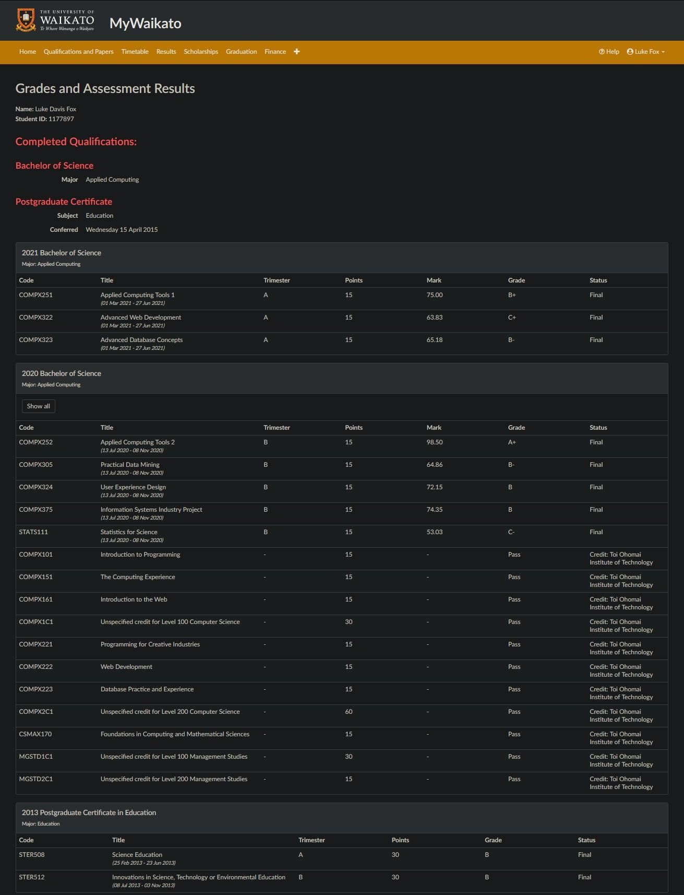

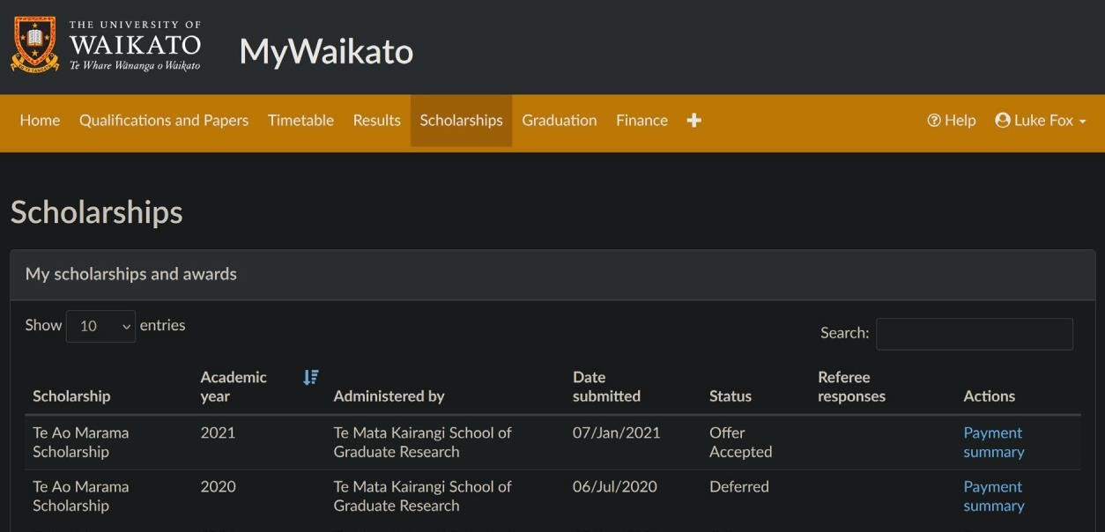

Awarded: University of Waikato’s Te Ao Marama Graduate Scholarship

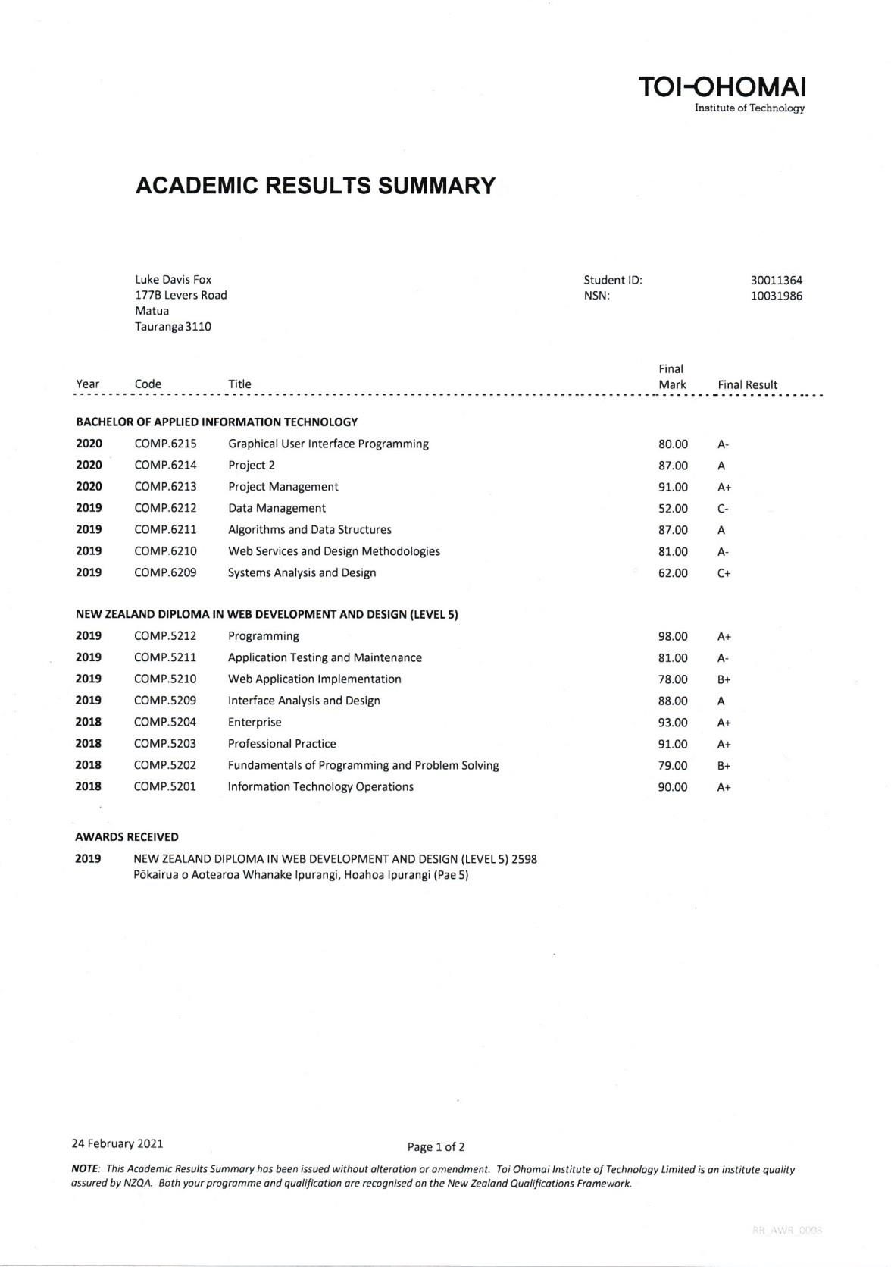

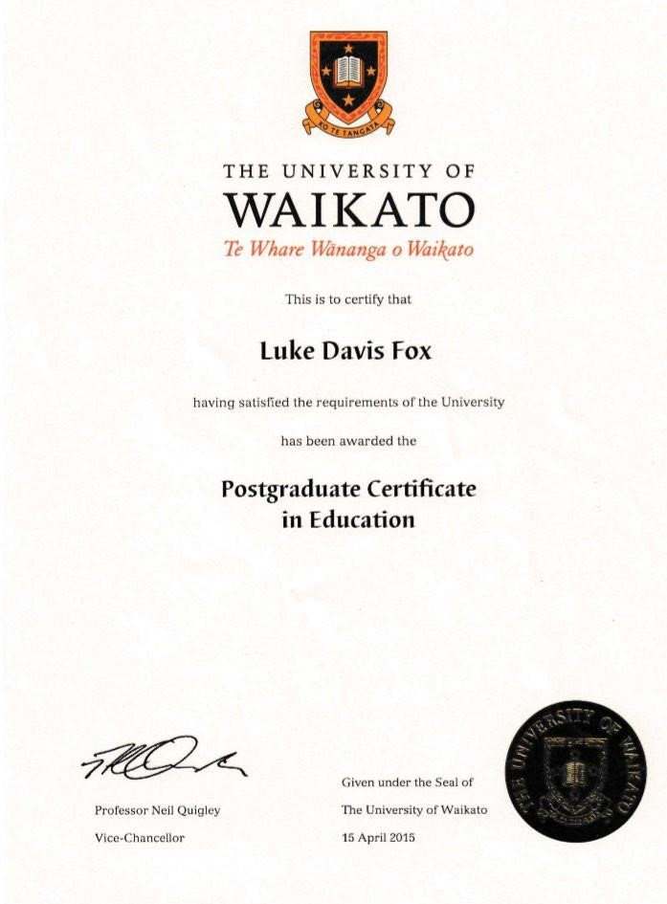

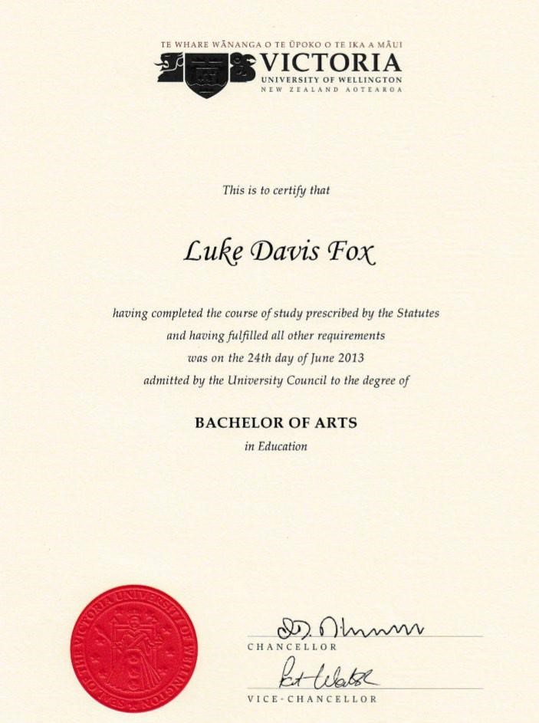

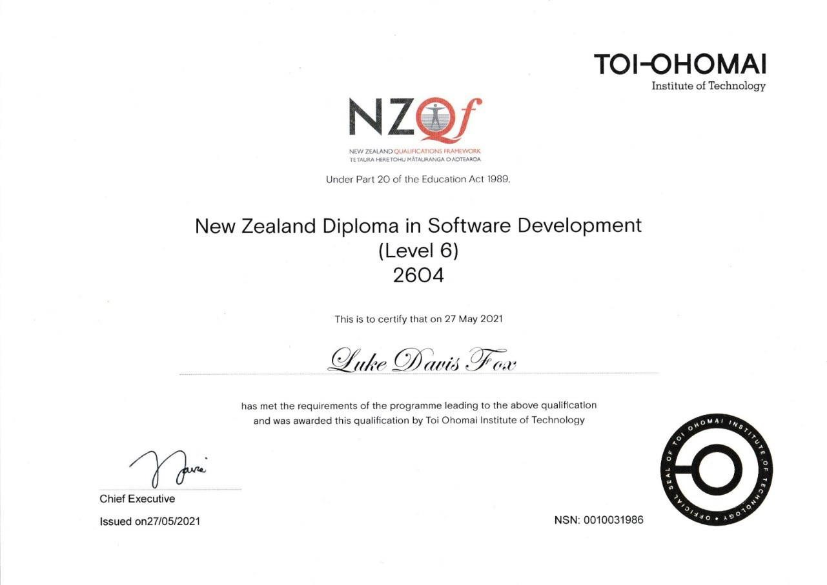

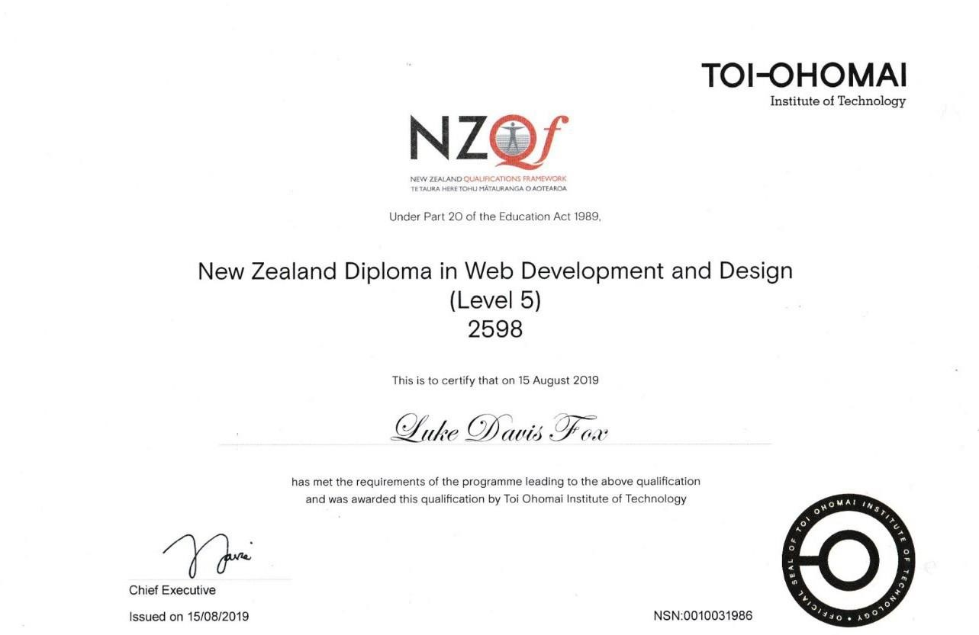

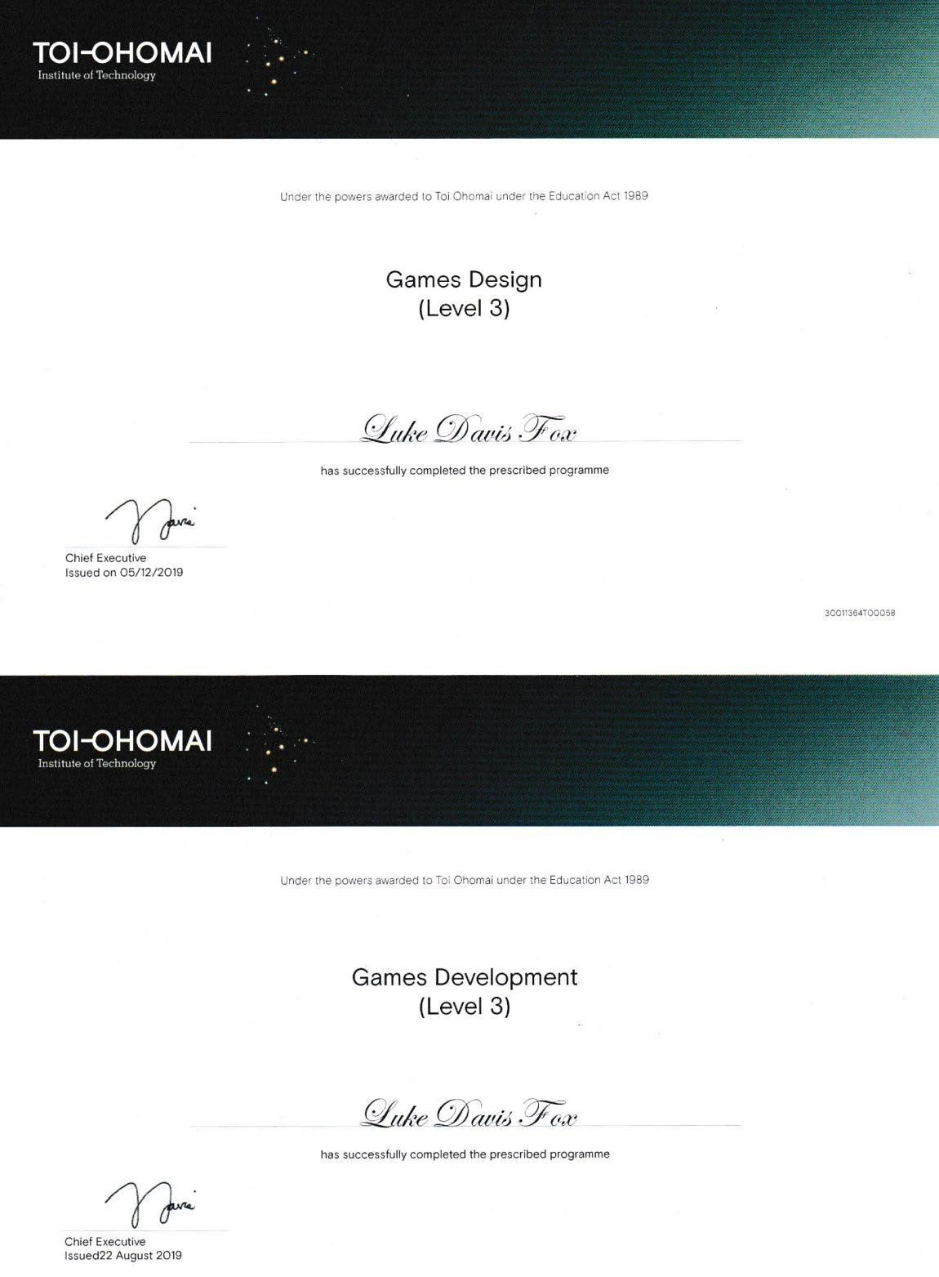

Please visit: <https://foxyflow.github.io/Portfolio> for more information and links; <https://github.com/foxyflow>for source codes and projects.