**Luke Davis Fox BA BSc**

**Programmer**

[**foxyflow@contractor.net**](mailto:foxyflow@contractor.net)

# Seeking

Software or Game development/design work. Or teaching programming. Have been applying for: Game studio positions; C# Unity positions; Unreal positions; teaching positions. Retail stores of interest such as Retro game or CeX game stores. Not seeking blockchain development however if you are, email above.

Public: C# Unity Project (Windows only; currently optimising for Android port).

Videogame released on itch.io

<https://foxyflow.itch.io/segas-tower-of-power>

(or play over the browser in my portfolio)

Private: Projects in the works (project for C++ work)

C and Assembly 68000: Creating an action retrogame to teach programming

Raspberry Pi PicoW C++ and Python to accommodate networking.

**Summary**

*I enjoy programming and design, however, am not limited to programming, I have retail and other IT experience.*

Previous Employer: Easter 2023 to late 2024 – Fulltime IT Technician and Consultant for Geeks on Wheels in NZ. However, have moved to Greater London UK.

# Skills from educational and work experience

**Experience:**

###### Educational Experience:

* Linux Bash
* Python
* ASP.Net Core
* C# Object Oriented.
* Web Development (JavaScript, CSS, HTML)
* Blockchain (Solidity, Hardhat, Truffle)

###### Software:

* Unreal Engine
* Unity 3D Software (C#)
* Visual Studio
* Adobe Suite software
* Microsoft 365 software
* API creation using JSON
* PHP
* SQL
* C++

###### Software:

* Maya
* Trello (Kanban and Scrum)
* Java Software (Weka for Machine Learning)
* Postman (Backend testing)
* Ubuntu on Windows (Bash)

# Portfolio

[**https://foxyflow.github.io/Portfolio/**](https://foxyflow.github.io/Portfolio/)

Ultimate roll-a-ball Unity game, find switches to activate different songs: <https://www.youtube.com/watch?v=uMmfBBgyuCo>

A series of lessons teaching programming concepts in Python via making a brick-buster game **https://tinyurl.com/LukesLessonsPlaylist**

# Computer experience

After graduating in Applied Computer Science, I worked on a blockchain project for a tattoo artist. The website converted your artwork into an NFT using the ERC721 standard smart-contract and connected to MetaMask.

<https://github.com/foxyflow/BlockchainWork>

###### Additional information

* + I hold a spouse visa for the UK, there is no need for any sponsorship. I simply convert the visa to a working visa after getting the job; The employer does not have to do anything.
  + I hold a current passport, full car, and learner bike license.
  + *Personal hobbies:* Chess; puzzle games; guitar; skateboarding; electronics.

###### Software role-models

John Carmack; Tim Sweeney; Bjarne Stroustrup; Paul Morris; Jacob Van Silfhout**.**

# Work experience

**IT Technician and Consultant** 2023 to Late 2024 for Geeks on Wheels.

**Printer Technician** at Brother New Zealand. Late 2022 to early 2023.

Developing a 2D retro pixel-art game for Tattoo World using Assembly6502 and NES Maker.

2022 to 2023. Edited NES Maker’s Documentation from all the spelling and grammar errors.

**Blockchain software developer** for NFT_Flash (January 2022 to April with small start-up company).

**Software consultant** for Manaaki (August. 2021 to December 2021 with Manaaki)

Helping small businesses by teaching the importance of learning programming via a series of videos to understand what is behind the software they pay for, EG Web-builders vs Web-developers, and demonstrating my brand design for ideas about their brand.

Unrelated software work history (while at university)

**Interior Plastering**

Self-employed for several years. *(April 2014 to 2020.)*

Foxstop Plaster Service *(2010 to March 2014.)*

## Weekend Hostel Manager

***Brookfield Accommodation Hamilton NZ*** *(2006 to 2010 4years 4months.)*

This job required administration and management skills; organising trades; managing; diverse and adverse people; Eftpos and till float management; collecting rent; Excel; reports and recommendations etc.

## Barista

#### Red Cart Hamilton East (4+ years while working at Brookfield Accommodation.)

I volunteered mornings for perfecting coffee skills with Rob at Red Cart Hamilton East for many years and remain good friends. If the beans and milk are fresh, I’ll make you a perfect coffee (unless you want sugar).

***Teacher***

Ministry of Education Wellington (6 months set-time contract)

Teaching high school Math. and English NCEA levels. *(2005.)*

Youth Horizons Porirua Wellington (1 year)

Teaching with outdoor activities such as skateboarding. Ages 12 to 15 with

‘Conduct disorders’ (contract with Youth Horizons Porirua Wellington) *(2004.)*

Music Teacher

Teaching guitar over the years to a range of children and adults. *(2001 – 2007 -- 7+ years part-time while studying.)*

# Referees

###### Character reference:

Donavan Hartel Geeks on Wheels

+64212085166

Rob Parr: Coffee maker:

+64221082847

###### Programming teachers and IT work reference:

Any Manager at Geeks on Wheels: 08004ageek (NZ)

Andrew Chapman*:* former graduate programming supervisor -- Project and Project Management.

[Andrew.chapman@toiohomai.ac.nz](mailto:Andrew.chapman@toiohomai.ac.nz)

Paul Morris: former GUI UI C# UWP (ASP.NET) Teacher from Manchester -- Paul worked on the

first Tomb Raider game.

[paul.morris@toiohomai.ac.nz](mailto:paul.morris@toiohomai.ac.nz%20)

Unrelated employment history: Construction

* + Phil Wickens painter -- 02108575915
  + PM building LTD Phil Murry -- 021-231-1879
  + Luke Blackman, builder -- 027-6901043

###### Hospitality

Former manager at hostel. Colin Nordstrom: +6421-831-094

# Formal Education

*Bachelor of Science: Major in Applied Computing (University of Waikato).*

Class representative, volunteering for these papers: Statistics for Science, Applied Computing Tools, and Advanced Database Concepts. Plus, managing and playing in the University of Waikato’s basketball team (good times).

###### Former tertiary education

* Postgraduate Certificate in Education (University of Waikato).
* Bachelor of Arts Major in Education (Victoria University of Wellington).
* Contemporary Music Certificate (Nelson School of Music). ➢ Teacher Aide Certificate

(University of Canterbury).

Please visit: <https://foxyflow.github.io/Portfolio> for certification and other projects.

<https://github.com/foxyflow> for source code.

### Certificates and Transcripts

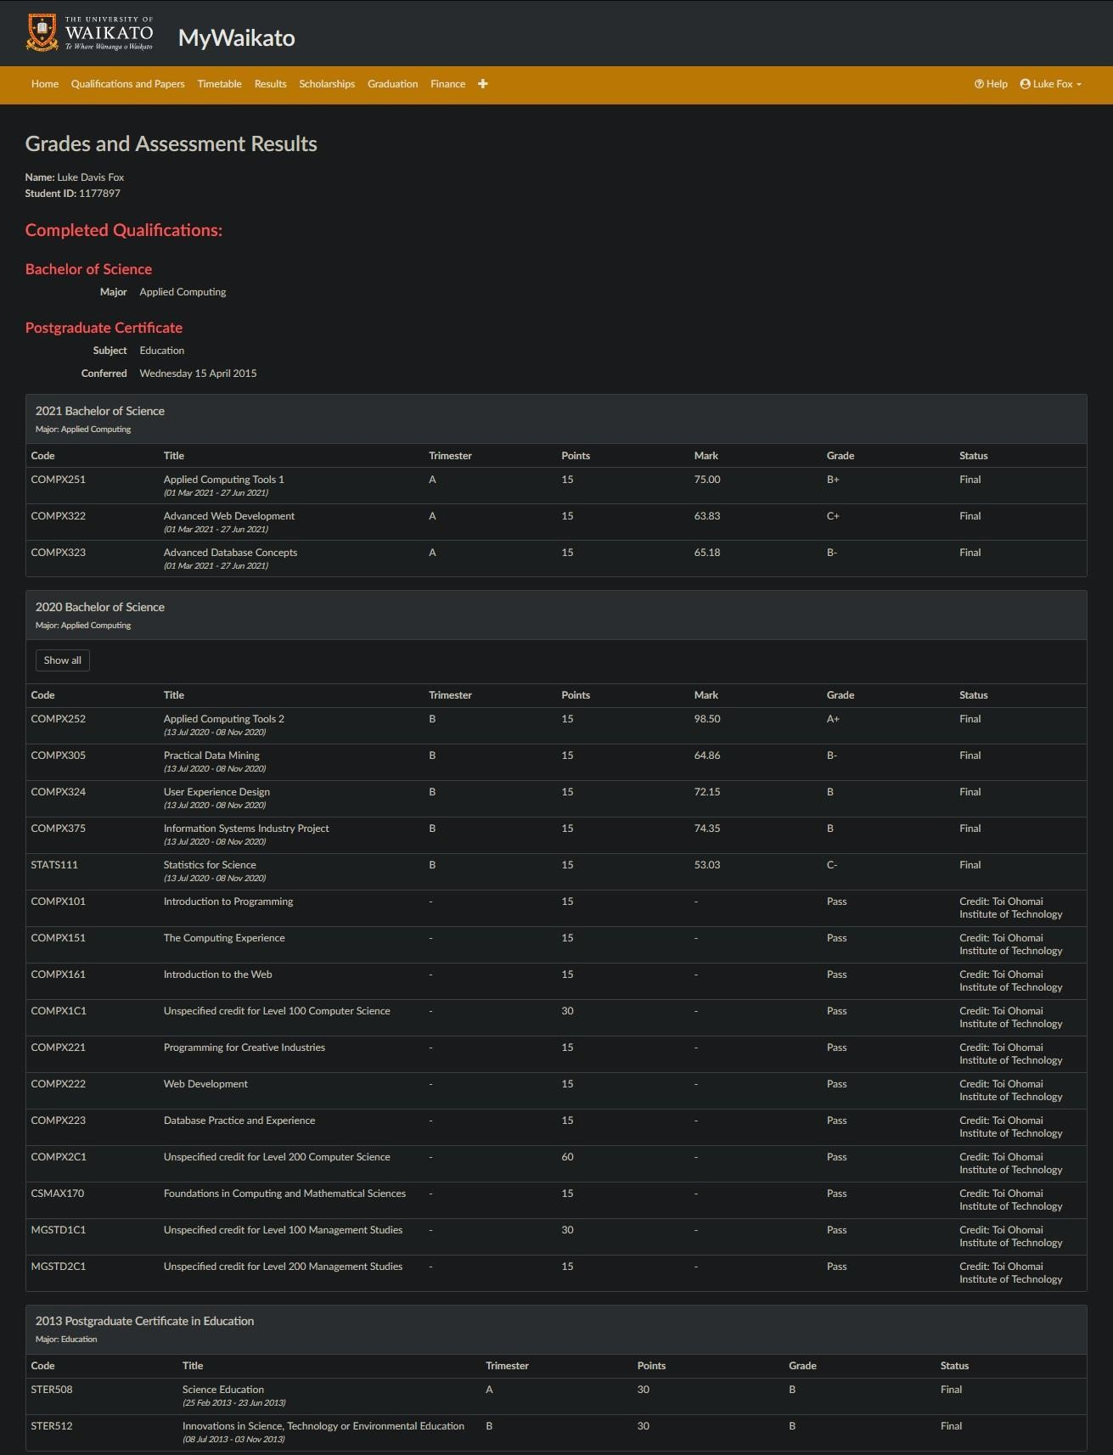

##### Luke Fox 2024 CV

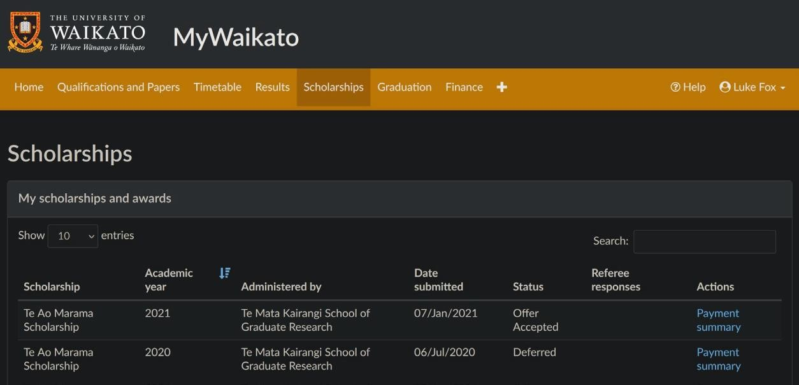

Awarded: University of Waikato’s Te Ao Marama Graduate Scholarship

Luke Fox CV 2024

**TOI-OHO MAI**

**Institute of Technology**

**ACADEMIC RESULTS SUMMARY**

**Luke Davis Fox** 1778 Levers Road Matua Tauranga3110

Student 10; NSN:

30011364

10031986

**Year** Code Title

Final

Mark Final Result

**BACHELOR OF APPLIED INFORMATION** TECHNOLOGY

|  |  |  |  |  |
| --- | --- | --- | --- | --- |
| **2020** | COMP.6215 | Graphical User Interface Programming | 80.00 | A- |
| **2020** | COMP.6214 | Project 2 | 87.00 | **A** |
| **2020** | COMP.6213 | **Project Management** | 91.00 | **A+** |
| **2019** | COMP.6212 | Data Management | 52.00 | C- |
| **2019** | COMP.6211 | Algorithms and Data Structures | 87.00 | **A** |
| **2019** | COMP.6210 | Web Services and Design Methodologies | 81.00 | A- |
| **2019** | COMP.6209 | Systems Analysis and Design | 62.00 | C+ |

**NEW ZEALAND DIPLOMA IN WEB DEVELOPMENT AND DESIGN !LEVEL51**

|  |  |  |  |  |
| --- | --- | --- | --- | --- |
| **2019** | COMP.5212 | Programming | 98.00 | **A+** |
| **2019** | COMP.5211 | **Application Testingand Maintenance** | 81.00 | A- |
| **2019** | COMP.5210 | Web Application Implementation | 78.00 | B+ |
| **2019** | COMP.5209 | **Interface Analysis and Design** | 88.00 | **A** |
| **2018** | COMP.5204 | **Enterprise** | 93.00 | **A+** |
| **2018** | COMP.5203 | **Professional Practice** | 91.00 | **A+** |
| **2018** | COMP.5202 | Fundamentals of Programming and Problem Solving | 79.00 | B+ |
| **2018** | COMP.5201 | Information Technology Operations | 90.00 | **A+** |

**AWARDS RECEIVED**

**2019** NEW ZEALAND DIPLOMA IN WEB DEVELOPMENT AND DESIGN {LEVELS) 2598

Piikairua o Aotearoa Whanake lpurangi, Hoahoa lpurangi (Pae 5)

24 February 2021 Page **1** of 2

***NOTE: Th{s Academic f?esultsSummory hos been Issued* wirhour *olrerorlat1 or omer,d,nem. Toi Ohomai lnsOtute- of Technology Umited is*an *institutequality assured by NZQA. Both your programme afld qualificuc;on ure recognisedon the New Zealand Qua/JJ,-corionsframework.***

##### Luke Fox CV 2024

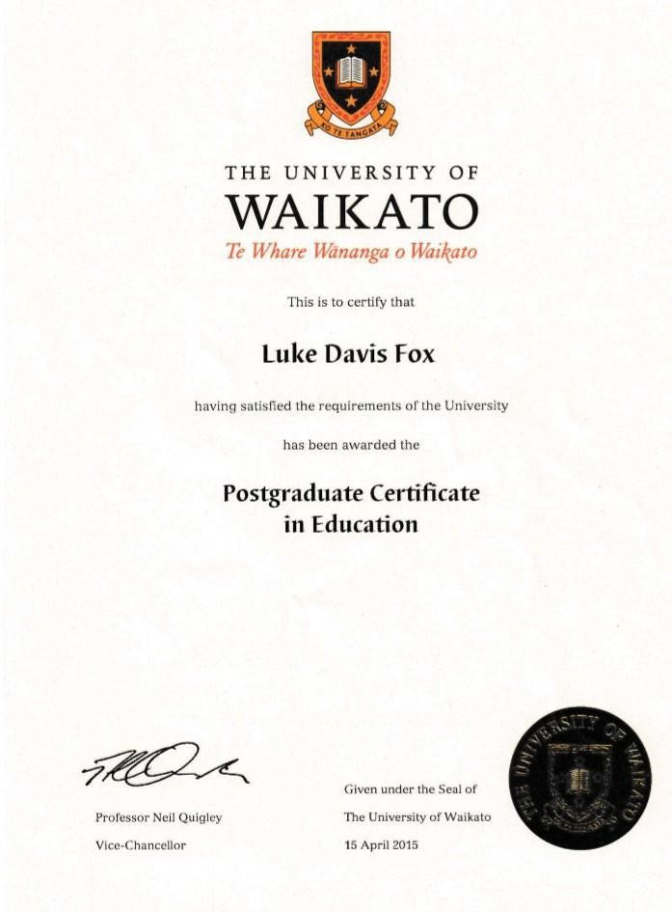

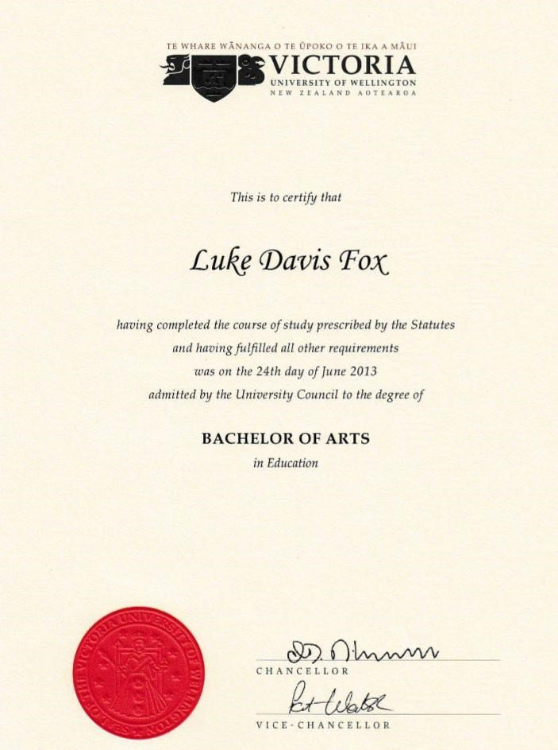

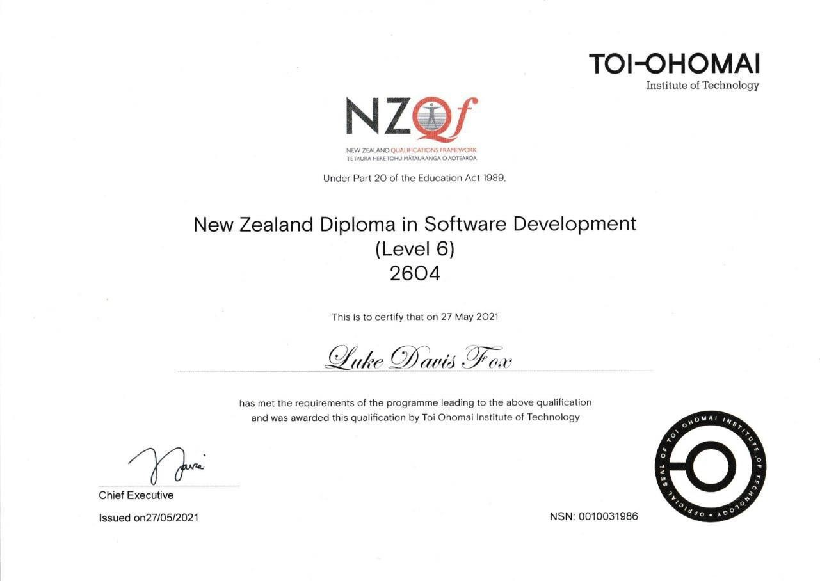

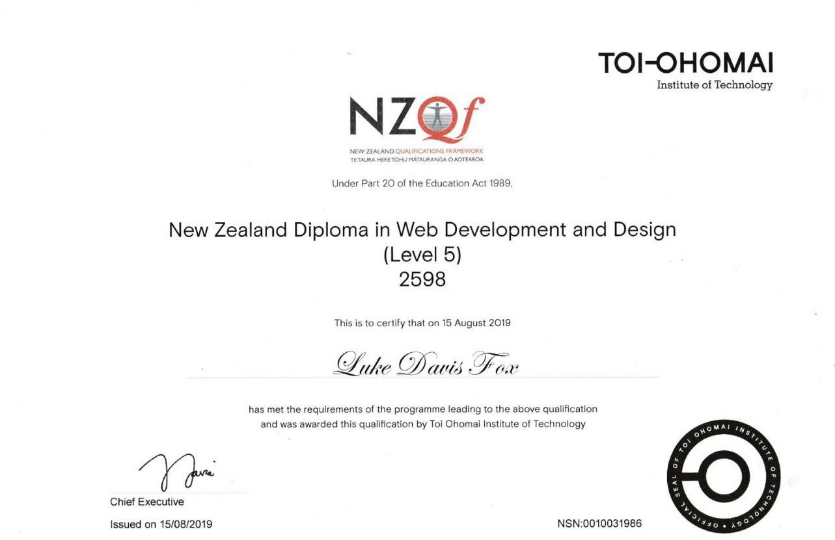





Chief Executive

**Issued** on 05/12/2019



Chief Executive

lssued22 August 2019

Under the pov1ers awarded to Toi Oh□mai under the Educat on Act 1989

Games Design (Level 3)



has successfully completed the prescribed programme



Under the powers awarded 10 Toi Ohomai under the Education Act 1989

**Games Development**

(Level 3)



has successfully completed the prescribed programme



THE **UNIVERSITY OF**



**WAIKATO**

*Te Whare Wananga o Uizikato*

This ts 10 cen1fy that

**Luke Davis Fox**

having satisfied the requuements of the University has been admitted to the Degree of

**Bachelor of Science major in Applied Computing**





Professor Neil Quigley

Vice-Chancellor

Given under the Seal of The University of Waikato I Apnl 2023