# Documentation for the RGB Kit: The Thief

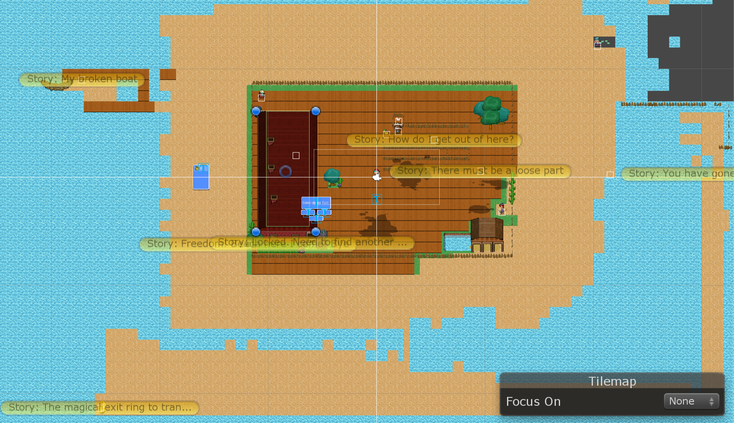

Figure 1: The map.

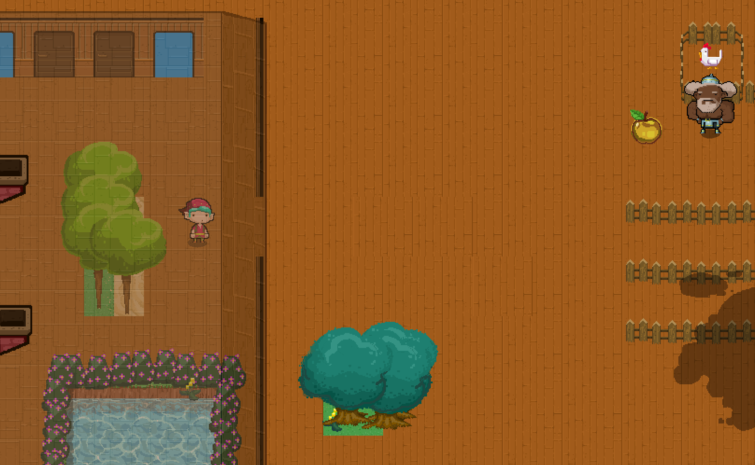

Figure 2: game play.

The game: You are a thief that ran away from a town to avoid jail. However, your boat crashed into the docks of an unknown island in the Pacific. Yes even, Google does not know about this and there is no cell phone towers.

You are hungry, you find an apple, however it belongs to a big farmer; he is angry. You go out to look for another one to pay him back. There are other charismatic characters to talk to and do quests. One may even help you get off the island… Use WASD and arrows/spacebar.