BRAHL PLATFORM
DEFECT ASSESSMENT REPORT
Date: 07 July 2026
Executive Summary
This report summarizes defects identified during execution of the Atomic77 suite within the BRAHL platform. The execution engine completed successfully; however, reporting, dashboard accessibility, and statistics consistency issues were observed.
ID | Issue | Severity | Priority
BRAHL-001 | Inconsistent Pass Counts | High | P1
BRAHL-002 | zDash File Not Found | Critical | P1
BRAHL-003 | Loop Recovery Visibility | Medium | P2
BRAHL-004 | Run vs Analyze Mismatch | High | P1

BRAHL-001 – Inconsistent Pass Count Reporting
Severity: High / Critical as noted in summary
Issue Description
Analyze displays varying counts such as 2, 33, and 71 passes across runs, while execution summaries show different totals.
Expected vs Actual Result
Expected: All modules display identical finalized execution counts.
Actual: Different modules display different totals.
Recommended Action
Standardize data sources, validate file paths, improve audit tracking, and ensure all modules use the same execution dataset.
Evidence Screenshots
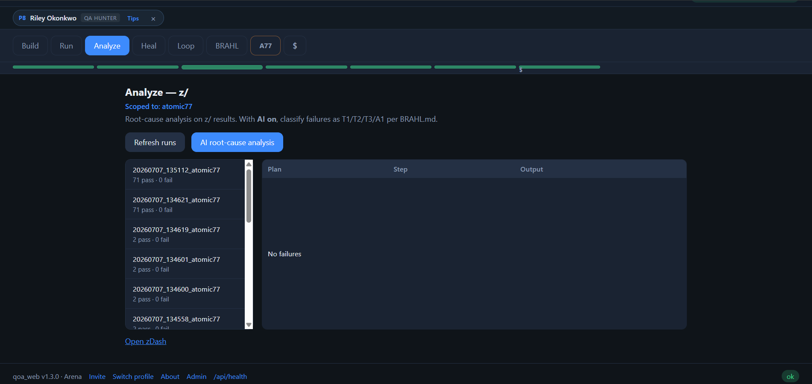
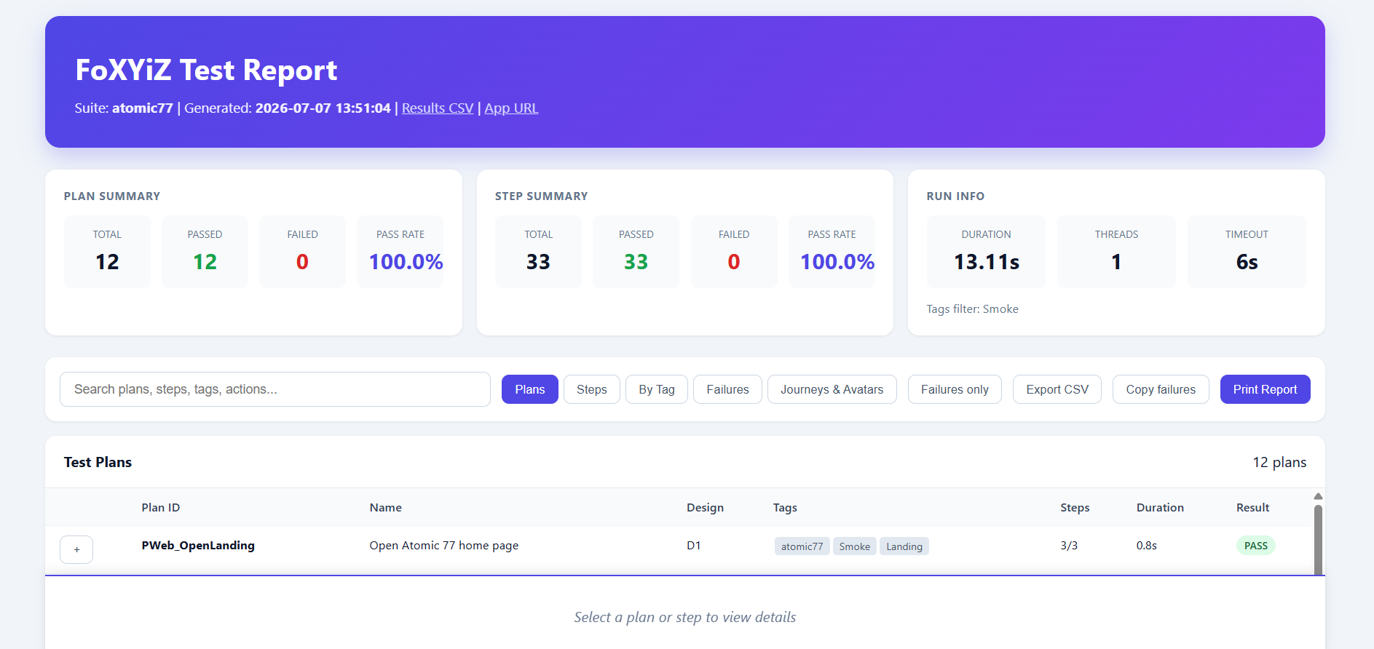

BRAHL-002 – zDash Accessibility Failure
Severity: High / Critical as noted in summary
Issue Description
After successful execution, clicking View zDash returns 'File not found' even though results exist and are visible elsewhere.
Expected vs Actual Result
Expected: Generated zDash opens directly from Run module.
Actual: File not found error is returned.
Recommended Action
Standardize data sources, validate file paths, improve audit tracking, and ensure all modules use the same execution dataset.
Evidence Screenshots
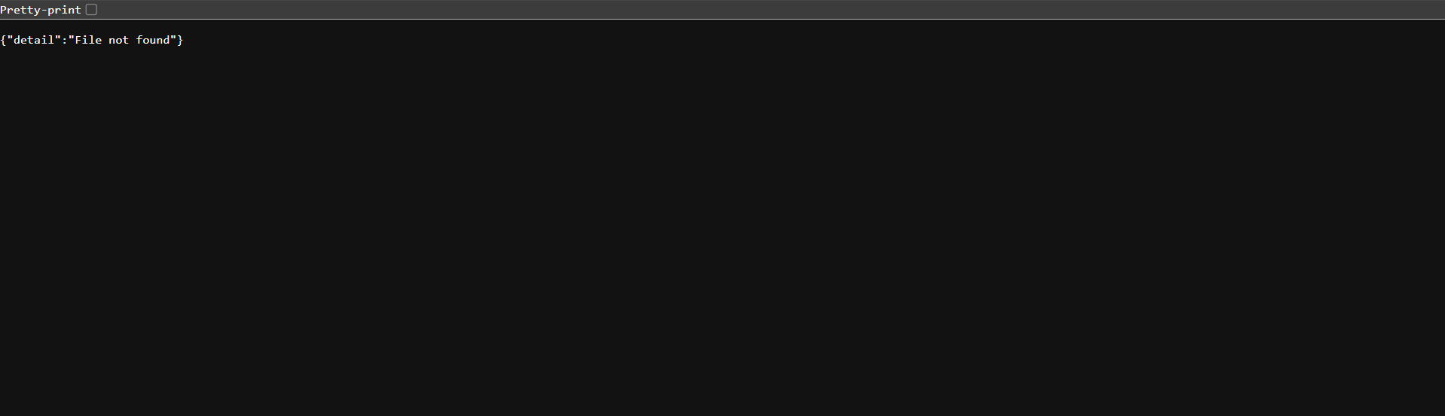
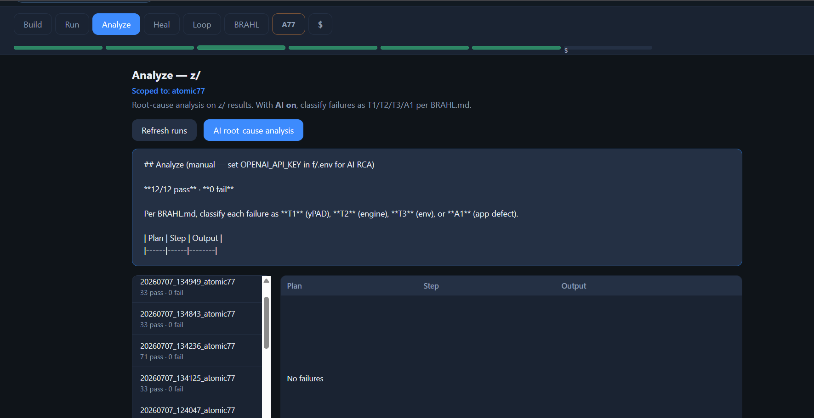

BRAHL-003 – Loop Failure Recovery Tracking
Severity: High / Critical as noted in summary
Issue Description
Two plans failed after tag modifications. Loop → Failures recovered the failures and Verify-Full passed all plans, but recovery history is not clearly presented.
Expected vs Actual Result
Expected: Recovery status should be visible in final reporting.
Actual: Recovery workflow lacks clear traceability.
Recommended Action
Standardize data sources, validate file paths, improve audit tracking, and ensure all modules use the same execution dataset.
Evidence Screenshots
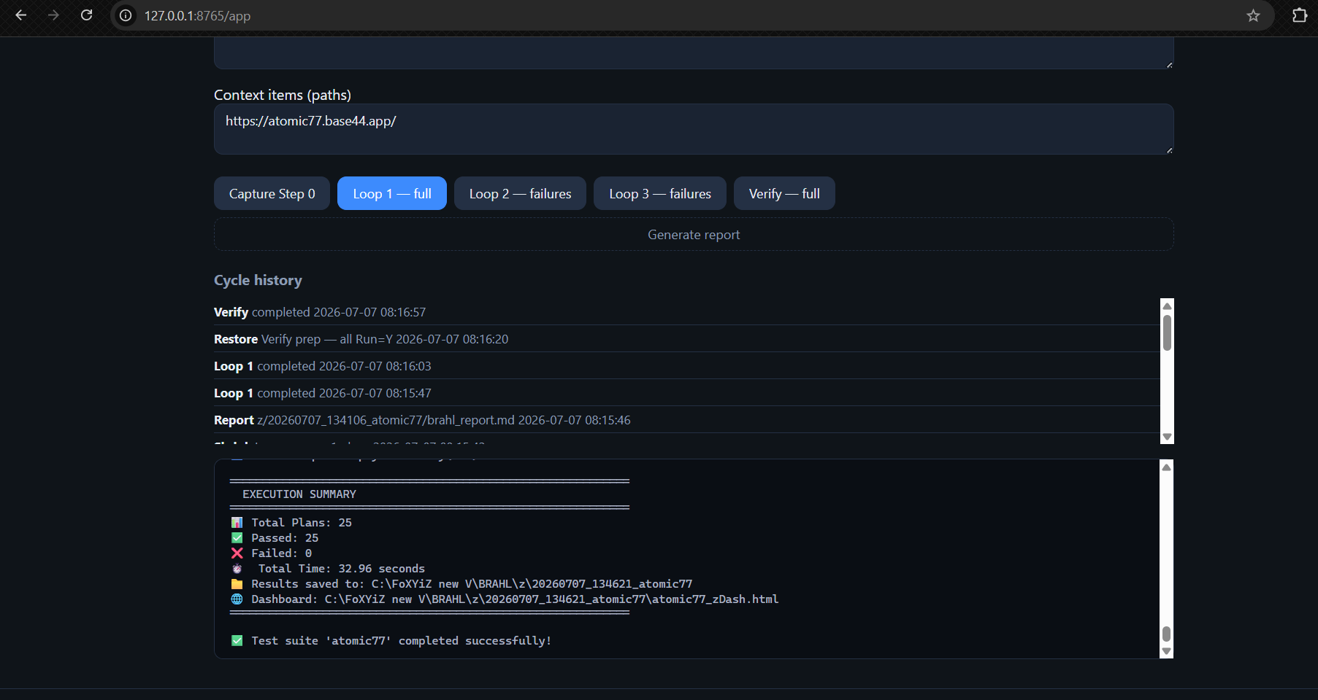
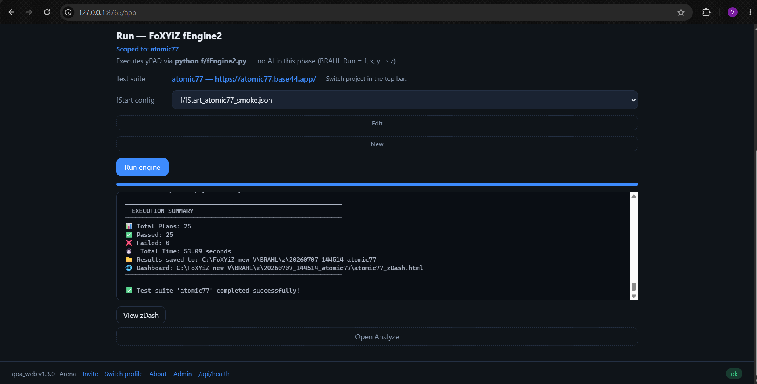
BRAHL-004 – Run and Analyze Statistics Mismatch
Severity: High / Critical as noted in summary
Issue Description
Run summaries and Analyze statistics appear to use different counting logic, resulting in conflicting metrics.
Expected vs Actual Result
Expected: Unified statistics across all modules.
Actual: Run and Analyze display different values.
Recommended Action
Standardize data sources, validate file paths, improve audit tracking, and ensure all modules use the same execution dataset.
Evidence Screenshots
