Rhidmo

Table of Contents
1 What is Rhidmo? 1
1.1 Introduction 1
1.2 Prerequisites 1
2 Installation 2
2.1 Deploy the EAR 2
2.2 Create RHIDMO_RT Datasource 3
2.3 Set Application Parameters 5
3 Use Rhidmo 7
4 Trouble Shooting 8
4.1 Configuration 8
4.2 Log Viewer 8
5 Licenses 10
5.1 Rhidmo 10
5.2 ByteBuddy 13
5.3 SLF4J 13
5.4 Rhino 14
5.5 INI4J 26

What is Rhidmo?

Introduction

Prerequisites

Installation
This chapter describes the installation of Rhidmo on the JAVA AS server. It assumes that the IDM WebDynPro GUI application (“IDM GUI”) is successfully installed on the same machine. Is is possible to install the IDM GUI application on more than one machine. If so, please install Rhidmo on machines where the IDM GUI is installed.

Deploy the EAR
There are several ways to deploy an EAR file to the SAP Java AS serve. One of the easiest is proably using the telnet interface.
1. Copy the EAR file to the JAVA AS machine. Make sure that the <sid>adm user is able to read the file.
2. Use the telnet program to connect to the telnet port (usually 50008) and log in using administrative privileges (WARNING: the telnet protocol is not encrypted, it is best used locally as shown in the screenshot below):
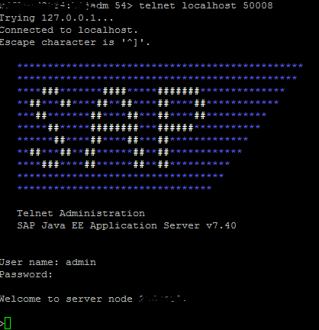
3. Deploy the application using the deploy command:
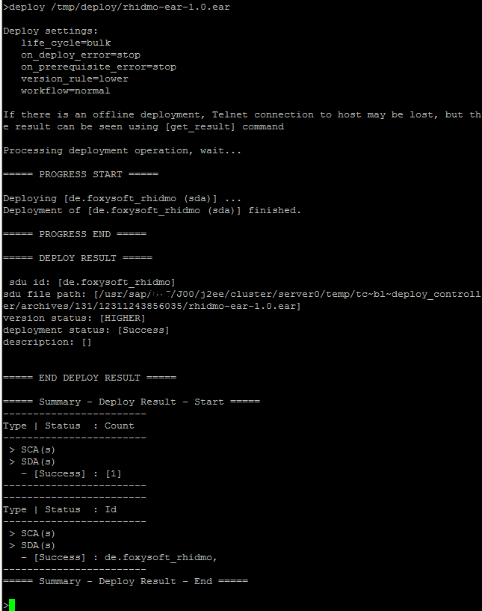
Watch for the “Success” message (as shown in the screenshot above). Correct any errors. Rhidmo is now deployed and must be configured before use. This is explained in the following chapter.

Create RHIDMO_RT Datasource
The standard IDM data source that is configured in JAVA AS uses the “<prefix>_prov” user which does not have sufficient privileges to be used with Rhidmo. Consequently, another data source must be configured with the “<prefix>_rt” user:
1. Log in with a SAP supported browser to the JAVA AS with a user with administrative privileges and start the Netweaver Administrator (URL: http://<machine>:<port>/nwa). Use https if available:
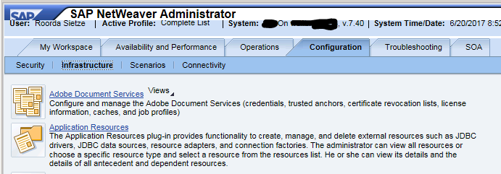
2. Go to “Configuration” → “Infrastructure” (as shown in the screenshot above) and click on the “Application Resources” link. Press the button “New JDBC Custom DataSource”:
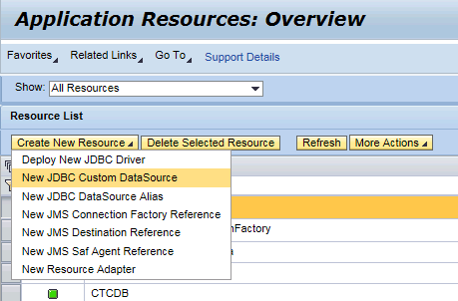
3. Fill in the form with the same values as for the “IDM_DataSource” Data Source. Please remember to exchange the “<prefix>_prov” user with the “<prefix>_rt” user (and adjust the password accordingly:
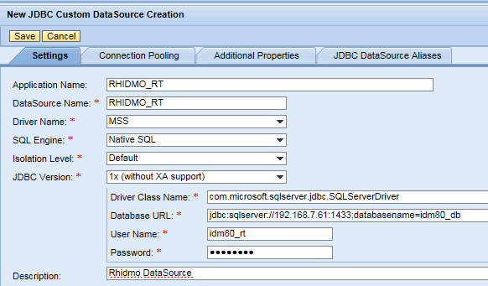
The screenshot above shows example values for the Microsoft SQL Server database using “idm80” as the prefix.

Set Application Parameters
1. While still in NWA, go to “Configuration” → “Infrastructure”:
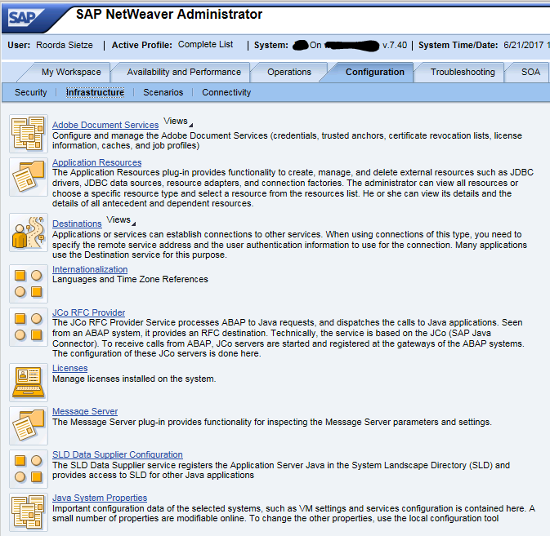
2. Press the link “Java System Properties” and find the tab “Applications” (somewhere in the middle. Filter on “idm” to see only SAP IDM relevant content:
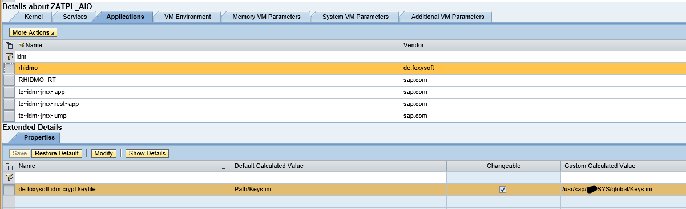
3. Change the property “de.foxysoft.idm.crypt.file” to have the same value as the property “com.sap.idm.jmx.crypt.keyfile” of the “tc~idm~jmx~app” application. Press the “Save” button to store your changes.

Use Rhidmo
Each form that needs to use Rhidmo must be configured. Please enter the following values in the form properties:
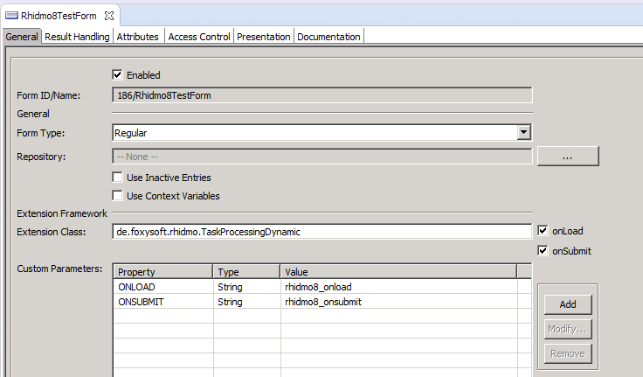
Use the extension class “de.foxysoft.rhidmo.TaskProcessingDynamic”. The “ONLOAD” and “ONSUBMIT” parameters denote the javascript functions to be called during the corresponding events. These functions must be declared in the same package where the form resides.

Trouble Shooting
Please check the JAVA AS log in case something goes wrong. If necessary, make sure that the log configuration shows the right amount of messages:
The log viewer can configured and accessed using the “/nwa” application (go to “Troubleshooting” → “Logs and Traces”):

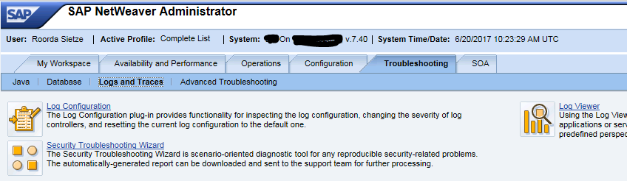
Configuration
By clicking on the link “Log Configration” you can configure the amount of logging that Rhidmo generates:
1. Select “Tracing Locations”:
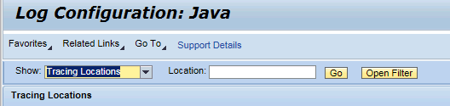
2. Then select “de.foxysoft.rhidmo” in the subtree below:
3. Select the log level you want from the dropdown box to the right and click on the “Copy to Subtree” button to copy this setting to all locations below.

Log Viewer
Click on the “Log Viewer” link to view the logs (Select the View “Developer Traces” to examine the Rhidmo logs):
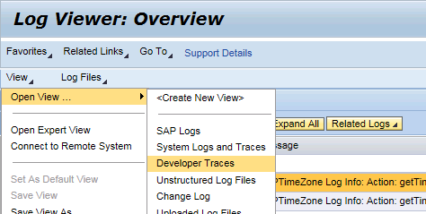
Example log:
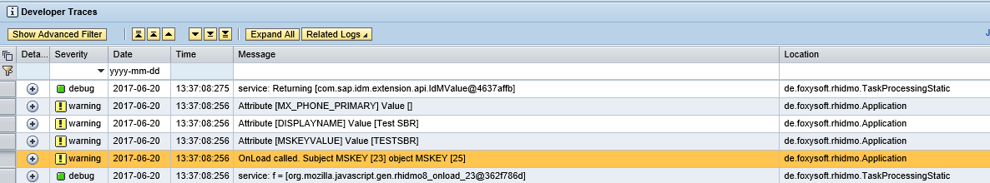

Licenses
This chapter details the licenses of Rhidmo itself and all the software libraries it uses. The definitive text can be found via the provided links; the text here is just a copy for your convenience.

Rhidmo
Rhidmo is licensed under the Apache License, Version 2.0 (the “License”). You can find the license at
http://www.apache.org/licenses/LICENSE-2.0
Apache License
Version 2.0, January 2004
http://www.apache.org/licenses/

TERMS AND CONDITIONS FOR USE, REPRODUCTION, AND DISTRIBUTION
1. Definitions.
"License" shall mean the terms and conditions for use, reproduction, and distribution as defined by Sections 1 through 9 of this document.
"Licensor" shall mean the copyright owner or entity authorized by the copyright owner that is granting the License.
"Legal Entity" shall mean the union of the acting entity and all other entities that control, are controlled by, or are under common control with that entity. For the purposes of this definition, "control" means (i) the power, direct or indirect, to cause the direction or management of such entity, whether by contract or otherwise, or (ii) ownership of fifty percent (50%) or more of the outstanding shares, or (iii) beneficial ownership of such entity.
"You" (or "Your") shall mean an individual or Legal Entity exercising permissions granted by this License.
"Source" form shall mean the preferred form for making modifications, including but not limited to software source code, documentation source, and configuration files.
"Object" form shall mean any form resulting from mechanical transformation or translation of a Source form, including but not limited to compiled object code, generated documentation, and conversions to other media types.
"Work" shall mean the work of authorship, whether in Source or Object form, made available under the License, as indicated by a copyright notice that is included in or attached to the work (an example is provided in the Appendix below).
"Derivative Works" shall mean any work, whether in Source or Object form, that is based on (or derived from) the Work and for which the editorial revisions, annotations, elaborations, or other modifications represent, as a whole, an original work of authorship. For the purposes of this License, Derivative Works shall not include works that remain separable from, or merely link (or bind by name) to the interfaces of, the Work and Derivative Works thereof.
"Contribution" shall mean any work of authorship, including the original version of the Work and any modifications or additions to that Work or Derivative Works thereof, that is intentionally submitted to Licensor for inclusion in the Work by the copyright owner or by an individual or Legal Entity authorized to submit on behalf of the copyright owner. For the purposes of this definition, "submitted" means any form of electronic, verbal, or written communication sent to the Licensor or its representatives, including but not limited to communication on electronic mailing lists, source code control systems, and issue tracking systems that are managed by, or on behalf of, the Licensor for the purpose of discussing and improving the Work, but excluding communication that is conspicuously marked or otherwise designated in writing by the copyright owner as "Not a Contribution."
"Contributor" shall mean Licensor and any individual or Legal Entity on behalf of whom a Contribution has been received by Licensor and subsequently incorporated within the Work.
2. Grant of Copyright License. Subject to the terms and conditions of this License, each Contributor hereby grants to You a perpetual, worldwide, non-exclusive, no-charge, royalty-free, irrevocable copyright license to reproduce, prepare Derivative Works of, publicly display, publicly perform, sublicense, and distribute the Work and such Derivative Works in Source or Object form.
3. Grant of Patent License. Subject to the terms and conditions of this License, each Contributor hereby grants to You a perpetual, worldwide, non-exclusive, no-charge, royalty-free, irrevocable (except as stated in this section) patent license to make, have made, use, offer to sell, sell, import, and otherwise transfer the Work, where such license applies only to those patent claims licensable by such Contributor that are necessarily infringed by their Contribution(s) alone or by combination of their Contribution(s) with the Work to which such Contribution(s) was submitted. If You institute patent litigation against any entity (including a cross-claim or counterclaim in a lawsuit) alleging that the Work or a Contribution incorporated within the Work constitutes direct or contributory patent infringement, then any patent licenses granted to You under this License for that Work shall terminate as of the date such litigation is filed.
4. Redistribution. You may reproduce and distribute copies of the Work or Derivative Works thereof in any medium, with or without modifications, and in Source or Object form, provided that You meet the following conditions:
You must give any other recipients of the Work or Derivative Works a copy of this License; and
You must cause any modified files to carry prominent notices stating that You changed the files; and
You must retain, in the Source form of any Derivative Works that You distribute, all copyright, patent, trademark, and attribution notices from the Source form of the Work, excluding those notices that do not pertain to any part of the Derivative Works; and
If the Work includes a "NOTICE" text file as part of its distribution, then any Derivative Works that You distribute must include a readable copy of the attribution notices contained within such NOTICE file, excluding those notices that do not pertain to any part of the Derivative Works, in at least one of the following places: within a NOTICE text file distributed as part of the Derivative Works; within the Source form or documentation, if provided along with the Derivative Works; or, within a display generated by the Derivative Works, if and wherever such third-party notices normally appear. The contents of the NOTICE file are for informational purposes only and do not modify the License. You may add Your own attribution notices within Derivative Works that You distribute, alongside or as an addendum to the NOTICE text from the Work, provided that such additional attribution notices cannot be construed as modifying the License.
You may add Your own copyright statement to Your modifications and may provide additional or different license terms and conditions for use, reproduction, or distribution of Your modifications, or for any such Derivative Works as a whole, provided Your use, reproduction, and distribution of the Work otherwise complies with the conditions stated in this License.
5. Submission of Contributions. Unless You explicitly state otherwise, any Contribution intentionally submitted for inclusion in the Work by You to the Licensor shall be under the terms and conditions of this License, without any additional terms or conditions. Notwithstanding the above, nothing herein shall supersede or modify the terms of any separate license agreement you may have executed with Licensor regarding such Contributions.
6. Trademarks. This License does not grant permission to use the trade names, trademarks, service marks, or product names of the Licensor, except as required for reasonable and customary use in describing the origin of the Work and reproducing the content of the NOTICE file.
7. Disclaimer of Warranty. Unless required by applicable law or agreed to in writing, Licensor provides the Work (and each Contributor provides its Contributions) on an "AS IS" BASIS, WITHOUT WARRANTIES OR CONDITIONS OF ANY KIND, either express or implied, including, without limitation, any warranties or conditions of TITLE, NON-INFRINGEMENT, MERCHANTABILITY, or FITNESS FOR A PARTICULAR PURPOSE. You are solely responsible for determining the appropriateness of using or redistributing the Work and assume any risks associated with Your exercise of permissions under this License.
8. Limitation of Liability. In no event and under no legal theory, whether in tort (including negligence), contract, or otherwise, unless required by applicable law (such as deliberate and grossly negligent acts) or agreed to in writing, shall any Contributor be liable to You for damages, including any direct, indirect, special, incidental, or consequential damages of any character arising as a result of this License or out of the use or inability to use the Work (including but not limited to damages for loss of goodwill, work stoppage, computer failure or malfunction, or any and all other commercial damages or losses), even if such Contributor has been advised of the possibility of such damages.
9. Accepting Warranty or Additional Liability. While redistributing the Work or Derivative Works thereof, You may choose to offer, and charge a fee for, acceptance of support, warranty, indemnity, or other liability obligations and/or rights consistent with this License. However, in accepting such obligations, You may act only on Your own behalf and on Your sole responsibility, not on behalf of any other Contributor, and only if You agree to indemnify, defend, and hold each Contributor harmless for any liability incurred by, or claims asserted against, such Contributor by reason of your accepting any such warranty or additional liability.
END OF TERMS AND CONDITIONS

ByteBuddy
ByteBuddy is distributed under the Apache 2.0 license. ByteBuddy depends on the ASM library which is distributed under a BSD license.

SLF4J
SLF4J is distributed under the MIT license.
Copyright (c) 2004-2017 QOS.ch
All rights reserved.
Permission is hereby granted, free of charge, to any person obtaining a copy of this software and associated documentation files (the "Software"), to deal in the Software without restriction, including without limitation the rights to use, copy, modify, merge, publish, distribute, sublicense, and/or sell copies of the Software, and to permit persons to whom the Software is furnished to do so, subject to the following conditions:
The above copyright notice and this permission notice shall be included in all copies or substantial portions of the Software.
THE SOFTWARE IS PROVIDED "AS IS", WITHOUT WARRANTY OF ANY KIND, EXPRESS OR IMPLIED, INCLUDING BUT NOT LIMITED TO THE WARRANTIES OF MERCHANTABILITY, FITNESS FOR A PARTICULAR PURPOSE AND NONINFRINGEMENT. IN NO EVENT SHALL THE AUTHORS OR COPYRIGHT HOLDERS BE LIABLE FOR ANY CLAIM, DAMAGES OR OTHER LIABILITY, WHETHER IN AN ACTION OF CONTRACT, TORT OR OTHERWISE, ARISING FROM, OUT OF OR IN CONNECTION WITH THE SOFTWARE OR THE USE OR OTHER DEALINGS IN THE SOFTWARE.

Rhino
Rhino is open source and is available under the MPL 2.0. Its contents are copied below:
Mozilla Public License Version 2.0
==================================

1. Definitions
--------------

1.1. "Contributor"
means each individual or legal entity that creates, contributes to
the creation of, or owns Covered Software.

1.2. "Contributor Version"
means the combination of the Contributions of others (if any) used
by a Contributor and that particular Contributor's Contribution.

1.3. "Contribution"
means Covered Software of a particular Contributor.

1.4. "Covered Software"
means Source Code Form to which the initial Contributor has attached
the notice in Exhibit A, the Executable Form of such Source Code
Form, and Modifications of such Source Code Form, in each case
including portions thereof.

1.5. "Incompatible With Secondary Licenses"
means

(a) that the initial Contributor has attached the notice described
in Exhibit B to the Covered Software; or

(b) that the Covered Software was made available under the terms of
version 1.1 or earlier of the License, but not also under the
terms of a Secondary License.

1.6. "Executable Form"
means any form of the work other than Source Code Form.

1.7. "Larger Work"
means a work that combines Covered Software with other material, in
a separate file or files, that is not Covered Software.

1.8. "License"
means this document.

1.9. "Licensable"
means having the right to grant, to the maximum extent possible,
whether at the time of the initial grant or subsequently, any and
all of the rights conveyed by this License.

1.10. "Modifications"
means any of the following:

(a) any file in Source Code Form that results from an addition to,
deletion from, or modification of the contents of Covered
Software; or

(b) any new file in Source Code Form that contains any Covered
Software.

1.11. "Patent Claims" of a Contributor
means any patent claim(s), including without limitation, method,
process, and apparatus claims, in any patent Licensable by such
Contributor that would be infringed, but for the grant of the
License, by the making, using, selling, offering for sale, having
made, import, or transfer of either its Contributions or its
Contributor Version.

1.12. "Secondary License"
means either the GNU General Public License, Version 2.0, the GNU
Lesser General Public License, Version 2.1, the GNU Affero General
Public License, Version 3.0, or any later versions of those
licenses.

1.13. "Source Code Form"
means the form of the work preferred for making modifications.

1.14. "You" (or "Your")
means an individual or a legal entity exercising rights under this
License. For legal entities, "You" includes any entity that
controls, is controlled by, or is under common control with You. For
purposes of this definition, "control" means (a) the power, direct
or indirect, to cause the direction or management of such entity,
whether by contract or otherwise, or (b) ownership of more than
fifty percent (50%) of the outstanding shares or beneficial
ownership of such entity.

2. License Grants and Conditions
--------------------------------

2.1. Grants

Each Contributor hereby grants You a world-wide, royalty-free,
non-exclusive license:

(a) under intellectual property rights (other than patent or trademark)
Licensable by such Contributor to use, reproduce, make available,
modify, display, perform, distribute, and otherwise exploit its
Contributions, either on an unmodified basis, with Modifications, or
as part of a Larger Work; and

(b) under Patent Claims of such Contributor to make, use, sell, offer
for sale, have made, import, and otherwise transfer either its
Contributions or its Contributor Version.

2.2. Effective Date

The licenses granted in Section 2.1 with respect to any Contribution
become effective for each Contribution on the date the Contributor first
distributes such Contribution.

2.3. Limitations on Grant Scope

The licenses granted in this Section 2 are the only rights granted under
this License. No additional rights or licenses will be implied from the
distribution or licensing of Covered Software under this License.
Notwithstanding Section 2.1(b) above, no patent license is granted by a
Contributor:

(a) for any code that a Contributor has removed from Covered Software;
or

(b) for infringements caused by: (i) Your and any other third party's
modifications of Covered Software, or (ii) the combination of its
Contributions with other software (except as part of its Contributor
Version); or

(c) under Patent Claims infringed by Covered Software in the absence of
its Contributions.

This License does not grant any rights in the trademarks, service marks,
or logos of any Contributor (except as may be necessary to comply with
the notice requirements in Section 3.4).

2.4. Subsequent Licenses

No Contributor makes additional grants as a result of Your choice to
distribute the Covered Software under a subsequent version of this
License (see Section 10.2) or under the terms of a Secondary License (if
permitted under the terms of Section 3.3).

2.5. Representation

Each Contributor represents that the Contributor believes its
Contributions are its original creation(s) or it has sufficient rights
to grant the rights to its Contributions conveyed by this License.

2.6. Fair Use

This License is not intended to limit any rights You have under
applicable copyright doctrines of fair use, fair dealing, or other
equivalents.

2.7. Conditions

Sections 3.1, 3.2, 3.3, and 3.4 are conditions of the licenses granted
in Section 2.1.

3. Responsibilities
-------------------

3.1. Distribution of Source Form

All distribution of Covered Software in Source Code Form, including any
Modifications that You create or to which You contribute, must be under
the terms of this License. You must inform recipients that the Source
Code Form of the Covered Software is governed by the terms of this
License, and how they can obtain a copy of this License. You may not
attempt to alter or restrict the recipients' rights in the Source Code
Form.

3.2. Distribution of Executable Form

If You distribute Covered Software in Executable Form then:

(a) such Covered Software must also be made available in Source Code
Form, as described in Section 3.1, and You must inform recipients of
the Executable Form how they can obtain a copy of such Source Code
Form by reasonable means in a timely manner, at a charge no more
than the cost of distribution to the recipient; and

(b) You may distribute such Executable Form under the terms of this
License, or sublicense it under different terms, provided that the
license for the Executable Form does not attempt to limit or alter
the recipients' rights in the Source Code Form under this License.

3.3. Distribution of a Larger Work

You may create and distribute a Larger Work under terms of Your choice,
provided that You also comply with the requirements of this License for
the Covered Software. If the Larger Work is a combination of Covered
Software with a work governed by one or more Secondary Licenses, and the
Covered Software is not Incompatible With Secondary Licenses, this
License permits You to additionally distribute such Covered Software
under the terms of such Secondary License(s), so that the recipient of
the Larger Work may, at their option, further distribute the Covered
Software under the terms of either this License or such Secondary
License(s).

3.4. Notices

You may not remove or alter the substance of any license notices
(including copyright notices, patent notices, disclaimers of warranty,
or limitations of liability) contained within the Source Code Form of
the Covered Software, except that You may alter any license notices to
the extent required to remedy known factual inaccuracies.

3.5. Application of Additional Terms

You may choose to offer, and to charge a fee for, warranty, support,
indemnity or liability obligations to one or more recipients of Covered
Software. However, You may do so only on Your own behalf, and not on
behalf of any Contributor. You must make it absolutely clear that any
such warranty, support, indemnity, or liability obligation is offered by
You alone, and You hereby agree to indemnify every Contributor for any
liability incurred by such Contributor as a result of warranty, support,
indemnity or liability terms You offer. You may include additional
disclaimers of warranty and limitations of liability specific to any
jurisdiction.

4. Inability to Comply Due to Statute or Regulation
---------------------------------------------------

If it is impossible for You to comply with any of the terms of this
License with respect to some or all of the Covered Software due to
statute, judicial order, or regulation then You must: (a) comply with
the terms of this License to the maximum extent possible; and (b)
describe the limitations and the code they affect. Such description must
be placed in a text file included with all distributions of the Covered
Software under this License. Except to the extent prohibited by statute
or regulation, such description must be sufficiently detailed for a
recipient of ordinary skill to be able to understand it.

5. Termination
--------------

5.1. The rights granted under this License will terminate automatically
if You fail to comply with any of its terms. However, if You become
compliant, then the rights granted under this License from a particular
Contributor are reinstated (a) provisionally, unless and until such
Contributor explicitly and finally terminates Your grants, and (b) on an
ongoing basis, if such Contributor fails to notify You of the
non-compliance by some reasonable means prior to 60 days after You have
come back into compliance. Moreover, Your grants from a particular
Contributor are reinstated on an ongoing basis if such Contributor
notifies You of the non-compliance by some reasonable means, this is the
first time You have received notice of non-compliance with this License
from such Contributor, and You become compliant prior to 30 days after
Your receipt of the notice.

5.2. If You initiate litigation against any entity by asserting a patent
infringement claim (excluding declaratory judgment actions,
counter-claims, and cross-claims) alleging that a Contributor Version
directly or indirectly infringes any patent, then the rights granted to
You by any and all Contributors for the Covered Software under Section
2.1 of this License shall terminate.

5.3. In the event of termination under Sections 5.1 or 5.2 above, all
end user license agreements (excluding distributors and resellers) which
have been validly granted by You or Your distributors under this License
prior to termination shall survive termination.

************************************************************************
* *
* 6. Disclaimer of Warranty *
* ------------------------- *
* *
* Covered Software is provided under this License on an "as is" *
* basis, without warranty of any kind, either expressed, implied, or *
* statutory, including, without limitation, warranties that the *
* Covered Software is free of defects, merchantable, fit for a *
* particular purpose or non-infringing. The entire risk as to the *
* quality and performance of the Covered Software is with You. *
* Should any Covered Software prove defective in any respect, You *
* (not any Contributor) assume the cost of any necessary servicing, *
* repair, or correction. This disclaimer of warranty constitutes an *
* essential part of this License. No use of any Covered Software is *
* authorized under this License except under this disclaimer. *
* *
************************************************************************

************************************************************************
* *
* 7. Limitation of Liability *
* -------------------------- *
* *
* Under no circumstances and under no legal theory, whether tort *
* (including negligence), contract, or otherwise, shall any *
* Contributor, or anyone who distributes Covered Software as *
* permitted above, be liable to You for any direct, indirect, *
* special, incidental, or consequential damages of any character *
* including, without limitation, damages for lost profits, loss of *
* goodwill, work stoppage, computer failure or malfunction, or any *
* and all other commercial damages or losses, even if such party *
* shall have been informed of the possibility of such damages. This *
* limitation of liability shall not apply to liability for death or *
* personal injury resulting from such party's negligence to the *
* extent applicable law prohibits such limitation. Some *
* jurisdictions do not allow the exclusion or limitation of *
* incidental or consequential damages, so this exclusion and *
* limitation may not apply to You. *
* *
************************************************************************

8. Litigation
-------------

Any litigation relating to this License may be brought only in the
courts of a jurisdiction where the defendant maintains its principal
place of business and such litigation shall be governed by laws of that
jurisdiction, without reference to its conflict-of-law provisions.
Nothing in this Section shall prevent a party's ability to bring
cross-claims or counter-claims.

9. Miscellaneous
----------------

This License represents the complete agreement concerning the subject
matter hereof. If any provision of this License is held to be
unenforceable, such provision shall be reformed only to the extent
necessary to make it enforceable. Any law or regulation which provides
that the language of a contract shall be construed against the drafter
shall not be used to construe this License against a Contributor.

10. Versions of the License
---------------------------

10.1. New Versions

Mozilla Foundation is the license steward. Except as provided in Section
10.3, no one other than the license steward has the right to modify or
publish new versions of this License. Each version will be given a
distinguishing version number.

10.2. Effect of New Versions

You may distribute the Covered Software under the terms of the version
of the License under which You originally received the Covered Software,
or under the terms of any subsequent version published by the license
steward.

10.3. Modified Versions

If you create software not governed by this License, and you want to
create a new license for such software, you may create and use a
modified version of this License if you rename the license and remove
any references to the name of the license steward (except to note that
such modified license differs from this License).

10.4. Distributing Source Code Form that is Incompatible With Secondary
Licenses

If You choose to distribute Source Code Form that is Incompatible With
Secondary Licenses under the terms of this version of the License, the
notice described in Exhibit B of this License must be attached.

Exhibit A - Source Code Form License Notice
-------------------------------------------

This Source Code Form is subject to the terms of the Mozilla Public
License, v. 2.0. If a copy of the MPL was not distributed with this
file, You can obtain one at http://mozilla.org/MPL/2.0/.

If it is not possible or desirable to put the notice in a particular
file, then You may include the notice in a location (such as a LICENSE
file in a relevant directory) where a recipient would be likely to look
for such a notice.

You may add additional accurate notices of copyright ownership.

Exhibit B - "Incompatible With Secondary Licenses" Notice
---------------------------------------------------------

This Source Code Form is "Incompatible With Secondary Licenses", as
defined by the Mozilla Public License, v. 2.0.

INI4J
The library ini4j has been made available under the Apache License, V2.0.

