Rhidmo® Installation Manual

Table of Contents
1 What is Rhidmo? 1
1.1 Introduction 1
1.2 Prerequisites 1
2 Rhidmo Installation 2
2.1 Deploy the Rhidmo EAR 2
2.2 Create RHIDMO_RT Datasource 3
2.3 Set Rhidmo Application Parameters 5
3 Rhidmo Example Code 7
3.1 Prerequisites 7
3.2 Considerations Before Using the Demo 7
3.2.1 Access Control 7
3.2.2 Creation of Persistent Test Data 7
3.2.3 Self-Deletion of Persistent Test Data 8
3.2.4 Potential Issues 8
3.3 Deploy the Demo Packages 8
3.4 Verify Your User’s UI Language 9
3.5 Use the Demo Form 10
4 Developing Forms Using Rhidmo 13
5 Rhidmo Troubleshooting 15
5.1 Configuration 15
5.2 Log Viewer 15
6 FAQ 17
6.1 “Invalid Key size” 17

What is Rhidmo?

Introduction

Prerequisites

Rhidmo Installation
This chapter describes the installation of Rhidmo on a SAP® JAVA AS server. It assumes that the IDM Web Dynpro GUI application (“IDM GUI”) is successfully installed on the same machine. It is possible to install the IDM GUI application on more than one machine. If so, please install Rhidmo on all machines where the IDM GUI application is installed.

Deploy the Rhidmo EAR
There are several ways to deploy an EAR file to the SAP JAVA AS server. One of the easiest is probably using the telnet interface.
1. Copy the EAR file to the JAVA AS machine. Make sure that the <sid>adm user is able to read the file.
2. Use the telnet program to connect to the telnet port (usually 50008) and log in using administrative privileges (WARNING: the telnet protocol is not encrypted, it is best used locally as shown in the screenshot below):
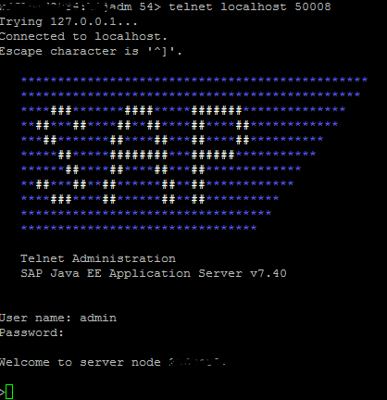
3. Deploy the application using the deploy command:
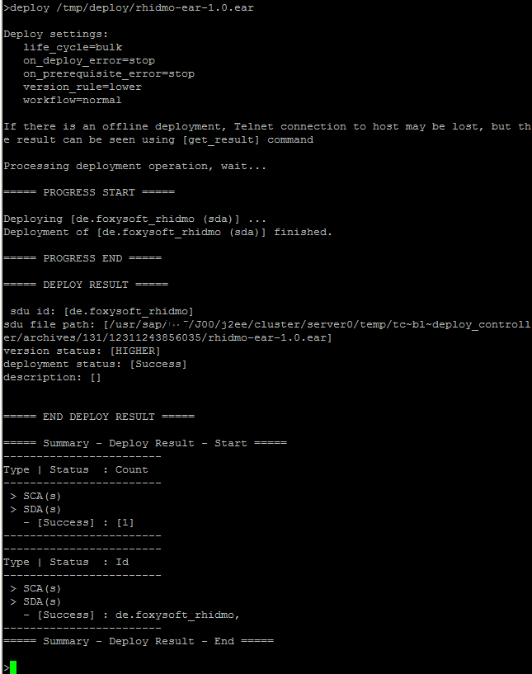
Watch for the “Success” message (as shown in the screenshot above). Correct any errors. Rhidmo is now deployed and must be configured before use. This is explained in the following chapter.

Create RHIDMO_RT Datasource
The standard IDM data source that is configured in JAVA AS uses the “<prefix>_prov” user which does not have sufficient privileges to be used with Rhidmo. Consequently, another data source must be configured with the “<prefix>_rt” user:
1. Log in with a SAP supported browser to the JAVA AS with a user with administrative privileges and start the NetWeaver Administrator (URL: http://<machine>:<port>/nwa). Use https if available:
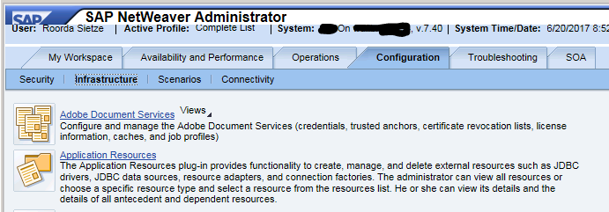
2. Go to “Configuration” → “Infrastructure” (as shown in the screenshot above) and click on the “Application Resources” link. Press the button “New JDBC Custom DataSource”:
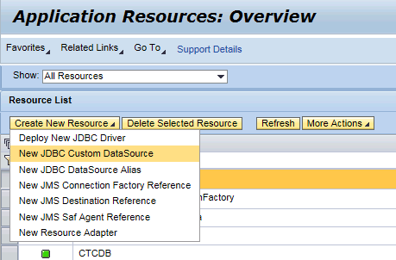
3. Fill in the form with the same values as for the “IDM_DataSource” Data Source. Please remember to exchange the “<prefix>_prov” user with the “<prefix>_rt” user (and adjust the password accordingly:
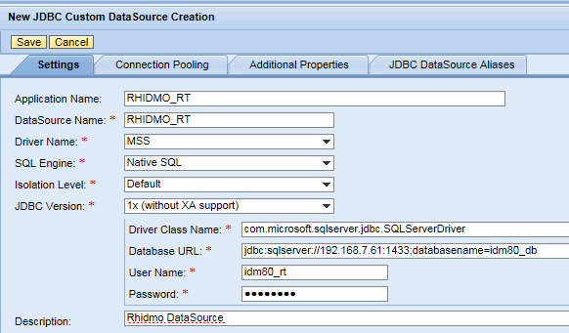
The screenshot above shows example values for the Microsoft SQL Server database using “idm80” as the prefix.

Set Rhidmo Application Parameters
1. While still in NWA, go to “Configuration” → “Infrastructure”:
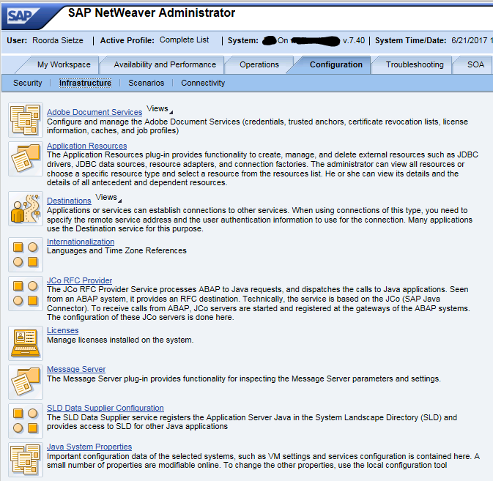
2. Press the link “Java System Properties” and find the tab “Applications” (somewhere in the middle. Filter on “idm” to see only SAP IDM relevant content:
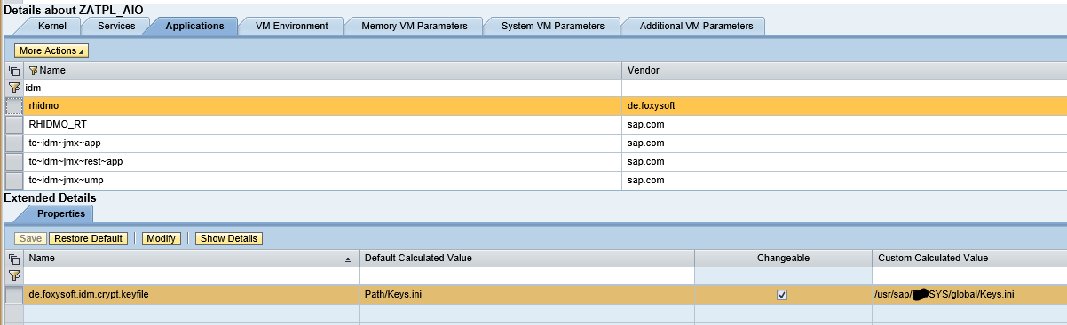
3. Change the property “de.foxysoft.idm.crypt.file” to have the same value as the property “com.sap.idm.jmx.crypt.keyfile” of the “tc~idm~jmx~app” application. Press the “Save” button to store your changes.

Rhidmo Example Code
Starting with release 1.2.0, Rhidmo includes demo packages with example code which can be used after the Rhidmo EAR has been deployed. While none of this content is recommended or even required for production use, developers may use it as a helpful starting point to learn more about how to use Rhidmo. Please refer also to chapter 3.6 for more developer-oriented material. Finally, the demo might also be useful as a ready-to-use example of Rhidmo in action for demonstration purposes.
The demo currently contains exactly one SAP IDM form that uses Rhidmo to provide the following features:
- computing attributes using a JavaScript function on load
- validating user input using a JavaScript function on submit
- displaying validation error messages in the language of the logged in user
The recommended starting points for studying implementation details of the demo are the following designtime objects from package de.foxysoft.rhidmo.demo.main:
- Form RhidmoDemoValidFromTo
- Package script rhidmo_onLoad_setValidFromToday
- Package script rhidmo_onSubmit_checkValidToNotBeforeValidFrom

Prerequisites
You have installed and configured the Rhidmo framework as described in chapter 2.

Considerations Before Using the Demo

Access Control
The Rhidmo demo form ships with an access control restricting access to members of the MX_ROLE:ADMIN role, which exists by default in every SAP IDM installation. Users not assigned to this role will not see the demo form in their navigation menu and not be able to start it with a direct link. If your personal user doesn’t have this role and it’s not practical or desirable to get it, you’ll not be able to use the demo as is.

Creation of Persistent Test Data
The most important use case of the Rhidmo demo form is demonstrating what happens when validation of user input fails. In this case, all data entered on the form is completely ephemeral. Everything remains in session memory and nothing will be committed to the database.
When you submit valid input though, your submit action will result in creation of a new persistent MX_PERSON entry in your database.
The rationale for providing a Create form instead of a form that modifies an existing entry is inspired by experience that creating new data for testing purposes is typically less problematic than modifying existing data. Existing data is typically there for a purpose, and we wanted to avoid making any such data inconsistent or unusable in your system.

Self-Deletion of Persistent Test Data
The next design aspect to carefully review is that the demo form has a result handling process which will asynchronously delete the new MX_PERSON only a couple of seconds after it has been created.
The rationale is not to pollute your database with long-lived test data and avoid any need for manual cleanup.

Potential Issues
While the Rhidmo demo has been designed carefully, there might be scenarios where it is not desirable or even acceptable to execute it. Potential issues to consider include:
- Custom entry event handlers which automatically execute whenever new MX_PERSON entries are created; these event handlers will likely fail for the entry created by the Rhidmo demo form because it may already have been deleted when the custom event handler executes. This may generate errors in your job log.
- Custom attribute event handlers which automatically execute whenever a new value for MX_VALIDFROM and/or MX_VALIDTO are added to the database; such handlers may fail for the same reason.
- Organizational policy prohibiting the deletion of SAP IDM entries, specifically of type MX_PERSON, for compliance or security reasons. As this demo creates and deletes test data only, this should not be an issue, but make sure to check in advance.
If you suspect that any of these potential issues could hurt in your environment, we recommend not to use the demo at all or at least not as-is. If you’re a developer, you’ll probably find it easy to modify the demo source code to make it more suitable for your environment, e.g. by changing the form’s access control, replacing the entry type of the form with something else and/or by disabling its result handling process.

Deploy the Demo Packages
The Rhidmo demo consists of two SAP IDM packages which are located under the examples folder of the Rhidmo ZIP distribution. Unpack the ZIP distribution and use SAP IDM Developer Studio to import these package files (file extension: .idmpck) into the main identity store of your system, i.e. the identity store which the SAP IDM Web Dynpro UI operates on.
Make sure you import both demo packages into your system. The exact order of import doesn’t matter.
- de.foxysoft.rhidmo.demo.util
- de.foxysoft.rhidmo.demo.main
After importing the main package, open the SAP IDM administration UI at URL path /idm/admin. On tab “Message Templates”, verify that the import has automatically created a new message template category called de.foxysoft.rhidmo.demo.main (like the package).
This message category contains language-specific versions of UI error messages used in the Rhidmo demo. Rhidmo ships with German and English language versions of these texts. Using the SAP IDM administration UI, you could add more languages as required.
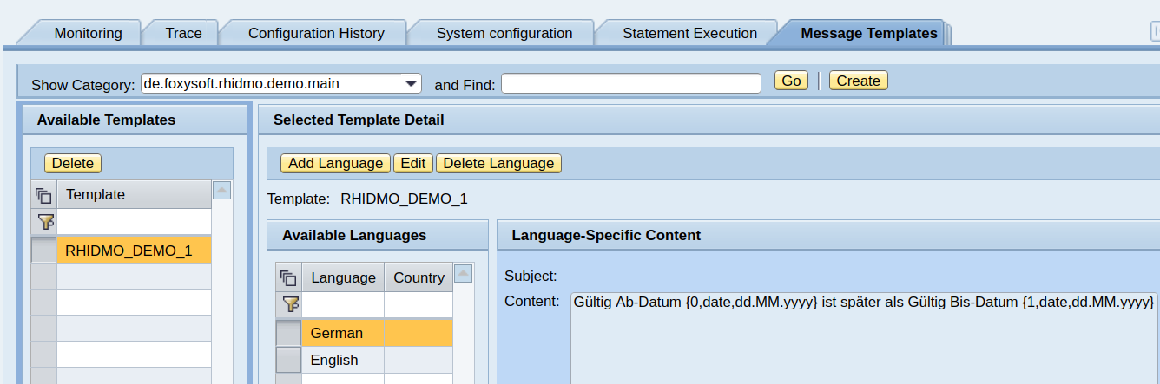

Verify Your User’s UI Language
All texts of the Rhidmo demo have been translated to German and English, so you may want to make sure that your UI language is set to one of those two in order to get the best demo experience. When logged in with a user whose UI language has been set to any other than those two, the UI and all message texts will use the English version as a fallback.
To check what your current UI language is, log in to SAP NetWeaver’s local user administration at URL path /useradmin. Verify or change your user’s UI language as illustrated below:
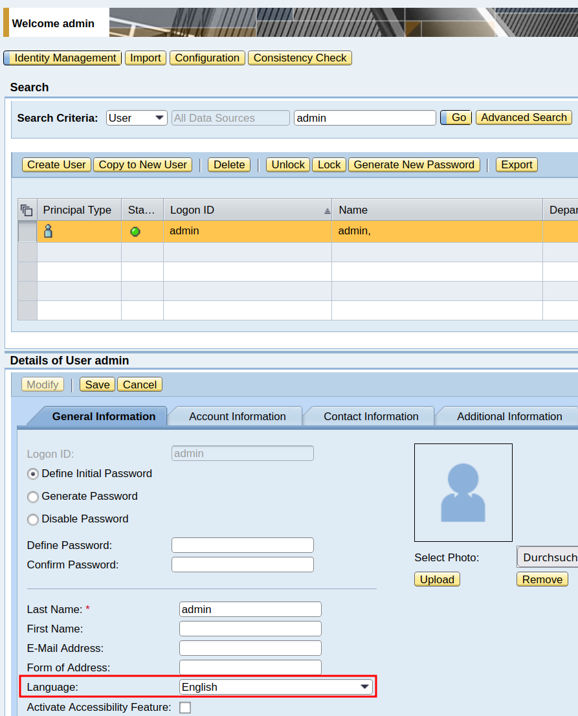

Use the Demo Form
To launch the demo form, open a browser at URL path /idm of your SAP NetWeaver host and log in with a user who is member of the MX_ROLE:ADMIN role.
Select the “Manage” tab. Keep the “Show” drop-down at its default selection “Person” and use the “Create…” button to see a list of available forms that can create new MX_PERSON entries.
A new forms folder “Rhidmo® Demo Forms” will be available. Expand that and launch the form “Rhidmo® Demo: Valid From/To with Computed Values, Validation and I18N” by using the “Choose Task” button.
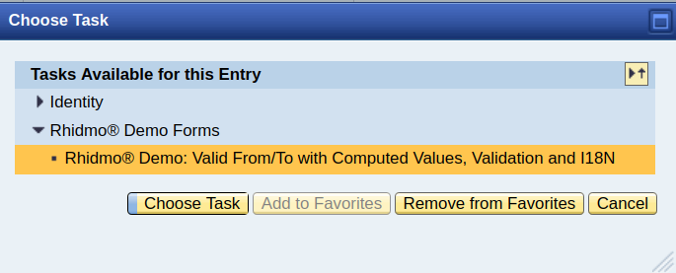
The form has two mandatory attributes open for edit:
- Valid From: this attribute has been set to today’s date automatically by package script rhidmo_onLoad_setValidFromToday
- Valid To: this attribute is initially empty and must be filled in by you
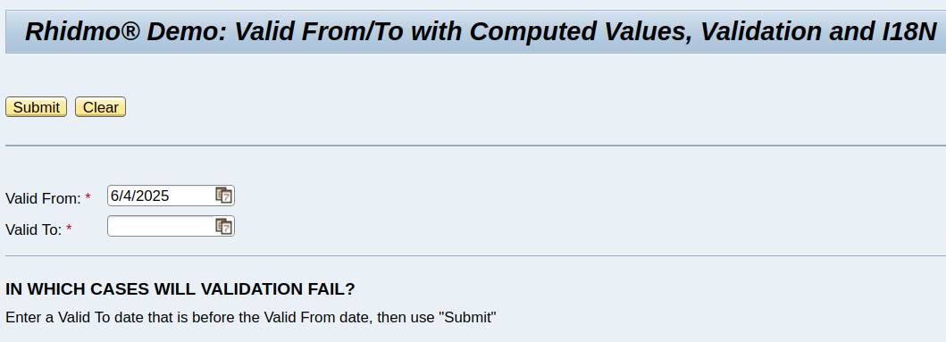
You can now proceed to fill in a value for Valid To and optionally also change the computed default value of Valid From.
Since the use case is demonstrating validation failure, you’ll want to enter a Valid From date that is before the Valid From date in order to see a corresponding validation error message in the UI. Validation passing is not particularly interesting, from a UI perspective.
When pressing Submit, package script rhidmo_onSubmit_checkValidToNotBeforeValidFrom will -as its name suggests- verify that the Valid To date is not before the Valid From date. If this validation fails, the script will generate an error message that will be displayed in the UI and whose exact text depends on the UI language of your user (see chapter 3.4).
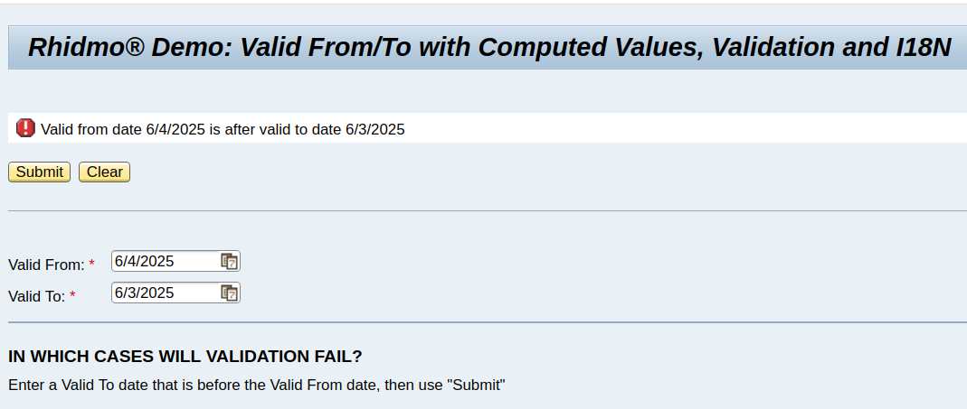
If you switch your UI language as illustrated in chapter 3.4, make sure to log out and back in again to actually see the change. All your existing sessions will continue to use the previous UI language.
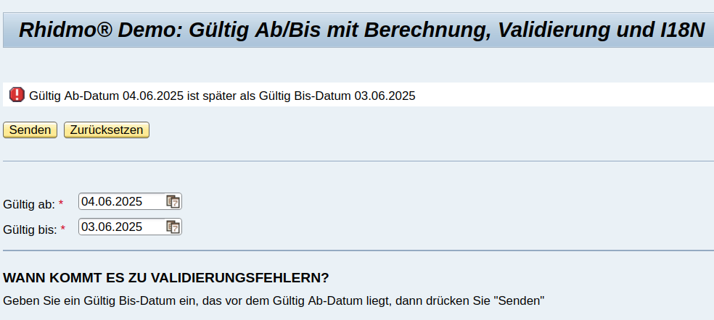
For completeness sake, here’s an illustration of what happens if validation succeeds: a success message will be displayed and your data be committed to the database.
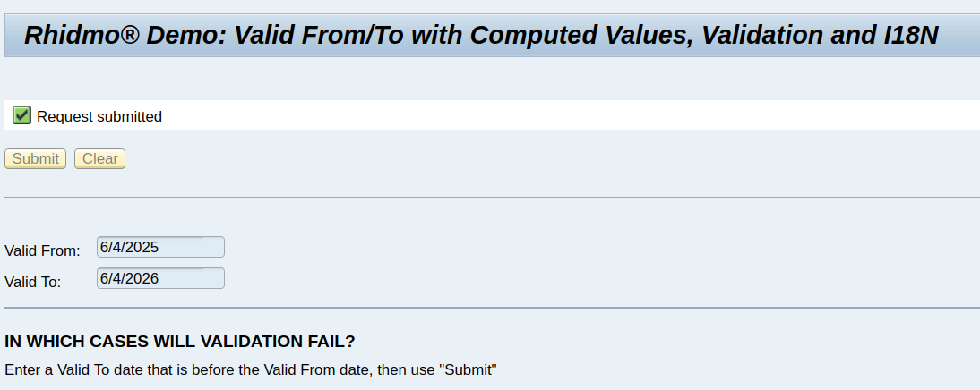

Uninstalling the Demo
To uninstall the Rhidmo demo, use the job Uninstall Demo Message Templates located in package de.foxysoft.rhidmo.demo.main as a first step. You can either run this job from SAP IDM Developer Studio, or use the administration UI at /idm/admin > System configuration > Packages > de.foxysoft.rhidmo.demo.main.
On the “Jobs” tab, the job can be executed directly using the “Run Now” button.
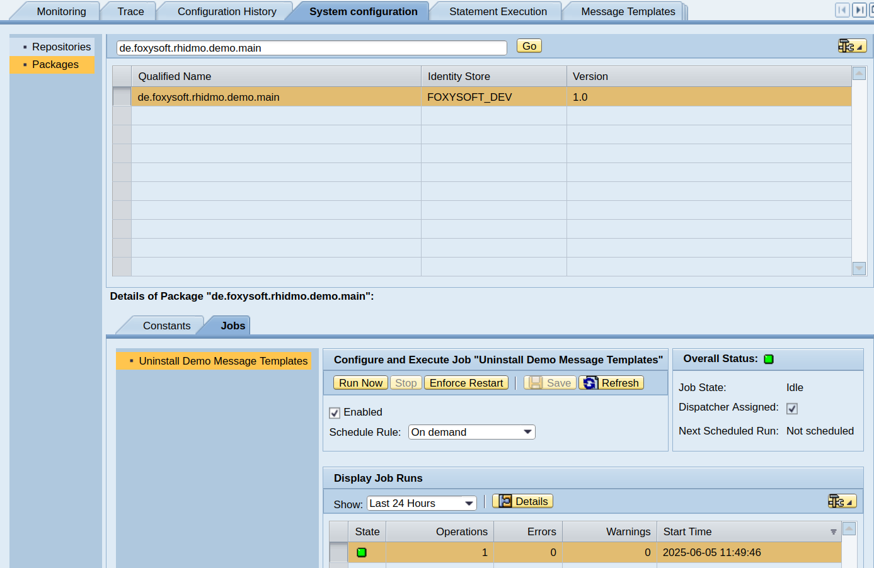
After job execution, first perform a browser refresh to reload any and all content displayed in the admin UI, then switch to tab “Message Templates” to verify that message template category de.foxysoft.rhidmo.demo.main including all of its templates have been removed.
As a final step, use SAP IDM Developer Studio to delete the demo packages:
- de.foxysoft.rhidmo.demo.util
- de.foxysoft.rhidmo.demo.main

Developing Forms Using Rhidmo
Each form that needs to use Rhidmo must be configured. Please enter the following values in the form properties:
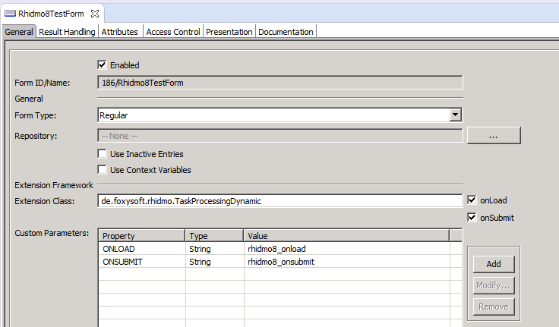
Use the extension class “de.foxysoft.rhidmo.TaskProcessingDynamic”. The “ONLOAD” and “ONSUBMIT” parameters denote the JavaScript functions to be called during the corresponding events. Starting with Rhidmo release 1.1.0, you can use scripts from the same package as the form and/or scripts from any other package.
For scripts from the same package as the form, use the following simple syntax for the value of properties:
<script_name>
For scripts from other packages, use the following extended syntax:
<package_name>/<script_name>
If your ONLOAD/ONSUBMIT script depends on other scripts, you need to specify these dependencies using properties REQ1 to REQn, where 1..n is an interval of contiguous integers which must start at 1.
For instance, if your ONLOAD script which has 3 dependencies, you need to specify:
REQ1=<first dependency>
REQ2=<second dependency>
REQ3=<third dependency>
The following screenshot illustrates this. The main script ONLOAD has three dependencies. Two of these, REQ1 and REQ2, use the simple syntax (script name only). The third dependency, REQ3, uses the extended syntax to refer to a script from package de.foxysoft.bobj.
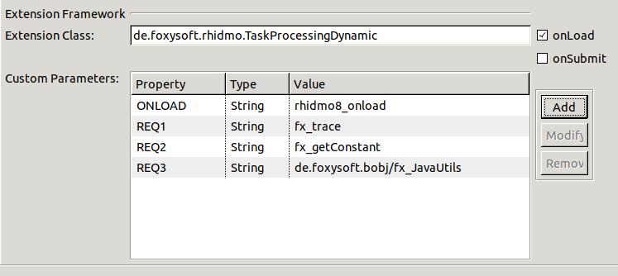

Rhidmo Troubleshooting
Please check the JAVA AS log in case something goes wrong. If necessary, make sure that the log configuration shows the right amount of messages:
The log viewer can configured and accessed using the “/nwa” application (go to “Troubleshooting” → “Logs and Traces”):

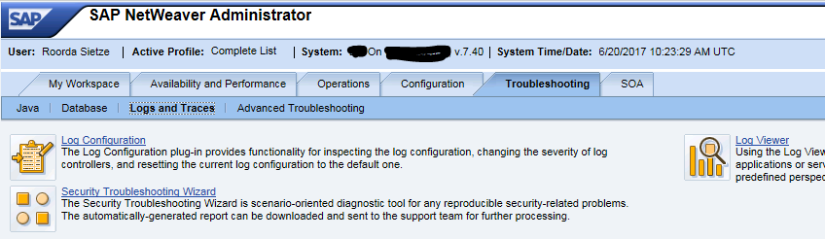
Configuration
By clicking on the link “Log Configuration” you can configure the amount of logging that Rhidmo generates:
1. Select “Tracing Locations”:
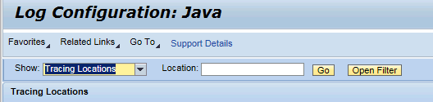
2. Then select “de.foxysoft.rhidmo” in the subtree below:
3. Select the log level you want from the drop-down box to the right and click on the “Copy to Subtree” button to copy this setting to all locations below.

Log Viewer
Click on the “Log Viewer” link to view the logs (Select the View “Developer Traces” to examine the Rhidmo logs):
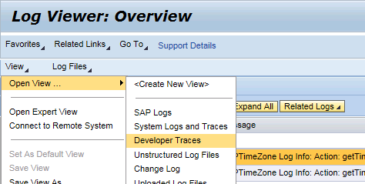
Example log:
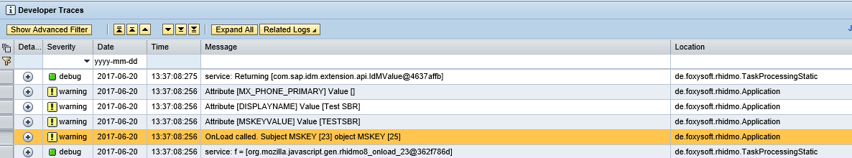

FAQ

“Invalid Key size”
The following two messages appear in the log file and (en-) or decryption is not possible:
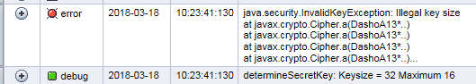
The second message tells us that maximum supported key size is 16 bytes (or 128 bits). However, the string is encrypted with a key having 32 bytes (or 256 bits).
This means that the SAP JAVA AS is running with a Java version with limited cryptography capabilities. See SAP Note 1240081 for further details.

