Web URL:

GitHub:

Frontend:

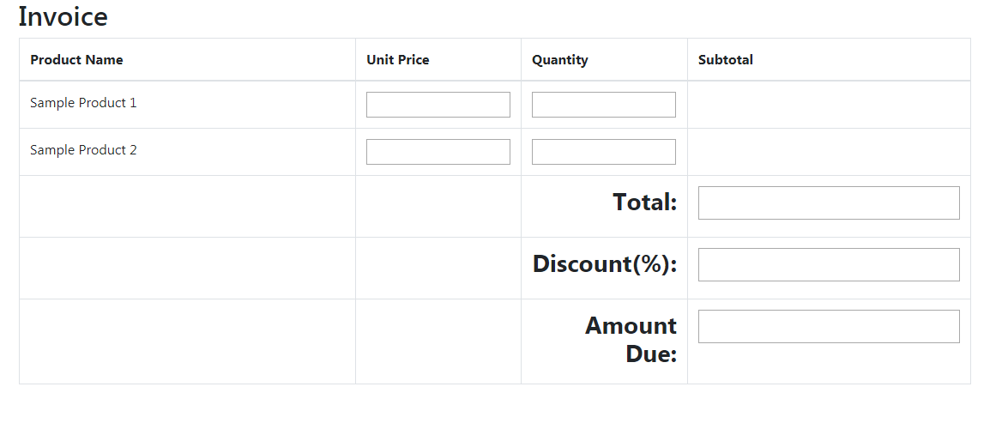

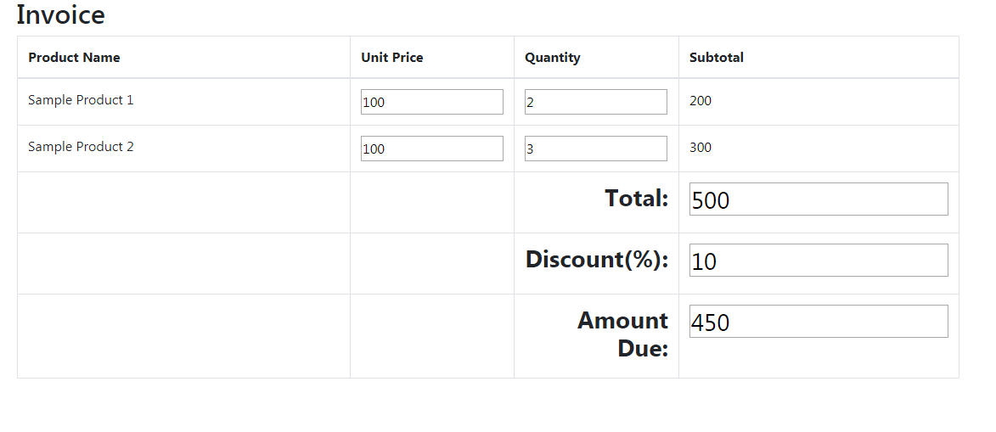Figure Figure 1 Frontend interface