# Cognition:

In our daily life we perform many different type of activities. In every activities started by a command which give us our brain before starting the activity process. When we thinking about an activities, our brain make two different types of decision that do or not. This means cognition. This our mental processing system. It’s our mental expressive method in the word and by this process we make any decision, make activities, feel emotion, gather knowledge, making understanding etc. Our brain take signal from human body sensor. When any signal comes from outside then brain receive signal and processing this, finally brain make a decision and give direction the body to complete the task. (study, n.d.)

# Cognitive psychology:

Psychology in a word “Human Behavior”. In 1967, Ulric Neisser firstly used the term of 'cognitive psychology'. Cognitive psychology is a part of psychology which focuses on the way of people processing information. According to the American Psychological Association (APA), cognitive psychology is the study of higher mental processes such as attention, language use, memory and perception, problem solving and thinking. Cognitive psychology will define how to interact with process of cognation. Cognitive psychology express a path about processing information of human. When any signal comes from outside Stimulus takes as an input and response immediately then give output. Basically cognitive psychology is deeply internal study of human brain. (bestpsychologydegrees, n.d.)

# Role of Cognitive Psychology in Interaction Design:

Cognitive psychology represent human behavior. Our brain gain knowledge from the world and gather Information which apply the brain when face those kind of situation. To make this task our brain maintain some process like as attention, memory etc. In present word many king of digital device and product come to our face and we use those. Interaction Design basically work in the field that “Make a Product that is Useable”. If we want any product will useable their customer we need to maintain some process of cognitive psychology which work people behavior and interaction. In interaction design process cognitive psychology is endless. Before developing a product, developer team must thinking about their customer interaction and they try to gain customer attention which is the process of cognitive psychology in Interaction Design. If any customer first look experience is go to bad expression and boring to using the product that effect the company which do not carry any good for industry. Cognitive psychology in interaction design is one of most important part.

# Cognition Work Process:

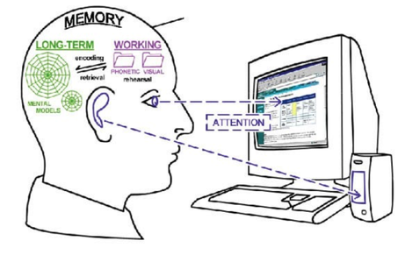

(margiemeacham2.files.wordpress, n.d.)

When we first look at a picture then we think in this image a man using a computer. But when we see again and send signal our brain response and say not. In this image represent a process which is known as a cognition working process. It occurs in our brain which known as cognition process. Many kind of steps exist in process are:

* Attention
* Perception and recognition
* Memory
* Learning
* Reading, speaking, and listening
* Decision making, planning, problem solving

In this section I like to briefly explain about these process of cognitive psychology. I try to explain four types of concept of every topic (“what is it?”, “How to work?”, “Role in Interaction Design”, “Guidelines”).