Table of Contents
01. Problem Statement 2
02. Aims and Objectives 3
03. Design 3
04. The Source Code 4
05. Input 5
06. Output 5
07. Execution Protocol 6
08. Conclusion 6

01. Problem Statement

Sudoku, originally called Number Place is a 9×9 grid puzzle based on logic, combinatorial number placement problem. In the grid, each box contains a number in the range 1-9 satisfying that each column, each row and each 3×3 block (i.e. the sub-blocks of the original 9×9 grid) contains all the numbers from 1-9 only once.
Solving Sudoku has been a challenging problem in the last decade. The purpose has been to develop more effective algorithm in order to reduce the computing time and utilize lower memory space.
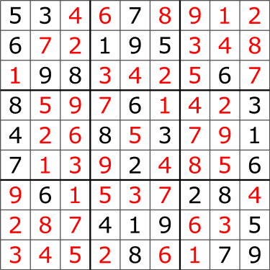Figure 1(b): Solution of the puzzle
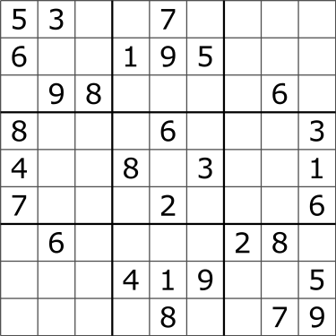Figure 1(a): A Sudoku puzzle

02. Aims and Objectives

The general problem of solving Sudoku puzzles on n2×n2 grids of n×n blocks is known to be NP-Complete. Many computer algorithms, such as backtracking and dancing-links can solve most 9×9 puzzles efficiently, but combinatorial explosion occurs as n increases, creating limits to the properties of Sudokus that can be constructed, analyzed, and solved as n increases. A Sudoku puzzle can be expressed as a graph-coloring problem. The aim is to construct a 9-coloring of a particular graph, given a partial 9-coloring.
The aim of this project is to convert the puzzle to a Constraints Satisfaction Problem (CSP). Then implement it in Prolog environment to build an expert system which will be able to solve a given sudoku puzzle.

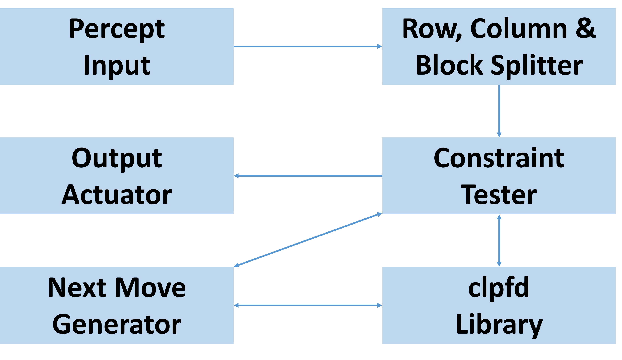
03. Design

04. The Source Code

%% sudoku.pl in SWI-Prolog version 8.0.3
:- use_module(library(clpfd)).
sudoku(Puzzle) :-
flatten(Puzzle, Tmp), Tmp ins 1..9,
Rows = Puzzle,
transpose(Rows, Columns),
blocks(Rows, Blocks),
maplist(all_distinct, Rows),
maplist(all_distinct, Columns),
maplist(all_distinct, Blocks),
maplist(label, Rows).
blocks([A,B,C,D,E,F,G,H,I], Blocks) :-
blocks(A,B,C,Block1), blocks(D,E,F,Block2), blocks(G,H,I,Block3),
append([Block1, Block2, Block3], Blocks).
blocks([], [], [], []).
blocks([A,B,C|Bs1],[D,E,F|Bs2],[G,H,I|Bs3], [Block|Blocks]) :-
Block = [A,B,C,D,E,F,G,H,I],
blocks(Bs1, Bs2, Bs3, Blocks).

05. Input

Puzzle = [
[2,_,_,_,9,_,_,_,1],
[3,_,9,_,_,7,_,_,_],
[_,_,1,_,4,_,_,7,_],
[_,6,_,_,_,_,_,_,_],
[_,_,_,_,_,3,_,_,_],
[_,_,8,6,_,_,7,9,_],
[6,_,_,7,_,_,8,_,_],
[1,2,3,_,_,8,_,_,_],
[_,8,7,_,_,4,3,_,_]], Puzzle = [A,B,C,D,E,F,G,H,I], sudoku(Puzzle).

06. Output

A = [2, 7, 6, 8, 9, 5, 4, 3, 1],
B = [3, 4, 9, 1, 2, 7, 5, 6, 8],
C = [8, 5, 1, 3, 4, 6, 2, 7, 9],
D = [7, 6, 2, 4, 8, 9, 1, 5, 3],
E = [9, 1, 5, 2, 7, 3, 6, 8, 4],
F = [4, 3, 8, 6, 5, 1, 7, 9, 2],
G = [6, 9, 4, 7, 3, 2, 8, 1, 5],
H = [1, 2, 3, 5, 6, 8, 9, 4, 7],
I = [5, 8, 7, 9, 1, 4, 3, 2, 6].

07. Execution Protocol

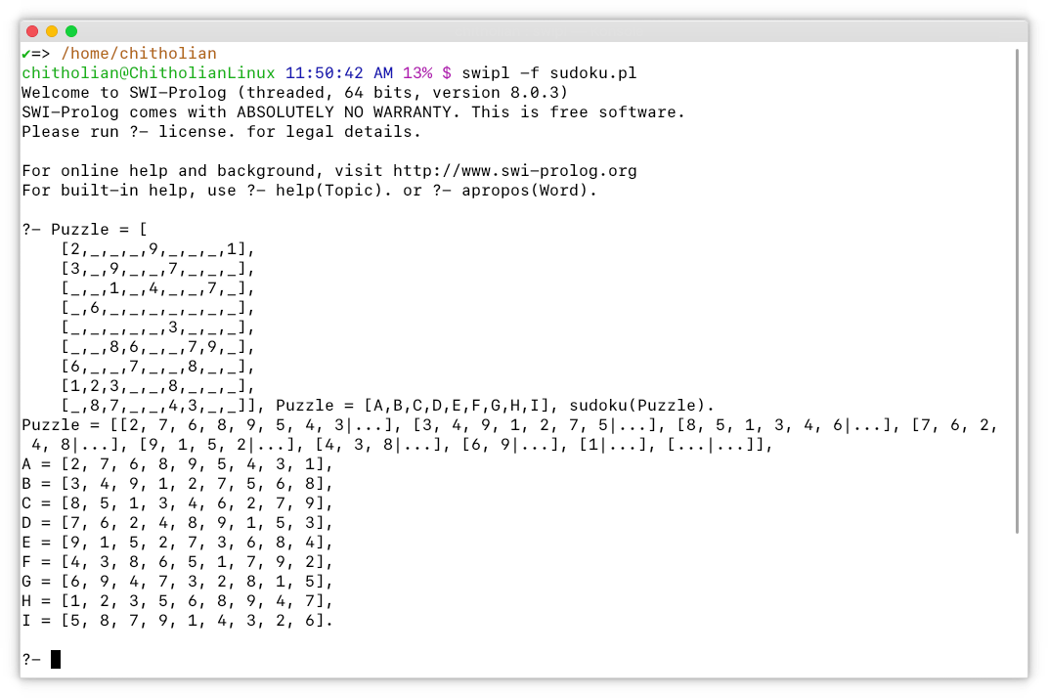

08. Conclusion

It is seen that the sudoku puzzle problem can be easily solved by making it a constraint satisfaction problem. Moreover, SWI-Prolog’s clpfd library allows us to set the constraints and get the solution at a very easy and fast way.
Finally, the source code is just around 25 lines, which is also easy to implement as well as easy to understant.

