Marketing Performance Report
Jun 1 – Jun 14, 2026 | Actual Results /Nikolai Didkovski
1. Website — Google Analytics 4
https://docs.google.com/spreadsheets/d/1uR2H3l2lxCpptnBcQ7X3g1ZzxFB3xz0UC5gl1G5S8SA/edit?gid=1739347052#gid=1739347052

Metric | Active Users | New Users | Sessions | Avg. Engagement
Jun 1–14, 2026 | 284 | 286 | 314 | 29s

Top traffic acquisition sources:
Source / Medium | Sessions | Key Events
google / cpc | 222 | 0
(direct) / (none) | 35 | 0
google / organic | 24 | 0
(data not available) | 18 | 0
elitecontractorsllc.biz / referral | 3 | 0
facebook.com / referral | 3 | 0
l.instagram.com / referral | 3 | 0

2. Google Ads (Jun 1–14, 2026)
https://docs.google.com/spreadsheets/d/1uR2H3l2lxCpptnBcQ7X3g1ZzxFB3xz0UC5gl1G5S8SA/edit?gid=875799042#gid=875799042
l
Impressions | Clicks | Avg. CPC | Total Spend
3,850 | 207 | $0.58 | $120

3. Google Search Console (Jun 1–14, 2026)

link https://docs.google.com/spreadsheets/d/1uR2H3l2lxCpptnBcQ7X3g1ZzxFB3xz0UC5gl1G5S8SA/edit?gid=1193242854#gid=1193242854
Impressions | Clicks | Avg. CTR | Avg. Position
165 | 2 | 1.2% | 29.4

4. Facebook (Jun 1–14, 2026)
Link to report: https://docs.google.com/spreadsheets/d/1uR2H3l2lxCpptnBcQ7X3g1ZzxFB3xz0UC5gl1G5S8SA/edit?gid=0#gid=0
Metric | Value | Change
Profile views | 735 | +273.1% vs prev 14d
People views | 86 | —
Content views | 88 | —

5. Instagram (Jun 1–14, 2026)
Link to report: https://docs.google.com/spreadsheets/d/1uR2H3l2lxCpptnBcQ7X3g1ZzxFB3xz0UC5gl1G5S8SA/edit?gid=606265187#gid=606265187
Metric | Value
Total views | 3,734
Accounts reached | 1,364
Followers share | 38.9%
Non-followers share | 61.1%
Top content: Reels | 53.4%
Stories | 32.4%
Posts | 14.2%

6. TikTok (Jun 7–13, 2026)

https://docs.google.com/spreadsheets/d/1uR2H3l2lxCpptnBcQ7X3g1ZzxFB3xz0UC5gl1G5S8SA/edit?gid=1554848451#gid=1554848451
Metric | Value | Change
Video views | 1,800 | +29.4%
Profile views | 2 | -80.0%
Likes | 5 | -87.2%
Comments | 1 | +1
Shares | 0 | -100%
Traffic: For You | 98.6% | —

7. LinkedIn (May 31 – Jun 14, 2026)
https://docs.google.com/spreadsheets/d/1uR2H3l2lxCpptnBcQ7X3g1ZzxFB3xz0UC5gl1G5S8SA/edit?gid=96528275#gid=96528275
Metric | Value | Change (7d)
Posts | 16 | +1,500%
Post views | 481 | +676%
Key Insights
Paid drives traffic: Google Ads accounts for 222 of 314 website sessions (71%). Organic is early-stage with avg. position 29.4.
Instagram leads reach: 3,734 views, 1,364 accounts reached — 61% non-followers, a positive discovery signal. Reels dominate at 53% of views.
Facebook surged: +273% profile views vs prior 14 days, though absolute numbers (735) remain modest.
LinkedIn accelerating: +1,500% posts and +676% views in the most recent 7 days, with a visible spike after Jun 11.
TikTok view-heavy, engagement-light: 1.8K video views but minimal profile visits (2), likes (5), and shares (0). 98.6% of traffic from For You page.

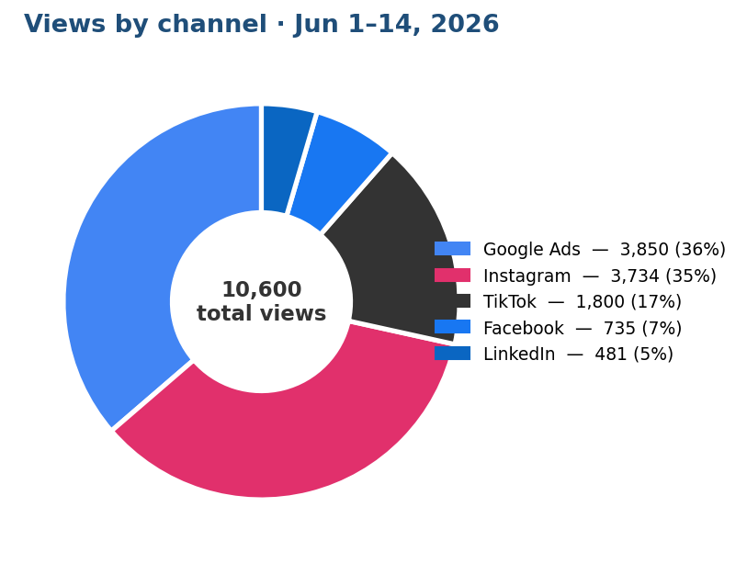
Channel | Views / Impressions | Share | Type
Google Ads | 3,850 | 36% | Paid impressions
Instagram | 3,734 | 35% | Organic views
TikTok | 1,800 | 17% | Organic views
Facebook | 735 | 7% | Organic views
LinkedIn | 481 | 5% | Organic views
Total | 10,600 | 100%
Note: Google Ads figure represents paid impressions; all other figures are organic social views.

Metric on posts

AWARENESS — Reach New Audiences
Content that puts the company in front of potential clients, developers, and partners.
Platform / Format | Total | Additional
Facebook | 16 posts
Instagram | 7 posts + reels posted by Jauslyne) | Algorithm reach, new follower growth
TikTok | 22 posts
LinkedIn | 16 posts | Humanize the brand, recruiting appeal
GoogleAd | 1 campaign

