EXAM

There are four sections in the assessment: various theory questions, a task to describe processes/definitions/structures or operations depicted in a diagram, a practical exercise to host a very small static web site on AWS and, finally, a task to create a new Docker Image and host this containerized application on AWS. You are welcome to use personal notes made throughout the course sessions to complete assessment tasks.If you use any external resources, please make sure to properly reference them in your answers.
You are given 2 hours to complete this assessment. We recommend that the best way to manage your time is to allocate approximately 30 min for each section and then move on to the next task. The maximum possible score that can be awarded for this test is 100 points, which is equivalent to 100% grade. This test contributes 90% weight to the overall course grade.

Good luck!

 | SECTION | POINTS
A | Theory questions | 30
B | Diagram description | 20
C | Static web-site with AWS | 20
D | Docker Image with AWS | 30
 | TOTAL | 100

Theory Questions (30 points total)

The following 10 questions are multiple-choice. Please choose one correct answer unless specified otherwise. You get awarded 1 point for each correctly answered question.

Q1) Which managed service could provide distribution of incoming traffic across multiple Amazon EC2 instances?

C. Elastic Load Balancing

Q2) Which element of AWS Global infrastructure consists of multiple Availability Zones?

B. Region

Q3) What feature of a Virtual Private Cloud (VPC) works like a virtual firewall for the network?

C. Security Groups

Q4) You are looking to launch a static website with minimal configuration. Which of the following AWS services provides this feature?

D. Amazon S3

Q5) Which online tool provides guidance in following AWS best practices by providing personalised recommendations for your cloud workloads?

- AWS Trusted Advisor

Q6) Which AWS support plan provides 500+ checks with AWS Trusted Advisor?

C. Enterprise Support

Q7) Your US-based team wants to expand an internal application to your office in Singapore. They are able to take the application and spin up a version in the ap-southeast-1 region. Which benefit of cloud computing is best illustrated with this scenario?

- Go global in minutes

Q8) Your organisation is looking to test a new web application concept. The team set up an AWS account and infrastructure within a day on which they will build a prototype for this application. Which cloud computing benefit does this illustrate?

- Increase speed and agility

Q9) Which element of the AWS Global Infrastructure is made up of one or more data centres connected by a low latency network with redundant power, networking, and connectivity within an AWS Region?

- Availability Zone

Q10) You want to have 24/7 phone, web and chat access to AWS Cloud Support Engineers for an
application you are building. What is the minimum support plan that provides this?

B. Business Support+

The following 10 questions are also multiple-choice and they are related to Docker. You will be awarded 1 point for each correctly answered question.

Q11) Which of these is NOT true about containers?

A. Containers include the operating system as well as code and libraries

Q12) What is a Dockerfile?

C. A template used to describe the build of an image

Q13) What command do we use to completely get rid of a Docker Image?

B. docker rmi

Q14) How do you manage Docker images?

D. Both A & B

Q15) What is Docker?

A. an open-source lightweight containerisation technology

Q16) What are the important features of Docker?

D. All of the above

Q17) What is a Docker image?

A. a read-only set of instructions for creating a container

Q18) What is Docker Engine?

A. an open-source containerisation technology for building and containerising your applications

Q19) What is Docker Swarm?

A. a container orchestration tool

Q20) What is Docker Hub?

A. a service provided by Docker for finding and sharing container images with your team

The following 10 questions are also multiple-choice and they are related to Kubernetes. You will be awarded 1 point for each correctly answered question.

Q21) What is the basic operational unit of Kubernetes?

A. Pod

Q22) What are the main components of Kubernetes?

D. All of the Above

Q23) Which of the following runs on each node and ensures containers are running in a pod?

C. Kubelet

Q24) Who developed Kubernetes?

A. Google

Q25) Kubernetes is a <…> platform.

D. All of the Above

Q26) A node is a <…> in Kubernetes.

B. worker machine

Q27) Which of the following manages assigning nodes to pods depending on resource availability?

C. Scheduler

Q28) Kubernetes is written in which programming language?

A. Go

Q29) To create a new deployment in Kubernetes, which of the following commands should you use?

A. kubectl run

Q30) Which command is used to create a kubernetes service.

C. kubectl expose

Diagram Description (20 points total)

Given the diagrams below, please describe these two models in detail and compare how their efficiency may differ from one another. You will be awarded 10 points for the correct description of these models and further 10 points for providing the “key points” comparison analysis.

Model 1

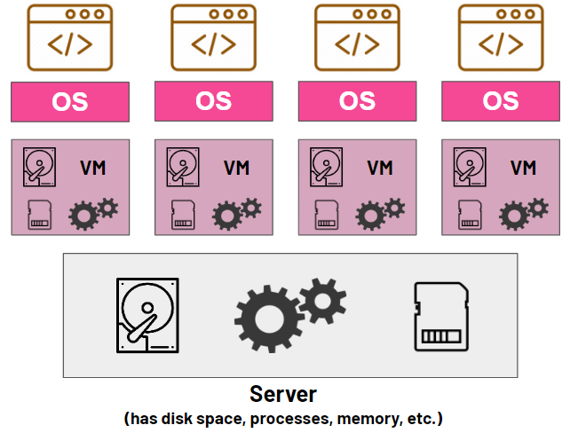

This is a traditional virtual machine (VM) deployment model.
The bottom layer shows the physical server which is only 1 server. This server includes the hardware like the CPU, memory, storage, etc.
On top of this layer you have the virtualisation layer with the hypervisor typically via VMware. The hypervisor splits the servers resources and allocates the CPU, RAM and stoeage to the VMs that sit ontop of this one physical server. This means ech VM has its own hardware but they are shared from the resoucres of the physical server.
The VMs are separate virtual machines with virtual memory, virtual CPU, etc. They are all distinct from one another and fully isolated so if one goes down the rest are still running and unaffected.
Each VM has it’s own operating system like Linux or Windows. This means it runs a full OS kernel. Because of this it will use higher memory, storage and have higher overheads.
The last layer is the application layer where each application runs on its own operating system and its own virtual machine. This has higher cost of efficiency but has the benefit of security and stability.

Model 2

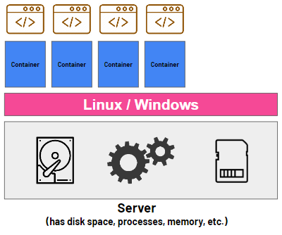

The second model shows a container deployment model(opposite to the traditional VM deployment). This often uses Docker and Kubernetes to run applications from one shared operating system instead of separate virtual machines.

The bottom layer is the physical server. Like the VM deployment model this is a single physical server which provides the CPU, memory, storage. On top of this layer is one single operating server. This host operating server could be Linux or Windows. It controls the hardware, manages the process, memory and provides a kernal that all the containers use. Unlike the model above it doesn’t have separate OS applications sitting on separate OS. This reduces the resource usage and start up time. On top of this there is the container runtime layer which creates and manages the containers. This might be Docker engine for instance. It makes sure there is file system separation, resource limits and process isolation. It runs many containers on the same OS. The containers sit ontop of this which include the app code, the libraries and dependencies. This may use docker swarm or Kubernetes as the containerisation and orchestration tool. The containers are lightweight (smaller than VM), portable (cloud prod, developer laptops), isolated (separate from each others file systems and processes) and scalable (allows microservices). The application layer sits at the top making each app independent, deployable separately, replaceable without affecting each other. This supports Devops principles with CI/CD and is a cloud native design.

Key points comparison analysis

      - The architecture is different for both. VM on hypovisors and on their own OS systems. Its heavy and layered. Whereas containers share a host OS and contain only the app and the dependancies. It is much lighter.
      - The resource usage differs for both. VM I high CPU, RAM and storage because it duplicates the OS on all VM. Containers are minimal resource usage and no OS duplicates
      - VM has slow boot time and must start full OS whereas containers start as normal OS processes
      - VM has strong isolation and separate nernals wherea containers have process level isolation and share same kenral so weaker security.
      - VM is portable but has large image size and migration is slow whereas container is highly portable and lightweight. It can run anywhere once its built.
      - VM is slow and resource heavy whereas containers are rapidly scaling and easy to replicate. Ideal for microservices and manged easily by Docker swarm or Kubernetes on large scale
      - VM requires OS updates and patching whereas containers has single OS so easier to manage and easier CI/CD and automation.

Hosting a Static Website with S3 (20 points total)

Please use the contents of the folder called “static-webpage” that have been shared with you at the beginning of this assessment. Open index.html in any browser to see an example of a simple static webpage. The task is to register and host this webpage (and all required contents like images and css) on cloud with the help of AWS S3 service.

URL:
http://foziaiqalassessment.s3-website.eu-west-2.amazonaws.com/

IMPORTANT NOTES:

- Prior to posting your webpage online, please open index.html in any editor (even a notepad) and update YOUR name and surname as highlighted in yellow in a snippet below

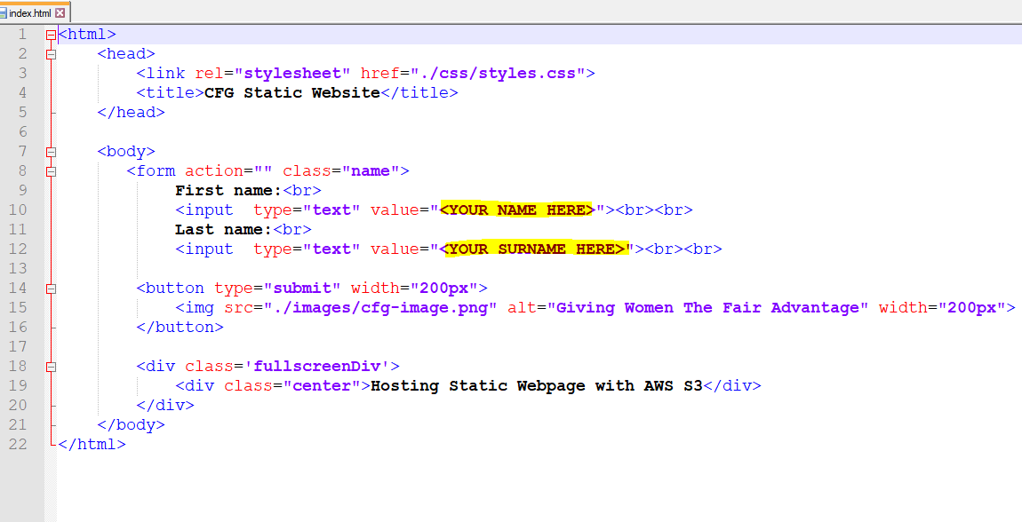

- You need to submit a URL address to your newly created website, so that an instructor can access it from their machine when they mark this assessment.

Example URL from our previous lesson: (see the URL)

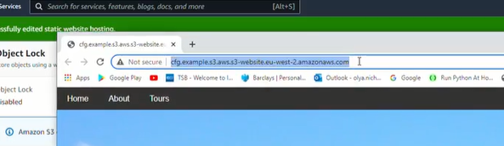

- In order to be on a safe side, PLEASE TAKE A SCREENSHOT OF YOUR WEBSITE AND THE URL to prove that it is up and running, in case there are some technical issues in the future and an instructor is unable to access your link.

Example: (we need to clearly see your website and the URL)

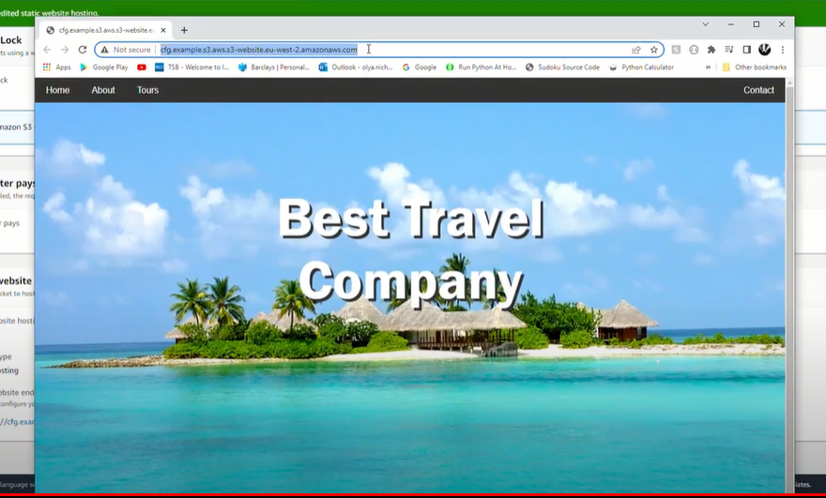

- You need to keep your website LIVE for 5 days! (Time required for instructors to mark all assessments). After one week you can take your website down (or sooner if your instructor says so). Please do not worry – it would NOT trigger any AWS payments as your free tier allows use of simple static webpages for thousands of hours.

Hosting Docker App with AWS (30 points total)

Please use the contents of the folder called “docker-app” that have been shared with you at the beginning of this assessment. Open index.html in any browser to see an example of a simple static webpage. You DO NOT NEED the index.html script. It is only an example of what to expect

URL:
http://ec2-100-48-78-209.compute-1.amazonaws.com:8080/

The task is:

- Use app.py and Dockerfile to create a new Docker Image
- Add this new Docker App to AWS ECR
- Then host the Docker App in the cloud with the help of AWS ECS
- Your containerised App should be up and running on AWS and accessible by anyone who knows the URL.
- NB: if you are unable to configure and host your Docker App with AWS, then please do push your Docker Image to Docker Hub and SUBMIT the full Docker Image name (with your user name) instead, so that your instructor can see that you did build the Docker Image! You will be awarded 10 points for this.

IMPORTANT NOTES:

- Prior to posting your webpage online, please open app.py in any editor (even a notepad) and update YOUR name and surname as highlighted in yellow in a snippet below

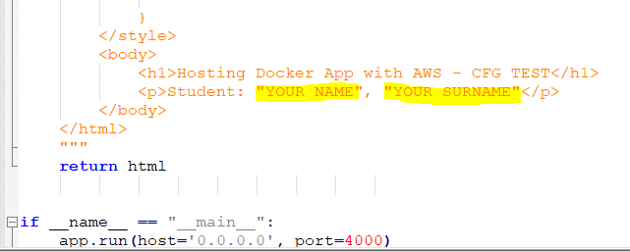

- You need to submit a URL address to your newly created website, so that an instructor can access it from their machine when they mark this assessment.

Example URL from our previous lesson: (see the URL)

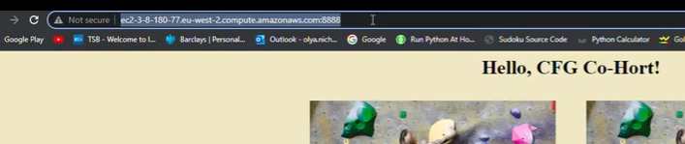

- In order to be on a safe side, PLEASE TAKE A SCREENSHOT OF YOUR WEBSITE AND THE URL to prove that it is up and running, in case there are some technical issues in the future and an instructor is unable to access your link.

Example: (we need to clearly see your website and the URL)

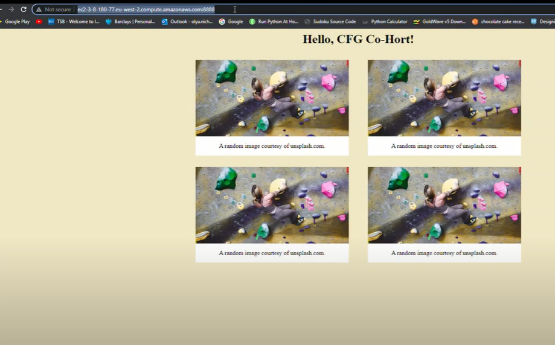

- You need to keep your website LIVE for 5 days! (Time required for instructors to mark all assessments). After one week you can take your website down (or sooner if your instructor says so). Please do not worry – it would NOT trigger any AWS payments as your free tier allows use of simple static webpages for thousands of hours.

