Patterns of Life HMW1 Francesco Pancaldi
09/07/2014

Lamarckian Evolution

Introduction

When learning about evolution we have heard about Lamarck, his theory of evolution induced by changes happening during the life of the parents and then passed to the children was first generally accepted and later totally discarded.
The classic example is almost always “giraffes started stretching their necks to get to higher leaves on trees, pass the acquired longer necks to their offspring and generation after generation they got longer necks”.
This theory was disproved with some very simple and crude experiments, like cutting the tails of lab rats and see if the next generation will or not have a shorter tail. The results obviously seemed to prove that Lamarckian evolution was completely false, but lately new experiments are challenging this conclusion.
Neither Lamarck or Darwin obviously knew about genes and DNA or most generally what are the mechanisms behind phenotype expression. Now we know that traits are regulated through DNA units called genes, these are passed between generations and is not normally possible to change your DNA during an individual life, unless mutation happens.
However, in the last decades a new branch of genetics has started to investigate changes occurring during life that can be passed to the next generations.
Epigenetic studies all those heritable changes not induced by changes in DNA.
Researchers found that the expression of certain genes can be turned ON or OFF and that this activation state may be passed to the offspring.
These late experiments seems to be bringing back to light Lamarck and his theories.

In this homework I will explore this subject offering different points of view as well as my personal opinion and I will also provide a simplified model (and relative Matlab code) to show how both “Lamarck-like” and “Darwin-like” evolutions are useful and in fact needed to assure the survival of a species.

Results and Discussion

In this section I will discuss Lamarckian and Darwinian evolution and epigenetic.

Lamarck theory of evolution is based on the following two principles [1]:

First Law. In every animal which has not passed the limit of its development, a more frequent and continuous use of any organ gradually strengthens, develops and enlarges that organ, and gives it a power proportional to the length of time it has been so used; while the permanent disuse of any organ imperceptibly weakens and deteriorates it, and progressively diminishes its functional capacity, until it finally disappears.

Second Law. All the acquisitions or losses wrought by nature on individuals, through the influence of the environment in which their race has long been placed, and hence through the influence of the predominant use or permanent disuse of any organ; all these are preserved by reproduction to the new individuals which arise, provided that the acquired modifications are common to both sexes, or at least to the individuals which produce the young.

This means that a change in the environment will induce change in behavior resulting in an increased or decreased use of a certain body part or organ that will cause development or underdevelopment of the same.
Therefore, Lamarck considered the use or disuse of a certain body part as the directing force under evolution.
On the other hand, Darwin believed natural selection to be the engine that drives evolution, with the fittest individuals be selected by environmental factors to pass on their traits to the next generation.
While observation of animals adaptation in the wild and evolutionary lines through fossils observations has proven Darwin right, interest in Lamarckian evolution greatly diminished and generally started to be considered completely wrong.
However, lately many studies have been published in which the acquisition of traits by parents is passed to the children. Examples of this are:

- In mice diet can cause cell dysfunction in the offsprings [2][3]
- Resistance to viral infection in the nematode Caenorhabditis elegans suggests that small RNA molecules may be inherited in a non Mendelian fashion and provide resistance to infection.[4]
- A scientific study of rice plants came to the conclusion that "gene expression is flexibly tuned by methylation, allowing plants to gain or lose particular traits which are heritable”.[5]
- Mutations caused by a father's lifestyle can be inherited by his children through multiple generations.[6]
- A Swedish study showed that exercise changes the epigenetic pattern of genes that affect fat storage in the body.[7]

All these studies are part of what is called Epigenetic. This branch of genetics deals with changes in the transcriptional potentials of genes, induced by different chemical factors attaching to the DNA and turning OFF and ON again the production of specific proteins. Examples of these are DNA methylation, histone modifications and action of repressor proteins.
Many of these process in these studies have been proven to be acquirable during life and passable to the next generation.
Many scientists now consider epigenetic as prove of Lamarckian evolution.
However, many other (and this is also my personal opinion) believe that the focus in the trigger to acquire a specific trait is not the same between epigenetic and Lamarckian evolution.
In fact, Lamarck underlined that the use and disuse are the driving forces to unlock the development or underdevelopment of a trait or body part and these may be induced by the environment.
On the other hand in epigenetic a collection of different factors including environment, diet, exercise, etc... can trigger the activation or deactivation of a gene that will provide ability to develop a specific trait or body part.
Therefore, will be more correct to consider Lamarckian evolution as a particular example of Epigenetic, induced by use of a specific body part, and the two should not be treated as the same.
Also Lamarck seemed to believe that this acquired changes will add with every generation resulting in evolution of the species, while from our current understanding they appear to be finite in nature. This means that if, for example, a gene is turned ON it cannot be turned more ON in the next generation, and also if there are level of activation there is a limit to them.

We can also expect that under certain condition the activation or deactivation of genes will provide with a significant difference in the expression of the same gene (being turned ON or OFF) when compared to a small difference due to random mutation between generation passed through normal Darwinian evolution, and this significant change can be passed and maintained in the offspring.

I will next present a simplified model of epigenetic evolution and Darwinian evolution working together.
In this simple model we will simulate a population of bacteria-like organisms reproducing under evolutionary pressure either through gene mutation or through epigenetic activation of a gene.

We start with a fixed number of cells, at each time step cells have a fixed probability to produce an offspring, the new cell in turn has a probability of having a small mutation (positive or negative) and will also retain the epigenetic state of the gene (ON or OFF) from the parent cell.
Also, under the evolutionary pressure, at each time step cells (not born at that step) have a probability of dying based on the current pressure level and their gene expression.

Specifically, we consider each cell to have an optimal maximum temperature for survival Tb, and initially this is 80°C, for all cells. If the environment temperature T is higher than the survival temperature, but lower than Tb+Td, for the cell there is a probability P=(T-Tb)/Td of the cell dying, and P=1 if higher than Tb+Td, where Td is the difference in temperature for which we have certain death.

For example, if the cell we are considering has a Tb=85°C it will have P=0 until T>85°C and P=1 if T>105°C (in this example and in the simulations below Td=20°C) and for 85<T<105°C P will increase linearly from 0 to 1.
Our environment temperature will start at T=79°C, at each time step will increase by 0.25°C and each cell in our population will start with Tb=80°C.
When the difference in temperature is higher than 5°C the cell activates a gene that raise its survival temperature to Tb+10°C (this effect does not add at each time step) and will stay activated until the condition holds. The activation or deactivation is passed to the daughter cells.
We start with 100 cells and at each step one cell can reproduce with a probability P=0.15.
Each daughter cell has a probability of mutating increasing or decreasing the Ts value acquired by the mother cell by 1°C (P=1/3 for both + or - 1°C).

Next I will show simulations to illustrate how the two mechanisms are both important to achieve survival of the species for a long time. Due to time constrains was not possible to run a big number of simulation or perform a theoretical analysis of the model, but the results seems qualitatively consistent between simulations sharing the same parameter set.
The results from this simulations are shown in the following graphs of the average bacteria survival temperature Tb, compared with environment temperature T at each time step, and the number of cells N at each time steps.

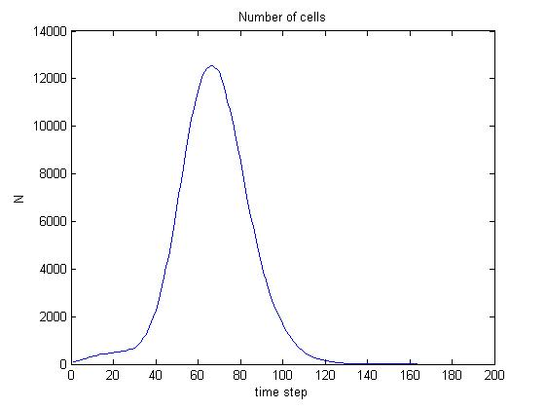Darwin+Lamarck number of cells
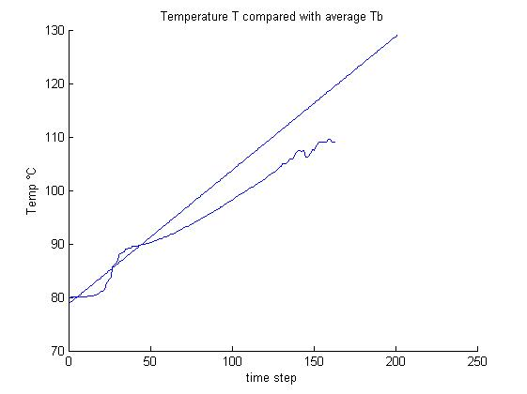Darwin+Lamarck temperature

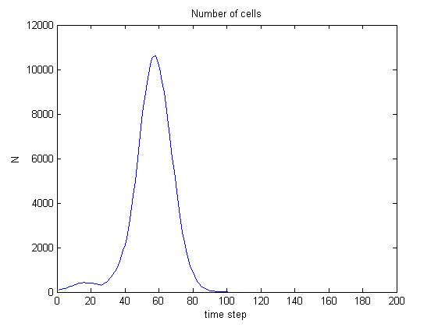Lamarck population
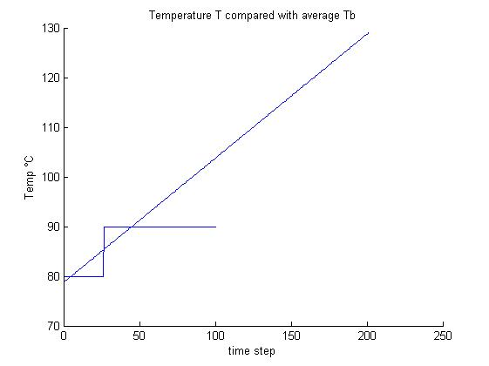Lamarck temperature

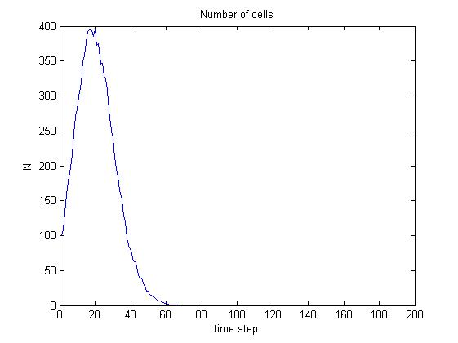Darwin population
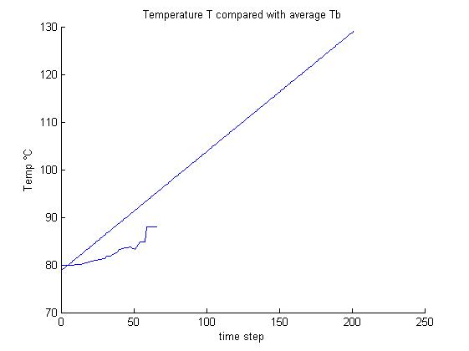Darwin temperature
As can be seen in the pictures above the population expressing both Darwinian and Epigenetic evolution has a clear advantage on the ones expressing only one type, this is reflected by the number of time steps before extinction and also in the closeness of the average Tb of the population to the environment temperature line and also the maximum number of cells.

Conclusions

Both mutation in DNA and epigenetic phenomena are important for evolution. This has also been shown in the simulations from the simple model reported above.

However, the effect of both epigenetic changes and mutation may be differ depending on reproduction rates, selective pressure, death rates, etc...
Therefore, the model should only be considered as a very simplified case and a first step to show the importance of both mechanisms.
Also as said the stochastic nature of the model will require more extensive simulations or more accurate analytical study of the model, unfortunately both will require time to be performed and was then not included here.

Models like the above could be used to determine if epigenetic have contributed to the evolution of certain trait under selective pressure and should be coupled with experiments to be made more biologically accurate.

In conclusion the importance of epigenetic is becoming more evident and more studies are coming out with new examples of traits acquired by the parents and passed to the children up to several generations.
Also, more people are starting to get interested in this subject and more computational models will be necessary to be able to better direct experiments.

References
[1] Jean-Baptiste Lamarck Zoological Philosophy trans. Hugh Elliot, 1914, p.113

[2] Ng, Sheau-Fang; Lin, Ruby C. Y.; Laybutt, D. Ross; Barres, Romain; Owens, Julie A.; Morris, Margaret J. (2010). "Chronic high-fat diet in fathers programs β-cell dysfunction in female rat offspring". Nature 467 (7318): 963–6. doi:10.1038/nature09491. PMID 20962845.

[3] http://www.ohio.edu/research/communications/obese_paternal.cfm

[4]Rechavi, Oded; Minevich, Gregory; Hobert, Oliver (2011). "Transgenerational Inheritance of an Acquired Small RNA-Based Antiviral Response in C. Elegans". Cell 147 (6): 1248–56. doi:10.1016/j.cell.2011.10.042. PMC 3250924. PMID 22119442.

[5]Akimoto, K.; Katakami, H.; Kim, H.-J.; Ogawa, E.; Sano, C. M.; Wada, Y.; Sano, H. (2007). "Epigenetic Inheritance in Rice Plants". Annals of Botany 100 (2): 205–17. doi:10.1093/aob/mcm110. PMC 2735323. PMID 17576658.

[6]Linschooten, J. O.; Verhofstad, N.; Gutzkow, K.; Olsen, A.-K.; Yauk, C.; Oligschlager, Y.; Brunborg, G.; Van Schooten, F. J.; Godschalk, R. W. L. (2013). "Paternal lifestyle as a potential source of germline mutations transmitted to offspring". The FASEB Journal 27 (7): 2873. doi:10.1096/fj.13-227694. Lay summary – ScienceDaily (July 1, 2013).

[7]Rönn, Tina; Volkov, Petr; Davegårdh, Cajsa; Dayeh, Tasnim; Hall, Elin; Olsson, Anders H.; Nilsson, Emma; Tornberg, Åsa; Dekker Nitert, Marloes; Eriksson, Karl-Fredrik; Jones, Helena A.; Groop, Leif; Ling, Charlotte (2013). "A Six Months Exercise Intervention Influences the Genome-wide DNA Methylation Pattern in Human Adipose Tissue". In Greally, John M. PLoS Genetics 9 (6): e1003572. doi:10.1371/journal.pgen.1003572. PMC 3694844. PMID 23825961. Lay summary – ScienceDaily (July 3, 2013).
[8]Wikipedia: Lamarck, Epigenetic, DNA methylation.

