WEFSys Model

**A free web tool for dynamic systems modeling of the water-energy-food nexus**

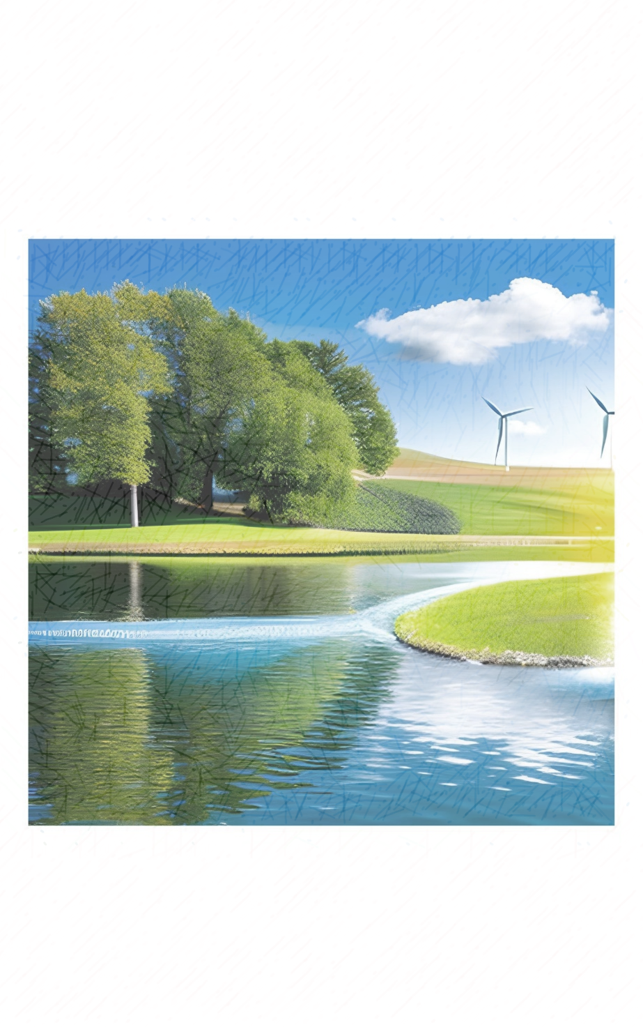

***Instruction Manual & Technical Documentation***

***Version 1.0***

Femeena Pandara Valappil, Rachel Brennan

The Pennsylvania State University

June 2023

**CONTENTS**

SECTION 1: OVERVIEW 3

SECTION 2: MODEL CONFIGURATION 3

SECTION 3: INPUT DATA FILE 4

SECTION 4: MODEL INTERFACE 6

4.1. Population 6

4.2. Land 6

4.3. Water 7

4.4. Energy 9

4.5. Food 11

4.6. Simulation Variables 12

REFERENCES 13

# SECTION 1: OVERVIEW

The WEFSys modeling tool is a first-of-its kind free online interface that allow users to simulate the water-energy-food nexus using dynamic systems modeling approach. The interface provided here is primarily based on a WEF-Nexus framework developed by [Purwanto et al. (2021)](https://www.sciencedirect.com/science/article/abs/pii/S2352550920304553). This model allows users to simulate a community or region with residential, industrial, and agricultural areas (including livestock and up to three staple crops). Temporal changes in these areas and in the production of energy, water, and food are used as input to quantify interlinkages between the three sectors.

Water, Energy, and Food security indices are calculated in the model using the same methodology used in estimating [Pardee RAND Food-Energy-Water Index](https://www.rand.org/pubs/tools/TL165.html). The indices range from 1 to 5, with 5 indicating the most secure status, as shown below.

**Least secure**

**Most secure**

**1**

**5**

**3**

**2**

**4**

Accessibility and availability of resources (water, energy, and food) are the main factors driving these indices. The model additionally determines two indicators for each sector: (1) **Availability per person** (water, energy, or food available per person) and (2) **Self-sufficiency level** (which quantifies the extent to which local resource production can meet the population demand without relying on imports).

This documentation describes the modeling interface (available at <https://p99qju-fpp5057.shinyapps.io/WEFSys/>) and breaks down the type of input data required to run the model successfully.

***Note: All the input data for the model are at an annual scale, even when the units don’t explicitly mention “per year”.***

# SECTION 2: MODEL CONFIGURATION

The original WEFSys model was initially built on the [Stella modeling platform](https://exchange.iseesystems.com/models/player/femeena-pandara-valappil/wefsys-model) with causal-loop diagrams, as shown below. Clicking on the image below will redirect you to the Stella model view, where you may view the different components of the model using the zoom feature. To provide a more user-friendly experience with enhanced results and data inputs, the model has now been redesigned and published on the online interface, which you will find on the 'Model' tab on top. The interface has been entirely built in R programming language using the Shiny package (RStudio - v2022.07.2). The code and sample data are available for free at https://github.com/fpandara/WEFSysModel.

[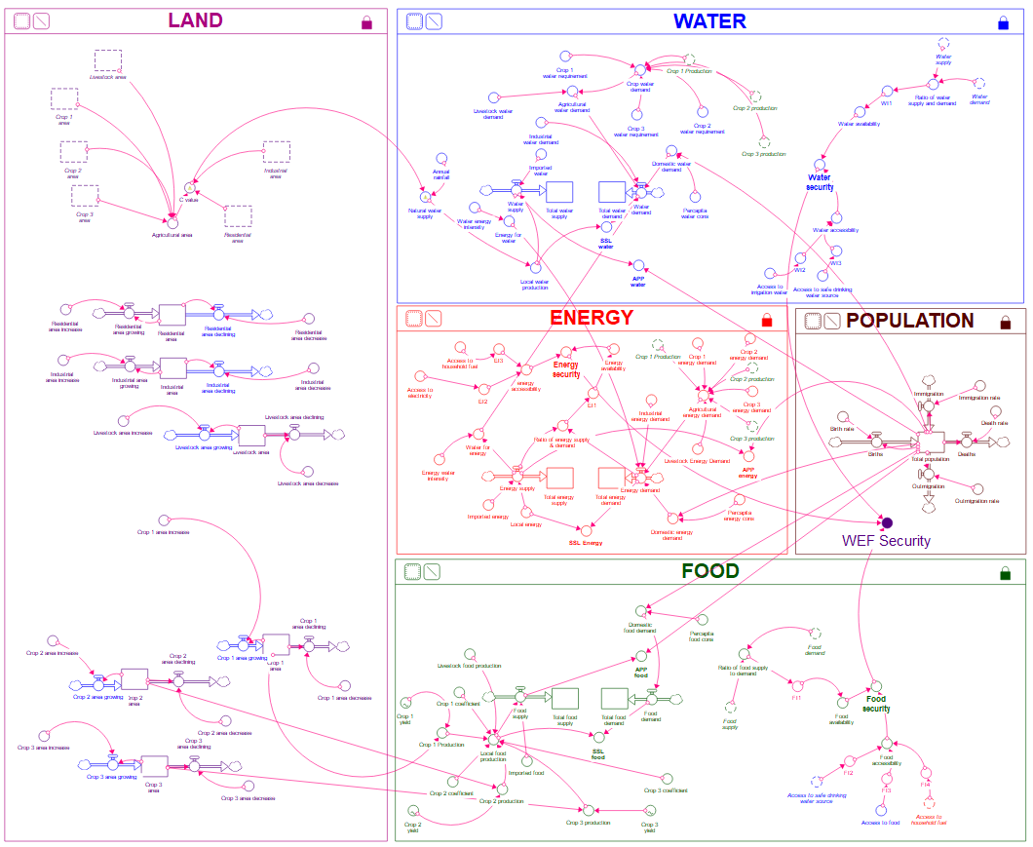](https://exchange.iseesystems.com/models/player/femeena-pandara-valappil/wefsys-model)

Figure 1. WEFSys model framework built on Stella Architect Platform (https://exchange.iseesystems.com/models/player/femeena-pandara-valappil/wefsys-model).

# SECTION 3: INPUT DATA FILE

In addition to entering user data on the web interface, the WEFSys tool requires an input CSV file to run the model. A sample file is provided in the project directory. The same template should be used for any new projects, with the file name remaining the same (‘Input_Data.csv’).

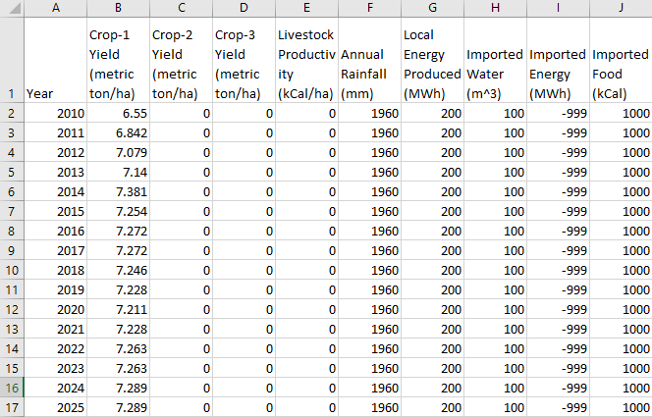

Figure 2. Snapshot of the input data file used to run the WEFSys model.

The variables used in the input file and their corresponding units are described below:

Col. 1: Year

Cols 2-3: Crop yields in metric tons per hectare per year

Col 4: Livestock productivity in kCal per hectare per year

Col 5: Annual rainfall in mm per year

Col 6: Local energy produced from all sources in MWh per year

Col 7: Total amount of water imported into the region in m3 per year

Col 8: Total amount of energy imported into the region in MWh per year

Col 9: Total amount of food imported into the region in kCal per year

The CSV file should be uploaded to the interface by clicking the ‘Browse’ button under the ‘Upload Input Data File’ prompt. Once the file is successfully uploaded, it will display ‘Upload complete’ (as shown below).

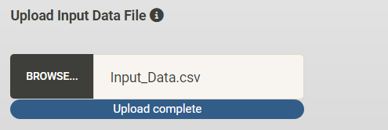

# SECTION 4: MODEL INTERFACE

This section describes the online interface of the WEFSys model and the type of input data required to run a WEF nexus simulation. Ideally, to build a model for s specific community or region, users should use all the data representative of that study area (collected through online databases, field surveys, etc.). However, since its challenging to find actual data for some of the model variables, given below are some recommended data sources that users could refer to in case of data scarcity. Please keep in mind that most of the data provided here are at a country scale and may not reflect the characteristics of a small-scale community. The model is simulated at an annual scale and all the data described here also corresponds to the same scale. The values displayed in each box in the online interface is the default value used by the model. To do a sample run, users may leave these options as such, upload the provided sample input CSV file and run the model as per instructions given in Section 5.

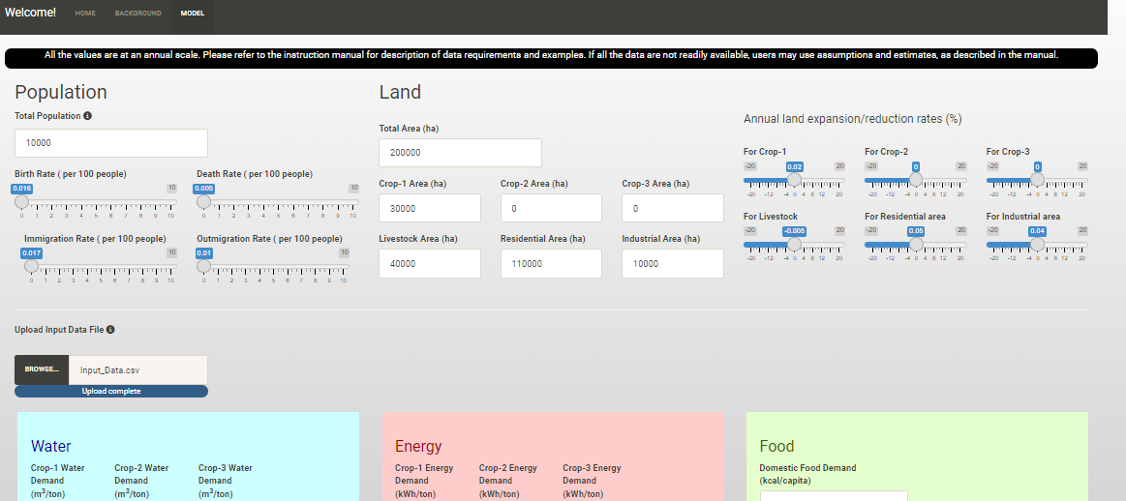

Figure . WEFSys Model interface

## 4.1. Population

The population module requires the total population and the birth, death, immigration, and outmigration rates (per 100 people) of the study area. Users may ignore the effect of migration by entering immigration and outmigration rates as 0 if it is known to be negligible.

1. Birth rate by country (per 1000 people): <https://data.worldbank.org/indicator/SP.DYN.CBRT.IN>
2. Death rate by country (per 1000 people) : <https://data.worldbank.org/indicator/SP.DYN.CDRT.IN>
3. Immigration and outmigration by country: <https://stats.oecd.org/Index.aspx?DataSetCode=MIG>

## 4.2. Land

The land module pertains to the land use distribution of the study area, specifically agricultural, industrial, and residential areas (all in hectares). In the current version, the model can simulate up to 3 staple crops the user chooses. Livestock area is modeled as a single variable, without any split between the different types of livestock animals. To account for changing land use, users have the option to enter increasing or decreasing rates (in %) of each land use area at an annual scale.

*[For the Sections 4.3, 4.4, and 4.5 concerning Water, Energy, and Food variables, below are some of the references that users may use to get approximate values in case actual data is not available. Users are free to use their own assumptions. Please keep in mind that the examples provided here are mostly country-scale data and hence may not accurately represent the study area chosen by the user. For more realistic modeling, we encourage using actual field-collected data.]*

***Note: The units of variables provided in the references below may be different from what the WEFSys models uses. Please use appropriate unit conversions, as needed.***

## 4.3. Water

1. Crop water demand (mm/growing period)
   * 1. <https://www.fao.org/3/s2022e/s2022e02.htm#TopOfPage>
     2. <https://fieldtomarket.org/national-indicators-report/energy-use/> (For US crops)

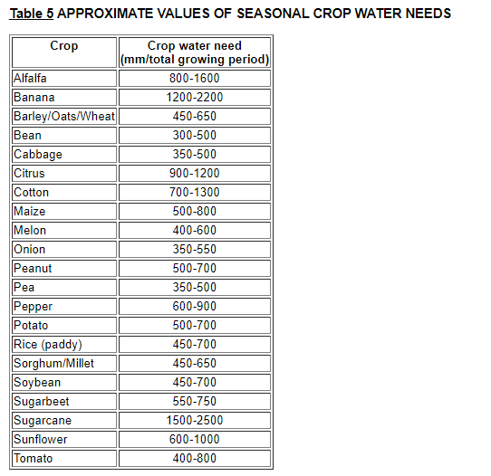

(From FAO, 2022)

1. Livestock water demand (litres/day)

<https://www.engineeringtoolbox.com/farm-use-animals-water-consumption-d_1588.html>

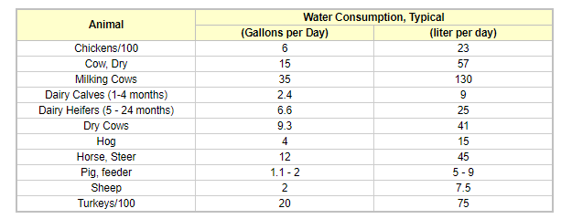

1. Industrial water demand by country (litres per capita per day)

Jin et al. (2019) provides industrial water demand for different countries, split according to different fuel types.

<https://www.sciencedirect.com/science/article/pii/S1364032119305994> (Jin et al., 2019)

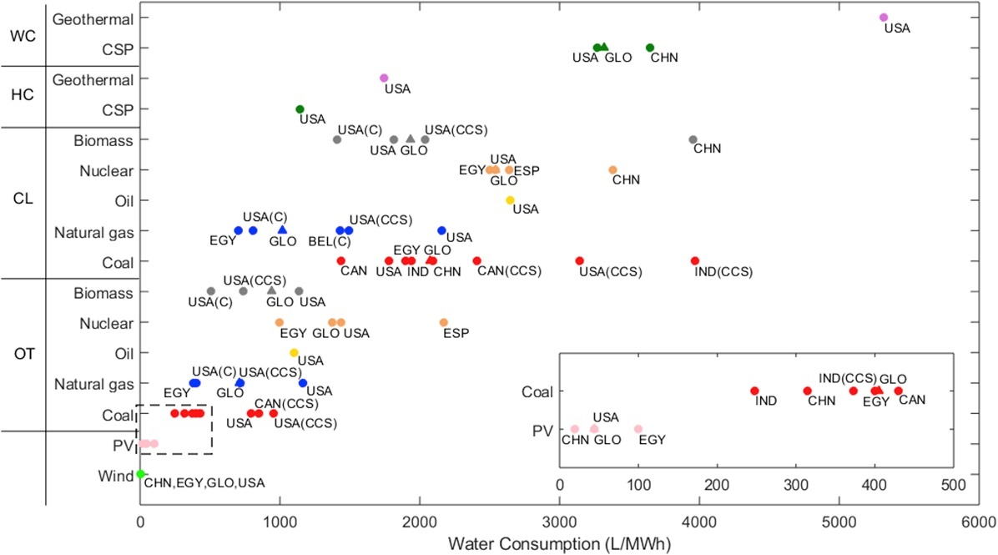

1. Domestic water demand by country (litres per capita per day)

<http://chartsbin.com/view/44463>

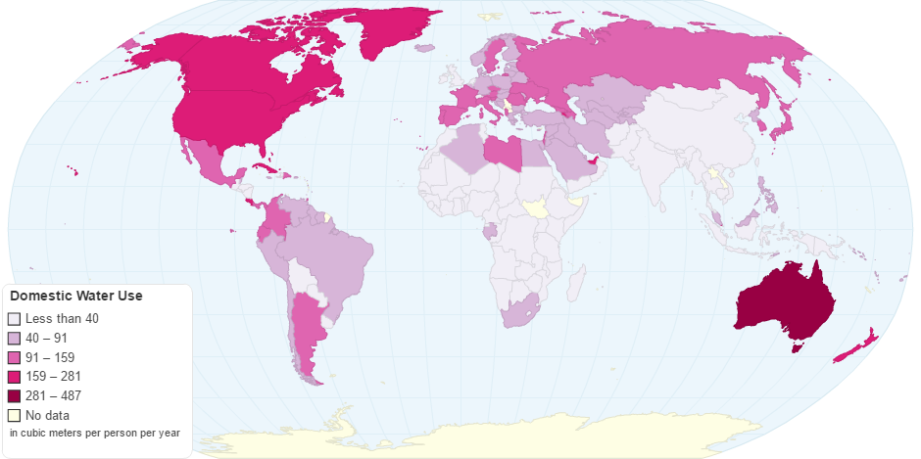

1. Water for energy (m3/MWh)

<https://mediamanager.sei.org/documents/Publications/SEI-Paper-Hoff-UnderstandingTheNexus-2011.pdf> (Hoff, 2011)

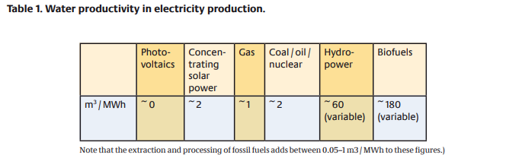

1. % population with access to safe water by country
   * 1. <https://ourworldindata.org/water-access#access-to-safe-drinking-water>
     2. <https://www.worldeconomics.com/Indicator-Data/ESG/Environment/Water-Access/>

## 4.4. Energy

* 1. Energy and water use of different crops
     1. For US-based crops:
* <https://fieldtomarket.org/national-indicators-report/energy-use/>
* <https://link.springer.com/article/10.1007/s11053-013-9226-4/tables/2> (Amenumey & Capel, 2014)

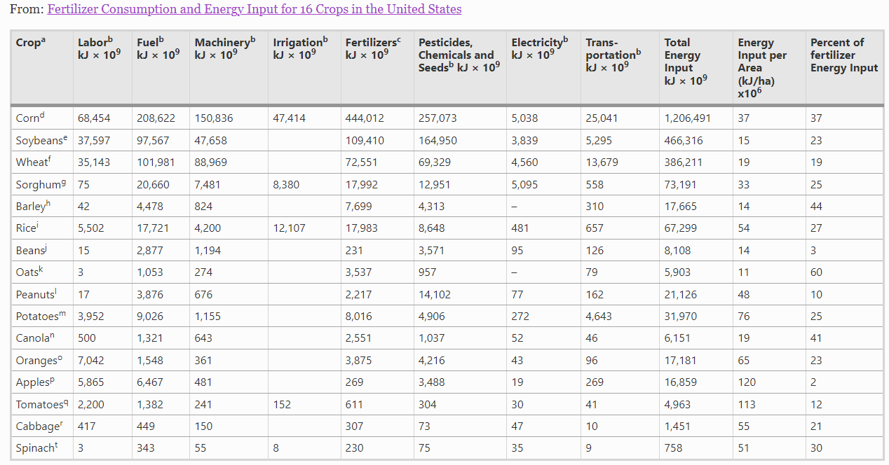

(From Amenumey & Capel (2014))

* + 1. Worldwide:

<https://www.fao.org/3/X8054E/x8054e05.htm> (general energy consumption for different regions around the world)

1. Domestic energy demand (kWh per capita)

https://ourworldindata.org/grapher/per-capita-energy-use?facet=entity

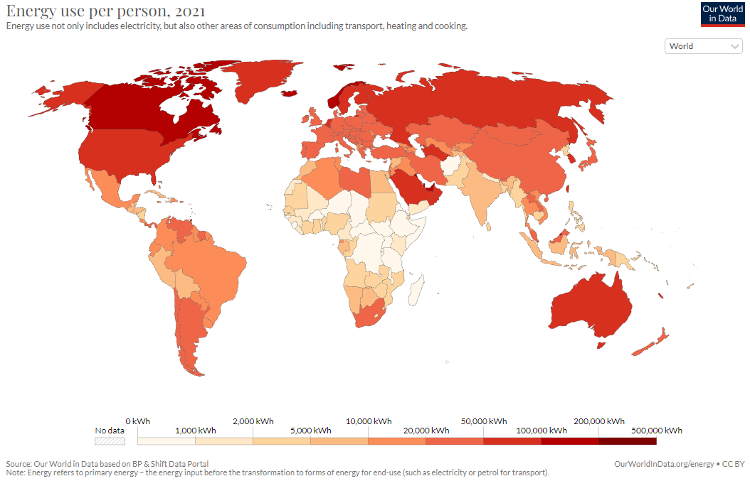

1. Energy for water (MWh/m3)

According to [Hoff (2011)](https://mediamanager.sei.org/documents/Publications/SEI-Paper-Hoff-UnderstandingTheNexus-2011.pdf), energy intensities per m3 of clean water produced vary by about a factor of 10 between different sources, e.g. about 0.37 kWh from locally produced surface water, 0.66–0.87 kWh from reclaimed wastewater and 2.6–4.36 kWh from desalinated seawater

1. % population with access to electricity by country

Following data includes energy access distribution based on urban/rural areas and based on the source of electricity.

* + 1. <https://data.worldbank.org/indicator/EG.ELC.ACCS.ZS>
    2. <https://ourworldindata.org/energy-access#what-share-of-people-have-access-to-electricity>

1. % population with access to cooking fuel by country

Following data includes distribution of cooking fuel access based on urban/rural areas and based on the source of electricity.

* + 1. <https://data.worldbank.org/indicator/EG.CFT.ACCS.ZS>
    2. <https://ourworldindata.org/energy-access#access-to-clean-fuels-for-cooking>

## 4.5. Food

1. Domestic food demand by country (kCal/capita/day)

<https://ourworldindata.org/food-supply>

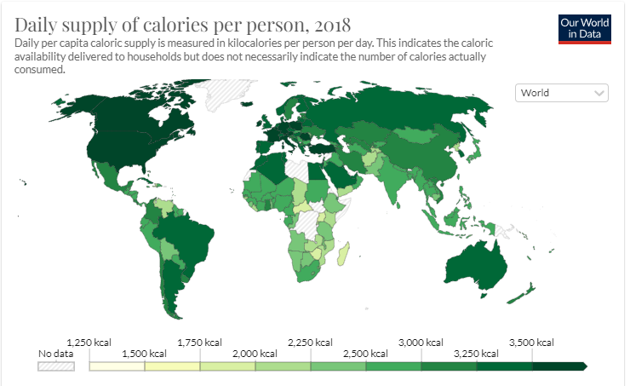

1. Crop coefficients for different crops and food items (kCal/100 grams)

<https://www.fao.org/3/X9892E/X9892e05.htm>

1. % population that are undernourished or food insecure

In the following list of data, ‘food insecure population’ includes those who struggle or worry about the ability to access or afford a healthy, nutritious balanced diet.

1. <https://ourworldindata.org/hunger-and-undernourishment#what-share-of-people-are-undernourished> (data on percentage of undernourished people in each country)
2. <https://data.worldbank.org/indicator/SN.ITK.DEFC.ZS>
3. <https://data.worldbank.org/indicator/SN.ITK.MSFI.ZS>
4. <http://web.archive.org/web/20141108183923/http://www.fao.org/economic/ess/ess-fs/fs-data/en/#.VF5ja3bP2Uk> (Excel sheet available for several access indicators)

## 4.6. Simulation Variables

The start and end year of simulation are entered in this module. This should match the range of years provided Column 1 of the input data file, as described in Section 3. Once all the data is entered and input data file is successfully uploaded, click on ‘RUN MODEL’. The results (charts and tables) are automatically displayed below this module.

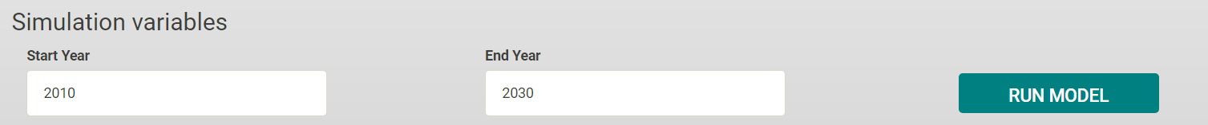

**4.7. Displaying and Interpreting Results**

After running the simulation, users can choose to display the results of several different variables, as a chart and a table. In the current version, the tool has the capability to display yearly trends for 16 variables: (1) Total water demand; (2) Total water supply; (3) Total energy demand; (4) Total energy supply; (5) Total food demand; (6) Total food supply; (7) Water security index; (8) Energy security index; (9) Food security index; and (10) Water-energy-food security index, (11) Per-capita water availability, (12) Per-capita energy availability, (13) Per-capita food availability, (14) Self-sufficiency level for water, (15) Self-sufficiency level for energy, (16) Self-sufficiency level for food. The plots for indices (from (7) to (10)) are color graded according to their value from 1 to 5.

The complete set of results can also be downloaded as a PDF by clicking on the ‘DOWNLOAD RESULTS’ button.

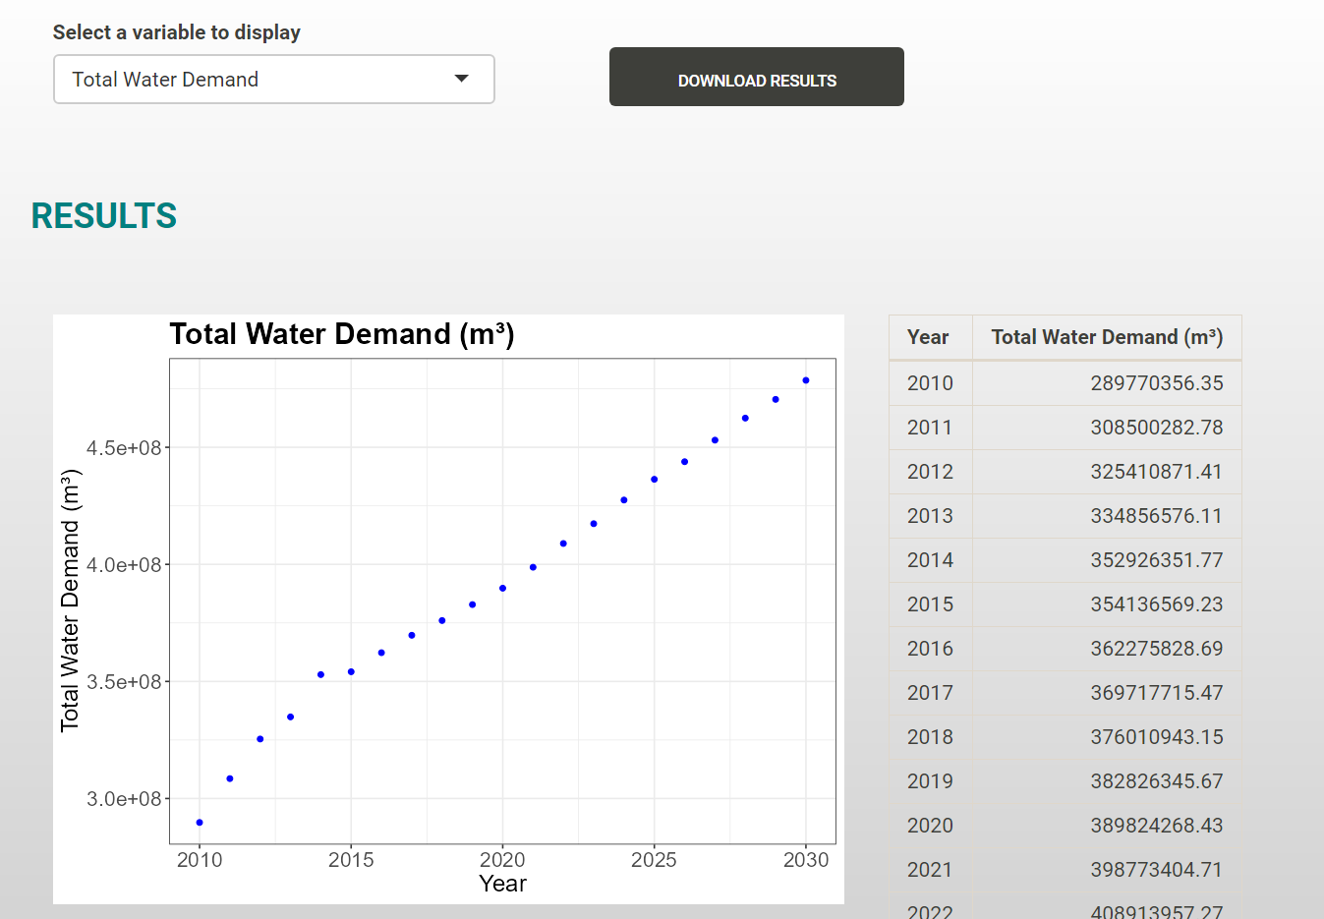

Edit the filename of the PDF as needed and click on “Download”. Once the download finishes, you will see a pop-up window confirming that the download is completed. Click “Close” to return to the interface.

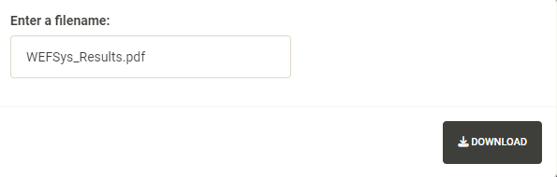

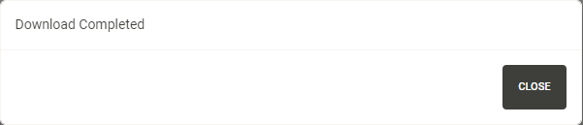

*From the authors:*

*We are pleased to present the initial release of the WEFSys model, now accessible online. Our team is committed to ongoing enhancements and greatly values your feedback. If you encounter any problems or errors while trying to run the model with your own data, please don't hesitate to reach out to us at* [*rab44@psu.edu*](mailto:rab44@psu.edu) *or* [*fpp5057@psu.edu*](mailto:fpp5057@psu.edu)*. As an open-source model, WEFSys thrives on your contributions to further improvements.*

# REFERENCES

Amenumey, S. E., & Capel, P. D. (2014). Fertilizer Consumption and Energy Input for 16 Crops in the United States. *Natural Resources Research*, *23*(3), 299–309. https://doi.org/10.1007/s11053-013-9226-4

Hoff. (2011). *Understanding the Nexus Background paper for the Bonn2011 Nexus Conference*. https://mediamanager.sei.org/documents/Publications/SEI-Paper-Hoff-UnderstandingTheNexus-2011.pdf

Jin, Y., Behrens, P., Tukker, A., & Scherer, L. (2019). Water use of electricity technologies: A global meta-analysis. *Renewable and Sustainable Energy Reviews*, *115*, 109391. https://doi.org/10.1016/j.rser.2019.109391