Update 23/02/2023:

* The dataset consists of 300 samples from 15 participants (9 men and 6 women). Participants use armbands on their right forearm, then be instructed to perform gestures a closed fist (finger flexion), spread open fingers (finger abduction), waving inwards (wrist flexion), and waving outwards (wrist extension) repeatedly for 60 seconds.
* This is the example of original fist gesture

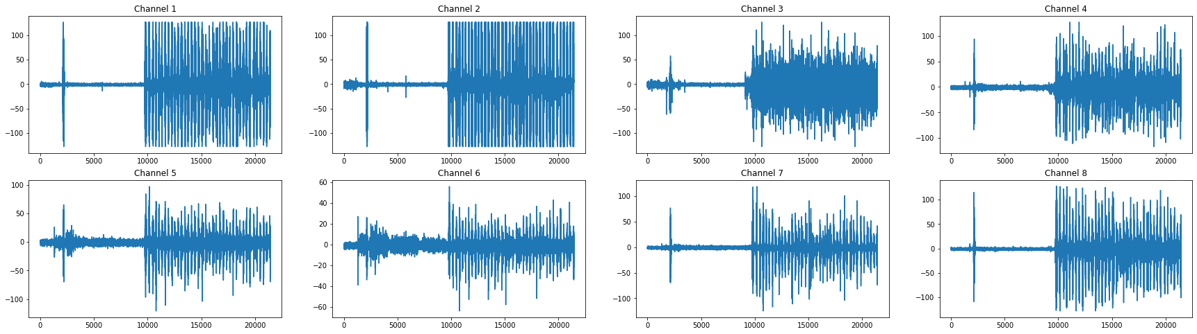

* In the experiment I do process the **original and rectification data** to see the impact of this process for the model
* Before I extract the feature from the data, first, I do rectification

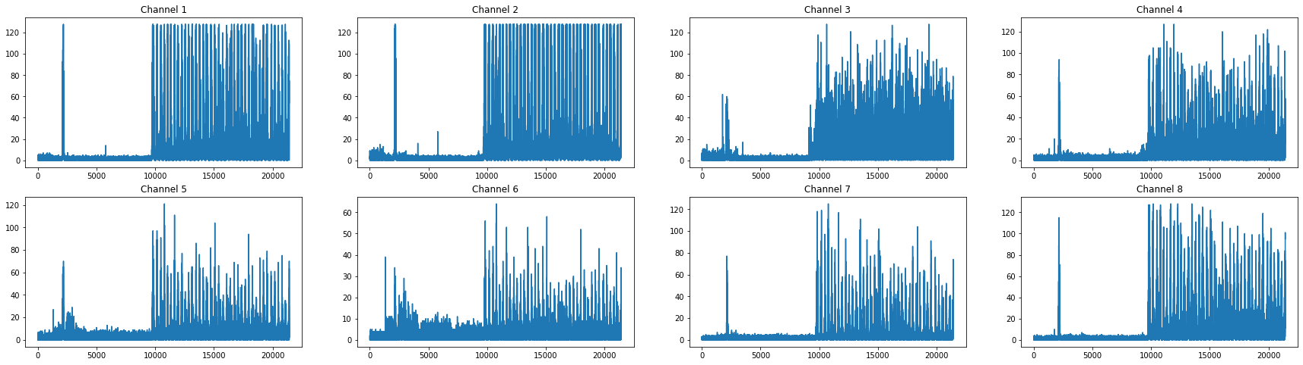

* Because the data have varying lengths, I cut the original and rectification data, so all the data have the same length (60 seconds). For this process, I am just taking the data from behind because the beginning of data is just a “rest gesture” when there is no movement

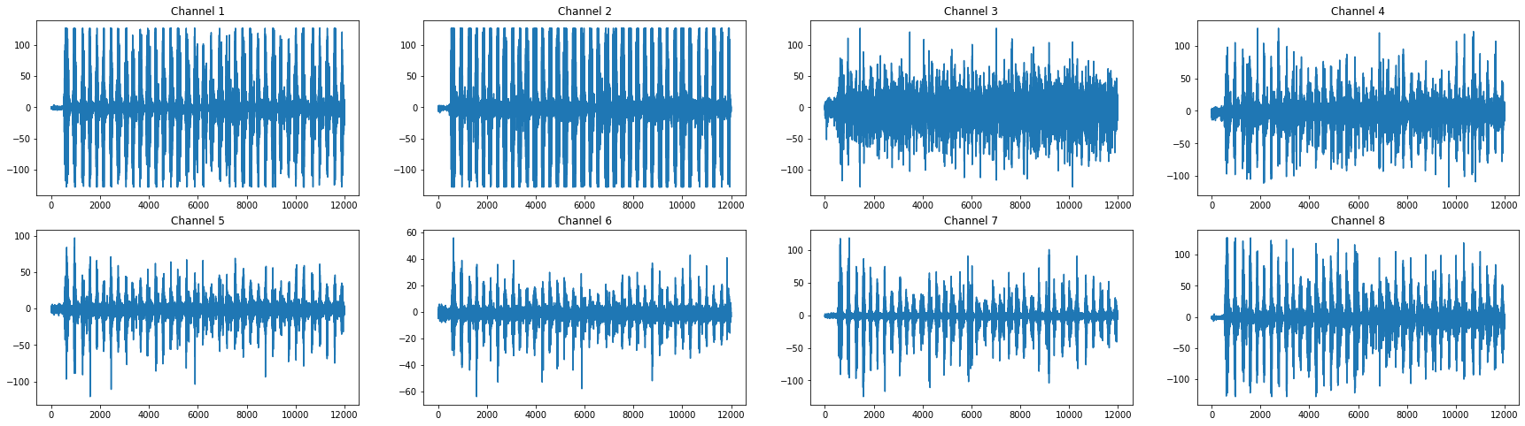

Figure 1. Original data

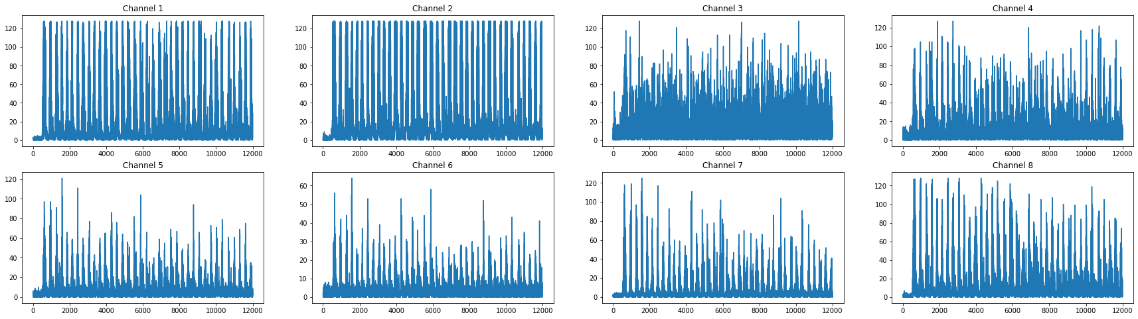

Figure 2. Rectification data

* After the data cut, I used sliding windows (1 second) for feature extraction. In this step, I am using Time-domain features (Mean, standard deviation, Max, Min) & Frequency-domain features (magnitude of frequency components of each signal (using FFT)) as extractor I tried to analyze again from the preprocessing. The final shape of the data is **(300, 60, 113, 8) -- (300, 60, 904)**

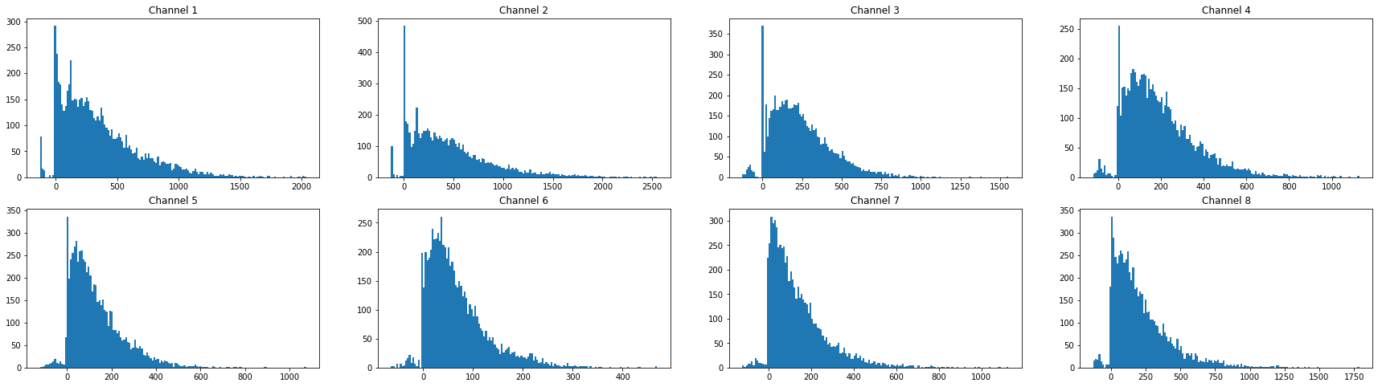

Figure 3. Histogram of the feature for original data

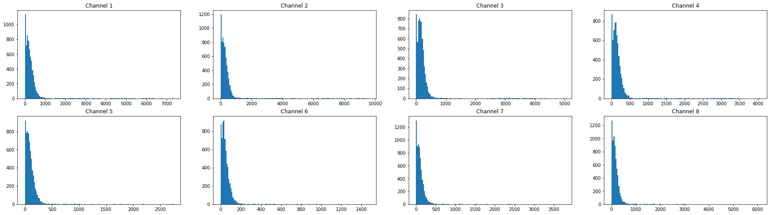

Figure 4. Histogram of the feature for rectification data

* After getting the feature before feeding it into the model, I reshape the data by multiplying the feature and the channel from **(300, 60, 113, 8) to (300, 60, 904).** There are only 4 label closed fist (g1), spread open fingers (g2), waving inwards (g3), and waving outwards (g4)
* After that, I used **MinMaxScaler** to normalize the into **[0, 1]**
* I split the dataset into 3 parts train, validation, and test. Train has (80%), Validation (Train*20%), and Test (20%)
* The model is a sequential neural network architecture that utilizes two LSTM layers with 128 and 64 units respectively, followed by a dropout layer for regularization. The input to the model is a 3D tensor with shape (batch_size, n_timesteps, n_features), where n_timesteps is the length of the time series sequence and n_features is the number of features. The output layer is a dense layer with softmax activation function for multi-class classification. The model is compiled with categorical cross-entropy loss function and Adam optimizer with a learning rate of 0.0001. Overall, the model aims to learn the temporal patterns in the time series data and predict the class labels for the given input.

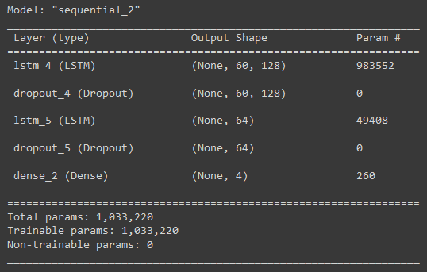

* The model is trained for a maximum of **100 epochs** and the training is performed in batches of **32 samples**. The validation data **X_val** and **y_val** are used to evaluate the performance of the model after each epoch. The training is stopped early if the validation accuracy does not improve for 5 consecutive epochs, as determined by the EarlyStopping callback.
* Result of training and test

|  |  |  |
| --- | --- | --- |
|  | **Training** | **Test** |
| Original data | 91% | 80% |
| Rectification data | 89% | 75% |

* After training the model, let’s try to predict using live data. There are 4 gestures: closed fist, spread open fingers, waving inwards, and waving outwards. Before predicting the data, all live data pass the same prepossessing step.
* Because there are two model (one for original data and for rectification data) I prepare 2 kind of input original and rectification.

Table 1. Histogram of the feature for original and rectification data (close fist gesture)

|  |
| --- |
|  |
|  |

Table 2. Histogram of the feature for original and rectification data (spread open fingers gesture)

|  |
| --- |
|  |
|  |

Table 3. Histogram of the feature for original and rectification data (waving inwards gesture)

|  |
| --- |
|  |
|  |

Table 4. Histogram of the feature for original and rectification data (waving outwards gesture)

|  |
| --- |
|  |
|  |

* For the original data because we only predict one gesture in a time, I expand the shape of data from (60, 904) to (1, 60, 904)
* Result for original data

|  |  |  |
| --- | --- | --- |
| **Real Class** | **Result** | **Predicted Class** |
| closed fist | [0.00640738 0.02502765 0.9598782 0.00868681] | waving inwards |
| spread open fingers | [0.01573293 0.03738646 0.88722324 0.05965742] | waving inwards |
| waving inwards | [0.00676375 0.02772214 0.9491883 0.01632582] | waving inwards |
| waving outwards | [0.00571709 0.02065796 0.9681474 0.00547752] | waving inwards |

* Result for rectification data

|  |  |  |
| --- | --- | --- |
| **Real Class** | **Result** | **Predicted Class** |
| closed fist | [0.00770298 0.00871158 0.97777224 0.00581318] | waving inwards |
| spread open fingers | [0.01723663 0.02242753 0.94165653 0.01867931] | waving inwards |
| waving inwards | [0.0315306 0.06136706 0.831898 0.07520438] | waving inwards |
| waving outwards | [0.01612896 0.01412359 0.9524619 0.01728562] | waving inwards |

* Because the result is very bad, I tried to modified the extraction, the idea is to add more feature extracted from the data. The list of the feature:
  + Mean
  + Std
  + Skewness
  + Kurtosis
  + Max
  + Min
  + Covariance
  + Variance
  + eigenvalues of covariance matrix
  + upper triangular matrix of covariance matrix
  + magnitude of frequency components of each signal (using FFT)
* Because there are different shape of feature, Covariance, upper triangular matrix of covariance matrix, and magnitude of frequency components of each signal (using FFT) were flatten and concatenate with all feature to 1 vector
* So, I get **(300, 60, 1792)** as my final data shape for my model.
* This is example of histogram for the first 10 second

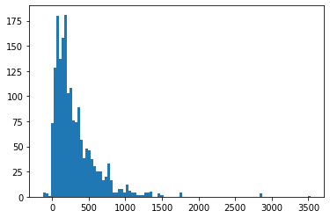

Figure 5. Original data

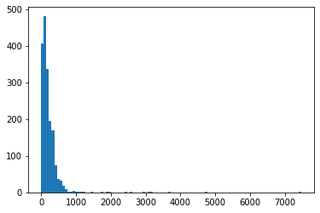

Figure 6. Rectified data

* Result of training and test

|  |  |  |
| --- | --- | --- |
|  | **Training** | **Test** |
| Original data | 82% | 88% |
| Rectification data | 94% | 88% |

* Live dataset

Table 5. Histogram of the feature for original and rectification data (close fist gesture)

|  |
| --- |
|  |
|  |

Table 6. Histogram of the feature for original and rectification data (spread open fingers gesture)

|  |
| --- |
|  |
|  |

Table 7. Histogram of the feature for original and rectification data (waving inwards gesture)

|  |
| --- |
|  |
|  |

Table 8. Histogram of the feature for original and rectification data (waving outwards gesture)

|  |
| --- |
|  |
|  |

* Result for original data

|  |  |  |
| --- | --- | --- |
| **Real Class** | **Result** | **Predicted Class** |
| closed fist | [0.0052417 0.01973423 0.9571653 0.01785889] | waving inwards |
| spread open fingers | [0.01722672 0.5020181 0.18531105 0.29544416] | spread open fingers |
| waving inwards | [0.03542518 0.17206195 0.6756863 0.11682664] | waving inwards |
| waving outwards | [0.01160458 0.03443729 0.9222128 0.03174531] | waving inwards |

* Result for rectification data

|  |  |  |
| --- | --- | --- |
| **Real Class** | **Result** | **Predicted Class** |
| closed fist | [0.05414798 0.13509169 0.73681676 0.07394361] | waving inwards |
| spread open fingers | [0.03632363 0.13859057 0.6924045 0.13268131] | waving inwards |
| waving inwards | [0.00510702 0.0299419 0.9522939 0.01265728] | waving inwards |
| waving outwards | [0.01476584 0.03363415 0.92224014 0.02935982] | waving inwards |