OSI Model Figure
For: Aalto University Fluid Power Lab c/o Fletcher Porter
Contact: Fletcher Porter · me@fletcherporter.com · +358 41 476 3167 · Telegram: @fpdotmonkey
Due: 30 June 2024, or negotiated
Pay: 30-40€, or negotiated

Description of Work
I would like to adapt this scientific figure of the OSI network model to better communicate my argumentative intents and to be easier to read across relevant communication media.
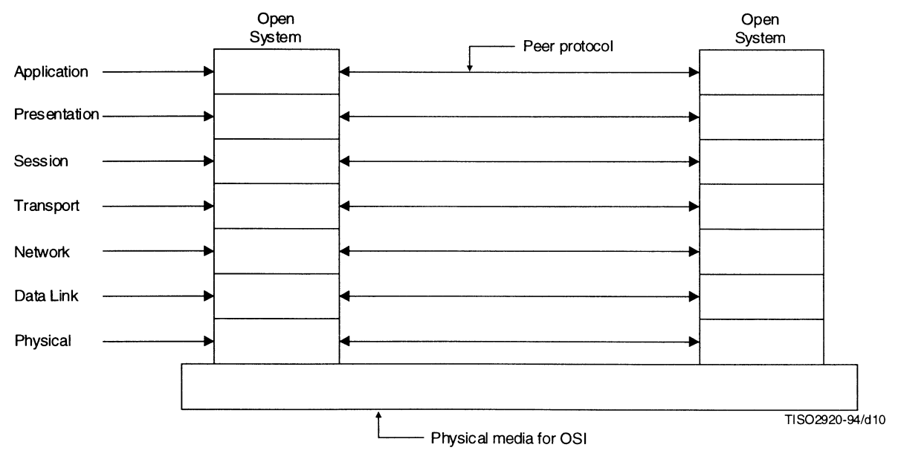
These qualities should be preserved.
- Behaviors are presented as layers
  - High-level behaviors (“Application”, “Presentation”, “Session”, “Transport”) are presented as being on top of low-level behaviors (“Network”, “Data Link”, “Physical”)
- Linear presentation
  - Each layer/behavior is connected to at most two layers, one above and one below
- Physical Communication Media (wires, cables, wireless, etc) is presented as below and outside the model
These qualities should be changed.
- Multiple peered systems (layer stacks on the left and right); this is irrelevant to my needs
- Small font size
- Unclear what the layers are or mean (fill with examples as below)
Here is a sketch of what I imagine a better figure would look like. I also describe what are the qualities I want out of the figure you produce.
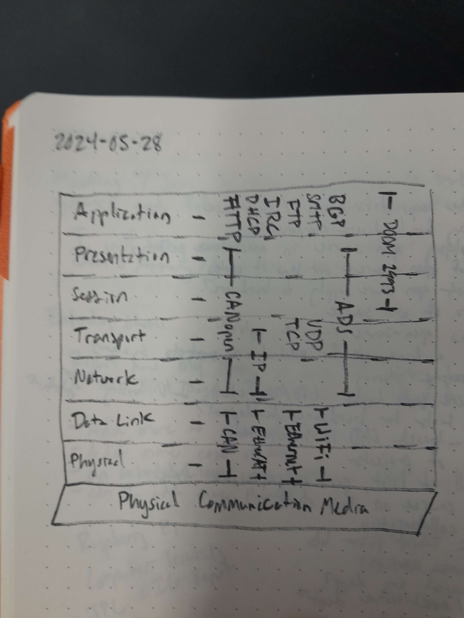
- The model is a sort of table
- Headings in the table are as above
- The table is populated with examples of protocols that perform that layer’s behaviors
  - Some protocols exist in a single layer
    - HTTP, DHCP, IRC, FTP, SMTP, and BGP are in the application layer
    - TCP and UDP are in the Transport layer
  - Other protocols span two or more layers
    - CAN, EtherCAT, Ethernet, and WiFi span the Physical and Data Link layers
    - IP spans the Transport and Network layers
    - CANopen and ADS span from the Network to the Presentation layer
    - DOOM 1993 spans from the Session to the Application layer
  - The horizontal arrangement of protocols is not important
- The Physical Commuication Media is visually distinct from the other layers
The idea to show is that protocols in high layers are agnostic to the goings-on of lower layers. IP doesn’t change if it’s going over Ethernet or WiFi, and in principal it could even go over CAN or EtherCAT given the implementation.
I also have created a similar figure which needs to show some similar properties, which you can see below. The “Sensors and transducers” layer fills the same role as the Physical Communication Media and behavior in high layers “just works” given the lower layers work.
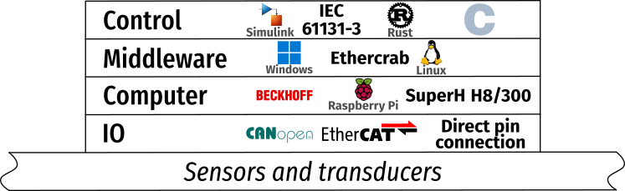
The figure should be presentable in these contexts.
- Digital The figure will be presented within a PDF. It will be sized to the width of an A4 paper minus margins. Consider this the canonical form.
- Slides The figure will be shown in slideshow presentations to probably medium-sized rooms. The projector will only probably be in good focus.
- Print The figure will be printed for scientific poster sessions. The figure will be the width of half the short side of an A1 paper minus margins. The printing will be done in a print shop and so will use good quality paper and printers.
Prioritize digital the highest, then slides, then print.

Deliverable
Provide an SVG file of the figure that implements the above requirements by the deadline.

I have never commissioned a designer before. If this is too little for the work requested, please say so we can find a more appropriate number.

