一．需要的文件包（这些都在openpose解压的文件夹下）：
1：E:\openpose\openpose-1.6.0\3rdparty ;E:\openpose\openpose-1.6.0\include
2：模型models
3：编译的windows里bin的所有dll文件以及编译的openpose.dll
4：openpose.lib库
- 环境配置
1:将3rdparty，include复制到项目同级目录
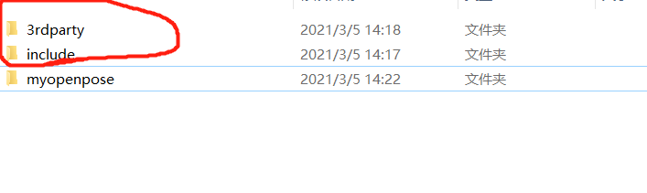
2:将模型models，openpose.lib复制到项目cpp文件的同级目录
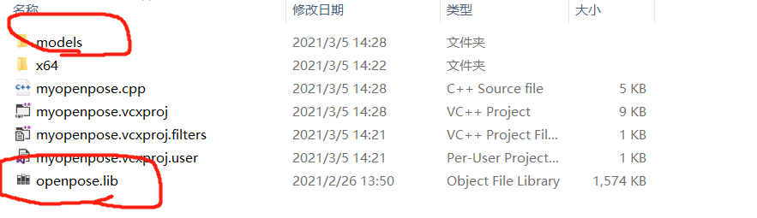
3:将dll库复制到exe同级目录下
4：右键打开项目属性，c/c++常规->附加包含目录导入库
..\..\..\include;
..\..\..\3rdparty\windows\opencv\include;
..\..\..\3rdparty\windows\caffe3rdparty\include;
..\..\..\3rdparty\windows\caffe\include;
..\..\..\3rdparty\windows\caffe\include2;
C:\Program Files\NVIDIA GPU Computing Toolkit\CUDA\v9.2\include
5:链接器->输出->附加依赖库
openpose.lib
C:\Program Files\NVIDIA GPU Computing Toolkit\CUDA\v9.2\lib\x64\cudart_static.lib
..\..\..\3rdparty\windows\opencv\x64\vc15\lib\opencv_world420.lib
..\..\..\3rdparty\windows\caffe3rdparty\lib\gflags.lib
..\..\..\3rdparty\windows\caffe3rdparty\lib\glog.lib
..\..\..\3rdparty\windows\caffe\lib\caffeproto-d.lib
..\..\..\3rdparty\windows\caffe\lib\caffe.lib
..\..\..\3rdparty\windows\caffe\lib\caffeproto.lib

6在cpp文件中编写openpose测试代码运行
