Digital Systems

Seven-Segment Display Project

7-Segment displays are versatile numerical indicators common on a variety of electronic equipment. These displays are widely used in digital clocks, electronic meters, basic calculators, displays in home appliances, cars, and various other electronic devices that display numerical information.

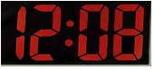

7-Segment displays are built with seven LED’s configured as common cathode or common anode, with the common pin being internally connected together. By applying power, or a logic ‘1’, to the seven pins of the display, the numbers 0, 1, 2, 3, 4, 5, 6, 7, 8, and 9 can be generated. The 7 segment LED outputs are labeled a, b, c, d, e, f, and g.

To minimize the number of input pin required, a binary coded decimal to 7-segment converter can be used. This requires 4 inputs, D0, D1, D2, and D3, to control 7 outputs, a, b, c, d, e, f, g.

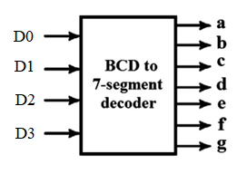

**Objective 1:** Write out the truth table for all 7 outputs. Put this into CircuitVerse for simulation.

**Objective 2:** Then, write out the k-maps and solve them for saving on multiple outputs. Select which outputs to group together.

Multiple 7-segment displays can be connected together to a single decoder by also combining circuitry to connect and disconnect the ground path of the displays. By multiplexing seven-segment displays, the number of pins required to drive the displays can be reduced. The required segments for digit 1 are set by the user on D0 to D3 and Q1 is strobed (turned on briefly). Then the required segments for digit 2 are turned on and Q2 is strobed, etc. The sequence is run quickly enough that all digits appear to be continuously lit due to persistence of vision.

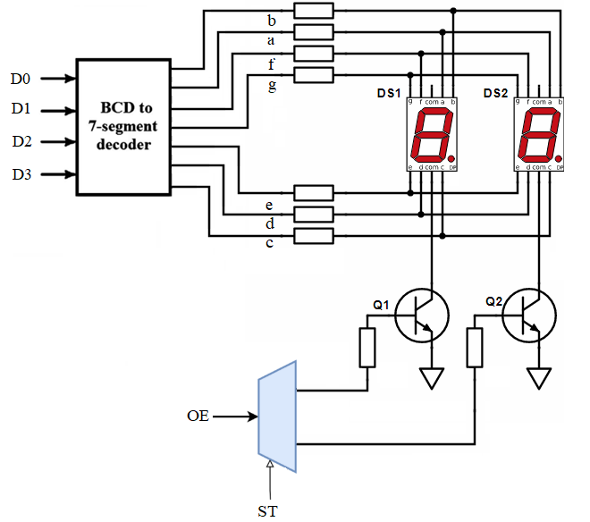

**Objective 3:** Write out the truth table for two seven segment displays connected by a multiplexer.

**Objective 4:** Verify the truth table on the provided hardware, MET1155-B. This printed circuit board (PCB) contains two 7-segment displays connected to a BCD to 7-segment decoder and a 2:1 mux/demux.   
  
SW1 above the 7-segment displays is controlled to switch between segments and displays characters. The board must be connected to a cadet board or power source with 3.3V or 5V tied to the VDD pin, and ground tied to the GND pin.