EASC2230: Fundamental Applications of Analog Devices

In a light meter, a sensor produces current proportional to the intensity of the incident radiation. Light meters are common in a variety of applications, from solar trackers to arcade machines. We wish to obtain a voltage proportional to the light’s intensity using the circuit in Figure 1.

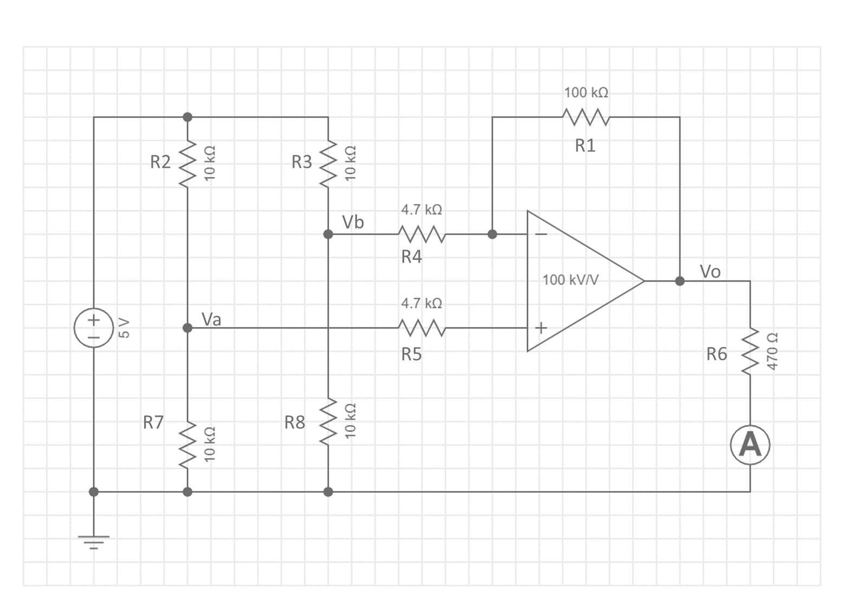

Figure 1: Schematic diagram modelling a solar tracking circuit.

**Objective 1:**

Using Nodal Analysis, derive the general equations for Va, Vb, and Vo. Note that R7 is a light dependent resistor whose value changes proportionally to light level. Determine the current through R6 for values of R7 at 6kOhm, 10kOhm, 14kOhm, and 20kOhm.

**Objective 2:**

Enter this schematic into Multisim, using a 741 Op Amp with VCC+ set to 5V and VCC- set to GND, and plot the waveform for current as it sweeps from 6kOhm to 20kOhm. Does the output current match the theoretical values? Are there any differences?

Figure 2: Multisim Parameter Sweep settings.

**Objective 3:**

Figure 3 is a printed circuit board which is the physical representation of the model described by the schematic in Figure 1. Circuit boards can be hand assembled using a technique called soldering. Build a MET2230 PCB and test it. Does the theoretical functionality match reality?

Figure : MET2230 PCB.

An application of this circuit is for solar tracking. The PCB can be mounted to a motorized solar panel and will change output depending on the light level. As the output changes, the motor is driven to find the optimal angle to maximize charging.