1. Create a class called *Window*. It will have 3 attributes: *name* (string), *width* (int) and *height* (int) and a constructor with 3 parameters to initialize its attributes. It must have as well a method called *toString()* that returns the information of the window. Create a *Main* class where it will have an array of 10 windows. Each *width* and *height* will be assigned using a random number. The *width* will be a number between 90 and 120 cm and the *height* will be a number between 40 and 100 cm.
2. Create a class called *PhotoAlbum* with an attribute called *pageNumber*. It will have:
   1. A constructor which receives the page number. (You have to use the word *this* in this constructor).
   2. A constructor without parameters and it will create a *PhotoAlbum* with 16 pages. This constructor will reuse the constructor above.
   3. Getter and setter for the attribute.
   4. A *toString* method which returns “I am an album with N pages”.

Create another class called *GrandAlbum* that inherits from *PhotoAlbum*. This class will have:

1. A constructor without parameters which will reuse the parent constructor and will create an Album with 64 pages.
2. A *toString()* method which will reuse the parent method and will add to the result string “and I am big”.

Create a *Main* class to test both classes. Create an array of 4 albums. 2 will be *PhotoAlbum* and the other 2 *GrandAlbum*.

1. Create a class called *ThreeDPoint,*  to represent a point in 3D space, with the coordinates x, y and z as attributes. It has to have these methods:
   1. A *constructor* to stablish the values for x, y and z.
   2. *moveTo(int x, int y, int z)* that will change the coordinates of the point with the new ones received as parameters.
   3. *distanceTo(ThreeDPoint p2)* to calculate the distance to p2 point: (the result will be a double)

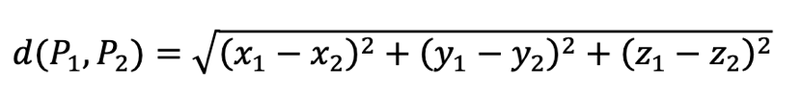

* 1. *toString()* method which will return a string with the representation of the point similar to “(2,-7,0)”
  2. All the getters and setters.

You will have to create a *Main* class to test it where you will have to create an array of 5 3D points, ask the user the information about them and after that show the distance between the first one to the others like this:

The distance between (7,4,3) to (17,6,2) is: 10.246951

1. A complex number has 2 parts: a real part and an imaginary part. In a number as a+bi (2-3i, for example) the real part would be “a”(2) and the imaginary part would be “b” (-3). Create a class called *ComplexNumber* to represent complex numbers. It will have:
   1. A constructor to establish both attributes.
   2. A constructor without parameter which reuse the constructor above.
   3. Setters and getters for both attributes.
   4. A *toString*() method that returns “2-3i”
   5. A *getMagnitude*() method that returns the magnitude of the complex number: $\sqrt{a^{2}+b^{2}}$
   6. A static method *Sum* that returns the sum of 2 complex numbers passed as parameters. The result will be: ${(a}_{1}+a_{2})+\left(b_{1}+b_{2}\right)i$