**Chapter 10, Advanced Interface homework solution**

*For code and Makefile see Chap_10_Advanced_Interface/homework_solution. To run do either “make questa_gui” or “make vcs”*

*Coverage window for ADDRESS_WIDTH set to 9.*

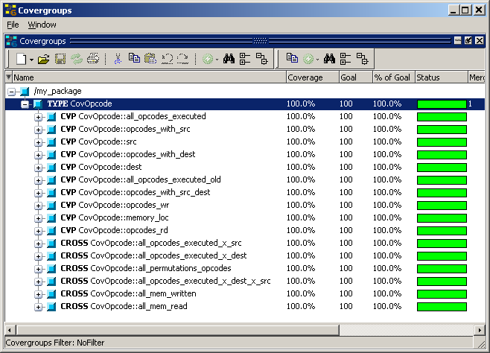

Run time table. The run time varies because the address range that must be written or read is different.

|  |  |
| --- | --- |
| ADDRESS_WIDTH | Run Time |
| 7 | 3,015,750ns |
| 8 | 4,856,450ns |
| 9 | 5,792,750ns |