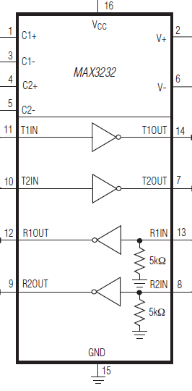
1
2
3
1
2
3
FX2_IO1
100n
100n
100n
100n
FX2_IO3
FX2_IO2
FX2_IO4
100n
+3V3
SERIAL 2
SERIAL 1
1
2
3
1
2
3
FX2_IO5
100n
100n
100n
100n
FX2_IO7
FX2_IO6
FX2_IO8
100n
+3V3
SERIAL 4
SERIAL 3
SERIAL INTERFACE 6DOF
1
2
3
1
2
3
FX2_IO9
100n
100n
100n
100n
FX2_IO11
FX2_IO10
FX2_IO12
100n
+3V3
SERIAL 6
SERIAL 5
4
5
SERIAL 1
stop
home
BC547
4K7
2K2
4K7
10K
100n
FX2_IO21
4
5
SERIAL 2
stop
home
BC547
4K7
2K2
4K7
10K
10n
FX2_IO22
4
5
SERIAL 3
stop
home
BC547
4K7
2K2
4K7
10K
10n
FX2_IO23
4
5
SERIAL 4
stop
home
BC547
4K7
2K2
4K7
10K
10n
FX2_IO24
4
5
SERIAL 5
stop
home
BC547
4K7
2K2
4K7
10K
10n
FX2_IO25
4
5
SERIAL 6
stop
home
BC547
4K7
2K2
4K7
10K
10n
FX2_IO26
FX2_IO30

led red

475

RUN / RST
reset
run
4K7
+3V3
4K7
100n
100n
FX2_IO31
FX2_IO33
1
2
3
47K5 (2x)
BC547
4K7
2K2
475
led yellow
FX2_IO34
POWER_OFF
+5V
1N4148
1
2
3
4
100n
relay 5V
BC547
4K7
2K2
FX2_IO39
BUZZER
+5V
buzzer 5V

