Real-Time Image Processing Framework for FPGA

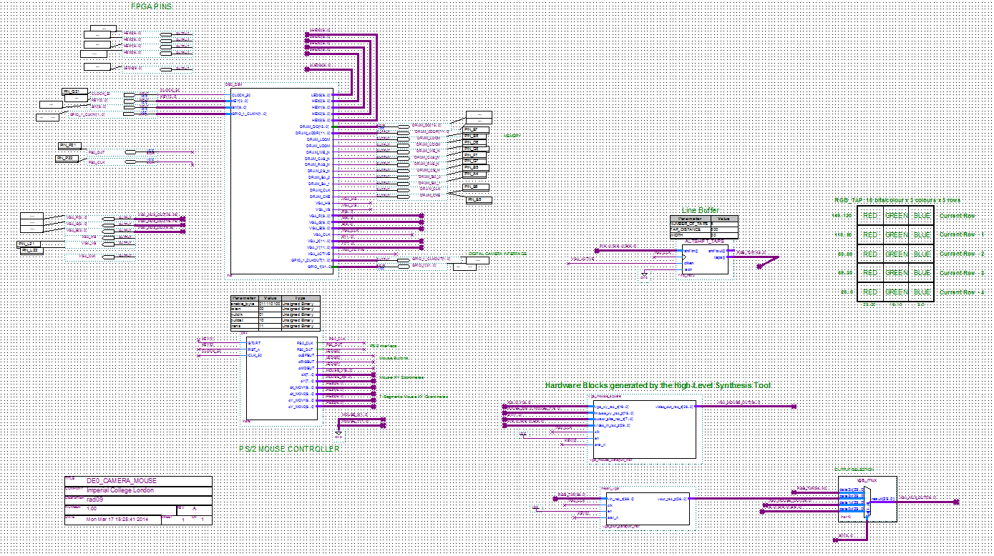

Instructions

KEY0: reset
KEY1: start acquiring frames + mouse init
KEY2: stop acquiring frames

SW0: exposure ctrl : off - increase exposure, on - decrease exposure
SW1: exposure adjust : off - adjust according to SW 0, on - no adjustment
SW2: zoom in

SW5, SW4: VGA output select
0, 0 : camera output
0, 1 : mouse demo
1, 0 : 3x3 blur demo
1, 1 : buffered camera output

SW6, SW7 : Size of the mouse window

- IP cores generated by Catapult are located inside subfolder catapult_ip.
- Be careful not to include same rtl files more than once.
- Use the same folder to copy the generated files, instead of adding-removing different versions from the project

