Modified Iowa Gambling Task: Descriptive Analysis

Data Loading and Preparation

Task Performance Analysis

Overall Performance Metrics
Descriptive Statistics for Key Performance Metrics
mean
sd
median
min
max
skew
kurtosis
total_money
1791.20
594.57
1800.00
0
3325
-0.21
0.39
good_deck_ratio
0.51
0.06
0.51
0
1
1.05
29.21
skip_ratio
0.29
0.16
0.28
0
1
1.12
3.25
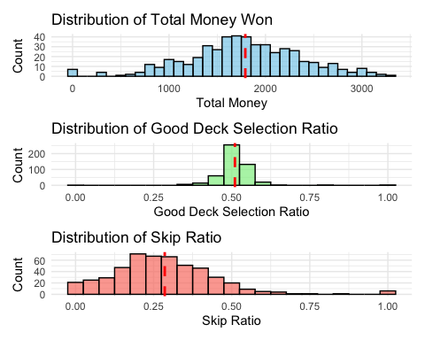

Learning Across Blocks
Block-by-Block Performance (with 95% CIs)
count_igtblocks
mean_money
lower_money
upper_money
mean_good_deck
lower_good_deck
upper_good_deck
mean_skip
lower_skip
upper_skip
1
875.80000
852.188795
899.41120
0.4957302
0.4874030
0.5040573
0.2764187
0.2612850
0.2915523
2
648.87526
622.147031
675.60348
0.5076125
0.4983523
0.5168728
0.2733742
0.2576587
0.2890897
3
230.53236
175.468027
285.59669
0.5207851
0.5131806
0.5283896
0.2696468
0.2537384
0.2855551
4
67.75053
9.304313
126.19675
0.5130206
0.5051509
0.5208902
0.2791451
0.2622017
0.2960885
5
-17.97210
-82.123983
46.17978
0.5139132
0.5041600
0.5236665
0.2946207
0.2766451
0.3125964
6
14.38731
-42.739134
71.51375
0.5084027
0.4992864
0.5175189
0.2943003
0.2757082
0.3128924
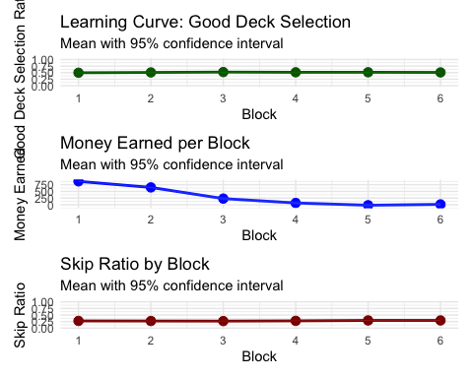
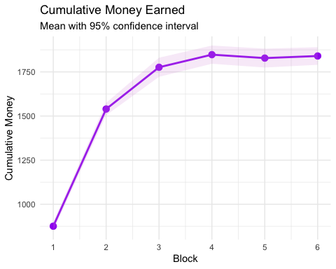

Reaction Time Analysis

RT Distributions
Descriptive Statistics for Reaction Times (seconds)
mean
sd
median
min
max
mean_rt
0.782
0.430
0.713
0.204
4.000
median_rt
0.633
0.434
0.567
0.088
4.000
mean_play_rt
0.702
0.256
0.675
0.140
2.951
median_play_rt
0.573
0.238
0.550
0.086
2.951
mean_pass_rt
1.010
0.569
0.892
0.239
4.000
median_pass_rt
0.828
0.592
0.700
0.075
4.000
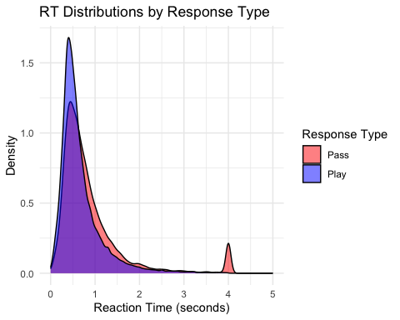
Descriptive Statistics for RT Quantiles (seconds)
mean
sd
median
min
max
rt_q10
0.366
0.219
0.358
0.022
4.000
rt_q30
0.477
0.241
0.456
0.071
4.000
rt_q50
0.594
0.279
0.565
0.088
4.000
rt_q70
0.779
0.345
0.740
0.141
4.000
rt_q90
1.277
0.512
1.204
0.293
4.000
play_rt_q10
0.356
0.139
0.355
0.021
1.067
play_rt_q30
0.456
0.164
0.446
0.070
1.223
play_rt_q50
0.563
0.202
0.548
0.086
1.392
play_rt_q70
0.726
0.260
0.705
0.137
1.923
play_rt_q90
1.170
0.417
1.118
0.248
2.912
pass_rt_q10
0.434
0.237
0.415
0.041
4.000
pass_rt_q30
0.566
0.265
0.529
0.049
4.000
pass_rt_q50
0.710
0.303
0.665
0.075
4.000
pass_rt_q70
0.931
0.405
0.859
0.119
4.000
pass_rt_q90
1.530
0.730
1.359
0.333
4.000
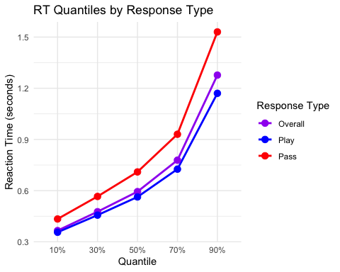

RT Changes Across Blocks
Mean RTs by Block (seconds)
count_igtblocks
mean_rt
mean_play_rt
mean_pass_rt
1
1.0538437
0.9062898
1.5096893
2
0.7459407
0.6991412
0.9400518
3
0.6973731
0.6575774
0.8572014
4
0.6780209
0.6403173
0.8263471
5
0.6508240
0.6209740
0.7603880
6
0.6222693
0.6089134
0.7338464
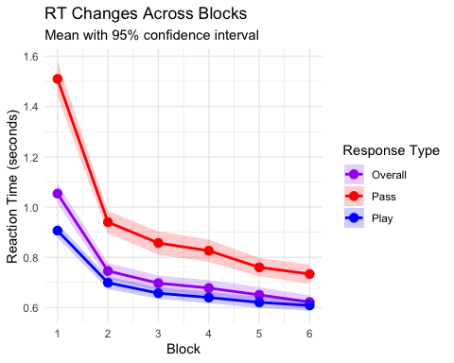Individual Differences

Distribution of Key Metrics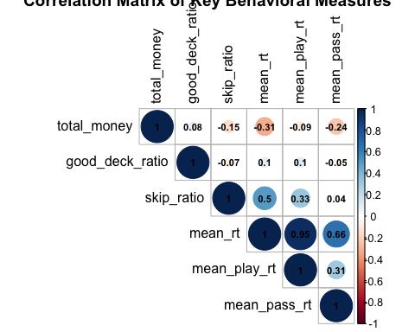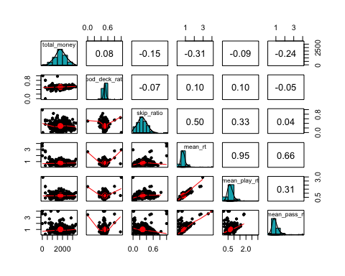
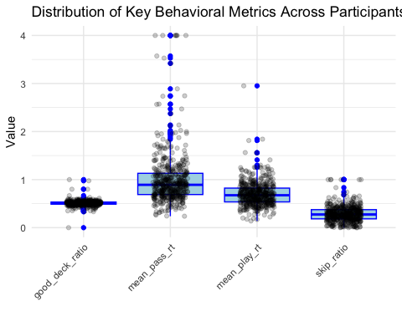

Strategy Classification
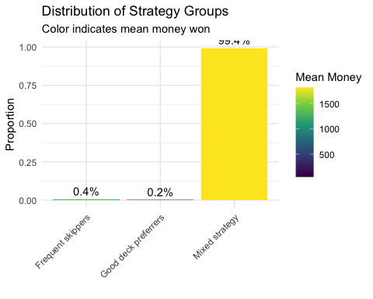

Summary Statistics for PPC Comparison
This section provides concise summary statistics for all key metrics that are used in posterior predictive checks (PPC).
Summary Statistics for RL Metrics (for PPC Comparison)
metric
mean
sd
q025
q25
median
q75
q975
good_deck_ratio
0.5102625
0.0591456
0.4100376
0.4891883
0.509902
0.5333333
0.5900401
skip_ratio
0.2855762
0.1631523
0.0166667
0.1833333
0.275000
0.3750000
0.6337500
total_money
1791.2000000
594.5688221
650.0000000
1425.0000000
1800.000000
2175.0000000
2975.0000000
Summary Statistics for RT Metrics (for PPC Comparison)
metric
mean
sd
q025
q25
median
q75
q975
mean_pass_rt
1.0104696
0.5690094
0.3854119
0.6894412
0.8918629
1.1313345
2.674321
mean_play_rt
0.7023691
0.2561574
0.3273412
0.5359341
0.6749057
0.8232313
1.246554
mean_rt
0.7823487
0.4300539
0.3308781
0.5763604
0.7127333
0.8782250
1.516841
median_pass_rt
0.8281613
0.5919445
0.3067500
0.5360000
0.6995000
0.9072500
2.736937
median_play_rt
0.5727621
0.2380963
0.2256500
0.4287500
0.5502500
0.6678750
1.087338
median_rt
0.6325910
0.4335465
0.2272500
0.4448750
0.5667500
0.7035000
1.295300
Summary Statistics for RT Quantiles (for PPC Comparison)
metric
mean
sd
q025
q25
median
q75
q975
pass_rt_q10
0.4339148
0.2374632
0.1260400
0.319200
0.41460
0.512000
0.8236400
pass_rt_q30
0.5659252
0.2651437
0.2311200
0.412700
0.52860
0.681000
1.0676000
pass_rt_q50
0.7097206
0.3032478
0.2944000
0.526000
0.66500
0.831000
1.3124000
pass_rt_q70
0.9305097
0.4054698
0.3822400
0.689000
0.85900
1.089800
1.7748000
pass_rt_q90
1.5301905
0.7304024
0.6098600
1.061400
1.35870
1.756800
3.7548800
play_rt_q10
0.3561900
0.1386880
0.0983400
0.265300
0.35500
0.432250
0.6250025
play_rt_q30
0.4564629
0.1635848
0.1689275
0.352950
0.44590
0.542075
0.8320375
play_rt_q50
0.5630765
0.2020398
0.2254500
0.428000
0.54775
0.663000
1.0480625
play_rt_q70
0.7260261
0.2595209
0.3182750
0.542125
0.70510
0.871000
1.3489400
play_rt_q90
1.1703606
0.4173198
0.5049200
0.868200
1.11800
1.409150
2.1033650
rt_q10
0.3658633
0.2187266
0.0942300
0.267000
0.35750
0.428600
0.6655400
rt_q30
0.4765434
0.2409969
0.1706200
0.361700
0.45650
0.555700
0.8722500
rt_q50
0.5942221
0.2790968
0.2255000
0.443500
0.56500
0.698500
1.0933500
rt_q70
0.7785235
0.3449632
0.3282800
0.578100
0.74000
0.913200
1.4604000
rt_q90
1.2771412
0.5123257
0.5469700
0.956800
1.20430
1.492200
2.4715500
Block-Level Metrics for PPC Comparison
count_igtblocks
block_good_deck_ratio_mean
block_good_deck_ratio_sd
block_skip_ratio_mean
block_skip_ratio_sd
block_money_mean
block_money_sd
1
0.4957302
0.0950004
0.2764187
0.1726525
875.80000
269.3687
2
0.5076125
0.1044773
0.2733742
0.1773073
648.87526
301.5564
3
0.5207851
0.0849146
0.2696468
0.1776388
230.53236
614.8682
4
0.5130206
0.0869535
0.2791451
0.1872104
67.75053
645.7833
5
0.5139132
0.1074201
0.2946207
0.1979801
-17.97210
706.5555
6
0.5084027
0.0994304
0.2943003
0.2027829
14.38731
623.0734

