SEIS2.5D
Version 1.0 Tutorial

Fred F. Pollitz

July 6, 2026

Acknowledgements

I thank Leah Langer and Chris Henze for testing an earlier version of this software package.

Bibliography

Komatitsch, D. and Tromp, J., Introduction to the spectral element method for three-dimensional seismic wave propagation. Geophys. J. Int.,139, 806-822 (1999).

Pollitz, F.F., Gravitational viscoelastic postseismic relaxation on a layered spherical Earth, J. Geophys. Res., 102, 17921-17941 (1997).

Pollitz, F. F., Post-earthquake relaxation using a spectral element method: 2.5-D case, Geophys. J. Int., doi: 10.1093/gji/ggu114 (2014).

Pollitz, F.F., Post-earthquake relaxation evidence for laterally variable viscoelastic structure and water content in the southern California mantle, J. Geophys. Res., 120, 2672-2696, doi:10.1002/2014JB011603 (2015).

Pollitz, F.F., Stone, I.A., Dunham, A., and Wirth, E.A., New constraints on northeast Seattle basin structure from converted seismic waves, The Seismic Record, 6, 96-105, https://doi.org/10.1785/0320250056

Sinclair, C., Greenhalgh, S., and Zhou, B., 2.5D modeling of elastic waves in transversely isotropic media using the spectral element method, Exploration Geophysics, 38, 225-234 (2007).

1 Introduction

SEIS2.5D is a software package to calculate seismic wavefields resulting from imposed earthquake sources in a spherical geometry. It solves the momentum equation using the spectral element method (SEM) on a two-dimensional structure, with imposed source and domain boundary conditions. The elastic structure is assumed to be azimuthally symmetric about a pole of symmetry (typically very distant from the model domain, in which case the structure practically varies in one horizontal Cartesian coordinate). In the spectral element domain, it produces time-dependent displacements at sets of points on Earth’s surface and vertical profiles, as well as specified `receiver’ locations.

The program package is intended as a tool in modeling wave propagation in the case that the elastic structure may be approximated as an isotropic medium and the structure is two-dimensional. Such 2D structures would correspond to a contrast in material properties across, e.g. a long strike slip fault or a long convergent plate boundary with a dipping downgoing plate.

2 Description of program

The main program seis2pt5d is used for all steps of the computations needed to define a 2D global grid, specify a 2D viscoelastic structure, compute 3D postseismic displacements at various points in the model domain in the Laplace transform domain, and obtain time domain results.

Pollitz (2014) adapted the SEM of Komatitsch and Tromp (1999) for seismic wave propagation to the case of quasi-static motions. For 2.5D seismic-wave propagation, we add the inertial term and follow the same development as Pollitz (2014). The approach is essentially that of Sinclair et al. (2007) adapted to the case of a spherical geometry, including the use of absorbing boundary conditions.

Following Pollitz (2014), the steps involved with calculating 2.5D seismic wavefields are:

- Define a 2D set of quadrilateral elements and derive a global indexing of this grid
- Use the strong form of the momentum equation
- Discretize the model
- mesh of elements
- obtain transformation between physical and local elemental coordinates
- Interpolate functions on the elements
- Lagrange polynomials
- Gauss-Lobatto-Legendre (GLL) points
- Integrate over individual elements
- GLL integration quadrature
- GLL points and weights
- Define stiffness matrix
- Assemble global linear system
- Solve for displacements at the GLL points as a function of azimuthal order number
- Perform weighted sum over azimuthal order, the weights depending on the azimuth of a given observation point
- Inverse Fourier transform to obtain time domain results.

Generally, three runs of seis2pt5d in sequence accomplish these steps. The first run accomplishes step (1), the second run steps (2) through (8), and the third run step (9).

We work in a r - θ - φ spherical coordinate system (hereafter `model coordinates’). A 2D spectral element domain is defined with respect to spherical coordinates of radius r and angular distance θ from a pole of symmetry P. Laterally variable 2D elastic structure depends only upon r and θ, i.e., it is azimuthally symmetric. A seismic point source is implemented with an assumed periodicity in longitude φ with respect to P. The computational domain occupies a vertical slice bounded by a spherical shell at depth, the free surface, and vertical surfaces at two given angular distances from P.

Figure 1. Geometry of model domain in 2.5D. Elastic structure is assumed symmetric with
respect to a symmetry pole P, i.e., it does not vary with φ, but may vary with θ and r. There are
Nθ and Nr divisions of the model domain in the θ and r coordinates, respectively. Figure 1 of Pollitz (2014).

The elastic structure and corresponding 2D GLL grid used in a typical run (e.g. Example 1 of this tutorial) look like
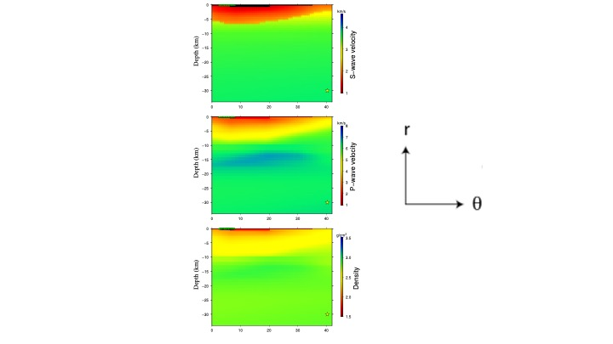
Figure 2. A 2D model domain of elastic structure (Vp, Vs, density) that varies only in r and θ in a (r, θ, φ) spherical coordinate system. This structure is employed in Example 1, and the star indicates the location of a point source in the example.

Figure 3. Division of 2D model domain into elements that are rectangular in r-θ space. The upper figure is a zoomed-in version of the lower figure and includes the locations of the 2D GLL points.
Perfectly matched layer absorbing boundary conditions are applied to the sides and base of the 2D domain.

The present implementation uses rectangles in r-θ space to represent individual elements, i.e., different radius levels are separated by spherical shells, and angular distances are discretized with the same spacing regardless of radius.

An individual element is discretized with GLL points, which serve as both collocation points for displacement and interpolation points for integrating the weighted equations of equilibrium over an element. For example, for 1D GLL functions of order N=5 in one dimension, the 2D GLL Cartesian grid looks like
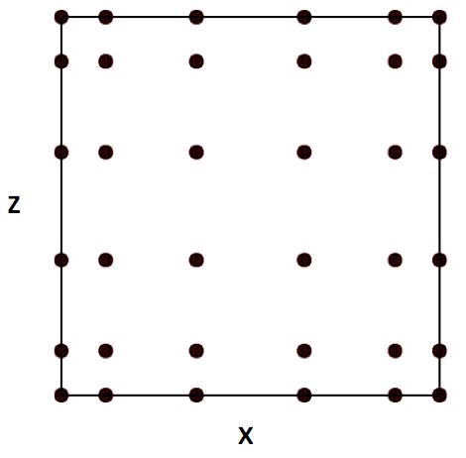
Figure 4. 2D GLL interpolation and quadrature points of one element.

There is a simple mapping between (x,z) in elemental coordinates and (θ,r) in physical spherical coordinates (eqns 17 and 18 of Pollitz, 2014). If there are N+1 points on the side of an element, then there are altogether (N N_{r} + 1)(N N_{θ} + 1) points in the global domain.

The momentum equation for elastic wave propagation in a 2D elastic medium is formulated in the frequency domain, which greatly simplifies the implementation of seismic wave attenuation. Letting ω represent the angular frequency, the frequency-dependent shear modulus μ(ω) and bulk modulus κ(ω) are specified with equations (6.128) and (6.129) of Dahlen and Tromp (1998) assuming a reference angular frequency of 2π s⁻¹.

The displacement field u(r, θ, φ; ω) for a given ω is parameterized with expansion coefficients evaluated at the 2D GLL collocation points. This displacement field depends on model radius r, colatitude θ, and longitude φ.

Assuming there is a global mapping between local coordinates x,z in an element and latitude and longitude in global model coordinates, the φ dependence is realized with a sum over azimuthal order number m.

(1)
where
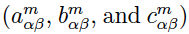
are expansion coefficients for displacement and the Ψ-functions are 2D GLL functions, e.g. Appendix A of Pollitz (2014).

There are three sets of displacement expansion coefficients, one for each of the local unit vector directions at a given location. Thus there are altogether 3(N N_{r} + 1)(N N_{θ} + 1) unknown expansion coefficients. A linear system of simultaneous equations results from manipulating the strong form of the momentum equation; the development is similar to the analysis of the equations of quasi-static equilibrium by Pollitz (2014), with the addition of an inertial term for the seismic wave propagation case. For a given ω, this system is solved for the expansion coefficients.

At the GLL points themselves,
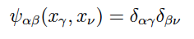 (2)
so that the displacement field at GLL points (r_{γν},θ_{γν}) and arbitrary φ is

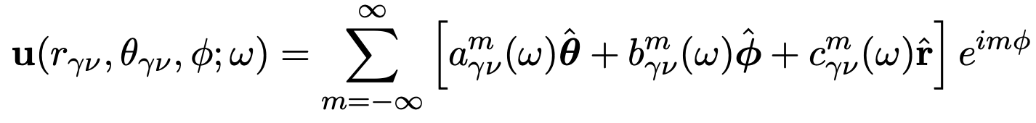 (3)

Equation (1) is used by seis2pt5d to calculate displacements at Earth’s surface, on a vertical profile, or at specified receiver points. Output files typically have the seismic velocity or the curl and div of displacement. For example, equation (3) is used by seis2pt5d to output three-component velocities and dynamic strains on a vertical profile along a chosen arc of constant longitude (presently, this is hardwired in the source code to be the arc φ=0).

3 Checklist of input parameters

All of the information below must be specified in the various input files used in SEIS2.5D.
Earth model
• Elastic structure as a function of depth and one lateral distance: density ρ, seismic wavespeeds V_{p} and V_{s} (equivalent to bulk modulus κ and shear modulus of Maxwell element μ₁), shear and bulk attenuation parameters Q_{μ} and Q_{k}, respectively.
Source model
• Number of fault planes
• Strike, dip, rake, slip, length, depths of upper and lower fault edges,
latitude and longitude of one fault corner
• Number of observation points
• Latitude, longitude, and depth of these observation points

4 Compiling

Folders OpenBLAS-0.3.13, AMD, Suitesparse, and UMFPACK comprise the linear algebra package needed to compile SEIS2PT5. They are in the SEIS2.5D folder. All but OpenBLAS were originally obtained as the package SuiteSparse v4.4.4 downloaded from
http://faculty.cse.tamu.edu/davis/suitesparse.html
This package is due to Timothy A Davis: http://faculty.cse.tamu.edu/davis/publications.html

The configuration file SEIS2.5D/ SuiteSparse_config/SuiteSparse_config.mk has been modified for our application.

gfortran must be installed in order to compile libraries and main programs.

AMD, Suitesparse, and UMFPACK libraries need to be compiled before the main program can be compiled. The names of the desired libraries are
SEIS2.5D/OpenBLAS-0.3.13/libopenblas.a
SEIS2.5D/Suitesparse/AMD/Lib/libamd.a
SEIS2.5D/Suitesparse/SuiteSparse_config/libsuitesparseconfig.a
SEIS2.5D/Suitesparse/UMFPACK/Lib/libumfpack.a

• Compile AMD, OpenBLAS-0.3.13, Suitesparse, and UMFPACK libraries.
Change directory to SEIS2.5D/MAINPROG
Type `make libs'

• Edit the file SEIS2.5D/SuiteSparse/SuiteSparse_config/SuiteSparse_config.mk
In the line that reads
BLAS = /Users/fpollitz/fred4/CIDER2015/SEIS2.5D/OpenBLAS-0.3.13/libopenblas.a
Replace the right hand side with the path to that library on your machine.

• Compile seis2pt5d
In SEIS2.5D/MAINPROG
Type `make seis2pt5d'

The above make is for 64 bit. You may need to type in
make umf4_f77zwrapper64.o
before you try
make seis2pt5d

5 Examples

The examples given here are abbreviated descriptions of how to compute seismic wavefields for single-plane ruptures. Before running the examples, compile seis2pt5d as directed above.

5.1 Example 1
This example will do all of the calculations necessary to replicate Figure S2 of Pollitz et al. (2026), which evaluates seismic velocity waveforms resulting from a small planar source representing the M3.0 July 17, 2019 Monroe, WA earthquake. The example script employs 25 CPUs on a Linux cluster that uses PBS (Portable Batch System) commands. Run the command file `example1.x’, which contains the lines

#!/bin/sh

export SEISDIR=/home/fpollitz/fred4/CIDER2015/SEIS2.5D/
export EXDIR=$SEISDIR/MAINPROG

echo "Running forward simulation on Stephenson et al. 2017 structure"
\cp seisstruc.paramSTE-sharp seisstruc.param
\cp seis2pt5d-spherical.infoEX1 > seis2pt5d-spherical.info

\cp $EXDIR/seis2pt5d .
\rm seis2pt5dsource-spherical.param
ln -sf seis2pt5dsource-spherical.param17Jul2019 seis2pt5dsource-spherical.param
ln -sf topo_EX1 topofile

sed s/AAA/"Monroe_eq_aftershock"/ laststep-25proc.x > laststep.x

\cp receivers-latlondep17Jul2019.txt receivers-latlondep.txt
\rm ../Work*/rec-j-m* ../Work*/displ-j-m*

date > ../Work1/seis2pt5d-progress1.txt
date > ../Work2/seis2pt5d-progress2.txt
…
date > ../Work1/seis2pt5d-progress25.txt

cp seisstruc.param ../Work1/.
cp seisstruc.param ../Work2/.
…
cp seisstruc.param ../Work25/.

cp seis2pt5d-spherical.info ../Work1/.
cp seis2pt5d-spherical.info ../Work2/.
…
cp seis2pt5d-spherical.info ../Work25/.

cp seis2pt5dsource-spherical.param ../Work1/.
cp seis2pt5dsource-spherical.param ../Work2/.
…
cp seis2pt5dsource-spherical.param ../Work25/.

cp receivers-latlondep.txt ../Work1/.
cp receivers-latlondep.txt ../Work2/.
…
cp receivers-latlondep.txt ../Work25/.

cp topofile ../Work1/.
cp topofile ../Work2/.
…
cp topofile ../Work25/.

cp seis2pt5d ../Work1/.
cp seis2pt5d ../Work2/.
…
cp seis2pt5d ../Work25/.

ZEROETH=`qsub -wd SEISDIR/EXAMPLES -l nodes=1 step0.x`
echo $ZEROETH

FIRST=`qsub -W depend=afterok:$ZEROETH -wd $SEISDIR/Work1 -l nodes=1 step1.x`
echo $FIRST
SECOND=`qsub -W depend=afterok:$ZEROETH -wd $SEISDIR/Work2 -l nodes=1 step2.x`
echo $SECOND
THIRD=`qsub -W depend=afterok:$ZEROETH -wd $SEISDIR/Work3 -l nodes=1 step3.x`
echo $THIRD
FOURTH=`qsub -W depend=afterok:$ZEROETH -wd $SEISDIR/Work4 -l nodes=1 step4.x`
echo $FOURTH
FIFTH=`qsub -W depend=afterok:$ZEROETH -wd $SEISDIR/Work5 -l nodes=1 step5.x`
echo $FIFTH
SIXTH=`qsub -W depend=afterok:$ZEROETH -wd $SEISDIR/Work6 -l nodes=1 step6.x`
echo $SIXTH
SEVENTH=`qsub -W depend=afterok:$ZEROETH -wd $SEISDIR/Work7 -l nodes=1 step7.x`
echo $SEVENTH
EIGHTH=`qsub -W depend=afterok:$ZEROETH -wd $SEISDIR/Work8 -l nodes=1 step8.x`
echo $EIGHTH
NINTH=`qsub -W depend=afterok:$ZEROETH -wd $SEISDIR/Work9 -l nodes=1 step9.x`
echo $NINTH
TENTH=`qsub -W depend=afterok:$ZEROETH -wd $SEISDIR/Work10 -l nodes=1 step10.x`
echo $TENTH
ELEVENTH=`qsub -W depend=afterok:$ZEROETH -wd $SEISDIR/Work11 -l nodes=1 step11.x`
echo $ELEVENTH
TWELVTH=`qsub -W depend=afterok:$ZEROETH -wd $SEISDIR/Work12 -l nodes=1 step12.x`
echo $TWELVTH
THIRTEENTH=`qsub -W depend=afterok:$ZEROETH -wd $SEISDIR/Work13 -l nodes=1 step13.x`
echo $THIRTEENTH
FOURTEENTH=`qsub -W depend=afterok:$ZEROETH -wd $SEISDIR/Work14 -l nodes=1 step14.x`
echo $FOURTEENTH
FIFTEENTH=`qsub -W depend=afterok:$ZEROETH -wd $SEISDIR/Work15 -l nodes=1 step15.x`
echo $FIFTEENTH
SIXTEENTH=`qsub -W depend=afterok:$ZEROETH -wd $SEISDIR/Work16 -l nodes=1 step16.x`
echo $SIXTEENTH
SEVENTEENTH=`qsub -W depend=afterok:$ZEROETH -wd $SEISDIR/Work17 -l nodes=1 step17.x`
echo $SEVENTEENTH
EIGHTEENTH=`qsub -W depend=afterok:$ZEROETH -wd $SEISDIR/Work18 -l nodes=1 step18.x`
echo $EIGHTEENTH
NINETEENTH=`qsub -W depend=afterok:$ZEROETH -wd $SEISDIR/Work19 -l nodes=1 step19.x`
echo $NINETEENTH
TWENTIETH=`qsub -W depend=afterok:$ZEROETH -wd $SEISDIR/Work20 -l nodes=1 step20.x`
echo $TWENTIETH
TWENTYFIRST=`qsub -W depend=afterok:$ZEROETH -wd $SEISDIR/Work21 -l nodes=1 step21.x`
echo $TWENTYFIRST
TWENTYSECOND=`qsub -W depend=afterok:$ZEROETH -wd $SEISDIR/Work22 -l nodes=1 step22.x`
echo $TWENTYSECOND
TWENTYTHIRD=`qsub -W depend=afterok:$ZEROETH -wd $SEISDIR/Work23 -l nodes=1 step23.x`
TWENTYFOURTH=`qsub -W depend=afterok:$ZEROETH -wd $SEISDIR/Work24 -l nodes=1 step24.x`
echo $TWENTYFOURTH
TWENTYFIFTH=`qsub -W depend=afterok:$ZEROETH -wd $SEISDIR/Work25 -l nodes=1 step25.x`
echo $TWENTYFIFTH

TWENTYSIXTH=`qsub -W depend=afterok:$FIRST:$SECOND:$THIRD:$FOURTH:$FIFTH:$SIXTH:$SEVENTH:$EIGHTH:$NINTH:$TENTH:$ELEVENTH:$TWELVTH:$THIRTEENTH:$FOURTEENTH:$FIFTEENTH:$SIXTEENTH:$SEVENTEENTH:$EIGHTEENTH:$NINETEENTH:$TWENTIETH:$TWENTYFIRST:$TWENTYSECOND:$TWENTYTHIRD:$TWENTYFOURTH:$TWENTYFIFTH -wd ~/fred4/OC-models -l nodes=1 laststep.x`
echo $TWENTYSIXTH

Explanation of example1.x:

The first line, which specifies SEISDIR, sets the directory from where the example is being launched. `example1.x’ (and similarly `example2.x’ and `example3.x’) must be edited and this first line changed to the appropriate directory on the user’s machine, i.e., where the
EXAMPLES directory resides.

EXDIR is the directory where a compiled version of seis2pt5d resides.

WORKDIR* are working directories where seis2pt5d is executed.

In a first step, relevant input files are copied to the WORK* directories. Then seis2pt5d is run in the EXAMPLES directory with `1’ in standard input. This tells it to only work on various indexing arrays that define the global grid, resulting in a file’sporder.out’.

In a second step, relevant input files are copied to the Work1, Work2, …, Work25 directories. Then seis2pt5d is run in each Work* directory with `0’ in standard input. The job that is launched in each of the 25 work directories does 4% of the frequencies needed to describe the Fourier-transformed wavefield. (Note that Work1/step1.x does the first 4% of the frequencies, Work2/step2.x does the next 4%, etc.) This generates frequency-domain displacements of several types. This includes deformation at a specified set of receivers, on a vertical profile corresponding to azimuth=0 in model coordinates, and on Earth's surface.

In a third step, which is executed by laststep.x (which is derived at the beginning of the script from laststep-25proc.x), several files which contain Fourier-transformed displacements are copied from the WORK* directories to the EXAMPLES directory. Then seis2pt5d is run in the EXAMPLES directory with `2’ in standard input. This converts the Fourier-transformed quantities to time-dependent velocities and dynamic strain components and written to various output files which will be in the EXAMPLES directory.
seis2pt5d.outxyz_vertp-Monroe_eq_aftershock has E, N, and Z-component velocity waveforms on a vertical profile corresponding to azimuth=0 in model coordinates.
seis2pt5d.outstrains_vertp-Monroe_eq_aftershock has corresponding dynamic strain components.
seis2pt5d.outCURL+DIVxyz_vertp-Monroe_eq_aftershock has the divergence and three-component curl of the dynamic displacements on the vertical profile.
seis2pt5d.outxyz_rec-Monroe_eq_aftershock has E, N, and Z-component velocity waveforms at the receiver points.

Explanation of input files:

(1) Annotated version of simulation-sphericalEX1.info, including the format of elastic model parameter file elastic.param

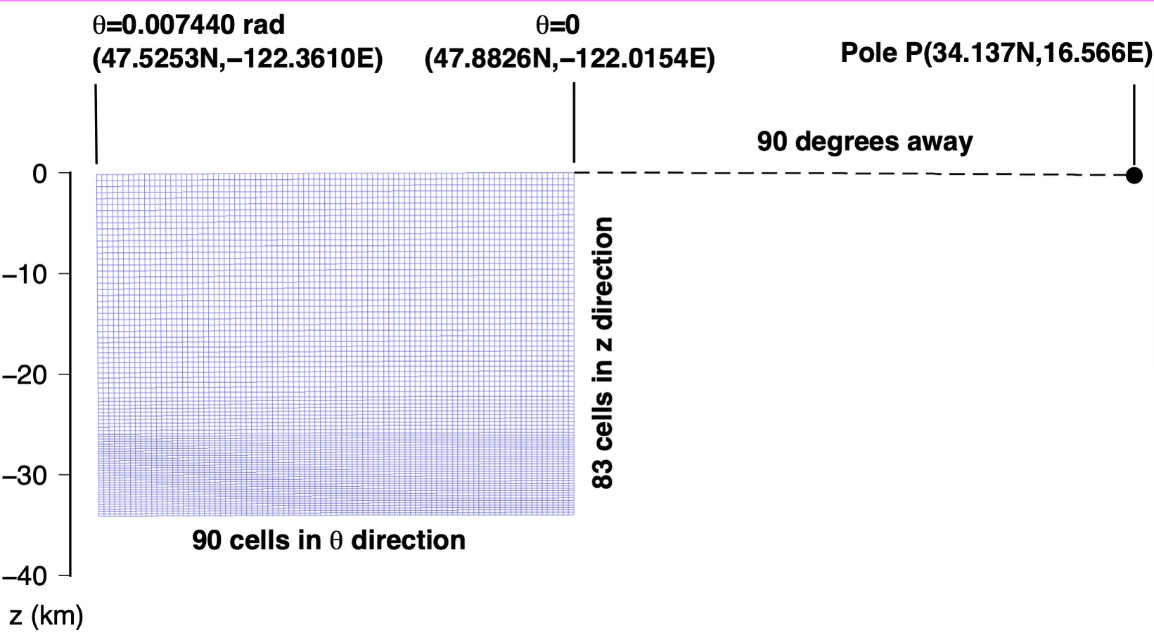
Figure 5. 2D model domain (in blue) and geometry specified in simulation-spherical.infoEX1.

The model domain depicted in Figure 5 is essentially bounded by two small circles centered on a pole prescribed by the first two input lines (as well the radial dimension as prescribed in input lines 5-6). In this file the pole is located 90 degrees away from (47.8826N,-122.0154E)
at an azimuth of 33.2 deg. from that point, i.e., at (34.137N, 16.566E).

# geographic coordinates of (theta,phi)=(theta_ref,0.) of spherical geometry in (deg.,deg.)
47.8826 -122.0154.
# Angular distance theta_ref (geocentric deg.) and azimuth (deg. CW from due N) of pole from the above point
90. 33.2
# number of cells in theta^-direction
90

The first small circle is defined as being 90 geocentric degrees away from P.
The second small circle is defined as being 90 geocentric degrees + SUM_T radians away
from P, where SUM_T is the sum of the 34 spherical-surface cell dimensions given below.
This turns out to be SUM_T = 0.00744077 radians = 0.4263247 degrees. So the second small circle is 90 + 0.4263247 = 90.4263247 degrees from P.

# theta-length of each cell (radians)
0.8267522E-04 0.8267522E-04 0.8267522E-04 0.8267522E-04 0.8267522E-04 0.8267522E-04 0.8267522E-04 0.8267522E-04 0.8267522E-04
0.8267522E-04 0.8267522E-04 0.8267522E-04 0.8267522E-04 0.8267522E-04 0.8267522E-04 0.8267522E-04 0.8267522E-04 0.8267522E-04
0.8267522E-04 0.8267522E-04 0.8267522E-04 0.8267522E-04 0.8267522E-04 0.8267522E-04 0.8267522E-04 0.8267522E-04 0.8267522E-04
0.8267522E-04 0.8267522E-04 0.8267522E-04 0.8267522E-04 0.8267522E-04 0.8267522E-04 0.8267522E-04 0.8267522E-04 0.8267522E-04
0.8267522E-04 0.8267522E-04 0.8267522E-04 0.8267522E-04 0.8267522E-04 0.8267522E-04 0.8267522E-04 0.8267522E-04 0.8267522E-04
0.8267522E-04 0.8267522E-04 0.8267522E-04 0.8267522E-04 0.8267522E-04 0.8267522E-04 0.8267522E-04 0.8267522E-04 0.8267522E-04
0.8267522E-04 0.8267522E-04 0.8267522E-04 0.8267522E-04 0.8267522E-04 0.8267522E-04 0.8267522E-04 0.8267522E-04 0.8267522E-04
0.8267522E-04 0.8267522E-04 0.8267522E-04 0.8267522E-04 0.8267522E-04 0.8267522E-04 0.8267522E-04 0.8267522E-04 0.8267522E-04
0.8267522E-04 0.8267522E-04 0.8267522E-04 0.8267522E-04 0.8267522E-04 0.8267522E-04 0.8267522E-04 0.8267522E-04 0.8267522E-04
0.8267522E-04 0.8267522E-04 0.8267522E-04 0.8267522E-04 0.8267522E-04 0.8267522E-04 0.8267522E-04 0.8267522E-04 0.8267522E-04
# number of cells in z-direction
83

There are 83 cells in the radial direction, going from a depth of SUM_Z to earth's surface,
where SUM_Z is the sum of the 23 radial cell dimensions given below.
This yields SUM_Z = 33.96 km, corresponding to a radius of 6371 – 33.96 = 6337.04 km.
The cell size is taken larger at greater depth, i.e. the first one in the radial dimension goes
from 33.96 to 33.72 km depth, the next from 33.72 to 33.48 km, etc.
Note that the actual computational domain is 2D
and goes from 0 to 0.00744077 radians in theta and 6337.04 to 6371 km in radius.
The theta computational domain is best thought of as being along an azimuth φ=0 defined
by the great circle connecting P with the given point (47.8826N,-122.0154E) on the first small circle. This great circle intersects the second small circle at (47.52535N,-122.36109E). So the 2D computational domain is bounded - in theta - by an arc connecting (47.8826N,-122.0154E) with (47.52535N,-122.36109E) and - in radius - by spherical shells at 33.96 and 0 km depth.

# z-length of each cell (km)
0.6 0.6 0.6 0.6 0.6 0.6 0.6 0.6 0.6 0.6 0.6 0.6 0.6 0.6 0.6 0.6 0.6 0.6 0.6 0.6 0.6 0.6 0.6 0.6 0.6 0.6 0.6 0.5 0.5 0.5 0.5 0.5 0.5 0.5 0.5 0.5 0.5 0.5 0.5 0.36 0.36 0.36 0.36 0.36 0.36 0.36 0.36 0.36 0.36
0.24 0.24 0.24 0.24 0.24 0.24 0.24 0.24 0.24 0.24 0.24 0.24 0.24 0.24 0.24 0.24 0.24 0.24 0.24 0.24 0.24 0.24 0.24 0.24 0.24 0.24 0.24 0.24 0.24 0.24 0.24 0.24 0.24 0.24
# Effective width of third (i.e. phi) dimension (km); minimum wavelength in third dimension (km)

For computational speedup, we suppose that there are sources evenly distributed in azimuth from P; the spacing between successive sources is 54 km. This implemented in a spherical geometry by stepping in azimuthal order number by an amount approximately equal to
twopi * 6371 km/(54 km * sin(90. deg.)) = 741. Similarly, with the 0.30 km minimum wavelength prescribed below, the maximum azimuthal order number used in the computation is twopi * 6371 km/(0.30 km * sin(90. deg.)) = 133434. The minimum azimuthal order number is 0.

54. 0.30
# input file with elastic parameters

This file has pointwise values of seismic velocities and Maxwell-solid parameters with the format
theta r-6371. Vp Vs Rho Q_{β} Q_{κ}
(deg.) (km) (km/s) (km/s) (g/cm^3) (dimensionless)
0.395362407 -11.50 5.99633312 3.46455979 2.71586990 300.0 750.0
0.395362407 -12.00 6.24843073 3.49152970 2.77218008 300.0 750.0
0.395362407 -12.50 6.24843073 3.49152970 2.77218008 300.0 750.0
(sample lines)
------------------------
theta is measured positive from (47.8826N,-122.0154E) along the great circle connecting P and that point, i.e., along the azimuth 33.2-180 = -146.8 deg. from (47.8826N,-122.0154E). So theta=0.4263247 degrees corresponds to the point (47.52535N,-122.36109E).
------------------------
r-6371 is 0 at earth's surface and -180 at the base of the computational model domain. The example file `elastic.paramEX1’, which is copied to elastic.param prior to running the main program, may permissibly go further down than 33.96 km. A simple scheme for identifying the closest point in this input file is used to assign elastic parameters to the GLL points.
------------------------
Vp and Vs are P-wave and S-wave isotropic seismic velocities; Rho is density. This structure is plotted in Figure 2.

seisstruc.param
# input file with topography

Alsthough the code is designed to accommodate topography of z-cell boundaries, we implement zero topography here, as specified in `topofile’.

topofile

# time increment
0.040000
# corner period

Low pass filtering is implemented at the given corner period.

0.25
# number of time samples

The output time series will extend to time=(time increment) X (number of time samples)

400

(2) Annotated version of source-spherical.paramEX1

# finite fault with # segments
1
# max depth, min depth (km), dip(deg.)

The lower edge depth is 30.02 km, upper edge depth is 30.00, dip=90 deg.

30.02 30.00 90.
# lat,lon(deg.),length(km),strike(deg.),rake(deg.),slip(cm) for each segment
47.856 -122.042 0.01 0.0 180. -1000.
3.39e-7 -2.94e-7 -4.45e-8 3.23e-8 6.37e-8 -1.23e-7
The first line above normally specifies the fault geometry of a dislocation plane.
The lower edge depth is 30.02 km, upper edge depth is 30.00, dip=90 deg.
47.856 -122.042 is the lat,lon of the point on the lower edge of the fault closest to the strike direction, which is 45 deg.= N0.0E. That is, it is the northernmost point on the lower edge.
The fault length is 0.01 km, rake is 180.0 (right-lateral slip), slip is -1000 cm. The conventions for strike, dip, and rake are the standard ones (e.g., Aki and Richards, 1980, p. 106).
The negative value of slip is a flag that the source geometry will instead be specified with a moment tensor with elements M_{rr} , M_{θθ} , M_{φφ} , M_{rθ} , M_{rφ} , M_{θφ} in units of 10²⁰ Nm.

The fault plane is represented with 5 x 5 point sources uniformly distributed on the plane. (Not important for the point source being employed.)

# along-strike discretization
5
# down-dip discretization
5

Explanation of output files:

The binary output file seis2pt5d.outstrains_vertp has the tensor strain of the dynamic displacement field on a vertical profile defined by phi=0, i.e., (static strains on a vertical slice sampling all GLL points on the arc phi=0.
Each group of lines is of the form
Longitude Latitude Depth
followed by a 1024-point time series with each line containing
time (seconds), eEE, eNN, eEN, eEZ, eNZ, and eZZ (units of microstrain), where E=East, N=North, and Z=Up.

The binary output file seis2pt5d.outCURL+DIVxyz_vertp has the div and curl of the dynamic velocity field on a vertical profile defined by phi=0.
Each group of lines is of the form
Longitude Latitude Depth
followed by a 1024-point time series with each line containing values:
time (seconds), time derivative of the vector curl of displacement wavefield, followed by the time derivative of the divergence of the displacement wavefield (units of microstrain per second). The three Cartesian components of the vector curl are in the local East, North, and Up directions.

The binary output file seis2pt5d.outS+Pxyz_vertp has the Cartesian components of the dynamic S-wavefield (curl of curl of displacement) and the P-wavefield (grad of div of displacement)on a vertical profile defined by phi=0.
Each group of lines is of the form
Longitude Latitude Depth
followed by a 1024-point time series with each line containing values:
time (seconds), vector S displacement, vector P displacement in units of m. The three Cartesian components are in the local East, North, and Up directions.

The binary output file seis2pt5d.outxyz_vertp has the Cartesian components of the dynamic acceleration field on a vertical profile defined by phi=0.
Each group of lines is of the form
Longitude Latitude Depth
followed by a 1024-point time series with each line containing values:
time (seconds), total vector acceleration in units of m/s². The three Cartesian components are in the local East, North, and Up directions.

The ascii output file seis2pt5d.outxyz_rec has the Cartesian components of the dynamic velocity field at each station originally specified in `receivers_latlondep.txt' with values
time (seconds), longitude, latitude, depth, E-velocity, N-velocity, Z-velocity in units of m/s.

Plots

Figure 6 was derived from output file seis2pt5d.outxyz_vertp-Monroe_eq_aftershock) and has snapshots of the vertical seismic acceleration wavefield at various times. It is comparable with Supplemental Figure S2 of Pollitz et al. (2025), with the caveat that the present figure results from 3D wave propagation on the seismic structure of Figure 3, whereas Supplemental Figure S2 of Pollitz et al. (2025) resulted from 2D wave propagation from the same source and structure. Since sources in Example 1 are spaced every 54 km along the small circle θ=0 (a choice done to speed up the computation), there is a small artifact at t=9.4s reflecting a P arrival from fictitious sources 54 km away. Similarly there is a larger artifact at the lower right of the t=15.4s reflecting a S arrival from the same fictitious sources.

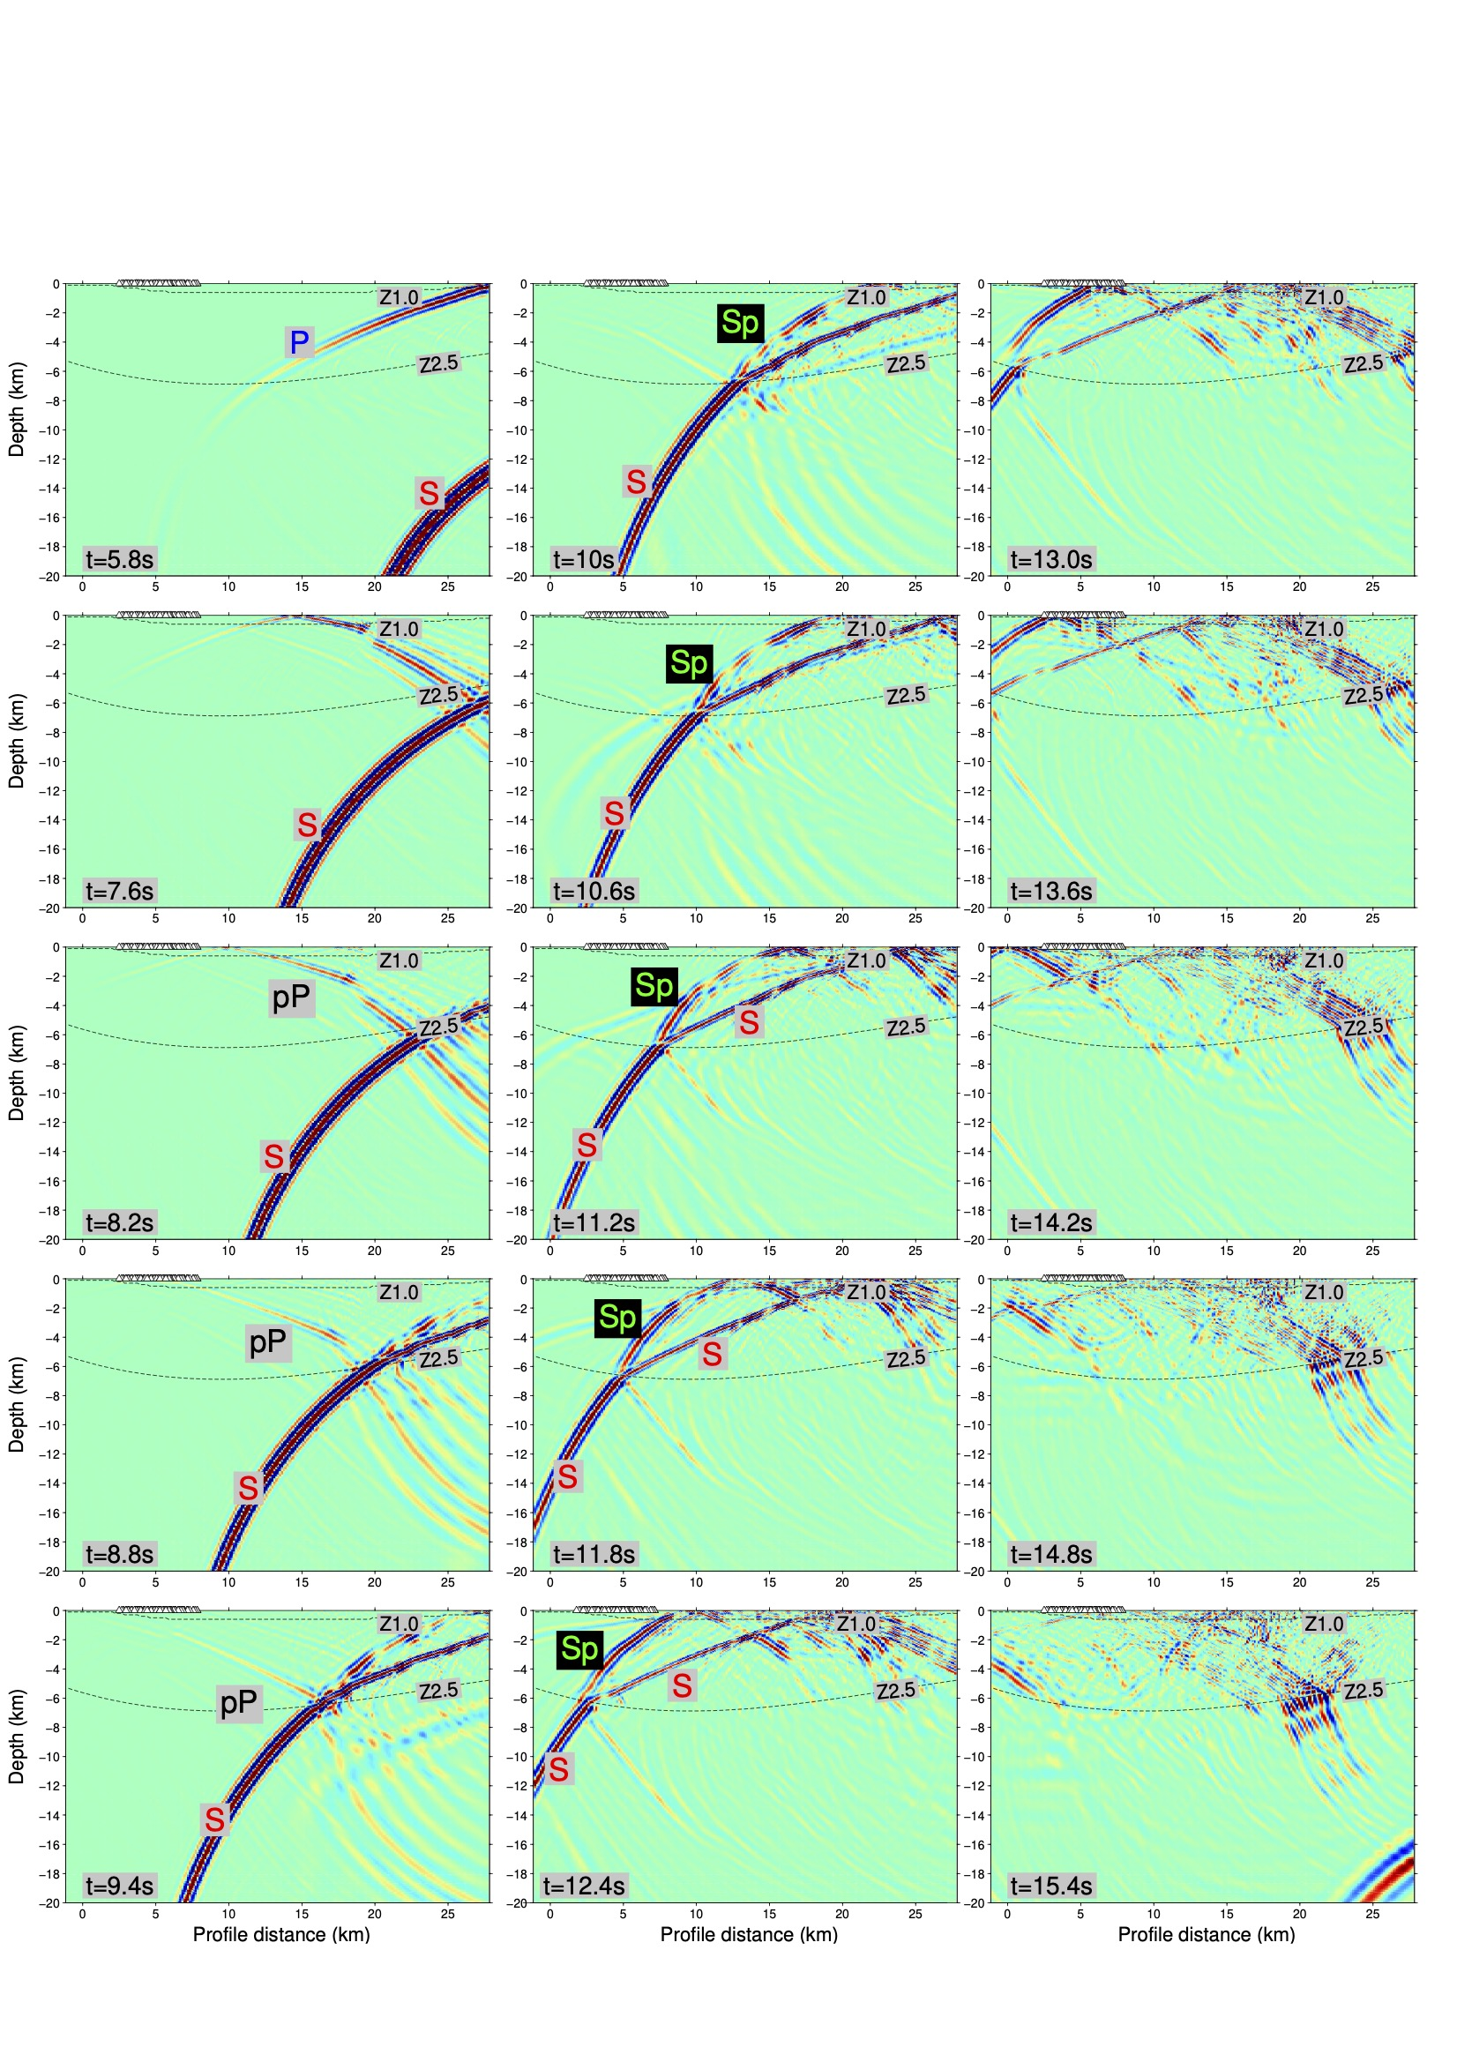
Figure 6 Snapshots of the vertical-component wavefield resulting from Example 1, i.e., a forward model of the 7/17/2019 source on the unsmoothed Stephenson et al. (2017) model, which has a sharp discontinuity at the basement contact (marked by the Z2.5 dashed line). Prominent arrivals include direct P and S, pP, and Sp generated by wave conversion at the basement contact.

