**VISCO3D**

Version 0.1 Tutorial

Fred F. Pollitz

February 15, 2023

**Acknowledgements**

**Bibliography**

Komatitsch, D. and Tromp, J., Introduction to the spectral element method for three-dimensional seismic wave propagation. Geophys. J. Int.,139, 806-822 (1999).

Pollitz, F.F., Gravitational viscoelastic postseismic relaxation on a layered spherical Earth, J. Geophys. Res., 102, 17921-17941 (1997).

Pollitz, F. F., Post-earthquake relaxation using a spectral element method: 2.5-D case, Geophys. J. Int., doi: 10.1093/gji/ggu114 (2014).

Pollitz, F.F., Post-earthquake relaxation evidence for laterally variable viscoelastic structure and water content in the southern California mantle, J. Geophys. Res., 120, 2672-2696, doi:10.1002/2014JB011603 (2015).

Sinclair, C., Greenhalgh, S., and Zhou, B., 2.5D modeling of elastic waves in transversely isotropic media using the spectral element method, Exploration Geophysics, 38, 225-234 (2007).

**1 Introduction**

VISCO3D is a software package to calculate quasi-static deformation resulting from imposed earthquake sources in a spherical geometry. It solves the 3D equations of quasi-static equilibrium using the spectral element method (SEM) on a three-dimensional structure, with imposed source and domain boundary conditions. The viscoelastic structure is defined in r-theta-phi coordinates with a pole defining the geographic location theta=0 (typically very distant from the model domain). In the spectral element domain, it produces time-dependent displacements at sets of points on Earth’s surface and vertical profiles, as well as specified `receiver’ locations.

The program package is intended as a tool in modeling postseismic crustal deformation in the case that the sub-lithosphere rheology may be approximated with a linear stress-strain relation and the viscoelastic structure is three-dimensional.

**2 Description of program**

The main program visco3d is used for all steps of the computations needed to define a 3D global grid, specify a 3D viscoelastic structure, compute 3D postseismic displacements at various points in the model domain in the Laplace transform domain, and obtain time domain results.

Pollitz (2014) adapted the SEM of Komatitsch and Tromp (1999) for seismic wave propagation to the case of quasi-static motions and implemented it in 2.5D under the assumption of a 2D structure. In the 3D case the governing equations are the same as for the 2.5D case, but the form of solution does not assume a 2D structure.

Following Pollitz (2014), the steps involved with calculating 3D quasi-static deformation are:

1. Define a 3D set of quadrilateral elements and derive a global indexing of this grid
2. Use the strong form of the equations of quasi-static equilibrium
3. Discretize the model

* mesh of elements
* obtain transformation between physical and local elemental coordinates

1. Interpolate functions on the elements

* Lagrange polynomials
* Gauss-Lobatto-Legendre (GLL) points

1. Integrate over individual elements

* GLL integration quadrature
* GLL points and weights

1. Define stiffness matrix
2. Assemble global linear system
3. Solve for displacements at the GLL points as a function of azimuthal order number
4. Perform weighted sum over azimuthal order, the weights depending on the azimuth of a given observation point
5. Inverse Laplace transform to obtain time domain results.

Generally, three runs of visco3d in sequence accomplish these steps. The first run accomplishes step (1), the second run steps (2) through (8), and the third run step (9).

We work in a r -  -  spherical coordinate system (hereafter `model coordinates’). A 3D spectral element domain is defined with respect to spherical coordinates of radius r, angular distance  from a pole of symmetry P, and azimuth . Laterally variable 3D viscoelastic structure depends upon r, , and . A seismic point source is implemented within the computational domain. The computational domain occupies a volume bounded by a spherical shell at depth, the free surface, vertical surfaces at two given angular distances from P (of constant ), and vertical surfaces at two given azimuth values (of constant ).

The present implementation uses cubes in r-- space to represent individual elements, i.e., different radius levels are separated by spherical shells, angular distances  are discretized with the same spacing regardless of r or , and angular distances  are discretized with the same spacing regardless of r or .

An individual element is discretized with GLL points, which serve as both collocation points for displacement and interpolation points for integrating the weighted equations of equilibrium over an element. For example, for 1D GLL points of order N=5 in one dimension (three interior points, two at the endpoints), the 3D GLL Cartesian grid looks like

Figure 1. 3D GLL interpolation and quadrature points of one element.

There is a simple mapping between (x,y,z) in elemental coordinates and (,,r) in physical spherical coordinates. If there are N+1 points on the side of an element, then there are altogether (N Nr  + 1)(N N + 1) (N N + 1) points in the global domain.

The equations of quasi-static equilibrium are formulated in the Laplace transform domain in order to facilitate the implementation of an assumed linear viscoelastic rheology. Letting *s* represent the Laplace transform parameter, the Burgers body rheology is represented with s-dependent bulk modulus 1 equal to the elastic bulk modulus  and s-dependent shear modulus given by

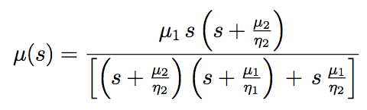 2005jb003672_p03_orig.eps

where μ1 and μ2 are the shear modulus of the Maxwell and Kelvin elements, respectively, and 1 and 2 are the viscosity of the Maxwell and Kelvin elements, respectively.

The displacement field u(r, , ; *s*) for a given *s* is parameterized with expansion coefficients evaluated at the 2D GLL collocation points. This displacement field depends on model radius r, colatitude , and longitude .

Assuming there is a global mapping between local coordinates x,y,z in an element and latitude and longitude in global model coordinates, the displacement field is

 (1)

where

are expansion coefficients for displacement and the -functions are 3D GLL functions.

There are three sets of displacement expansion coefficients, one for each of the local unit vector directions at a given location. Thus there are altogether 3(N Nr  + 1)(N N + 1) (N Nf + 1) unknown expansion coefficients. The linear system of simultaneous equations that results from manipulating the strong form of the equations of quasi-static equilibrium is derived in Pollitz (2014). For a given Laplace transform parameter, this system is solved for these expansion coefficients.

At the GLL points themselves,

(2)

so that the displacement field at GLL points 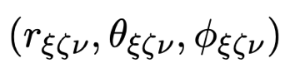is

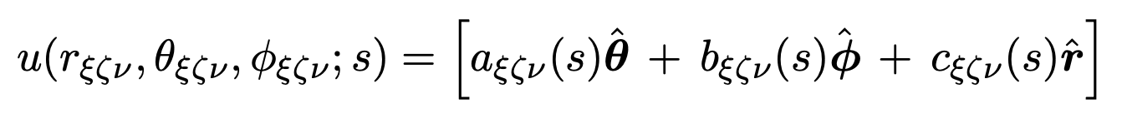(3)

Equation (1) is used by visco3d to output static and time-dependent postseismic displacements at Earth’s surface and Equation (3) is used to output static and time-dependent postseismic displacements at selected receiver points.

**3 Checklist of input parameters**

All of the information below must be specified in the various input files used

in VISCO3D.

**Earth model**

• Viscoelastic structure as a function of depth and one lateral distance: density , seismic wavespeeds Vp and Vs (equivalent to bulk modulus  and shear modulus of Maxwell element μ1), shear modulus of Kelvin element μ2, Maxwellian viscosity 1, and Kelvin viscosity 2 as a function of radius. μ2 is prescribed indirectly through the strength construct μ’= μ1 μ2 / (μ1 + μ2 )

• Radius of Earth

**Source model**

• Number of fault planes

• Strike, dip, rake, slip, length, depths of upper and lower fault edges,

latitude and longitude of one fault corner

• Earthquake origin time; start and end times of cumulative postseismic displacements

**(Optional) Observation points to output displacements - in addition to GLL points**

• Number of observation points

• Latitude, longitude, and depth of these observation points

**4 Compiling**

Folders OpenBLAS-0.3.13, AMD, Suitesparse, and UMFPACK comprise the linear algebra package needed to compile VISCO3D. They are in the VISCO2.5D folder. All but OpenBLAS were originally obtained as the package SuiteSparse v4.4.4 downloaded from

<http://faculty.cse.tamu.edu/davis/suitesparse.html>

This package is due to Timothy A Davis: <http://faculty.cse.tamu.edu/davis/publications.html>

The configuration file VISCO2.5D/ SuiteSparse\_config/SuiteSparse\_config.mk has been modified for our application.

gfortran must be installed in order to compile libraries and main programs.

AMD, Suitesparse, and UMFPACK libraries need to be compiled before the main program can be compiled. The names of the desired libraries are

VISCO2.5D/OpenBLAS-0.3.13/libopenblas.a

VISCO2.5D/Suitesparse/AMD/Lib/libamd.a

VISCO2.5D/Suitesparse/SuiteSparse\_config/libsuitesparseconfig.a

VISCO2.5D/Suitesparse/UMFPACK/Lib/libumfpack.a

• Compile AMD, OpenBLAS-0.3.13, Suitesparse, and UMFPACK libraries.

Change directory to VISCO2.5D/MAINPROG

Type `make libs'

• Edit the file VISCO2.5D/SuiteSparse/SuiteSparse\_config/SuiteSparse\_config.mk

In the line that reads

BLAS = /Users/fpollitz/fred4/CIDER2015/VISCO2.5D/OpenBLAS-0.3.13/libopenblas.a

Replace the right hand side with the path to that library on your machine.

• Compile visco3d

In VISCO2.5D/MAINPROG

Type `make visco3d'

The above make is for 64 bit.  You may need to type in

make umf4\_f77zwrapper64.o

before you try

make visco3d

**5 Examples**

The examples given here are abbreviated descriptions of how to compute post-earthquake deformation for single-plane ruptures. Before running the examples, compile visco3d as directed above. Note that the examples were run by the author on a BEOWULF cluster.

5.1 Example 1

This example will do all of the calculations necessary to evaluate post-strike-slip faulting displacements generated by a 100 km-long vertical fault occupying the lower portion of the elastic layer on a spherically-layered model. Coupling of gravity and quasi-static deformation is neglected. This model has a prescribed Maxwell viscoelastic asthenosphere below an elastic lithosphere.

To run this example, go to the EXAMPLES-VISCO3D folder and run the command file `example.x-3dSS-nograv-hydra’, which contains the lines

#!/bin/sh

export VISCODIR=/Users/fpollitz/fred4/CIDER2015/VISCO2.5D/

export EXDIR=$VISCODIR/MAINPROG

echo "Running forward simulation"

\cp elastic.paramEX1-3dtry elastic.param

\cp simulation-spherical.infoEX3-3dtry simulation-spherical.info

sed s/"nograv"/"nograv"/ laststep-nograv-7proc.x > laststep-7proc.x

\cp source-spherical.param-3dtry source-spherical.param

\cp receivers-latlondep-3dtry.txt receivers-latlondep.txt

\cp $EXDIR/visco3d .

\rm ../Work\*/rec-j-m\* ../Work\*/displ-j-m\*

date > ../Work1/visco3d-progress1.txt

date > ../Work2/visco3d-progress2.txt

date > ../Work3/visco3d-progress3.txt

date > ../Work4/visco3d-progress4.txt

date > ../Work5/visco3d-progress5.txt

date > ../Work6/visco3d-progress6.txt

date > ../Work7/visco3d-progress7.txt

cp elastic.param ../Work1/.

cp elastic.param ../Work2/.

cp elastic.param ../Work3/.

cp elastic.param ../Work4/.

cp elastic.param ../Work5/.

cp elastic.param ../Work6/.

cp elastic.param ../Work7/.

cp simulation-spherical.info ../Work1/.

cp simulation-spherical.info ../Work2/.

cp simulation-spherical.info ../Work3/.

cp simulation-spherical.info ../Work4/.

cp simulation-spherical.info ../Work5/.

cp simulation-spherical.info ../Work6/.

cp simulation-spherical.info ../Work7/.

cp source-spherical.param ../Work1/.

cp source-spherical.param ../Work2/.

cp source-spherical.param ../Work3/.

cp source-spherical.param ../Work4/.

cp source-spherical.param ../Work5/.

cp source-spherical.param ../Work6/.

cp source-spherical.param ../Work7/.

cp visco3d ../Work1/.

cp visco3d ../Work2/.

cp visco3d ../Work3/.

cp visco3d ../Work4/.

cp visco3d ../Work5/.

cp visco3d ../Work6/.

cp visco3d ../Work7/.

cp INVLAPL.PARAM ../Work1/.

cp INVLAPL.PARAM ../Work2/.

cp INVLAPL.PARAM ../Work3/.

cp INVLAPL.PARAM ../Work4/.

cp INVLAPL.PARAM ../Work5/.

cp INVLAPL.PARAM ../Work6/.

cp INVLAPL.PARAM ../Work7/.

ZEROETH=`qsub -wd $VISCODIR/EXAMPLES-VISCO3D -l nodes=1 step0.x`

echo $ZEROETH

FIRST=`qsub -W depend=afterok:$ZEROETH -wd $VISCODIR/Work1 -l nodes=1 step1.x`

echo $FIRST

SECOND=`qsub -W depend=afterok:$ZEROETH -wd $VISCODIR/Work2 -l nodes=1 step2.x`

echo $SECOND

THIRD=`qsub -W depend=afterok:$ZEROETH -wd $VISCODIR/Work3 -l nodes=1 step3.x`

echo $THIRD

FOURTH=`qsub -W depend=afterok:$ZEROETH -wd $VISCODIR/Work4 -l nodes=1 step4.x`

echo $FOURTH

FIFTH=`qsub -W depend=afterok:$ZEROETH -wd $VISCODIR/Work5 -l nodes=1 step5.x`

echo $FIFTH

SIXTH=`qsub -W depend=afterok:$ZEROETH -wd $VISCODIR/Work6 -l nodes=1 step6.x`

echo $SIXTH

SEVENTH=`qsub -W depend=afterok:$ZEROETH -wd $VISCODIR/VISCO2.5D/Work7 -l nodes=1 step7.x`

echo $SEVENTH

EIGHTH=`qsub -W depend=afterok:$FIRST:$SECOND:$THIRD:$FOURTH:$FIFTH:$SIXTH:$SEVENTH -wd $VISCODIR/EXAMPLES-VISCO3D -l nodes=1 laststep-7proc.x`

echo $EIGHTH

*Explanation of example.x-3dSS-nograv-hydra’*:

The first line, which specifies VISCODIR, sets the directory from where the example is being launched. `example.x-3dSS-nograv-hydra must be edited and this first line changed to the appropriate directory on the user’s machine, i.e., where the EXAMPLES-VISCO3D directory resides.

EXDIR is the directory where a compiled version of visco3d resides.

In a first step, relevant input files are copied to seven different WORK[n] directories. Then visco3d is run in the EXAMPLES-VISCO3D directory with `1’ in standard input. This tells it to only work on various indexing arrays that define the global grid.

In a second step, visco3d is run in the seven different WORK[n] directories with `0’ in standard input. This generates displacements of several types in the Laplace transform domain. This includes static and post-earthquake deformation at a specified set of receivers, and at all of the GLL modes.

In a third step, several files which contain Laplace-transformed displacements are copied from the WORK[n] directories to the EXAMPLES-VISCO3D directory. Then visco3d is run in the EXAMPLES-VISCO3D directory with `2’ in standard input. This converts the Laplace-transformed displacements to time-dependent displacements and written to various output files which are finally in the EXAMPLES-VISCO3D directory. The input file “INVLAPL.PARAM” is used as part of a numerical Laplace inverse transform discussed in Appendix A.

**visco3d-stat-rec.gmt** has static displacements at the receiver points.

**visco3d-post-rec.gmt** has postseismic displacements at the receiver points.

**visco3d-stat\_all\_nodes.gmt** has static displacements at all of the GLL nodes.

**visco3d-post\_all\_nodes.gmt** has postseismic displacements at all of the GLL nodes.

*Explanation of input files*:

(1) Annotated version of **simulation-spherical.infoEX3-3dtry**, including the format of viscoelastic model parameter file elastic.paramEX1-3dtry

Figure 2. r- slice of 3D model domain (in blue) and geometry specified in **simulation-spherical.infoEX3-3dtry.** The  dimension is out of the page.

[The model domain is essentially bounded in the  dimension by two small circles centered on a pole prescribed by the first two input lines, as well as the  dimension as prescribed in input lines 5-6 and the radial dimension as prescribed in input lines 7-8).

In this file the pole is located 90 degrees away from (0.0N,0.0E)

at an azimuth of 90 deg. from that point. This pole is located at P=(0.0,90.0E).]

# geographic coordinates of (theta,phi)=(theta\_ref,0.) of spherical geometry in (deg.,deg.)

0. 0.

# Angular distance theta\_ref (geocentric deg.) and azimuth (deg. CW from due N) of pole from the above point

90. 90.

# number of cells in theta^-direction

13

[The first small circle in the  dimension is defined as being 90 geocentric degrees away from P.

The second small circle is defined as being 90 geocentric degrees + SUM\_T radians away

from P, where SUM\_T is the sum of the 13 spherical-surface cell dimensions given below.

This turns out to be SUM\_T = 0.1078929 radians = 6.181810 degrees. So the second small circle is 90 + 6.181810 = 96.181810 degrees from P.]

# theta-length of each cell (radians)

1.7453e-2 1.569612e-2 7.8480615e-3 4.7088369e-3 2.354418e-3 2.354418e-3 2.354418e-3 4.7088369e-3 4.7088369e-3 4.7088369e-3 7.8480615e-3 1.569612e-2 1.7453e-2

# number of cells in phi^-direction

12

[The first boundary in the  dimension is defined as a vertical plane with trace that coincides with the great circle arc connecting the original reference point (0.,0.) and the pole P. The second boundary in the  dimension is defined as a vertical plane with trace that connects P and the original reference point rotated by an amount SUM\_PHI counterclockwise about P. This turns out to be SUM\_PHI= 0.105538547 radians = 6.04691315 degrees. So the second vertical plane is the first vertical plane rotated clockwise from P by 6.04691315 degrees.

# phi-length of each cell (radians)

1.7453e-2 1.569612e-2 7.8480615e-3 4.7088369e-3 4.7088369e-3 2.354418e-3 2.354418e-3 4.7088369e-3 4.7088369e-3 7.8480615e-3 1.569612e-2 1.7453e-2

# number of cells in z-direction

10

# z-length of each cell (km)

50. 50. 50. 30. 20. 10. 5. 5. 5. 5.

# input file with elastic parameters

[This file has pointwise values of seismic velocities and Maxwell-solid parameters with the format

theta phi. r-6371. Vp Vs Rho \mu' \eta\_2 \eta\_1

(deg.) ( km) (km) (km/s) (km/s) (g/cm^3) (10^{10} Pa) (10^{18} Pa s) (10^{18} Pa s)

0.00000000 0.000 -180.000000 5.47720003 3.16230011 3.00000000 10.0000000

0.00000000 2.000 -180.000000 5.47720003 3.16230011 3.00000000 10.0000000

0.00000000 4.000 -180.000000 5.47720003 3.16230011 3.00000000 10.0000000

…

…

0.00000000 0.000 -178.000198 5.47720003 3.16230011 3.00000000 10.0000000

0.00000000 2.000 -178.000198 5.47720003 3.16230011 3.00000000 10.0000000

0.00000000 4.000 -178.000198 5.47720003 3.16230011 3.00000000 10.0000000

0.00000000 6.000 -178.000198 5.47720003 3.16230011 3.00000000 10.0000000

0.00000000 8.000 -178.000198 5.47720003 3.16230011 3.00000000 10.0000000

(sample lines)

------------------------

theta is measured positive from (0.0N,0.0E) along the great circle connecting P and that point, i.e., along the azimuth 90-180 = -90 deg. from (0.0N,0.0E). So theta=6.181810 degrees corresponds to the point (0.0N,- 6.181810E).

------------------------

Phi is measured positive counterclockwise about P, phi=0 being on the great circle connecting P and the original reference point (0.0N,0.0E).

------------------------

r-6371 is 0 at earth's surface and -180 at the base of the computational model domain. The example file `elastic.paramEX1-3dtry’, which is copied to elastic.param prior to running the main program, may permissibly go further down than 180 km. A simple scheme for identifying the closest point in this input file is used to assign viscoelastic parameters to the GLL points.

------------------------

Vp and Vs are P-wave and S-wave isotropic seismic velocities; Rho is density.

For the Maxwell solid example here, \eta\_2 and \mu\_2 are omitted.

For a Burgers body, \eta\_2 and \mu\_2 are the viscosity and shear modulus of the Kelvin element (transient viscosity and shear modulus), and \eta\_2 and \mu\_2 are the viscosity and shear modulus of the Maxwell element

(steady state viscosity and shear modulus). The seismic velocities and rho together determine the elastic bulk modulus and shear modulus \mu\_1. \mu' is defined as

\mu' = (\mu\_1 \* \mu\_2)/(\mu\_1 + \mu\_2).

Note that for a Maxwell solid, one can either assign \mu'=\mu\_1, \eta\_2=arbitrary, and \eta\_1=Maxwell viscosity or equivalently, assign \mu'=0, \eta\_1=very large, and \eta\_2=Maxwell viscosity, or, as is done in the example file, omit \mu' and \eta\_2 and provide only \eta\_1.]

elastic.param

# gravitational acceleration at earth's surface (m/s^2) (0 for non-gravitational case)

[In computations without gravitation, this is set to 0; in computations with gravitation, this is set to 9.8]

0.0E+0

(2) Annotated version of **source-spherical.paramEX1**

[cumulative postseismic displacements are evaluated in most cases from time t1 to t2 from an earthquake source at time t0, where t0 is the year of earthquake, t1 is the year obs. #1, and t2 is year obs. #2. The viscosity multiplier has the effect multiplying all viscosities in the prescribed viscoelastic model by the given number. It is set to unity in these examples.]

# year of earthquake, year obs.#1, year obs.#2 (yrs), viscosity multiplier

1975. 1975. 1996.164 1.

# finite fault with # segments

1

# max depth, min depth (km), dip(deg.)

# lat,lon(deg.),length(km),strike(deg.),rake(deg.),slip(cm) for each segment

29.00 15.00 90.

-2.72516 -2.72516 100. 45. 180. 100.

[This last line specifies the fault geometry of a dislocation plane.

The lower edge depth is 29.00 km, upper edge depth is 15.00, dip=90 deg.

-2.72516 -2.72516 is the lat,lon of the point on the lower edge of the fault closest to the strike direction, which is 45 deg.= N45E.  That is, it is the northernmost point on the lower edge.

The fault length is 100 km, rake is 180.0 (right-lateral slip), slip is 100 cm. The conventions for strike, dip, and rake are the standard ones (e.g., Aki and Richards, 1980, p. 106).]

[The fault plane is represented with 17 x 25 point sources uniformly distributed on the plane.]

# along-strike discretization

17

# down-dip discretization

25

*Explanation of output files*:

The first few lines of the output file **visco3d-post-rec-nograv.gmt** (postseismic displacements at specified receiver locations) are:

0.0000000000000000 3.1745998905474431 -2.39968157 -2.17483521 -5.0000000000000001E-004 2.4403501420378859E-004 1.4517455127076519E-003 3.31655552E-04

0.0000000000000000 5.2955517828174372 -2.39968157 -2.17483521 -5.0000000000000001E-004 3.9836766022253561E-004 2.3191162759060783E-003 5.50957979E-04

0.0000000000000000 8.8335127736884953 -2.39968157 -2.17483521 -5.0000000000000001E-004 6.2478986806896886E-004 3.6373595900352994E-003 9.14719771E-04

0.0000000000000000 14.735187403153361 -2.39968157 -2.17483521 -5.0000000000000001E-004 9.0640546331840219E-004 5.5698731751390633E-003 1.51682470E-03

0.0000000000000000 24.579774022943663 -2.39968157 -2.17483521 -5.0000000000000001E-004 1.1632052655119011E-003 8.2191840097728033E-003 2.50103162E-03

0.0000000000000000 41.001534251928369 -2.39968157 -2.17483521 -5.0000000000000001E-004 1.2979349529414013E-003 1.1387575979808532E-002 4.05598013E-03

0.0000000000000000 68.394681311668350 -2.39968157 -2.17483521 -5.0000000000000001E-004 1.3744447345525131E-003 1.4420174849444318E-002 6.37675123E-03

0.0000000000000000 114.08920463762077 -2.39968157 -2.17483521 -5.0000000000000001E-004 1.7787177038864174E-003 1.6517254902745474E-002 9.59391892E-03

0.0000000000000000 190.31226354474262 -2.39968157 -2.17483521 -5.0000000000000001E-004 3.1045449171111651E-003 1.6922631825310893E-002 1.36586763E-02

0.0000000000000000 317.45998905474443 -2.39968157 -2.17483521 -5.0000000000000001E-004 5.5022496452255881E-003 1.5323724721836090E-002 1.82368830E-02

Columns 1 and 2 have the time interval (years) for cumulative displacement.

Columns 3 and 4 have the longitude and latitude of the receiver point in geographic coordinates (degrees), column 5 the (negative of the) depth (km), columns 6-8 the displacements (meters).

Note that **visco3d-post-rec-nograv.gmt** has cumulative displacements (columns 6,7,8 [E, N, Up displacements]) for each of 10 logarithmically-spaced postseismic time intervals at 41 receiver sites -- those in `receivers-latlondep-3dtry.txt '.

**visco3d-post\_all\_nodes-nograv.gmt** has the same format as **visco3d-post-rec-nograv.gmt**, and it has cumulative displacements for each of 10 logarithmically-spaced postseismic time intervals, in this case at all of the GLL nodes.

*Plots*

Figures 3 and 4a,c below are comparisons between the visco3d solutions (from output file

**visco3d-post\_all\_nodes-nograv.gmt**) and the semi-analytic solution from viscoelastic mode summation (Pollitz, 1997).

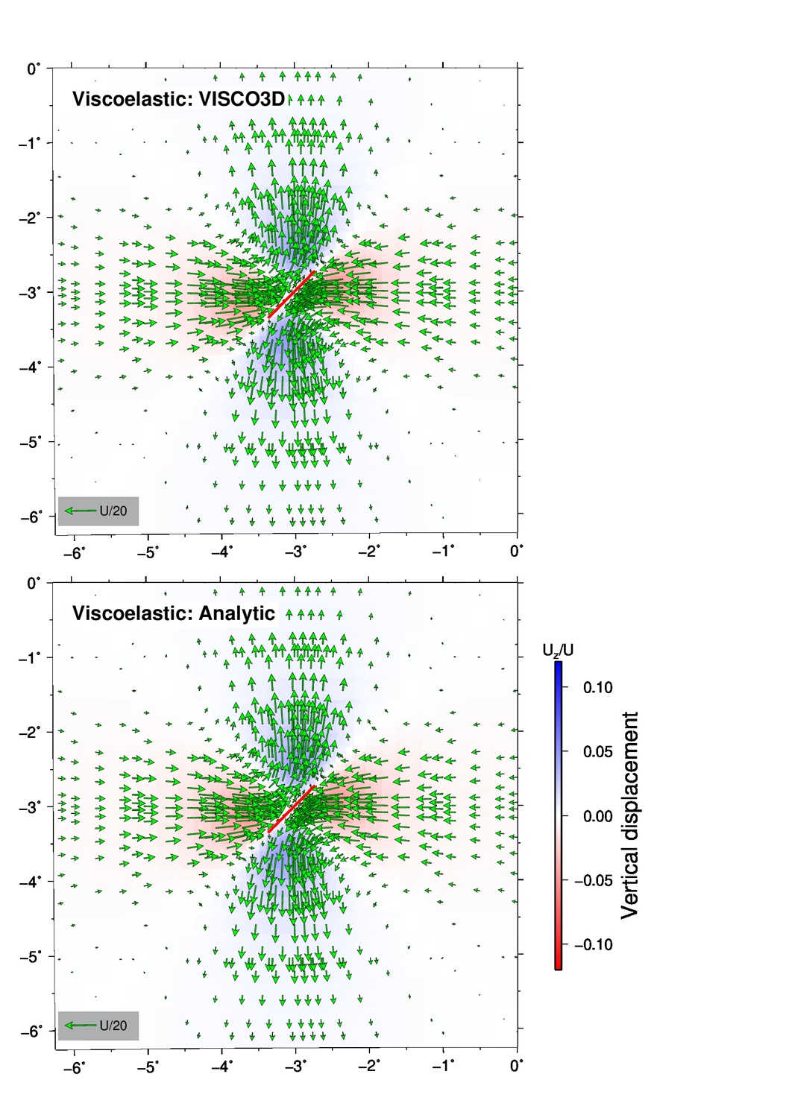

Figure 3. Horizontal displacements (arrows) and vertical displacements (color shading) for relaxation (non-gravitational case) following strike-slip faulting on the vertical fault plane indicated with the red rectangle. These are cumulative displacements up to 114.1 years following the slip event. The color scale indicates the ratio of vertical displacement Uz to fault slip U.

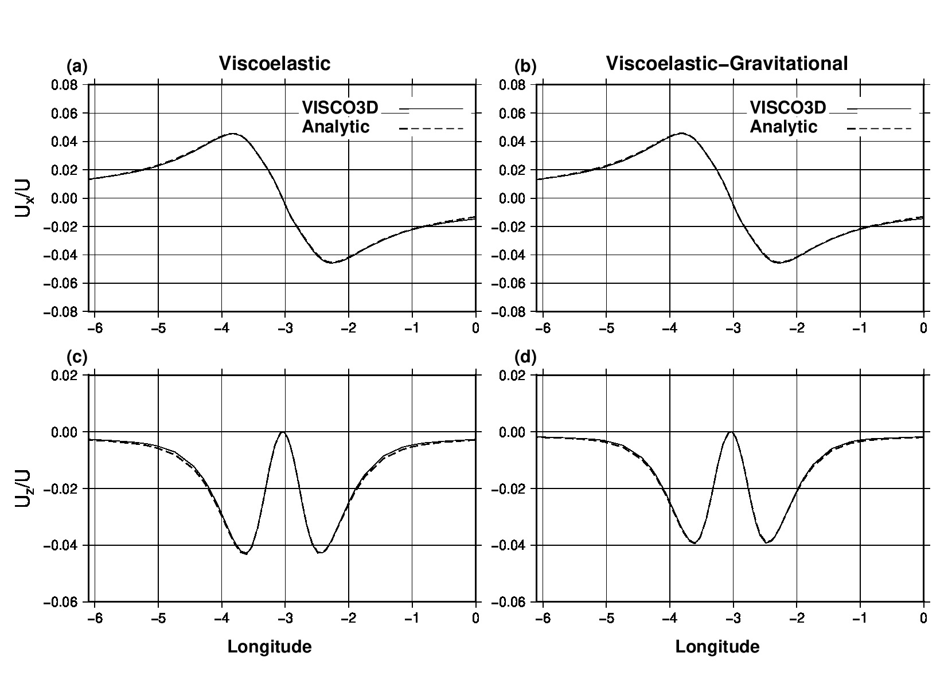

Figure 4. Ratio of horizontal displacement Ux (a,c) and vertical displacement Uz (b,d) to fault slip U for cumulative displacements following strike-slip faulting at post-seismic time 114.1 years along the equator of the area shown in Figure 3. Non-gravitational displacements from the spectral element and analytic methods are compared in a,b, and gravitational displacements in c,d.

5.2 Example 2

This example repeats Example 1 to evaluate post-strike-slip faulting displacements generated by a 100 km-long vertical fault occupying the lower portion of the elastic layer on a spherically-layered model. In Example 2, coupling of gravity and quasi-static deformation is included. This model has a prescribed Maxwell viscoelastic asthenosphere below an elastic lithosphere.

To run this example, go to the EXAMPLES-VISCO3D folder and run the command file `example.x-3dSS-grav-hydra’. This differs from the Example 1 command file only in the lines

sed s/"0.0E+0"/"9.8E+0"/ simulation-spherical.infoEX3-3dtry > simulation-spherical.info

sed s/"nograv"/"grav"/ laststep-nograv-7proc.x > laststep-7proc.x

which specify gravitational acceleration of 9.8 m/s2 in the last line of `simulation-spherical.info’ and revised (`grav’) names of the output files in ` laststep-7proc.x’

*Plots*

Figure 5 below and Figure 4b,d above are comparisons between the visco3d solutions (from output file

**visco3d-post\_all\_nodes-grav.gmt**) and the semi-analytic solution from viscoelastic mode summation (Pollitz, 1997).

Figure 5. Horizontal displacements (arrows) and vertical displacements (color shading) for relaxation (gravitational case) following strike-slip faulting on the vertical fault plane indicated with the red rectangle. These are cumulative displacements up to 114.1 years following the slip event. The color scale indicates the ratio of vertical displacement Uz to fault slip U.

5.3 Example 3

This example will do all of the calculations necessary to evaluate post-thrusting displacements generated by a 100 km-long vertical fault occupying the lower portion of the elastic layer on a spherically-layered model. Coupling of gravity and quasi-static deformation is neglected. This model has a prescribed Maxwell viscoelastic asthenosphere below an elastic lithosphere.

To run this example, go to the EXAMPLES-VISCO3D folder and run the command file `example.x-3dTH-nograv-hydra’. This case differs from the post-strike-slip faulting case (Example 1) only in the source parameters. In ` example.x-3dTH-nograv-hydra’ this is accomplished by modifying the original `source-spherical.param-3dtry’ for different strike, dip, and rake:

sed s/"29.00 15.00 90."/"29.00 15.00 60."/ source-spherical.param-3dtry > tmp

sed s/"-2.72516 -2.72516 100. 45. 180. 100."/"-2.72516 -2.95000 100. 0. 90. 100."/ tmp > source-spherical.param

These two lines change the dip from 90o of Example 1 to 60o, change the strike from 45o to 0o, and change the rake from 180o to 90o.

The final output file names also change according to

sed s/"nograv"/"TH-nograv"/ laststep-nograv-7proc.x > laststep-7proc.x

*Plots*

Figures 6 and 7a,c below are comparisons between the visco3d solutions (from output file

**visco3d-post\_all\_nodes-TH-nograv.gmt**) and the semi-analytic solution from viscoelastic mode summation (Pollitz, 1997).

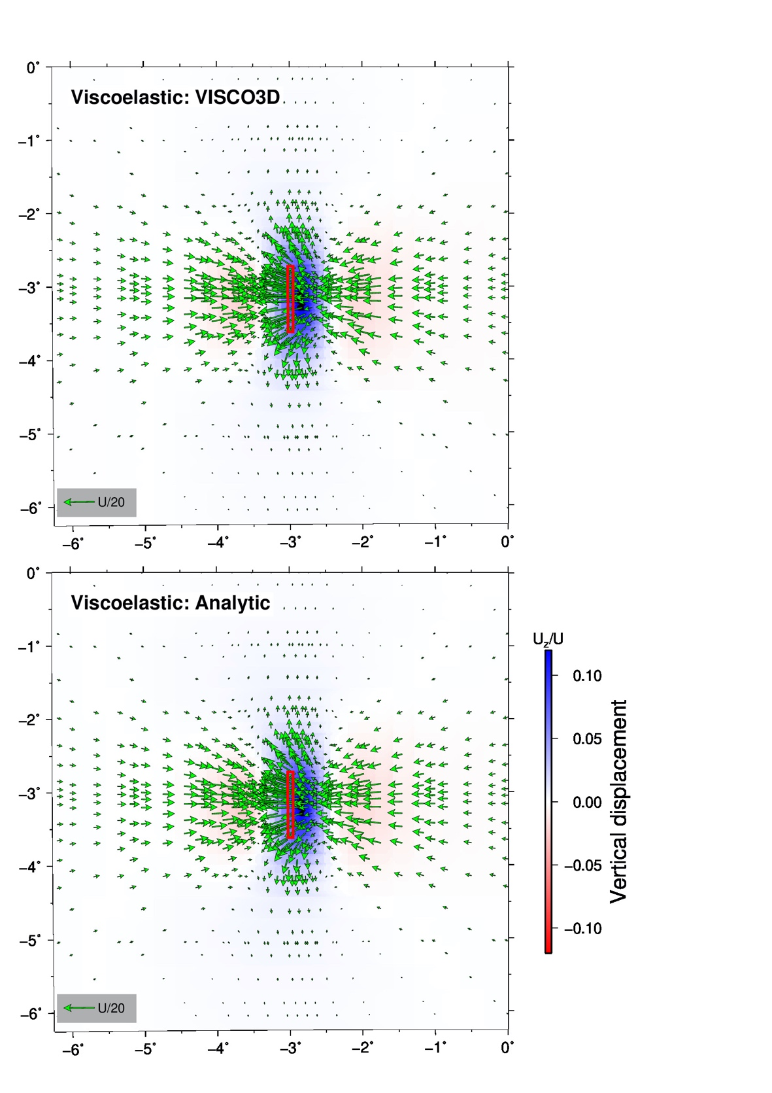

Figure 6. Horizontal displacements (arrows) and vertical displacements (color shading) for relaxation (non-gravitational case) following thrust faulting on the 60o-dipping, north striking fault plane indicated with the red rectangle. These are cumulative displacements up to 114.1 years following the slip event. The color scale indicates the ratio of vertical displacement Uz to fault slip U.

Figure 7. Ratio of horizontal displacement Ux (a,c) and vertical displacement Uz (b,d) to fault slip U for cumulative displacements following thrust faulting at post-seismic time 114.1 years along the equator of the area shown in Figure 6. Non-gravitational displacements from the spectral element and analytic methods are compared in a,b, and gravitational displacements in c,d.