**Academic Reading**

**READING PASSAGE 1**

You should spend 20 minutes on Questions 1-13, which are based on Reading Passage 1.

*Climate change heralds thirsty times ahead for most*

**A new modelling study suggests that increasing temperatures**

**will dramatically affect the world's great rivers**

Veteran climate modeller Syukuro Manabe, and colleagues at Princeton University, modelled what effect a quadrupling of atmospheric carbon dioxide above pre-industrial levels would have on the global hydrological (water) cycle over the next 300 years. That looks further ahead than most climate models, but the scenario is inevitable unless governments take drastic action to limit greenhouse gas emissions. Rising CO2 levels will trigger higher temperatures not only at the Earth 's surface, but also in the troposphere, the team says. By factoring this into the models together with changes to levels of water vapour, cloud cover, solar radiation and ozone, the team predicted the effect that climate changes could have on evaporation and precipitation (rain). Both would increase, the researchers found, causing the discharge of fresh water from rivers around the world to rise by almost 15 per cent.

However, while water is going to be more plentiful in regions that already have plenty, the net effect will be to take the world's water further from where the people are. 'Water stresses will increase significantly in regions that are already relatively dry,' Manabe reports in the journal *Climate Change.* He goes on to predict that evaporation will reduce the moisture content of soils in many semi-arid parts of the world, including north-east China, the grasslands of Africa, the Mediterranean and the southern and western coasts of Australia. Soil moisture will fall by up to 40 per cent in southern US states, representing the greatest reduction.

The effects on the world's rivers will be just as dramatic. The biggest increases will be in the far north of Canada and Russia. For instance, the flow of the river Ob in Siberia is projected to increase by 42 per cent by the end of the 23rd century. This prediction could encourage Russia's plans to divert Siberian rivers to irrigate the deserts around the Aral Sea. Similar changes could increase pressure from the US for Canada to allow transfers from its giant Pacific rivers to water the American West. Manabe predicts a 47 per cent increase in the flow of the Yukon river.

By contrast, there will be lower flows in many mid-latitude rivers, which run through heavily populated regions. Those that will start to decline include the Mississippi, Mekong and especially the Nile, one of the world's most heavily used and politically contested rivers, where his model predicts an 18 per cent fall in flow.

The changes will present a 'profound challenge' to the world's water managers, Manabe says. They are also likely to fuel calls for a new generation of super-dams and canals to move water round the planet like China's current scheme to transfer water between north and south.

Some of the findings are controversial. The UK Meteorological Office's climate model predicts that flows in the Amazon could fall this century, while Manabe's team predicts greater rainfall could increase its flow by 23 per cent. And while Manabe foresees a 49 per cent increase in the flow of the Ganges and Brahmaputra rivers that drain the Himalayas, an international study reported that the Ganges would lose flow as the glaciers that feed it melt away.

***Questions 1-7***

*Complete the notes.*

*Choose* ***NO MORE THAN THREE WORDS AND/OR A NUMBER*** *from the passage for each answer.*

*Write your answers in boxes 1-7 on your answer sheet.*

**Syukuro Manabe's climate model**

based on: fourfold increase of **1…………………………...**

period covered: looks ***2……………………*** ahead

processes monitored: effects of climate change on **3……………………** as well as **4………………………**

**Syed Iqbal Hasnain's predictions**

based on: the loss of **5………………………**

period covered: looks **6…………………..** ahead

**David Labat's predictions**

based on: data going back to **7 ……………………….**.

features studied: 200 of the world's largest rivers.

Global warming has already increased glacier melting by up to 30 per cent. 'After 40 years, most of the glaciers will be wiped out and then we will have severe water problems,' says Syed Iqbal Hasnain of Calicut University, Kerala, reporting the results of a three-year study by British, Indian and Nepalese researchers. The study finds the biggest impact in Pakistan, where the River Indus irrigates half the country's crops. Flows here could double before crashing to less than half current levels by the end of the century. But the declining flows predicted for the Ganges will also throw into disarray a vast Indian government scheme to avoid drought by diverting water from the country's glacier-fed northern rivers to the arid south.

Meanwhile, a team of researchers in France say that climate change is already affecting the world's rivers. David Labat and colleagues at the government's CNRS research agency in Toulouse in France reconstructed the monthly discharges of more than 200 of the world's largest rivers since 1875. They took discharge data held by the Global Runoff Data Centre in Germany and the UNESCO River Discharge Database and used a statistical technique to fill in gaps left by missing data, or changes to run-off caused by dams and irrigation projects.

Their findings reveal that changing temperatures cause river flows to rise and fall after a delay of approximately 15 years, and the team predicts that global flows will increase by about 4 per cent for every 1 ° C rise in global temperature. However, climate change over the past few decades has already caused discharge from rivers in North and South America and Asia to increase. Run-off in Europe has remained stable, but the flow of water from Africa's rivers has fallen.

***Questions 8-12***

*Complete the table below.*

*Choose* ***NO MORE THAN THREE WORDS AND/OR A NUMBER*** *from the passage for each answer.*

*Write your answers in boxes 8-12 on your answer sheet.*

**Predictions about increasing temperatures**

|  |  |  |
| --- | --- | --- |
|  | **Rivers** | **Soil** |
| ***Syukuro Manabe*** | Overall increase in flow of  approximately **8………………..**  Decreases in flow at mid latitudes, in particular for the **10 ………………** | Most significant decline in water content will be in **9……………….**. |
| ***Syed Iqbal Hasnain*** | Greatest flow increase in **11…………….**  e.g. River Indus  Flows will rise and then fall. |  |
| ***David Labat*** | Flow rates change about **12………….** after the change in temperature occurs. |  |

***Question 13***

*Choose* **TWO** *letters,* ***A-E.***

*Write your answers in box 13 on your answer sheet.*

*Which* ***TWO*** *of the following countries are developing* systems *to solve their own water problems?*

**A** China

**B** Africa

**C** Canada

**D** India

**E** France

**READING PASSAGE 2**

You should spend 20 minutes on Questions 14-26, which are based on Reading Passage 2.

**Principles of Persuasion**

***Successful advertising has to keep up with the times***

A

By the early twentieth century, key consumer markets for products such as confectionery, soap and tobacco had already become saturated. Though advertisers had developed strategies such an expanding consumer pending through increasing credit, they also turned to advertising messages to help increase sale. As early as 1908, when *The Psychology of Advertising* by Professor Walter Dill Scott was published, advertisers began to formulate theories of human behaviour and motivation which could unlock the consumer's mind through persuasive treatments (Leiss et al. 1990). New approaches to persuasiveness were grouped and systematised in the 1920s into 'reason-why' and 'atmosphere' advertising techniques.

B

'Reason-why' was designed to stimulate demand by constructing a reason for purchase, such as helping to save time, being modem, or being socially acceptable. Reason-why ads were used to differentiate the product from others on the market, as in an example from the 1960s: 'Make sure it's Cadbury's. Because no other chocolate can possibly give you the proper, creamy, Cadbury taste.' The premise was that consumers were essentially rational and made consuming decisions based upon reason. ln an expanding market, there is no reason to try to make appeals other than 'reason-why', because consumers continue to buy, but once competition rises and the market flattens, advertisers need to find new appeals. 'Atmosphere' advertising, on the other hand, was meant to evoke non-rational responses such as sexual desire and patriotism from consumers and was useful when the market became saturated and advertisers needed a competitive advantage.

C

These approaches tried to get to the essence of what advertising is all about and consequently solve all of the problems of advertising. In reality advertisers used a combination of the two. New products, for example, at the turn of the century had to be explained, and the reason for using them developed, in the advertising. However, new inventions could not rely just on 'reason-why' ads, they *also* used suggestion and atmosphere. One technique was to associate the new brand with traditional and cosy settings such as nature and the family.

D

A later version of the 'reason-why' advertisement of the 1920s was the Unique selling Proposition (USP) developed by US agency boss Rosser Reeve in the 1950s. This too was based on 'rational' consumer decisions, but more explicitly tried to find an essence to advertising. Rosser Reeve specified that 'Each advertisement must make a proposition to the consumer. Each advertisement must say to each reader, "Buy this product, and you will get this specific benefit ... one that the competition either cannot or does not offer." It must be unique - either a uniqueness of the brand or a claim not otherwise made in that particular field of advertising. The proposition must be so strong that it can move the mass millions, i.e. pull over the new customer to your product' (Reeves 1961).

E

A USP could be achieved through the packaging, such as a unique bottle shape or a boiled sweet 'double-wrapped to keep in the freshness'. These differences in the product (the look, shape, size, colour and market position; the biggest/best/leading) are less to do with the advertising and more to do with the manufacturer. The manufacturer may decide to design the product in a certain way to provide the USP, such as an unusual pack design. Whether the consumers were interested enough in the USP to make them want to buy the product was of little relevance. This imperative for differentiation came from the companies and the competitive market, not from any predilection towards the consumer. The greatest strength of the approach was that it re-emphasised the basic communications principle that to be effective advertising must emphasise difference; it did not matter for what rational or irrational reason the product was differentiated, just that it was differentiated.

F

Reason-why and USP are still used today in different settings, especially for new products. However, the speed with which goods lose their difference means that the straightforward explanation of the goods' use, and the appeal of product difference, is lost and other ways are needed to differentiate the product, such as the emotional sell and the advertising 'brand image'.

G

David Ogilvy was one of the biggest exponents of the power of the brand to influence consumer-buying decisions, though the term 'brand image' had been used for decades before. Building a brand is as much about establishing familiarity as it is about establishing difference. Even if you are not a Coke addict, you may tum to Coke in a store because you are so familiar with its design and its name and packaging. Any new brands that come on the market have the weight of this to fight against. The new brand has to differentiate through a separate product feature or benefit, or, more usually (if there is no difference), to develop a separate personality so that the brand is remembered as quite distinct.

***Questions 14-18***

Reading Passage 2 has seven paragraphs, **A-G.**

Which paragraph contains the following information?

*Write the correct letter* ***A-G*** *in boxes 14-18 on your answer sheet.*

**14** a reference to customers owing money for their purchases

**15** an expert's explanation of a particular advertising method

**16** an example of how advertising makes a link between the product and familiar situations

**17** why current advertising can't rely only on traditional techniques

**18** when investigations began into how advertising could appeal to consumer logic

***Questions 19-22***

*Classify the following features as being true of*

***A*** *'reason why' advertising*

***B*** *'USP' advertising*

***C*** *'atmosphere' advertising*

*Write the correct letter* ***A-C*** *in boxes 19-22 on your answer sheet.*

**19** It was created by the manager of an advertising company.

**20** Its main approach was to suggest a motive for purchasing the product.

**21** It was a useful technique if the customer base was no longer growing.

**22** It moved the focus from advertising to what the product looked like.

***Questions* 23-26**

*Complete the summary below.*

*Choose* ***NO MORE THAN TWO WORDS*** *from the passage for each answer.*

*Write your answers in boxes 23-26 on your answer sheet.*

**Brand Advertising**

The need for brand advertising was created because of the **23……………** with which products

today begin to look alike. David Ogilvy is considered a pioneer in this area, although

people were using the expression **24 ………**many years earlier.

In addition to focusing on difference, branding highlights customers' **25 ……….**with a

product. A good example of this is **26……………** which is instantly recognisable in the shops.

Manufacturers of new products have to find a way of matching this.

**READING PASSAGE 3**

You should spend 20 minutes on Questions 27-40, which are based on Reading Passage 3.

**Roses are blue, violets are red**

*If* ***you don 't like GM food, try flowers instead***

Beautiful flowers, like any other beautiful object, can separate the most sensible of people from their money. On special occasions, people invest in a display of beautiful stems and petal to signal their own feelings or intentions. The result is a cut-flower industry in which roses alone are worth $10 billion a year. But that is nothing, compared with what happened in the past. In 17th-century Holland, tulip (the fashionable flower of the day) grew so expensive that people exchanged their bulbs for house. One bulb of the most sought-after variety, the flaming red striped Semper Augustus sold for twice the yearly income of a rich merchant.

For modern flower growers, the equivalent of the Semper Augustus is the blue rose, which horticulturalist have longed for since the 19th century. Any blue rose sent on Valentine's Day this year will have been dyed. But if Yoshi Tanaka, a researcher at Suntory, a Japanese drinks company, has his way, that will soon change. Dr Tanaka is currently over-seeing the first field trial of a blue rose developed by Suntory's subsidiary, Florigene. If the trials are successful, a dozen blue roses – even if they do look slightly mauve - could, by 2010, be available in florists worldwide.

What Dutch growers of old and Dr Tanaka' employers both grasped isthat rarity, and hence economic value, can be created by genetic manipulation.

The stripes of the Semper Augustus were caused by the genes of a virus. Not knowing that an infection was involved, the Dutch growers were puzzled as to why the Semper Augustus would not breed true. The genetics of blue roses too have turned out to be more complicated than expected. The relevant genes cannot easily be pasted into rose DNA because the metabolic pathway for creating blue pigment in a rose consists of more chemical step than it does in other types of flower. (Florigene has sold bluish genetically modified carnations since 1998.)

Success, then, has been a matter of pinning down the gene that allow those extra steps to happen, and then trans planting them to their new host.

Mere colour, however, is for unsophisticated buyers. A truly harmonious gift should smell beautiful as well. Sadly, commercial varieties of cut roses lack fragrance. This is because there is a trade-off between the energy that plants spend on making the complex, volatile chemical that attract people and insects alike, and that available for making and maintaining pretty coloured petals. So, by artificially electing big, long-lasting flowers, breeders have all but erased another desirable characteristic.

Smell is tougher to implant than colour because it not only matters whether a plant can make sweet-smelling chemicals, it also matters what it does with them. This was made plain by the first experiment designed to fix the problem. In 2001, Joost Lucker, then as researcher at Plant Research International in Wageningen, in the Netherlands, added genes for a new scent into small colourful flowers called petunia. Chemical analysis showed that the new scent was, indeed, being made, but unfortunately the flowers did not smell any different. As happens in Florigene's blue carnation and roses, Dr Lucker's petunia dumped the foreign chemical they were being forced to create into cellular waste buckets known a vacuoles. Whereas pigments are able to alter a petal's colour even when they are inside a vacuole, because the cell contents surrounding the vacuole are transparent, smelly molecules must find a route to the sniffer nose by getting out of the cell and evaporating.

Like Dr Lucker, Natalia Dudareva, of Purdue University, in Indiana, eschews experiments with roses, since these plants have scents composed of 300 to 400 different molecules. She prefers to understand basic odour science using petunia and other similar plants, which have about ten smelly chemicals apiece. She has made an encouraging discovery. By studying the many different pathways through which flowers make their fragrances, she has found consistent patterns in the way these pathways are regulated.

Such co-ordinated patterns suggest that a type of protein called a transcription factor is involved. Transcription factor switch genes on and off in groups. If Dr Dudareva is right, cut rose have lost their fragrance not because the genes that encode their hundreds of scent molecules have each lost their function, but because the plants no longer make a few transcription factors needed to tum the whole system on.

This suggests that the task of replacing lost fragrance is more manageable than it seemed at first. But even when the transcription factors in question have been identified the problem of the energetic trade-off with pigment production and longevity will remain. So, Dr Dudareva is also measuring how quickly the enzyme in scent-production pathways work in order to identify bottlenecks and thus places where her metabolic-engineering effort would best be concentrated.

Dr Dudareva's methods may also help to improve the job that flower-scents originally evolved to do - attracting insects that will carry pollen from flower to flower. By modifying the smell of crops such as vanilla which have specific pollinator species, different insects might be attracted. That could expand the range in which such crops could be grown and thus make some poor farmers richer.

***Questions 27-32***

Do the following statements agree with the claims of the writer in Reading Passage 3?

*In boxes 27-32 on your answer sheet write*

***YES*** *if the statement agrees with the claims of the writer*

***NO*** *if the statement contradicts the claims of the writer*

***NOT GIVEN*** *if it is impossible to say what the writer thinks about this*

**27** Historically, people have been willing to pay excessive amounts for flowers.

**28** Farmers who grow flowers are generally richer than other farmers.

**29** Blue roses were available for purchase in the 19th century.

**30** Dutch plant growers deliberately used a virus to produce the striped Semper Augustus.

**31** Blue carnations are more popular than carnations of other colours.

**32** Plant breeders are to blame for the loss of smell in today's roses.

***Questions 33-36***

*Choose the correct letter,* ***A, B, C*** *or* ***D.***

*Write the correct letter in boxes 33-36 on your answer sheet.*

**33 Dr Tanaka hopes that his field trials will**

**A** result in a more expensive flower than the Semper Augustus.

**B** produce blue roses that can be sold commercially.

**C** show that flowers can be dyed unusual colours.

**D** verify the link between flowers and romance.

**34 Dr Lucker's experiment with petunias showed that**

**A** plant fragrances depend on the colour of the petals.

**B** the more colourful plants are, the less they smell.

**C** plants are able to reject the chemicals that produce smell.

**D** colour and smell are equally difficult to introduce into plants.

**35 Dr Dudareva prefers to study petunias, rather than roses, because petunias**

**A** are easier to grow.

**B** have a wider range of scents.

**C** are found in a wider range of places.

**D** have less complex molecular scent structures.

**36 In what way could Dr Dudareva's work benefit agriculture?**

**A** More farmers would be able to grow flowers.

**B** A wider range of insects would pollinate certain plants.

**C** More unusual flowers could be created.

**D** A wider variety of plant species would be grown.

***Questions 37-40***

*Answer the questions below.*

*Choose* ***NO MORE THAN THREE WORDS AND/OR A NUMBER*** *from the passage for each answer.*

*Write your answers in boxes 37-40 on your answer sheet.*

**37** What items were traded for flower bulbs in 17th-century Holland?

**38** What aspect of a rose's internal biology slows down attempts to change its DNA?

**39** What is the name of the waste area in which Dr Lucker's petunias were placing foreign chemicals?

**40** What is the name of the protein that plants must make in order to release scent molecules?

**Listening**

**Section 1** Questions 1-10

**Questions 1-6**

Complete the form below.

Write **NO MORE THAN THREE WORDS AND/OR A NUMBER** for each answer.

|  |  |
| --- | --- |
| Patient Record | |
| Time of appointment | **Example: 10 am________** |
| Given names | Simon **1**………………………. |
| Family name | Lee |
| Date of birth | **2** …………………………. 1989 |
| Address | **3** ………………………….. Adams Terrace, Wellington. |
| Phone no. | 0211558809 |
| Name of insurance company | **4**……………………………. |
| Date of last eye test | **5**…………………………….. |
| Patient's observations | **6** Problems seeing …………………… |

**Questions 7-10**

Answer the questions below.

Write **NO MORE THAN THREE WORDS** for each answer.

**7** When must Simon wear his glasses? ………………………….

**8** What type of glasses are the least expensive? ………………………….

**9** What is good about the glasses Simon chooses? ………………………….

**10** How does Simon decide to pay? ………………………….

**SECTION 2** Questions 11-20

**Questions 11-12**

*Choose the correct letter,* ***A, B*** *or* **C.**

**11 Who is buried in the tomb of the Taj Mahal?**

**A** the emperor Shahjahan

**B** the wife of Shahjahan

**C** the emperor and his wife

**12 Where did the white marble come from?**

**A** India

**B** China

**C** Persia

***Questions 13-16***

Label the plan below.

Write **NO MORE THAN THREE WORDS** for each answer.

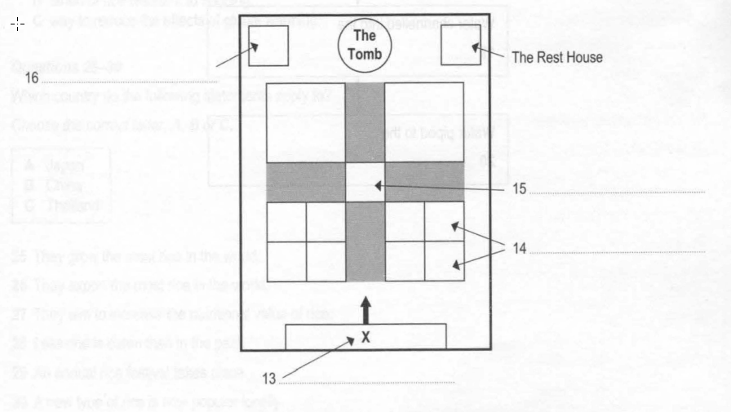

**Question 17**

Choose the correct letter**, A, B or C.**

**17** What is the purpose of the Rest House?

**A** a place for the poor to stay

**B** a meeting place for pilgrims

**C** an architectural feature

**Questions 18-20**

Complete the flow chart below.

Write **NO MORE THAN TWO WORDS** for each answer.

**How running water is provided**

**SECTION 3 Questions 21-30**

***Questions 21-24***

*Choose the correct letter,* ***A, B or* C.**

**21** What background information does Daisy give about rice?

**A** Wild rice is grown throughout Asia.

**B** Some types of rice need less water than others.

**C** All rice varieties have a lovely aroma.

**22** Erik says that a priority for rice farmers is to be able to

**A** grow rice without fertilizers.

**B** predict the weather patterns.

**C** manage water resources.

**23** Where is the International Rice Research Institute?

**A** The Philippines

**B** China

**C** Japan

**24** Scientists in Bangladesh want to find a

**A** more effective type of fertilizer.

**B** strain of rice resistant to flooding.

**C** way to reduce the effects of global warming.

**Questions 25-30**

Which country do the following statements apply to?

*Choose the correct letter,* ***A, 8 or* C.**

**A** Japan

**B** China

**C** Thailand

**25** They grow the most rice in the world.

**26** They export the most rice in the world.

**27** They aim to increase the nutritional value of rice.

**28** Less rice is eaten than in the past.

**29** An annual rice festival takes place.

**30** A new type of rice is now popular locally.

**SECTION 4 Questions 31-40**

**Questions 31-33**

Complete the sentences below.

Write **NO MORE THAN ONE WORD** for each answer.

**RADIO WRITING**

**31** You may have to ignore some of the ordinary……………………….. of writing.

**32** Written words do not indicate things like emphasis, the………………………..of reading or where to pause.

**33** A script needs to sound like a………………………..

**Questions 34-40**

Complete the notes below.

Write **NO MORE THAN THREE WORDS** for each answer.

**Know who you are talking to**

Imagine a typical listener:

e.g. imagine telling your **34 ……………………………..** about a film

Create an informal tone:

e.g. use words like **35………………….** and ………………………

**Work out what you are going to say**

Remember: listeners cannot ask questions

you cannot **36 ……………………** ideas

Make your script logical:

* ……………………………. **37** the information.
* Use concrete images e.g. compare the size of a field to a **38 …………………………**
* Use the **39 ………………………………** to get attention.

Check the script by **40………………………….**

**Academic Writing**

**TASK1**

You should spend about 20 minutes on this task.

**The charts below show information about India's trade.**

**Summarise the information by selecting and reporting the main features and make comparisons where relevant.**

Write at least 150 words.

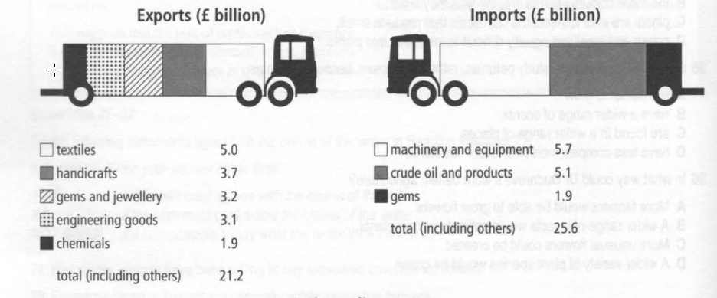

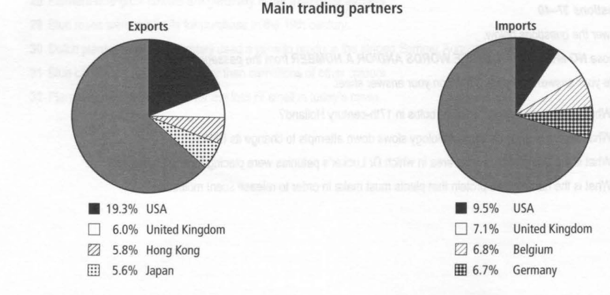

**TASK 2**

You should spend about 40 minutes on this task.

Write about the following topic.

**Some people think that it is very important to get a university education.**

**Others feel we should encourage more young people to take up a trade such as**

**plumbing, painting or building to ensure a good balance of skills in our society.**

**Discuss both these views and give your opinion.**

Give reasons for your answer and include any relevant examples from your own knowledge and experience.

Write at least 250 words.

**ACADEMIC READING**

**Section 1 Section 3**

1 (atmospheric) carbon dioxide 27 YES

2 300 years 28 NOT GIVEN

3 evaporation 29 NO

4 precipitation (rain) 30 NO

5 glaciers 31 NOT GIVEN

6 40 years 32 YES

7 1875 33 B

8 15% / 15 percent 34 C

9 southern US states 35 D

10 (River) Nile 36 B

11 Pakistan 37 houses

12 15 years 38 (its/the) metabolic pathway

13 A and D 39 (a/ the) vacuole / vacoules

**Section 2** 40 (a) transcription factor

14 A

15 D

16 C

17 F

18 A

19 B

20 A

21 C

22 B

23 speed

24 brand image

25 familiarity

26 Coke

**LISTENING**

**Section 1 Section 3**

1 Anthony 21 B

2 1 (st) June 22 C

3 University Hall 23 A

4 Health for Life 24 B

5 September 2006 25 B

6 (in the) distance 26 C

7 (for) driving 27 B

8 (the) full frame / full frame 28 A

9 (they are) strong 29 C

10 (in/by) cash 30 A

**Section 2 Section 4**

11 C 31 rules

12 A

13 (The) Main Gateway

14 (the) (16/sixteen) flower beds

15 (a/the) (raised) pond

16 (a/the) Mosque

17 C

18 river

19 (supply) tanks

20 fountains

32. speed

33. conversation

34. grandmother

35. us (and) we

36. repeat

37. space (out)

38. football pitch

39. first sentence

40. reading (it) aloud