SUPREME COURT OF THE STATE OF NEW YORK
COUNTY OF NASSAU
------------------------------ | X
FELIX PROCACCI  PETITIONER | :  :
 | :  :  : |  | Index No.  18--xxxxxx  PETITION
-against- | :
 | :
TOWN OF HEMPSTEAD,  RESPONDENT | :  :
:
:
:
:
 | :
For a Judgment Pursuant to Article 78 of the Civil Practice Law and Rules | :  :  :
------------------------------ | X
TO THE SUPREME COURT OF THE STATE OF NEW YORK, COUNTY OF NASSAU:
The petition of Felix Procacci respectfully shows to this Court as follows:

- Petitioner Felix Procacci resides at 1165 Barnes St, Franklin Square, New York 11010, located in the County of Nassau.
- Petitioner is appearing pro se on this matter and is fully familiar with the facts and circumstances surrounding it.
- Respondent Town of Hempstead (hereinafter referred to as “The Town”) is a municipal corporation organized and existing under the laws of the State of New York with its principal place of business located at One Washington Street, Hempstead, New York, County of Nassau.
- The within proceeding is brought pursuant to Article 78 of the Civil Procedure Law and Rules in the nature of mandamus to compel Respondents to comply with all applicable provisions of the Public Officers Law, Article 6, Sections 84-90, Freedom of Information Law (hearinafter referred to as “FOIL”).

RELEVANT FACTS
- The Town's Building department fees for public records exceeds the limits specified by New York State's Freedom of Information Law.
- New York State's Freedom of Information Law states the following “the fees for copies of records which shall not exceed twenty-five cents per photocopy not in excess of nine inches by fourteen inches, or the actual cost of reproducing any other record in accordance with the provisions of paragraph (c) of this subdivision, except when a different fee is otherwise prescribed by statute.”
- A copy of a receipt from the Town's building department for a record request is attached hereto as Exibit 1.
- The Town's building department charges $5.00 for the first copy and $2.00 for each additional copy for records that do not exceed nine inches by fourteen inches (Hereinafter these costs will be referred to as “fees”).
- The Town prohibits the used of photographic equipment in the computer room where persons may print records from the Town's Building Department computer system.
- The prohibition of photographic equipment in the computer room is to ensure patrons have to pay the fees charged by the Town's Building Department.
- Pictures of signs located in the Town's Building department computer room, which show the Town prohibits the use of photographic equipment, is attached hereto as Exhibit 2.
- A copy of the advisory opinion from the Committee on Open Government asking the Town to reconsider its practices regarding the fees for copies is attached hereto as Exhibit 3.
- A copy of the advisory opinion (Exhibit 3) from the Committee on Open Government was sent to Town Attorney Joseph Ra.
- A copy of the advisory opinion (Exhibit 3) from the Committee on Open Government was sent to Town Clerk Sylvia Cabana.
- On September 4, 2018, the Petitioner presented a draft copy of this petition to the Hempstead Town Board and the Town Attorney.
- On September 4, 2018 the Petitioner asked the Town Attorney to provide a written explanation for the fees charged by the Building Department.
- On September 4, 2018 the Petitioner asked the Town Attorney to provide a written explanation for the photography prohibition in the Building Department Computer room.
- As of October 2, 2018, the petitioner did not receive a written response from the Town Attorney, Joseph Ra regarding the fees charged by the Building Department.

- As of October 2, 2018, the petitioner did not receive a written response from any Town Official regarding the fees charged by the Building Department.
LEGAL ANALYSIS
New York State – Department of State - Committee on Open Government

Public Officers Law, Article 6 Section 87(1)(b)(iii)
- Per New York State's Freedom of Information Law the fees for copies cannot exceed 25 cents for copies that do not exceed 9 x 14 inches. The statute for fees states :
iii. the fees for copies of records which shall not exceed twenty-five cents per photocopy not in excess of nine inches by fourteen inches, or the actual cost of reproducing any other record in accordance with the provisions of paragraph (c) of this subdivision, except when a different fee is otherwise prescribed by statute.
c. In determining the actual cost of reproducing a record, an agency may include only:
i. an amount equal to the hourly salary attributed to the lowest paid agency employee who has the necessary skill required to prepare a copy of the requested record;
ii. the actual cost of the storage devices or media provided to the person making the request in complying with such request;
iii. the actual cost to the agency of engaging an outside professional service to prepare a copy of a record, but only when an agency`s information technology equipment is inadequate to prepare a copy, if such service is used to prepare the copy; and
iv. preparing a copy shall not include search time or administrative costs, and no fee shall be charged unless at least two hours of agency employee time is needed to prepare a copy of the record requested. A person requesting a record shall be informed of the estimated cost of preparing a copy of the record if more than two hours of an agency employee`s time is needed, or if an outside professional service would be retained to prepare a copy of the record.
New York State Public Officers Law, Article 6, Section 87
- Public Officers Law, Article 6 Section 87(2) states “Each agency shall, in accordance with its published rules, make available for public inspection and copying all
records ...”.
New York State Public Officers Law, Article 6, Section 89
- Public Officers Law, Article 6 Section 89(3)(a) states : “When an agency has the ability to retrieve or extract a record or data maintained in a computer storage system with reasonable effort, it shall be required to do so. When doing so requires less employee time than engaging in manual retrieval or redactions from non-electronic records, the agency shall be required to retrieve or extract such record or data electronically. Any programming necessary to retrieve a record maintained in a computer storage system and to transfer that record to the medium requested by a person or to allow the transferred record to be read or printed shall not be deemed to be the preparation or creation of a new record.”

LEGAL ANALYSIS - continued
- Public Officers Law, Article 6 Section 89(8) states : “Any person who, with intent to prevent public inspection of a record pursuant to this article, willfully conceals or destroys any such record shall be guilty of a violation”

Complaint against Respondent, TOWN OF HEMPSTEAD
- By overcharging for copies less that 9 x 14 inches in size the Town of Hempstead is in violation of FOIL raises legitimate issues for judicial review pursuant to CPLR section 7803.
- By not allowing people to make copies of documents the Town of Hempstead violation of FOIL raises legitimate issues for judicial review pursuant to CPLR section 7803.
- Petitioner has no other remedy at law.

WHEREFORE, Petitioner FELIX PROCACCI respectfully request an order compelling Respondent TOWN OF HEMPSTEAD, to comply with all relevant provisions of Article 6 of New York State's Public Officers Law, sections 84 to 90, referred to as the Freedom of Information Law together with the costs and disbursements of this action, and such other relief as the Court may find just and proper. In particular, the Petitioner requests that said Respondents pay for all costs of this legal action and order that the Town of Hempstead stop charging over twenty-five cents for copies 9 x 14 inchs and under, and allow patrons to make copies of documents using phographic equipment.

DATED: Nassau County, New York
October 3, 2018

Respectfully submitted,

_______________________
Felix Procacci
Pro Se
1165 Barnes Street
Franklin Square, New York 11010
(516) 233-1562
EXHIBIT 1
Typical Receit for Record Copy NOT EXCEEDING 9 x 14 inches

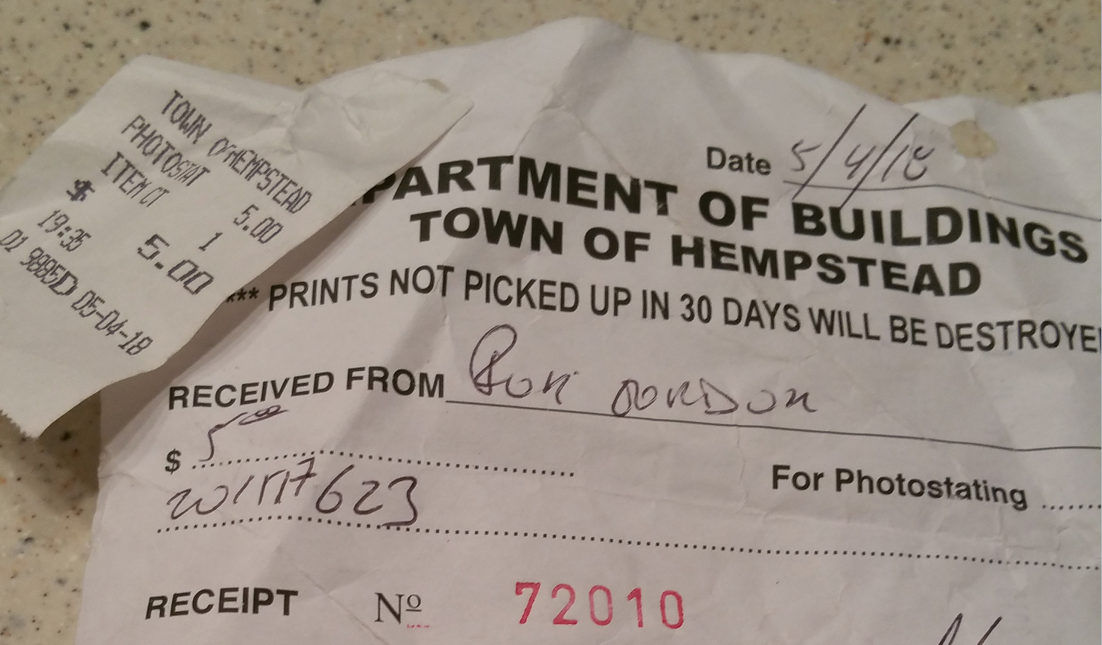

EXHIBIT 2
Picture of Building Department Computer Room with
Signs Prohibiting any form of Photography

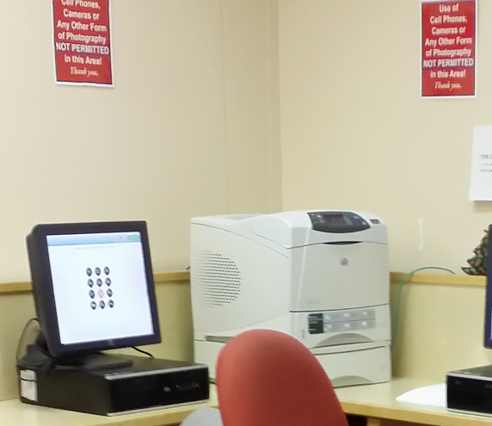

EXHIBIT 3
Adivisor Opinion from the Committee on Open Government asking the
Town to reconsider its practices regarding costs of FOILed records and its
prohibition of photography in the Town's Building Department
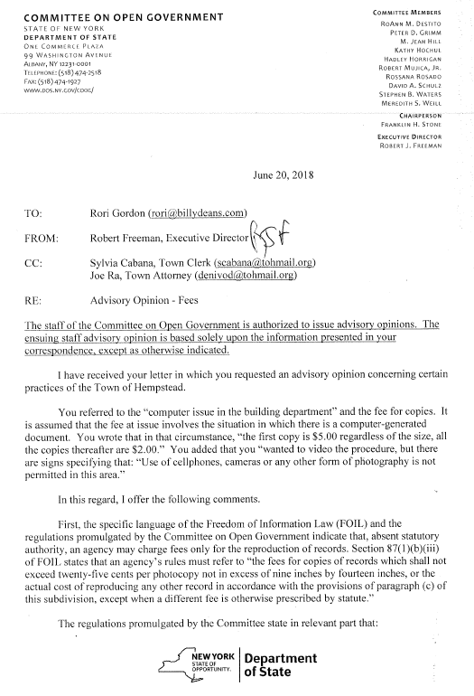
EXHIBIT 3 – continued

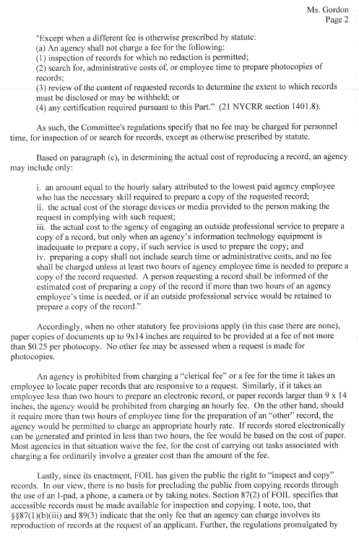

EXHIBIT 3 – continued

