**Residential Buildings  
 Lite**

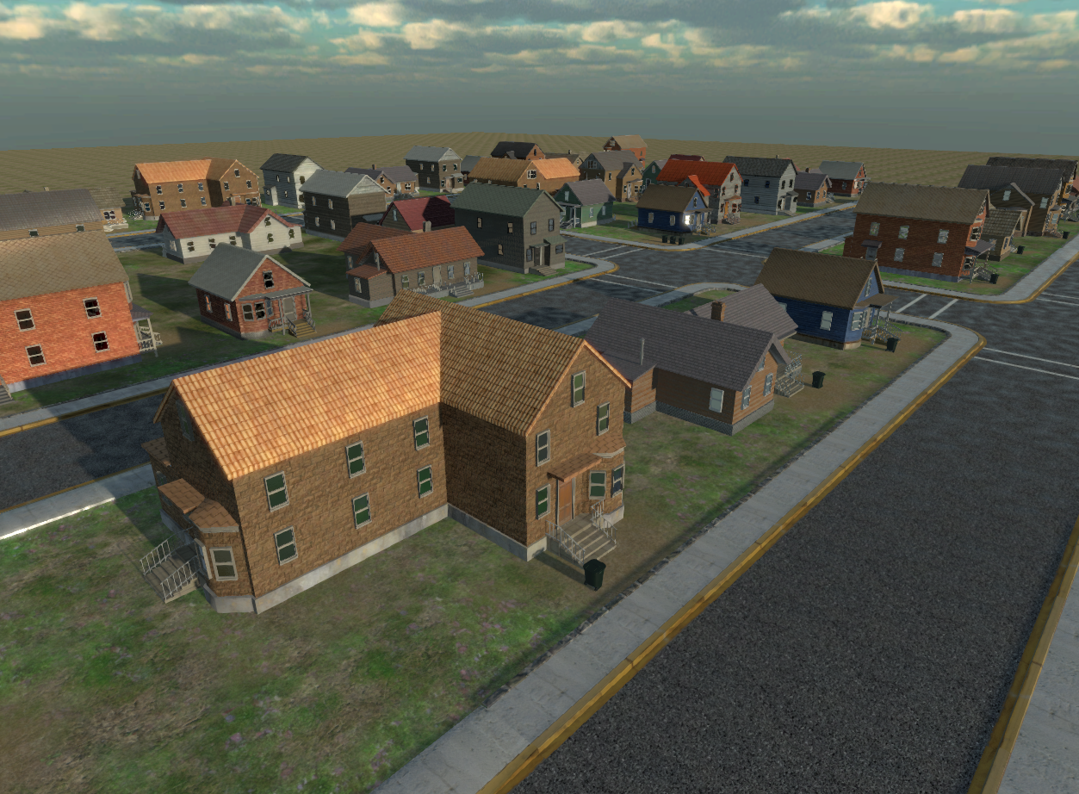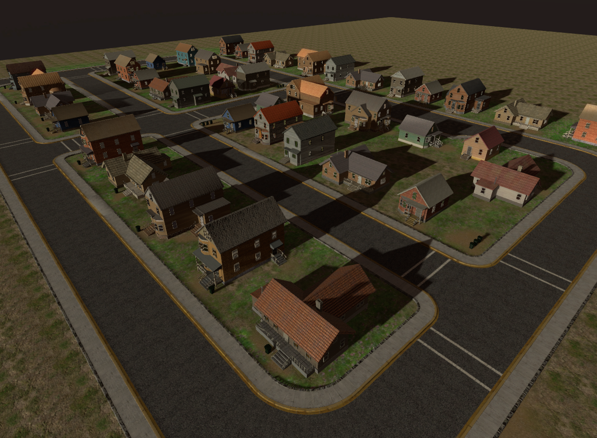

This asset was created to let you see and try what I offer in the full asset at <https://www.assetstore.unity3d.com/en/#!/content/39272>

Some assets are modified/simplified compared to the full version, however, by having this demo, you have the chance to try and have some fun with the buildings and see if the complete version fits your needs ☺

The full asset includes:

* 22 buildings total
* 1 bonus church
* Intersections, wide roads and transitions
* Trash can, mailbox, another fence set, street lights (big and small) and manhole covers, additional pavement plane
* Park area with several props

**Note: This asset may not be updated together with the full release in the future, as it enjoys priority.**

*Support e-mail is always there for you at* [*gabromedia@gmail.com*](mailto:gabromedia@gmail.com)

Stay tuned for updates and new products! [www.facebook.com/gabromedia](http://www.facebook.com/gabromedia)

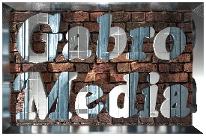Twitter: @GabroMedia

Happy game developing!

Gabro Media Team 2015

/GS