

**DRIVER LICENSE EXAM SUPPORT**

**Software Requirement Specification**

– HoChiMinh, August 2022 –

**Table of Contents**

Record of Changes 3

I. Introduction 4

1. Product Background 4

2. Business Opportunity 4

3. Software Product Vision 4

4. Major Features 5

5. Limitations and Exclusions 5

# Record of Changes

|  |  |  |  |
| --- | --- | --- | --- |
| **Date** | **A* M, D** | **In charge** | **Change Description** |
|  |  |  |  |
|  |  |  |  |
|  |  |  |  |
|  |  |  |  |
|  |  |  |  |
|  |  |  |  |
|  |  |  |  |
|  |  |  |  |
|  |  |  |  |
|  |  |  |  |
|  |  |  |  |
|  |  |  |  |
|  |  |  |  |

*A - Added M - Modified D - Deleted

# I. Introduction

## 1. Website Background

## Before the driver license exam support website was born, preparing for the driving test often encountered many difficulties and troubles. Learners need to collect information from many different sources, such as textbooks, traffic laws, and reference materials. This can take a lot of time and effort.

## 2. Business Opportunity

With the development of information technology and the internet, a website to support driving test review was born to solve this problem. This website provides an online platform where students can review and prepare for their driving test at their convenience.The driving test review support website provides many study materials, including practice tests and multiple choice questions about traffic laws. Students can access the website at any time and at any location with an internet connection. They can choose exams to review and receive the score on their exams.

## 3. Website Vision

The website is offering a wide range of study materials and resources to help learners master the rules of the road and develop safe driving skills. We envision a platform that is accessible anytime, anywhere, empowering users to study at their own pace and convenience.

## 4. Major Features

4.1 Driver License Support Exam for learners

FE-01. Attending practice quiz

- Show all practice quizs

- Start quiz

- View marks

FE-02.

-

4.2 Admin system

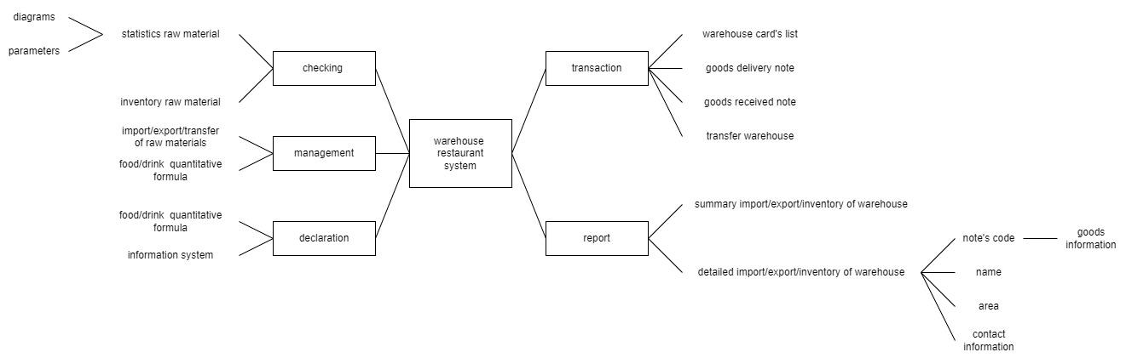

## 5. Limitations and Exclusions

- LI-01: The system needs to be online

- LI-02: The system needs to be maintained if information is too much